AI INTERACTION FRAMEWORK
Mendix Module · Technical Design
Microflows, Nanoflows, Java Actions, Domain Model
Foundational module for the Mendix Marketplace AI portfolio
Prepared by Marco Leon · April 2026 · v0.1 draft

Table of Contents

1 · Introduction

1.1 Purpose
This document specifies the AI Interaction Framework, the foundational Mendix module on which every application in the Marketplace AI portfolio is built. It defines the seven interaction primitives (microflows), the cross-cutting services (microflows + Java actions), the client-side nanoflows, the supporting Java actions, and the domain model. The document is written for Mendix developers who will build the module in Studio Pro, with sufficient context for solution architects, business process owners, and licensing or compliance reviewers to assess fit.

1.2 Design principles
- Standardize the interaction, not the model. Every primitive is defined by its inputs, outputs, governance, and audit shape — never by the features of a single LLM provider. Backends are swappable.
- Cite every fact. Every output that is shown to a user carries a machine-readable Citation pointing to the source chunk, page, and revision. Refuse rather than fabricate.
- Refuse-if-ungrounded by default. Where retrieval is part of the primitive, falling below a configurable grounding threshold triggers a deterministic refusal — the LLM is not called speculatively.
- Human in the loop for anything irreversible. Side effects on the business state never happen autonomously. The framework provides the reviewer queue, e-signature, and approval workflow.
- Audit everything. Every invocation persists an Invocation row plus AuditEvent rows; payloads are content-addressed and cryptographically hashed for tamper-evidence.
- Role and classification first. Identity, role, and data-classification scope filter every retrieval and every output. The framework will not return content the caller is not entitled to see.
- Microflow-first orchestration. The framework prefers microflows over Java actions; Java actions are the escape hatch for HTTP streaming, vector math, hashing, and PII redaction.

1.3 What is in scope and what is not
In scope: the module structure, domain model, microflows (server), nanoflows (client), Java actions, REST endpoints (consumed and published), constants, configuration, and the evaluation harness. Out of scope: app-specific business workflows (those are built by the consuming applications), tenant-level Mendix Cloud or PrivateCloud deployment topology, and the choice of LLM vendor (the framework supports multiple).

1.4 Module layout in Studio Pro
The framework ships as a single module, AIInteractionFramework, with the following sub-folders in Studio Pro:
- _Domain — domain model, enumerations, validation rules
- Primitives — the 7 IPF_* microflows
- Services — SVC_* microflows for backend selection, retrieval, guardrails, HITL, audit, eval, identity
- JavaActions — Java action wrappers (HTTP streaming, vector math, hashing, PII redaction)
- Nanoflows — client-side NF_* nanoflows
- Pages — Atlas UI building-block pages (cited-answer card, approval queue, evidence panel, confidence banner, dose/classification banner)
- REST_Published — REST endpoints other apps can call when not using the microflow API directly
- REST_Consumed — connectors to Azure OpenAI, Bedrock, Vertex, on-prem gateway, vector stores
- Workflows — Mendix Workflow definitions for HITL approval and eval campaigns
- Constants — runtime configuration
- USE_ME — the integration surface every consuming app calls; nothing else is part of the public API

2 · Architecture

2.1 Layered view
The framework is organized into four horizontal layers. Consuming applications interact with the UI Layer (Atlas pages and nanoflows) and the Primitive Layer (microflows). Primitives delegate cross-cutting concerns — backend selection, retrieval, guardrails, human-in-the-loop, audit, identity, evaluation — to the Cross-Cutting Services layer. The Backend layer exposes external systems (LLM providers, vector stores, identity, log sinks) behind narrow REST or SDK adapters.
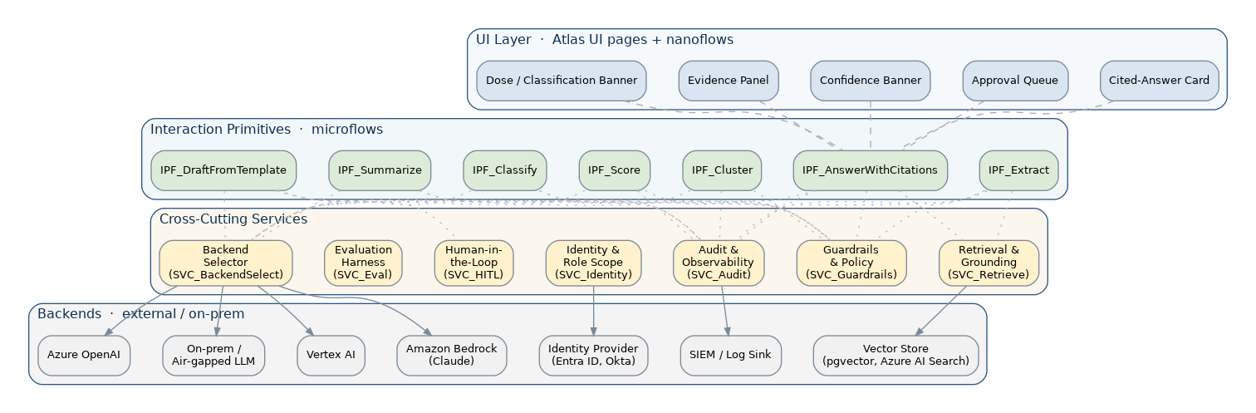
Figure 2-1 · Layered architecture of the AI Interaction Framework

2.2 Calling conventions
Every primitive accepts a single Invocation context object plus its primitive-specific inputs, and returns a single Result object that contains the typed payload, a list of Citations, a confidence indicator, and a reference to the Invocation row that was persisted. Primitives are pure with respect to business state — they never mutate the consuming application's data. When a side effect is required (e.g., publishing a draft), the consuming app explicitly performs the action after reviewing the Result.

2.3 Threading and timeouts
Synchronous calls return inside the calling microflow. Long-running primitives (e.g., IPF_Cluster on a large corpus) are queued via the Mendix Process Queue module and emit a Result with status RUNNING; the consuming app subscribes via WebSocket or polls. Defaults: 15s soft timeout for Q&A, 90s for extraction, 5min for clustering. All timeouts are configurable as constants.

2.4 Backwards compatibility and versioning
Each primitive is versioned. Every prompt template is versioned. Every model profile is versioned. The framework guarantees that an Invocation persisted today can be re-played tomorrow with the same prompt template and model profile and produce a reproducible result (subject to provider-side determinism). Breaking changes ship behind a major version increment of the module.

3 · Domain Model

3.1 Entity overview
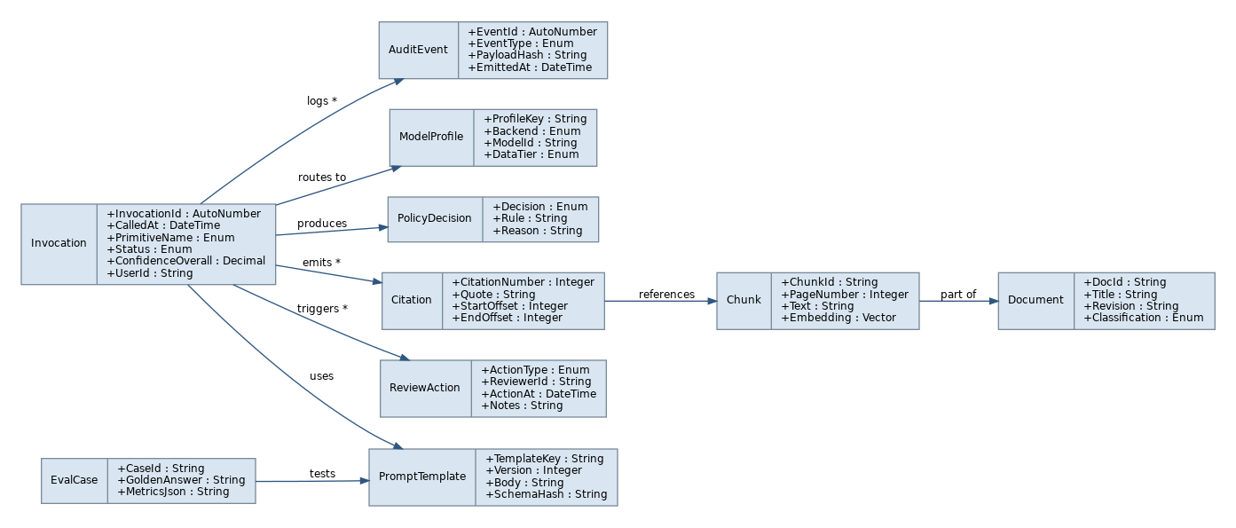
Figure 3-1 · Domain model — entities and key associations

3.2 Entity catalog

Entity · Invocation
One row per primitive call. Anchor of audit and reproducibility.
Name | Type | Description
InvocationId | AutoNumber | Primary key.
CalledAt | DateTime (UTC) | When the call started.
PrimitiveName | Enum | EXTRACT | CLASSIFY | SUMMARIZE | DRAFT | ANSWER | CLUSTER | SCORE.
Status | Enum | PENDING | RUNNING | COMPLETED | REFUSED | FAILED.
ConfidenceOverall | Decimal(0–1) | Aggregate confidence across the result.
UserId | String | Calling Mendix user (denormalized from System.User).
CorrelationId | String | Optional caller-provided correlation key for cross-system traces.
DurationMs | Integer | Wall-clock duration.
TokensIn / TokensOut | Integer | For cost reporting.

Entity · PromptTemplate
Versioned prompt definition. Owned by the framework, never edited by consuming apps.
Name | Type | Description
TemplateKey | String | Stable key, e.g., 'awc.v1'.
Version | Integer | Monotonically increasing.
Body | String (Long) | The full prompt with placeholders ({{question}}, {{chunks}}).
SchemaHash | String (SHA-256) | Hash of the expected JSON output schema for tamper evidence.
Owner | String | Framework maintainer email.

Entity · ModelProfile
A named, policy-controlled selection of backend, model, and routing tier.
Name | Type | Description
ProfileKey | String | Stable key, e.g., 'reg-default'.
Backend | Enum | AZURE_OPENAI | BEDROCK_CLAUDE | VERTEX | ONPREM_GATEWAY.
ModelId | String | Provider-specific model id.
DataTier | Enum | PUBLIC | INTERNAL | RESTRICTED | SGI. Restricts which Invocations may use this profile.
MaxOutputTokens | Integer | Hard ceiling enforced before submit.
Temperature | Decimal | Default 0.0 for governed primitives.

Entity · PolicyDecision
Outcome of a Guardrails check. One per check (precheck, postcheck).
Name | Type | Description
Decision | Enum | ALLOW | REDACT | REFUSE.
Rule | String | Identifier of the rule that fired.
Reason | String | Human-readable rationale.
AppliedAt | DateTime | Timestamp.

Entity · Document
A source document registered in the retrieval store.
Name | Type | Description
DocId | String | External system id (e.g., ADAMS accession number, Documentum object id).
Title | String | Human-readable title.
Revision | String | Plant or document-management revision.
Classification | Enum | PUBLIC | INTERNAL | RESTRICTED | SGI | EXPORT_810.
IngestedAt | DateTime | Last ingestion.
Source | String | Originating system.

Entity · Chunk
A retrieval-unit of a Document. Embeddings live here.
Name | Type | Description
ChunkId | String | Stable id (e.g., docId:page:offset).
PageNumber | Integer | Source page or section.
Text | String (Long) | Original chunk text after normalization.
Embedding | Vector(float[]) | Persisted via JA_VectorSearch.
TokenCount | Integer | Cached for budgeting.

Entity · Citation
A pointer from a span of model output to the supporting Chunk.
Name | Type | Description
CitationNumber | Integer | 1-based ordinal within the result.
Quote | String | Verbatim supporting quote (post-trim).
StartOffset / EndOffset | Integer | Character offsets into the result text.
ChunkRef | Association → Chunk | Source chunk.

Entity · ReviewAction
A row in the human-in-the-loop reviewer queue.
Name | Type | Description
ActionType | Enum | PENDING | APPROVED | CHANGES_REQUESTED | REJECTED.
ReviewerId | String | Mendix user id of the reviewer.
ActionAt | DateTime | Timestamp of the decision.
Notes | String | Reviewer comments.
SignatureHash | String | Hash of the e-signature payload.

Entity · AuditEvent
Append-only log of governance-significant events.
Name | Type | Description
EventId | AutoNumber | Primary key.
EventType | Enum | INVOKE | RETRIEVE | LLM_CALL | POLICY | REVIEW | EXPORT.
PayloadHash | String (SHA-256) | Hash of the canonicalized payload.
EmittedAt | DateTime | When emitted; immutable.
UpstreamRef | Association → Invocation | Anchor.

Entity · EvalCase
A test case for the evaluation harness.
Name | Type | Description
CaseId | String | Stable id.
GoldenAnswer | String (Long) | Reference output.
MetricsJson | String (Long) | Per-run metric snapshot.
TemplateRef | Association → PromptTemplate | Template under test.

4 · Cross-Cutting Services
These services are shared by every primitive. They are implemented as microflows in the Services folder, with Java actions where required for performance or external SDK access. The contract for each service is small and stable; primitives cannot bypass them.

4.1 SVC_BackendSelect
Resolve which ModelProfile a given Invocation will use, based on primitive, data classification of inputs, tenant policy, and override.

Inputs
Name | Type | Description
PrimitiveName | Enum | From the calling Invocation.
DataTier | Enum | Highest classification observed in inputs.
ProfileOverride | String | Optional explicit profile key. Subject to allow-list.

Outputs
Name | Type | Description
ModelProfile | Object | Resolved profile. Never null; defaults to SAFE_REFUSE profile if no match.
Reason | String | Why this profile was chosen.

Activities (microflow body)
# | Mendix Activity | Description | On error / branch
1 | Retrieve | List of ModelProfile where DataTier ≥ inputDataTier ordered by priority.
2 | Decision | If ProfileOverride supplied, validate against allow-list. | On invalid: throw FrameworkException PROFILE_NOT_PERMITTED
3 | Decision | If list empty, return SAFE_REFUSE profile. | Triggers downstream refusal
4 | Sub-microflow | SVC_Audit_LogPolicy with 'profile.selected' event.
5 | Return | Best-match ModelProfile + reason.

Telemetry / Errors
Telemetry events | Error model
• profile.selected (profileKey, dataTier, reason)  • profile.refused (inputDataTier, reason) | • PROFILE_NOT_PERMITTED — override not in allow-list  • NO_PROFILE_AVAILABLE — falls back to SAFE_REFUSE

4.2 SVC_Retrieve
Retrieval & grounding. Returns top-k Chunks for a query, scoped by user role and document classification.

Inputs
Name | Type | Description
Query | String | Free-text query.
UserContext | Object | Identity + role + classification level.
K | Integer | Top-k. Default 8.
MinScore | Decimal | Minimum cosine similarity. Default 0.5.
DocFilter | Object | Optional doc-source / classification filters.

Outputs
Name | Type | Description
Chunks | List<Chunk> | Top-k chunks with score and metadata.
MaxScore | Decimal | Highest similarity in result set.
GroundingScore | Decimal | Aggregate (max + diversity) score for refuse-if-ungrounded.

Activities (microflow body)
# | Mendix Activity | Description | On error / branch
1 | Java Action | JA_VectorSearch.embed(query) → vector. | On error: rethrow VECTOR_SEARCH_FAILED
2 | Java Action | JA_VectorSearch.searchTopK(vector, k, filter) → raw hits.
3 | Loop | For each hit, retrieve Chunk + Document; filter by user role and Document.Classification ≤ user max.
4 | Decision | If filtered set empty or maxScore < MinScore, set GroundingScore = 0.
5 | Sub-microflow | SVC_Audit_LogRetrieve with chunk ids + scores.
6 | Return | RetrievalResult.

Telemetry / Errors
Telemetry events | Error model
• retrieve.invoked (k, minScore)  • retrieve.returned (count, maxScore, groundingScore)  • retrieve.scoped_out (count_dropped_for_role) | • VECTOR_SEARCH_FAILED — propagated to caller  • RETRIEVAL_EMPTY — non-fatal; caller decides

4.3 SVC_Guardrails
Pre- and post-checks for prompts and outputs. Owns the deny list, PII / SGI redaction, prompt-injection defenses, and refuse-if-ungrounded thresholds.

Inputs
Name | Type | Description
Phase | Enum | PRECHECK | POSTCHECK.
Payload | Object | Question + context (PRECHECK) or answer + citations (POSTCHECK).
Policy | Object | Active policy bundle for the tenant + primitive.

Outputs
Name | Type | Description
Decision | Enum | ALLOW | REDACT | REFUSE.
RedactedPayload | Object | Same shape as input with sensitive spans masked.
Reasons | List<PolicyDecision> | One per rule fired.

Activities (microflow body)
# | Mendix Activity | Description | On error / branch
1 | Sub-microflow | Run deny-list rules over Payload.
2 | Java Action | JA_RedactPII over text spans.
3 | Sub-microflow | Prompt-injection sniff (suspicious instruction patterns, content-template breaks).
4 | Decision | If Phase=POSTCHECK and any answer span lacks a citation, mark REDACT or REFUSE per policy. | Refuse-if-ungrounded
5 | Sub-microflow | SVC_Audit_LogPolicy with each PolicyDecision.
6 | Return | GuardrailDecision.

Telemetry / Errors
Telemetry events | Error model
• guardrails.precheck.decision  • guardrails.postcheck.decision  • guardrails.redacted (rule, span_count) | • POLICY_BUNDLE_MISSING  • REDACTION_FAILED — fail closed (REFUSE)

4.4 SVC_HITL
Human-in-the-Loop reviewer queue. Wraps a Mendix Workflow for approval, requests-changes, and rejection, with e-signature.

Inputs
Name | Type | Description
Item | Object | Draft / proposal payload.
Policy | Object | Routing rules (who can review; SLA; required signers).
RequireApproval | Boolean | If false, becomes a notification-only step.

Outputs
Name | Type | Description
ReviewAction | Object | Final review state.
FinalPayload | Object | Possibly modified by reviewer.

Activities (microflow body)
# | Mendix Activity | Description | On error / branch
1 | Create | Create ReviewAction(PENDING) with hash of Item.
2 | Workflow Start | Start ReviewWorkflow with the policy-derived participants list.
3 | Wait | Suspend on user-task completion (microflow returns; primitive returns RUNNING to caller).
4 | Java Action | JA_HashAuditRecord on the reviewer's signature payload.
5 | Sub-microflow | SVC_Audit_LogReview with action + signature hash.
6 | Return | ReviewAction with final state.

Telemetry / Errors
Telemetry events | Error model
• hitl.enqueued  • hitl.completed (action, durationMs)  • hitl.escalated (rule) | • WORKFLOW_FAILED — escalate to admin  • SIGNATURE_INVALID — reject and audit

4.5 SVC_Audit
Append-only audit log. Persists Invocations, AuditEvents, and exports an inspector-ready bundle on demand.

Inputs
Name | Type | Description
EventType | Enum | INVOKE | RETRIEVE | LLM_CALL | POLICY | REVIEW | EXPORT.
UpstreamInvocation | Object | The Invocation row this event belongs to.
Payload | Object | Free-form payload to canonicalize and hash.

Outputs
Name | Type | Description
AuditEvent | Object | Persisted event.

Activities (microflow body)
# | Mendix Activity | Description | On error / branch
1 | Java Action | JA_HashAuditRecord on canonical JSON of Payload.
2 | Create | AuditEvent with EventType, UpstreamRef, PayloadHash, EmittedAt = NOW.
3 | Optional | Stream AuditEvent JSON to SIEM via SVC_Audit_StreamSink.
4 | Return | AuditEvent.

Telemetry / Errors
Telemetry events | Error model
• audit.event.emitted (eventType)  • audit.sink.failed (sinkName) | • AUDIT_PERSIST_FAILED — fail closed (caller refuses to return result)  • SIEM_UNAVAILABLE — non-fatal, retry queue

4.6 SVC_Eval
Evaluation harness. Runs an EvalCase set against the current PromptTemplate / ModelProfile and reports metrics.

Inputs
Name | Type | Description
TemplateKey | String | Template under test.
ProfileKey | String | Profile under test.
EvalSetId | String | Named set of EvalCases.

Outputs
Name | Type | Description
MetricsJson | String | Grounding precision, citation rate, hallucination rate, refusal rate, latency, cost.
RegressionFlag | Boolean | True if any metric crossed a configured tolerance vs. baseline.

Activities (microflow body)
# | Mendix Activity | Description | On error / branch
1 | Retrieve | EvalCases in EvalSet.
2 | Loop | For each case, run the primitive in shadow mode (isEval=true) — bypasses HITL but records audit.
3 | Sub-microflow | Compute metrics per case (string match, BLEU/ROUGE, citation overlap, refusal correctness).
4 | Aggregate | Roll up to set-level metrics; compare to baseline.
5 | Sub-microflow | SVC_Audit_LogPolicy with eval summary.
6 | Return | MetricsJson + RegressionFlag.

Telemetry / Errors
Telemetry events | Error model
• eval.run.started  • eval.run.completed (metricsHash)  • eval.regression.detected (metric, delta) | • EVAL_SET_EMPTY  • BASELINE_MISSING — first-run mode (record as new baseline)

4.7 SVC_Identity
Resolve user identity + roles + maximum data classification. Read-only wrapper around Mendix System module + tenant identity provider.

Inputs
Name | Type | Description
MendixUser | Object | System.User.

Outputs
Name | Type | Description
UserContext | Object | { userId, roles, maxClassification, plant, unit, tenant }.

Activities (microflow body)
# | Mendix Activity | Description | On error / branch
1 | Retrieve | System.User and associated System.UserRole(s).
2 | REST Call | Tenant identity provider claims endpoint (Entra ID / Okta) for plant/unit/program scope. | On error: cached claim + alert
3 | Decision | Compute MaxClassification from role-to-classification mapping.
4 | Return | UserContext.

Telemetry / Errors
Telemetry events | Error model
• identity.resolved (userId, roleCount)  • identity.idp_unavailable | • IDP_UNAVAILABLE — degrade to Mendix-local roles only; mark Invocation as DEGRADED

5 · Interaction Primitives
Each primitive is a microflow that consuming applications call. Every primitive follows the same pattern: resolve identity and model profile → load prompt template → precheck guardrails → do the primitive's work → postcheck guardrails → persist Invocation and AuditEvents → return the typed Result. Differences between primitives are concentrated in the middle steps. The flowchart for each primitive shows the activity-level structure.

5.1 IPF_Extract
Structured extraction from documents into Mendix entities, with per-field citation.

Inputs
Name | Type | Description
Source | Document or List<Chunk> | Source material.
TargetEntityKey | String | Logical name of the target entity (e.g., 'Requirement', 'Commitment').
TemplateKey | String | Prompt template; default 'extract.{TargetEntityKey}.v1'.
UserContext | Object | Caller identity.

Outputs
Name | Type | Description
Records | List<Object> | Strongly typed records matching the target schema.
Citations | List<Citation> | Per-field source pointers.
Confidence | Decimal(0–1) | Per-record + aggregate.
Invocation | Object | Persisted invocation row.

Activities (microflow body)
# | Mendix Activity | Description | On error / branch
1 | Sub-microflow | SVC_Identity → UserContext.
2 | Sub-microflow | SVC_BackendSelect → ModelProfile.
3 | Retrieve | PromptTemplate by TemplateKey + latest version.
4 | Sub-microflow | SVC_Guardrails(PRECHECK). | Decision REFUSE → return refuse envelope
5 | Sub-microflow | SVC_Retrieve when Source is a query rather than concrete chunks.
6 | Java Action | JA_StreamCompletion with prompt + chunks; bind output to TargetEntity JSON schema. | On parse error: retry once with stricter schema; if fail, FAILED
7 | Loop | For each parsed record, attach Citations from per-field source spans returned by the model.
8 | Sub-microflow | SVC_Guardrails(POSTCHECK) on records + citations. | Decision REDACT → mask spans
9 | Sub-microflow | SVC_Audit on Invocation + per-event LLM_CALL/POLICY rows.
10 | Return | ExtractResult.

Telemetry / Errors
Telemetry events | Error model
• extract.invoked (targetEntityKey)  • extract.records.count  • extract.confidence.avg  • extract.parse_retry | • SCHEMA_PARSE_FAILED — Invocation FAILED  • GROUNDING_INSUFFICIENT — REFUSED
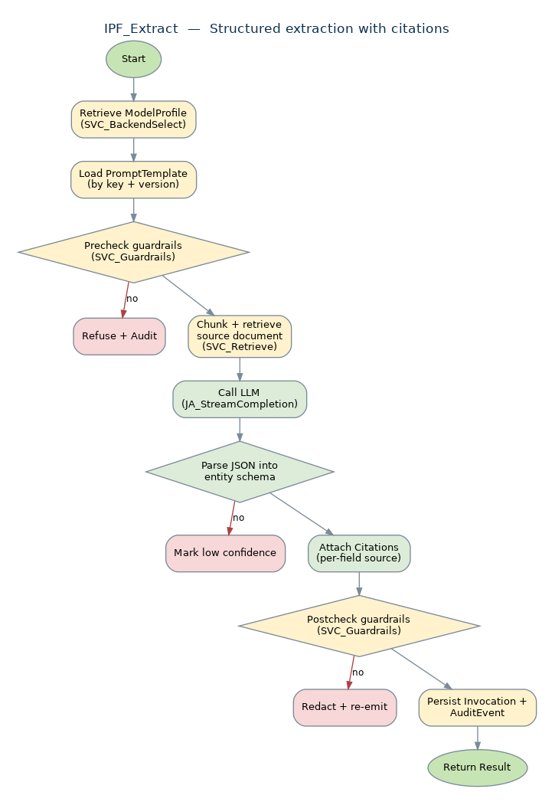
Figure 5-1 · IPF_Extract activity flow

5.2 IPF_Classify
Assign one or more labels from a controlled taxonomy with per-label confidence.

Inputs
Name | Type | Description
Item | Object | Text or structured record to classify.
TaxonomyKey | String | Named controlled vocabulary.
MultiLabel | Boolean | Single-label vs. multi-label. Default false.
UserContext | Object | Caller identity.

Outputs
Name | Type | Description
Labels | List<{label, confidence}> | Sorted descending by confidence.
Citations | List<Citation> | Optional supporting evidence (when Item is a Document).
Invocation | Object | Persisted invocation row.

Activities (microflow body)
# | Mendix Activity | Description | On error / branch
1 | Sub-microflow | SVC_Identity → UserContext.
2 | Sub-microflow | SVC_BackendSelect → ModelProfile.
3 | Retrieve | Taxonomy and PromptTemplate.
4 | Sub-microflow | SVC_Guardrails(PRECHECK).
5 | Java Action | JA_StreamCompletion with constrained label-set output. | On invalid label: retry once
6 | Decision | If max confidence < threshold (default 0.7) and !isEval, mark for HITL escalation. | Status WAITING_REVIEW
7 | Sub-microflow | SVC_Guardrails(POSTCHECK).
8 | Sub-microflow | SVC_Audit.
9 | Return | ClassifyResult.

Telemetry / Errors
Telemetry events | Error model
• classify.invoked (taxonomyKey)  • classify.confidence.max  • classify.escalated | • INVALID_LABEL — Invocation FAILED  • TAXONOMY_MISSING — Invocation FAILED
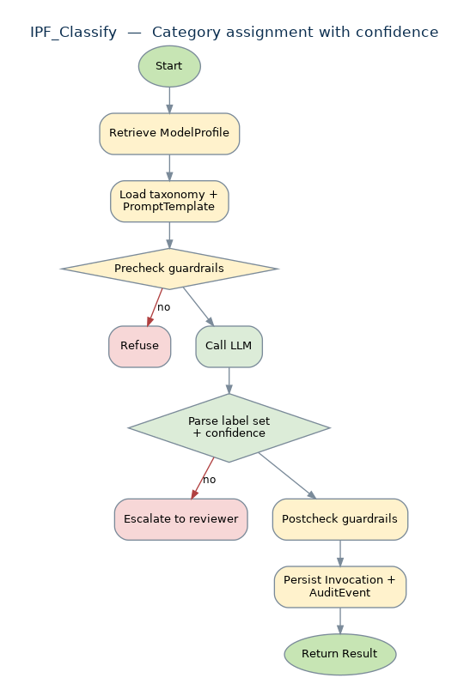
Figure 5-2 · IPF_Classify activity flow

5.3 IPF_Summarize
Grounded summarization of one or more source documents, with citations.

Inputs
Name | Type | Description
Sources | List<Document> | Documents to summarize.
TargetLength | Enum | BRIEF | STANDARD | LONG.
Style | Enum | EXEC | TECHNICAL | ACTION_ORIENTED.
UserContext | Object | Caller identity.

Outputs
Name | Type | Description
Summary | String | Final summary.
Citations | List<Citation> | Per-claim source pointers.
Invocation | Object | Persisted invocation row.

Activities (microflow body)
# | Mendix Activity | Description | On error / branch
1 | Sub-microflow | SVC_Identity, SVC_BackendSelect, retrieve PromptTemplate.
2 | Sub-microflow | SVC_Retrieve to chunk sources to fit context window.
3 | Sub-microflow | SVC_Guardrails(PRECHECK).
4 | Loop | Map step: per chunk, summarize-with-anchor.
5 | Java Action | Reduce step: concatenate, then re-summarize to TargetLength while preserving citation spans.
6 | Sub-microflow | SVC_Guardrails(POSTCHECK) — refuse-if-ungrounded.
7 | Sub-microflow | SVC_Audit.
8 | Return | SummaryResult.

Telemetry / Errors
Telemetry events | Error model
• summarize.invoked (sourceCount, targetLength)  • summarize.citations.count  • summarize.compression_ratio | • GROUNDING_INSUFFICIENT — REFUSED  • CONTEXT_OVERFLOW — partial summary returned with warning
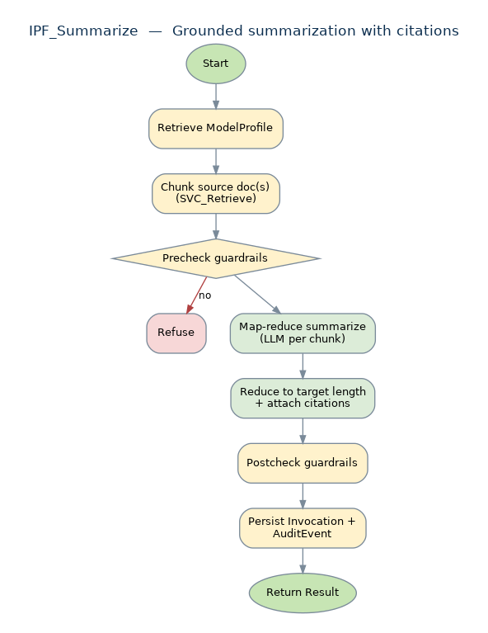
Figure 5-3 · IPF_Summarize activity flow

5.4 IPF_DraftFromTemplate
Template-driven generation of a regulated artifact (LER, RWP, ECO narrative, work package). Always paired with HITL.

Inputs
Name | Type | Description
TemplateKey | String | Domain template identifier (e.g., 'ler.v3', 'rwp.v2').
StructuredInputs | Object | Schema-validated input bag.
RequireApproval | Boolean | Default true.
ReviewerPolicy | Object | Routing rules. Optional; defaults from template.
UserContext | Object | Caller identity.

Outputs
Name | Type | Description
Draft | String | Generated artifact text.
Citations | List<Citation> | Per-section sources.
ReviewAction | Object | Pending review (when RequireApproval).
Invocation | Object | Persisted invocation row.

Activities (microflow body)
# | Mendix Activity | Description | On error / branch
1 | Sub-microflow | SVC_Identity, SVC_BackendSelect, retrieve PromptTemplate + output schema.
2 | Decision | Validate StructuredInputs against the template's input schema. | On invalid: return validation error envelope
3 | Sub-microflow | SVC_Guardrails(PRECHECK).
4 | Java Action | JA_StreamCompletion with template + inputs; produces sectioned output.
5 | Sub-microflow | SVC_Guardrails(POSTCHECK) — citation completeness.
6 | Decision | If RequireApproval, sub-microflow SVC_HITL(enqueue, ReviewerPolicy). | Status WAITING_REVIEW
7 | Sub-microflow | SVC_Audit.
8 | Return | DraftResult.

Telemetry / Errors
Telemetry events | Error model
• draft.invoked (templateKey)  • draft.sections.count  • draft.review.enqueued  • draft.review.outcome | • INPUT_SCHEMA_INVALID  • TEMPLATE_NOT_FOUND  • WORKFLOW_FAILED
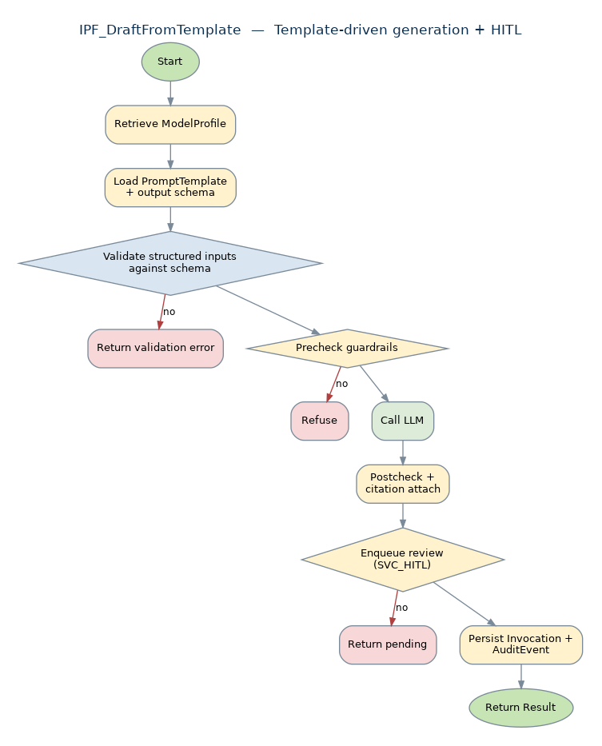
Figure 5-4 · IPF_DraftFromTemplate activity flow

5.5 IPF_AnswerWithCitations
Retrieval-grounded Q&A with per-span citations. Refuses rather than fabricates when retrieval is weak.

Inputs
Name | Type | Description
Question | String | Free-text question.
ScopeFilter | Object | Optional doc-source / classification filter.
UserContext | Object | Caller identity.

Outputs
Name | Type | Description
Answer | String | Final answer with inline citation markers [n].
Citations | List<Citation> | Per-span source pointers.
Confidence | Decimal(0–1) | Aggregate.
Invocation | Object | Persisted invocation row.

Activities (microflow body)
# | Mendix Activity | Description | On error / branch
1 | Sub-microflow | SVC_Identity, SVC_BackendSelect, retrieve PromptTemplate.
2 | Sub-microflow | SVC_Retrieve(Question, UserContext, ScopeFilter).
3 | Decision | If GroundingScore < threshold (default 0.55), refuse-if-ungrounded. | Status REFUSED
4 | Sub-microflow | SVC_Guardrails(PRECHECK).
5 | Java Action | JA_StreamCompletion with prompt + chunks; output requires inline [n] markers.
6 | Loop | Resolve each [n] to a Citation pointing to the source Chunk; spans without a marker are flagged.
7 | Sub-microflow | SVC_Guardrails(POSTCHECK) — REFUSE if any non-trivial span is uncited.
8 | Sub-microflow | SVC_Audit.
9 | Return | AnswerResult.

Telemetry / Errors
Telemetry events | Error model
• answer.invoked  • answer.refused.ungrounded  • answer.citations.count  • answer.uncited_span.detected | • GROUNDING_INSUFFICIENT — REFUSED  • CITATION_RESOLUTION_FAILED — REFUSED
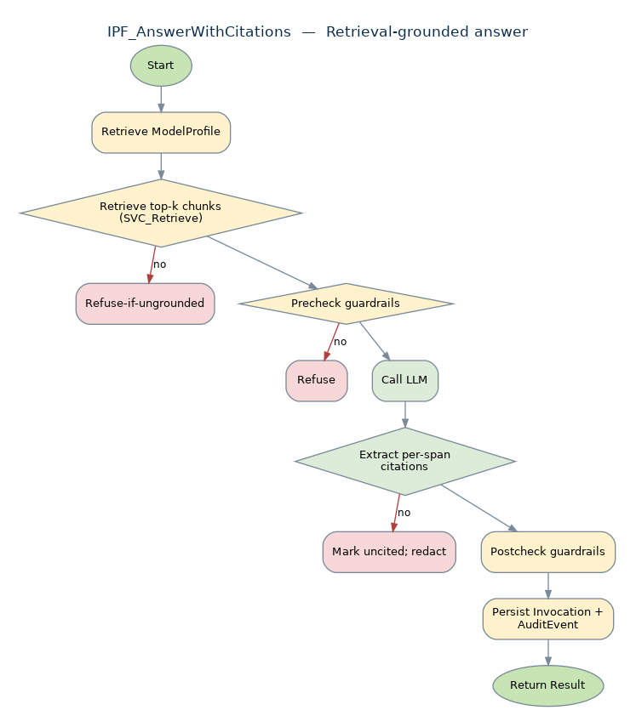
Figure 5-5 · IPF_AnswerWithCitations activity flow

5.6 IPF_Cluster
Unsupervised grouping of records (e.g., maintenance logs, OpEx items, plasma anomalies) with named clusters and exemplars.

Inputs
Name | Type | Description
Records | List<Object> | Items to cluster.
Algorithm | Enum | HDBSCAN | KMEANS | AGGLOM. Default HDBSCAN.
MaxClusters | Integer | Optional cap.
UserContext | Object | Caller identity.

Outputs
Name | Type | Description
Clusters | List<{name, size, exemplarIds, centroid}> | Named clusters with exemplars.
Assignments | Map<recordId, clusterId> | Per-record assignment + outlier flag.
Invocation | Object | Persisted invocation row.

Activities (microflow body)
# | Mendix Activity | Description | On error / branch
1 | Sub-microflow | SVC_Identity, SVC_BackendSelect.
2 | Sub-microflow | SVC_Guardrails(PRECHECK).
3 | Java Action | JA_VectorSearch.embedBatch(Records).
4 | Java Action | Run Algorithm in JA_Cluster (returns clusters + assignments).
5 | Loop | For each cluster, ask LLM to name it from exemplars (constrained ≤ 6 words).
6 | Sub-microflow | SVC_Guardrails(POSTCHECK).
7 | Sub-microflow | SVC_Audit.
8 | Return | ClusterResult.

Telemetry / Errors
Telemetry events | Error model
• cluster.invoked (algo, recordCount)  • cluster.count  • cluster.outlier.rate | • EMBED_BATCH_FAILED  • CLUSTER_DEGENERATE — single cluster — return as warning
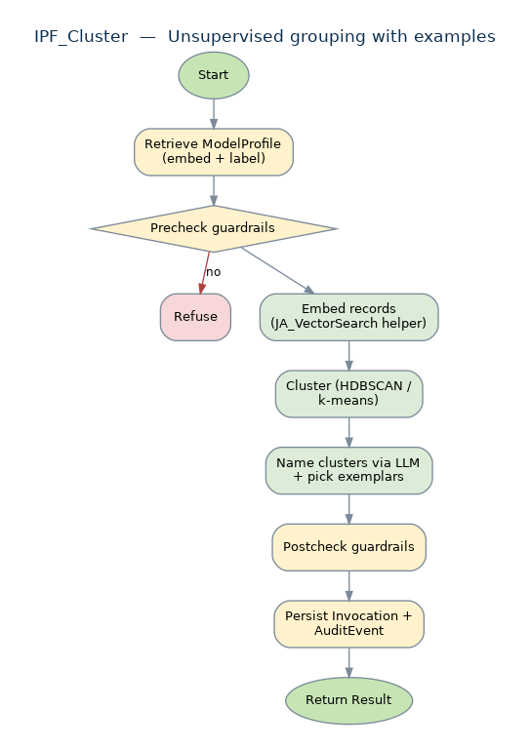
Figure 5-6 · IPF_Cluster activity flow

5.7 IPF_Score
Explainable 0–100 score with factor attribution. Hybrid of deterministic factors and LLM rationale.

Inputs
Name | Type | Description
Subject | Object | What is being scored (Supplier, Item, Alert, etc.).
RubricKey | String | Named rubric (set of factors + weights).
Evidence | List<Object> | Source records the score may cite.
UserContext | Object | Caller identity.

Outputs
Name | Type | Description
Score | Integer 0–100 | Final score.
Factors | List<{factor, weight, value, contribution, citationRef}> | Factor breakdown.
Rationale | String | Plain-language explanation.
Invocation | Object | Persisted invocation row.

Activities (microflow body)
# | Mendix Activity | Description | On error / branch
1 | Sub-microflow | SVC_Identity, SVC_BackendSelect.
2 | Sub-microflow | SVC_Guardrails(PRECHECK).
3 | Sub-microflow | Compute deterministic factors (SQL/Java) per Rubric. | On missing data: factor.value=null
4 | Java Action | JA_StreamCompletion: ask LLM only for factor attribution + rationale, never the score.
5 | Aggregate | Score = Σ (weight × value); clamp to 0–100.
6 | Loop | For each factor, attach Citation to Evidence record.
7 | Sub-microflow | SVC_Guardrails(POSTCHECK).
8 | Sub-microflow | SVC_Audit.
9 | Return | ScoreResult.

Telemetry / Errors
Telemetry events | Error model
• score.invoked (rubricKey)  • score.value  • score.factor.missing.count | • RUBRIC_NOT_FOUND  • FACTOR_COMPUTE_FAILED — Invocation FAILED
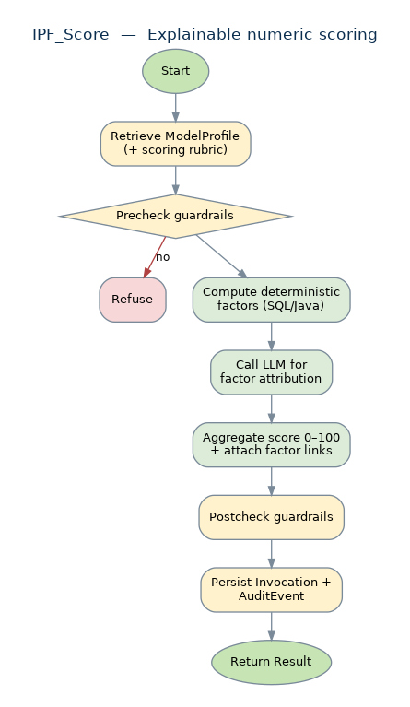
Figure 5-7 · IPF_Score activity flow

6 · End-to-End Sequences
These diagrams show how primitives, services, and external systems collaborate at runtime. They are the canonical reference for runtime behavior; if a diagram and a per-microflow activity table disagree, the activity table wins (it is the lower-level spec).

6.1 IPF_AnswerWithCitations — happy path
The full retrieval-grounded Q&A flow, from a UI nanoflow call through guardrails, retrieval, model invocation, citation resolution, and audit, back to the UI as a CitedAnswer object.
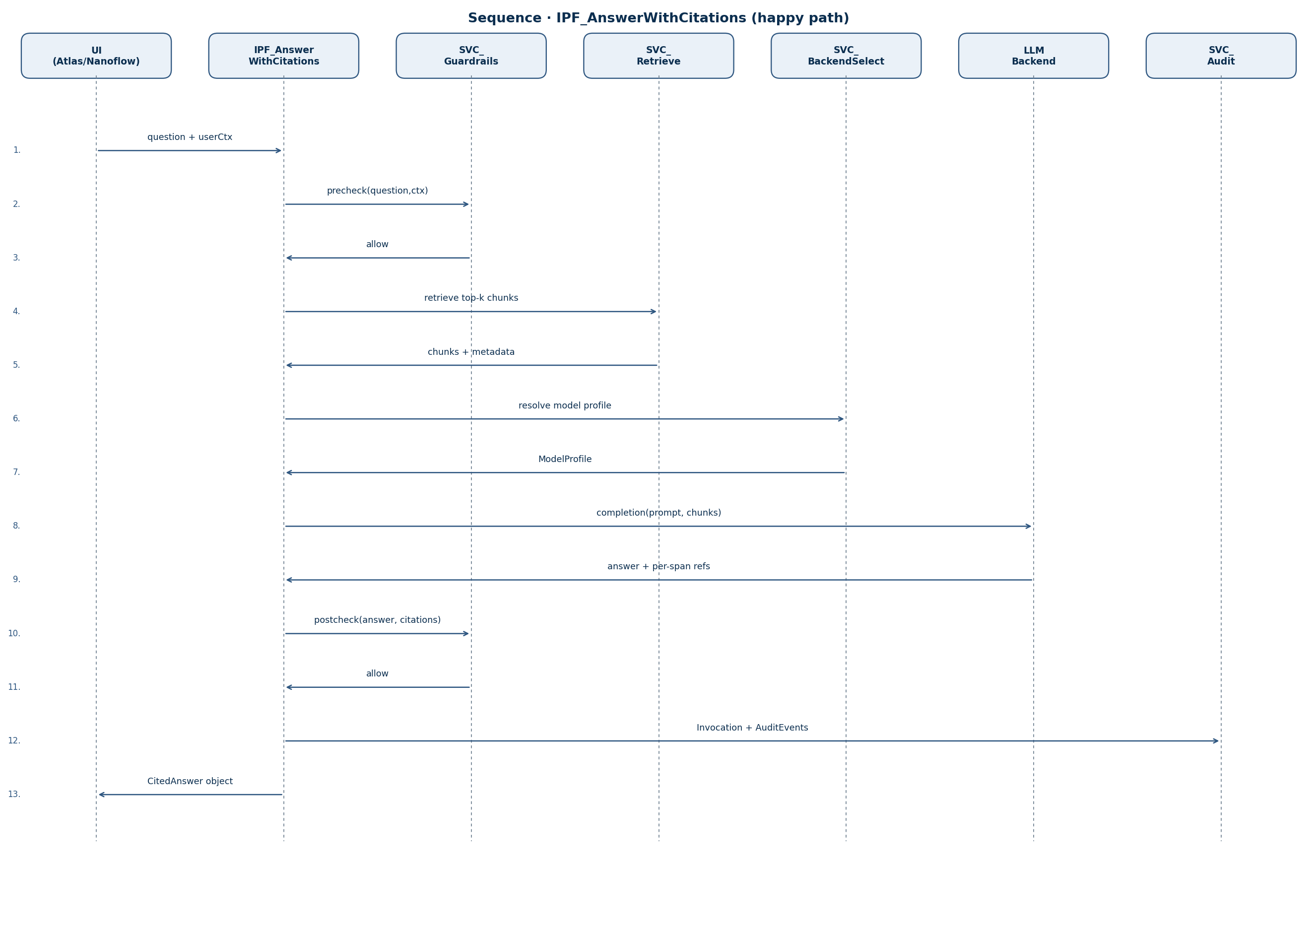
Figure 6-1 · AnswerWithCitations end-to-end happy path

6.2 Refuse-if-ungrounded
When SVC_Retrieve cannot find chunks above the grounding threshold, IPF_AnswerWithCitations refuses without ever calling the LLM. The refusal is audited with the same rigor as a returned answer.
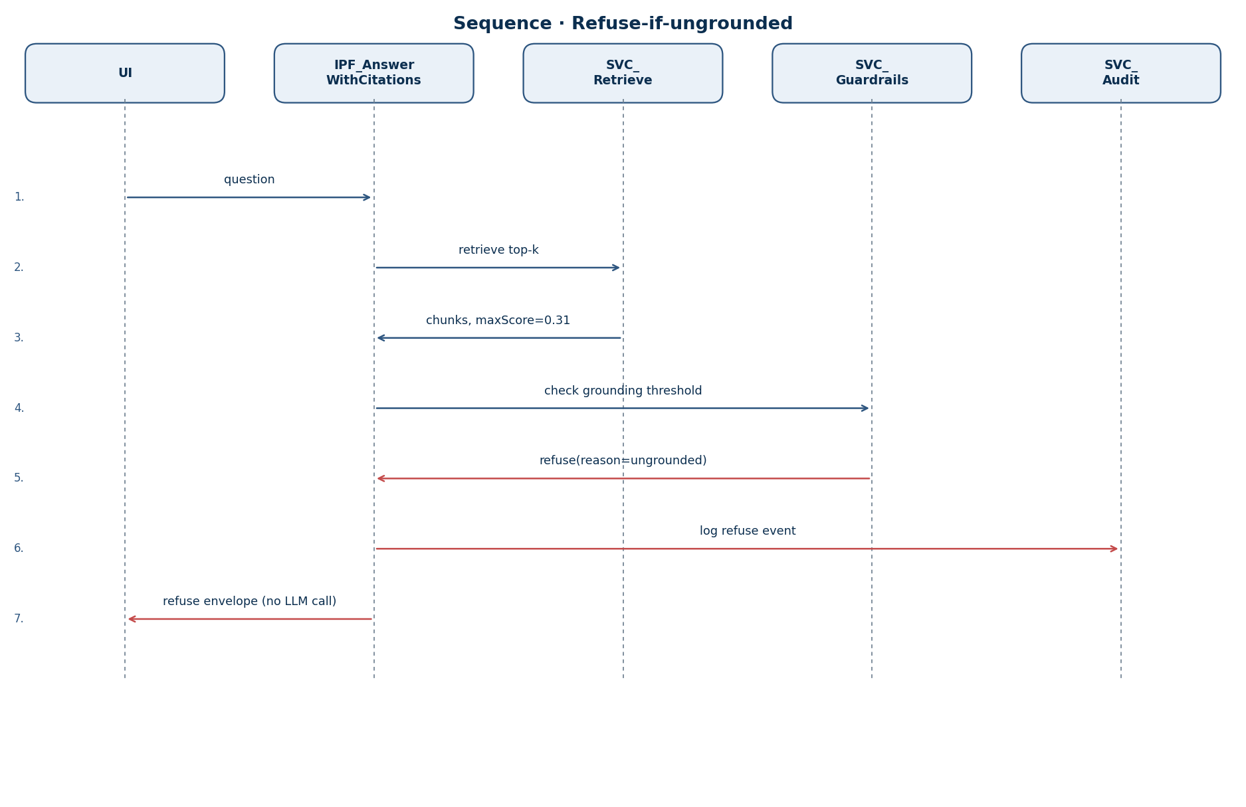
Figure 6-2 · Refuse-if-ungrounded path

6.3 Human-in-the-Loop with e-signature
IPF_DraftFromTemplate enqueues a ReviewAction via SVC_HITL. The Mendix Workflow drives the reviewer queue UI; on completion the reviewer's e-signature is hashed and audited.
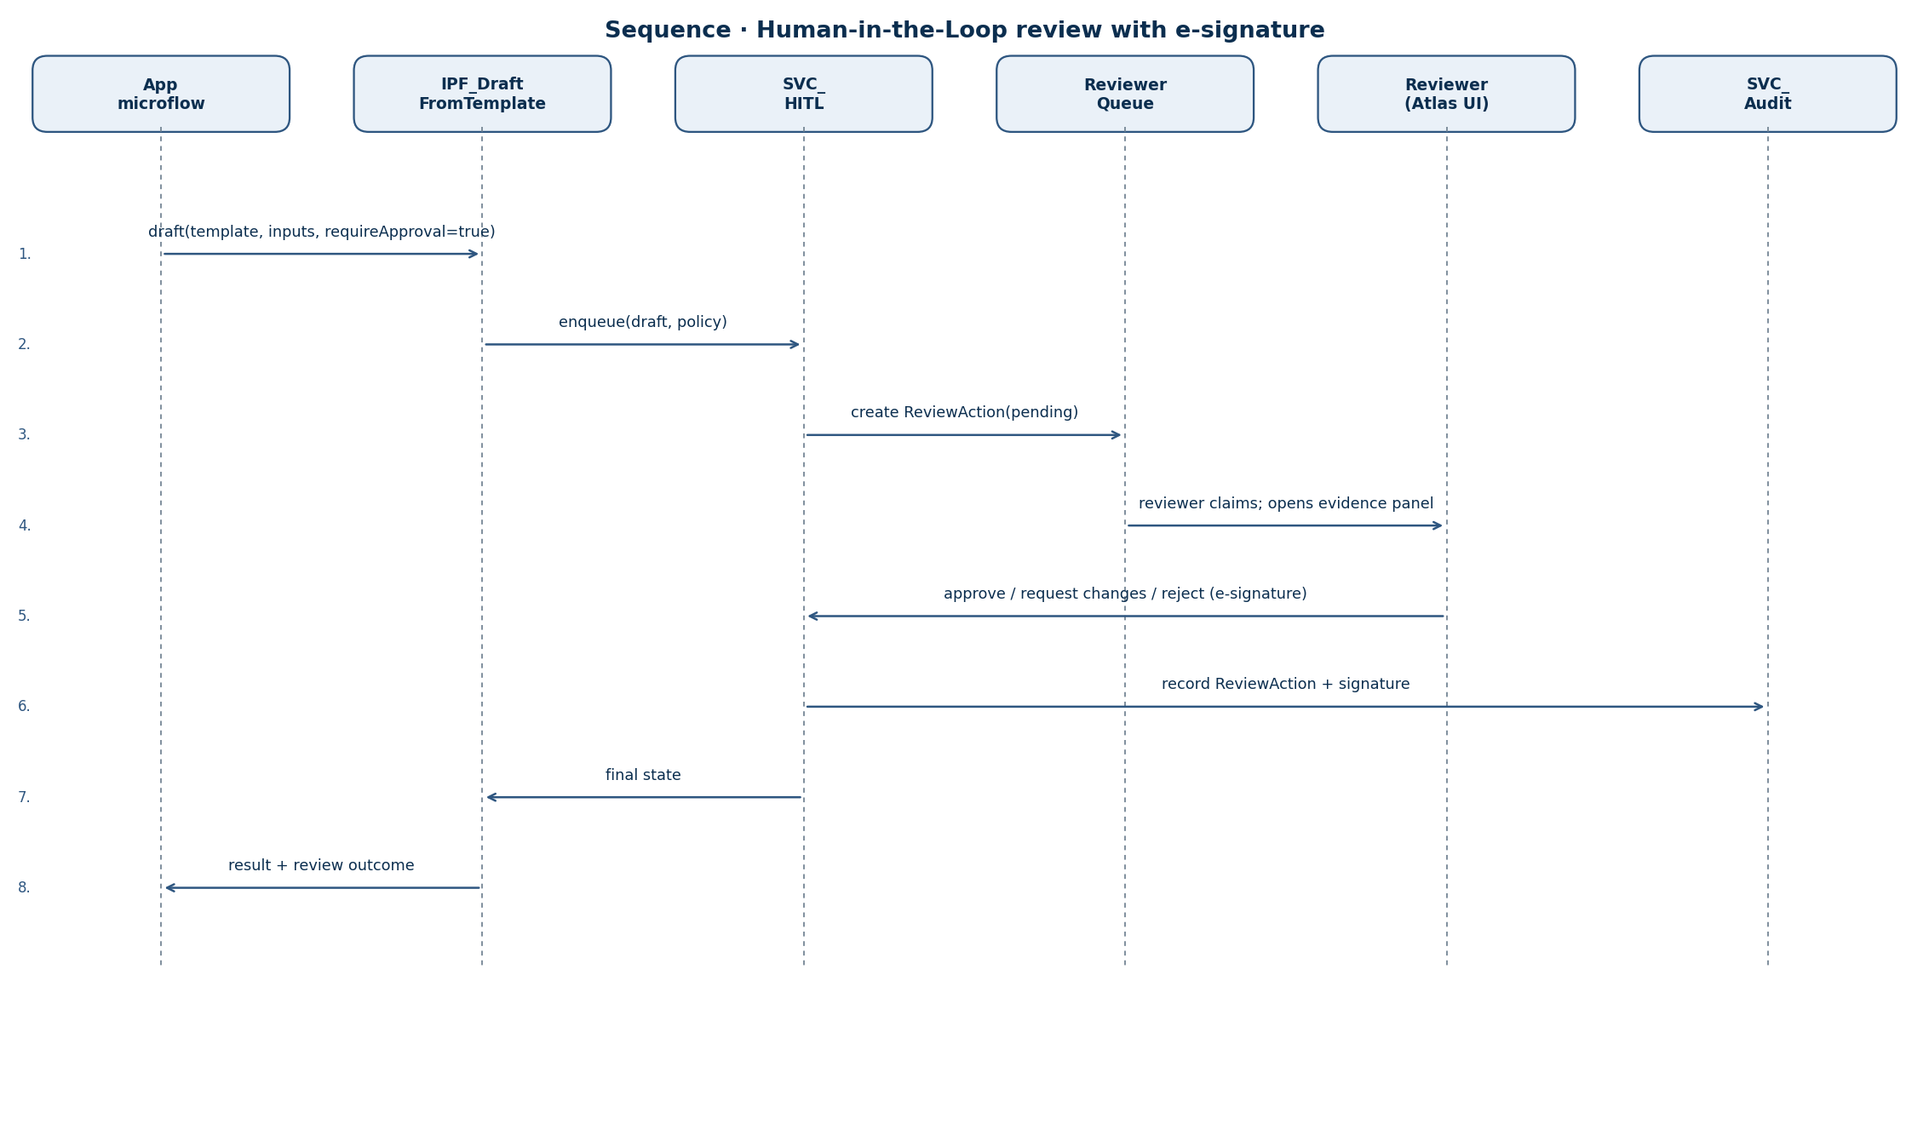
Figure 6-3 · HITL approval with e-signature

7 · Nanoflows (client-side)
Nanoflows run in the browser or mobile client and orchestrate UI behavior that should not require a server round-trip. They never call LLMs directly; they call published REST endpoints or the Mendix microflow API and render results.

NF_RenderCitedAnswer
Render a CitedAnswer object: inline-mark each citation [n], hover-to-source, and click-to-open Evidence Panel.

Inputs
Name | Type | Description
citedAnswer | Object | {answer, citations, confidence}

Outputs
Name | Type | Description
— | — | Side effect: updates the Cited-Answer Card UI region.

Activities (nanoflow body)
# | Mendix Activity | Description | On error / branch
1 | Loop | For each Citation, wrap [n] markers with hover handlers.
2 | Set Variable | Compute confidence band (HIGH/MED/LOW).
3 | Call Nanoflow | NF_ShowConfidenceBanner(band).
4 | Bind | Click handler on [n] → NF_OpenEvidencePanel(citation).

NF_TriggerStreamingAnswer
Open a streaming connection to a primitive that supports server-sent events (Q&A, summarize) and progressively render tokens.

Inputs
Name | Type | Description
primitiveCallSpec | Object | primitive + inputs

Outputs
Name | Type | Description
— | — | Side effect: updates target text region as tokens arrive.

Activities (nanoflow body)
# | Mendix Activity | Description | On error / branch
1 | JS Action | Open SSE/WebSocket via REST_Published streaming endpoint.
2 | On token | Append to UI; debounce re-render to 30 fps.
3 | On final | Hand off final CitedAnswer to NF_RenderCitedAnswer.
4 | On error | Show retry banner; NF_LogClientEvent('stream.failed').

NF_ConfirmIrreversibleAction
Pre-action e-signature collection. Used for any UI that triggers a side effect on regulated state.

Inputs
Name | Type | Description
actionDescription | String | Plain-language description shown to user
requireReason | Boolean | Whether the user must enter a justification

Outputs
Name | Type | Description
signaturePayload | Object | {userId, timestamp, reason, hash}

Activities (nanoflow body)
# | Mendix Activity | Description | On error / branch
1 | Show Page | Open ConfirmActionPage with description + reason field.
2 | Wait | On submit, call REST_Published /sign with username + password (re-auth).
3 | Decision | If re-auth fails, abort.
4 | Return | signaturePayload.

NF_ApplyClassificationFilter
UI-side filter that hides records the current user is not entitled to see, even if they appear in a result set due to caching.

Inputs
Name | Type | Description
recordList | List | Unfiltered records
userContext | Object | Identity + role + maxClassification

Outputs
Name | Type | Description
filteredList | List | Records ≤ maxClassification

Activities (nanoflow body)
# | Mendix Activity | Description | On error / branch
1 | Loop | Drop any record whose Classification > userContext.maxClassification.
2 | Set Variable | Set badge if drop count > 0.
3 | Return | filteredList.

NF_ShowConfidenceBanner
Render a banner indicating overall confidence of the result. HIGH=green, MED=amber, LOW=red.

Inputs
Name | Type | Description
band | Enum | HIGH | MED | LOW

Outputs
Name | Type | Description
— | — | Side effect: updates the Confidence Banner region.

Activities (nanoflow body)
# | Mendix Activity | Description | On error / branch
1 | Set Variable | Banner color, label, accessibility text per band.
2 | Render | Show in Confidence Banner snippet.

NF_OpenEvidencePanel
Open the side panel that shows the source Chunk for a Citation, with surrounding context and a deep-link to the original Document.

Inputs
Name | Type | Description
citation | Object | Citation row

Outputs
Name | Type | Description
— | — | Side effect: updates the Evidence Panel region.

Activities (nanoflow body)
# | Mendix Activity | Description | On error / branch
1 | REST Call | REST_Published /citations/{id}/context (returns chunk + ±2 chunks).
2 | Render | Show quote, page, document title; provide deep-link.
3 | Log | NF_LogClientEvent('evidence.viewed').

NF_LogClientEvent
Client-side telemetry emission. Posts a structured event to REST_Published /telemetry.

Inputs
Name | Type | Description
eventName | String | Dot-namespaced event name
properties | Object | Optional

Outputs
Name | Type | Description
— | — | Side effect: HTTP POST.

Activities (nanoflow body)
# | Mendix Activity | Description | On error / branch
1 | JS Action | Build payload with eventName, properties, sessionId, ts.
2 | REST Call | POST /telemetry (best-effort, fire-and-forget).

8 · Java Actions
Java actions are the framework's escape hatches for things the Mendix microflow language is not best suited to: HTTP streaming, vector math, cryptographic hashing, and PII redaction. Each is exposed as a single Java action with a documented signature and is the only place those concerns are implemented.

8.1 JA_VectorSearch
Embedding generation and top-k cosine similarity search. Wraps an in-process or external vector store (pgvector, Azure AI Search, Pinecone). Methods: embed(text) → float[]; embedBatch(List<String>); searchTopK(vector, k, filter) → List<Hit>.

8.2 JA_StreamCompletion
Server-sent token streaming from the LLM backend selected by SVC_BackendSelect. Encapsulates retry, exponential backoff, request signing, and per-tenant budget enforcement. Returns a Result with full text, token counts, and any per-span source markers the model emitted (for citation resolution).

8.3 JA_RedactPII
Text-span redaction for personal data, dose data linked to an individual, SGI markers, and export-controlled patterns. Configurable rule packs by jurisdiction (NRC, CNSC, ONR, IAEA). Returns the redacted text plus a list of {start, end, rule} so audit can record what was redacted without storing the raw.

8.4 JA_HashAuditRecord
Canonicalize a JSON payload (sorted keys, normalized whitespace) and compute SHA-256. Returns the hex digest. Used by SVC_Audit and SVC_HITL for tamper-evident logging.

9 · Configuration & Deployment

9.1 Constants
All runtime knobs are exposed as Mendix Constants. Defaults are conservative.
Name | Type | Description
AIInteractionFramework.GroundingThreshold | Decimal | Default 0.55. Below this, IPF_AnswerWithCitations refuses.
AIInteractionFramework.ClassifyConfidenceThreshold | Decimal | Default 0.7. Below this, IPF_Classify escalates.
AIInteractionFramework.DefaultProfileKey | String | Default 'safe-default'. Fallback ModelProfile.
AIInteractionFramework.SoftTimeoutMs.QA | Integer | Default 15000.
AIInteractionFramework.SoftTimeoutMs.Extract | Integer | Default 90000.
AIInteractionFramework.SoftTimeoutMs.Cluster | Integer | Default 300000.
AIInteractionFramework.AuditSink.SiemUrl | String | Optional SIEM endpoint.
AIInteractionFramework.PromptTemplateAllowEdit | Boolean | Default false. When true, permits runtime template editing in admin UI.

9.2 User roles
The framework declares the following module roles; consuming apps map them to project User Roles.
Name | Type | Description
AIIF_Caller | Module Role | May invoke any IPF_* primitive subject to data classification.
AIIF_Reviewer | Module Role | May claim and resolve ReviewActions.
AIIF_Auditor | Module Role | Read-only access to Invocations and AuditEvents.
AIIF_Admin | Module Role | May create / version PromptTemplates, ModelProfiles, EvalCases.

9.3 Deployment shapes
- Mendix Cloud (multi-tenant). All primitives available; SVC_BackendSelect routes restricted payloads to ONPREM_GATEWAY profile only.
- Mendix Private Cloud (single-tenant). Identical to Mendix Cloud but with tenant-scoped secrets and a private SIEM endpoint.
- Air-gapped. SVC_BackendSelect locked to ONPREM_GATEWAY; vector store runs in-cluster (pgvector). Outbound network disabled. Eval harness requires network for baseline export only.

9.4 Observability
Every primitive emits structured logs to the Mendix log stream and (optionally) to SIEM via SVC_Audit_StreamSink. The framework ships a pre-built Atlas dashboard widget showing invocation volume, refusal rate, average grounding score, citation rate, hallucination rate, p95 latency, and per-tenant cost.

Appendix A · Telemetry event catalog
All telemetry events are dot-namespaced. Properties are JSON-stringified for the SIEM.
Name | Type | Description
framework.invocation.created | INVOKE | primitive, profileKey, userId, dataTier, correlationId
framework.invocation.completed | INVOKE | primitive, status, durationMs, tokensIn, tokensOut, confidenceOverall
framework.retrieve.invoked | RETRIEVE | k, minScore, scopeFilter
framework.retrieve.returned | RETRIEVE | count, maxScore, groundingScore
framework.guardrails.precheck.decision | POLICY | decision, rules
framework.guardrails.postcheck.decision | POLICY | decision, rules
framework.llm.call.started | LLM_CALL | backend, modelId, profileKey
framework.llm.call.completed | LLM_CALL | durationMs, tokensIn, tokensOut
framework.hitl.enqueued | REVIEW | policyKey, signersRequired
framework.hitl.completed | REVIEW | action, durationMs, signatureHash
framework.audit.event.emitted | EXPORT | eventType, payloadHash
framework.eval.run.completed | EXPORT | metricsHash, regressionFlag

Appendix B · Error model
Errors are returned as a typed envelope, never as raw exceptions across the framework boundary. The envelope is { code, message, primitive, invocationId, retryable }.
Name | Type | Description
GROUNDING_INSUFFICIENT | REFUSED | Retrieval below threshold; LLM not called. Not retryable on identical inputs.
CITATION_RESOLUTION_FAILED | REFUSED | Model emitted spans without resolvable references.
SCHEMA_PARSE_FAILED | FAILED | Output did not match the requested schema after one retry.
INPUT_SCHEMA_INVALID | FAILED | Caller supplied inputs that do not match the template's input schema.
TEMPLATE_NOT_FOUND | FAILED | Unknown TemplateKey or version.
PROFILE_NOT_PERMITTED | FAILED | Override profile not in allow-list for the calling tenant.
AUDIT_PERSIST_FAILED | FAILED | Audit log write failed; result not returned (fail-closed).
VECTOR_SEARCH_FAILED | FAILED | Retrieval backend unavailable.
IDP_UNAVAILABLE | DEGRADED | Identity provider down; framework operates with cached claims and marks Invocation DEGRADED.

Appendix C · Prompt template registry
Templates are stored in the PromptTemplate entity and shipped as data with the module. Each template is referenced by a stable key + version. Sample keys (non-exhaustive):
Name | Type | Description
awc.v1 | IPF_AnswerWithCitations | Default Q&A template; expects {{question}}, {{chunks}}; output requires inline [n] markers.
extract.Requirement.v1 | IPF_Extract | Shall-statement extraction for ENG-01 / LIC-01.
extract.Commitment.v1 | IPF_Extract | Licensing commitment extraction for LIC-01.
classify.NCR.v1 | IPF_Classify | NCR taxonomy classification.
draft.LER.v3 | IPF_DraftFromTemplate | Licensee Event Report drafting (REG-01).
draft.RWP.v2 | IPF_DraftFromTemplate | Radiation Work Permit drafting (RAD-01).
summarize.OpEx.v1 | IPF_Summarize | Operating Experience summarization (OPS-01).
cluster.MaintLog.v1 | IPF_Cluster | Maintenance log clustering (OPS-05 / MFG-03).
score.Supplier.v1 | IPF_Score | Supplier risk scoring (SCM-01).

Appendix D · Glossary
Name | Type | Description
Microflow | Mendix | Server-side visual workflow.
Nanoflow | Mendix | Client-side visual workflow that runs in the browser/mobile client.
Java Action | Mendix | Custom Java code wrapped as a Mendix activity.
Mendix Workflow | Mendix | Long-running, user-task-driven workflow; used by SVC_HITL.
Atlas UI | Mendix | Mendix's design system.
Module Role | Mendix | Permission set declared inside a module; mapped to project User Roles by the consuming app.
IPF_* | Framework | Microflow naming convention for the seven Interaction Primitives.
SVC_* | Framework | Microflow naming convention for the cross-cutting Services.
NF_* | Framework | Nanoflow naming convention.
JA_* | Framework | Java action naming convention.

