Saving changes in GIT:
- Move to the project folder in the command line

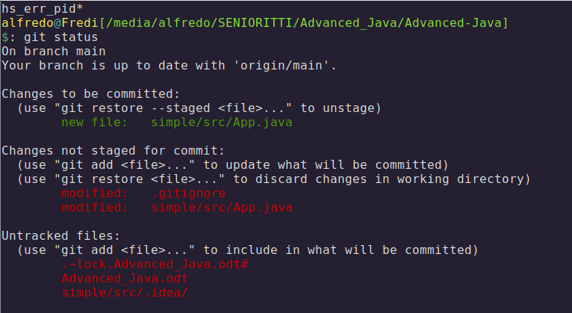
We see that here are new files to stage + un-tracked files

we add the .gitignore file:
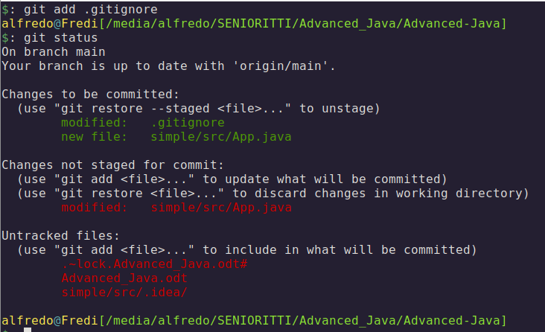
We add .gitignore to add to GIT
Commit the changes:
we add a comment with -m
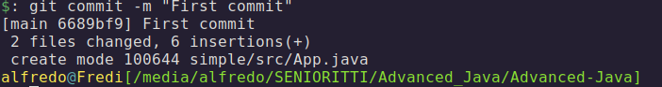
Push the changes:
> git push

After we change the source file we type
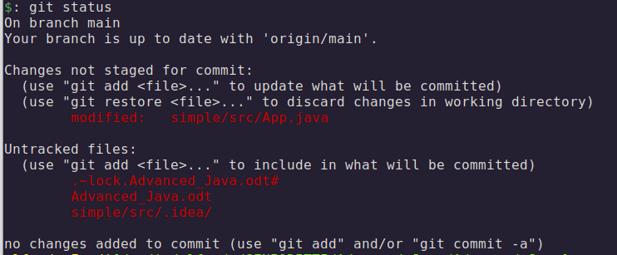
> git add *
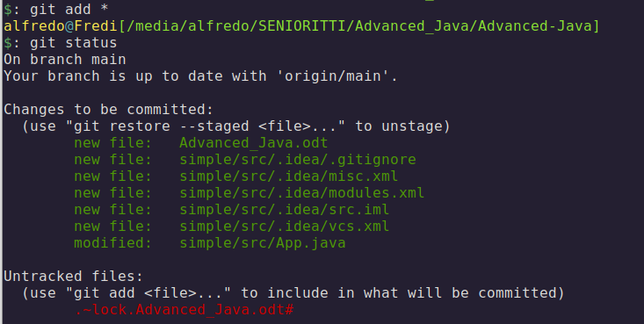
We see the new files ready for commit

Git Branches:
Sometimes you want to make separates copy of your work and save a copy to that.
To create a new branch: Alfredo in this case
> git branch Alfredo
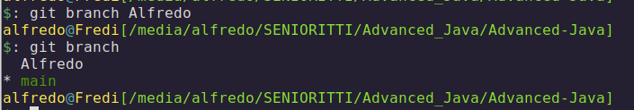
To change to the branch Alfredo we do:
> git checkout Alfredo
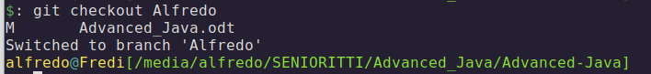

To change again to the main branch we type
> git checkout main

