To start using Typescript:

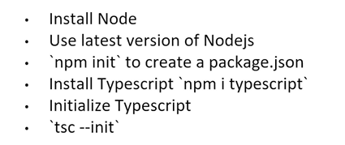

Angular setup:

If you want to use a local angular version for a project instead of the global one:

npx -p @angular/cli@13 ng new sample-application

in this case we use Angular 13 to create an app called sample-application

Install an older Angular version locally:

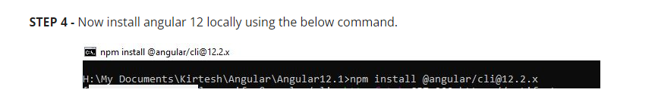

Mono-repo:

In angular you can have multiple app and libraries in the same repo

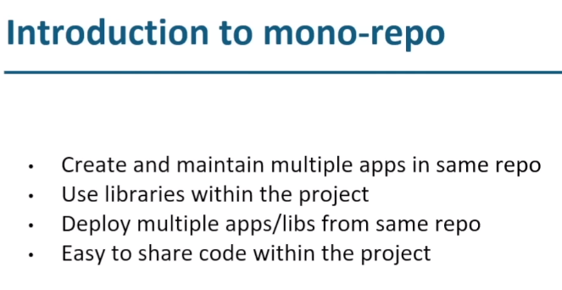

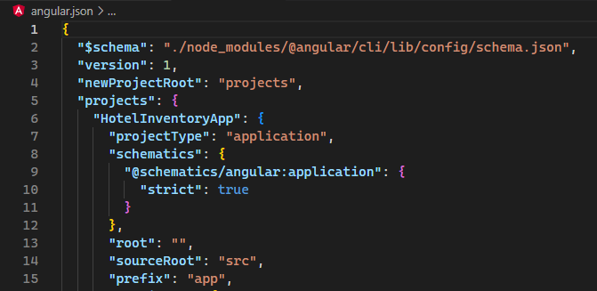

When we create a new component it will have the prefix defined here, app in this case

It is possible to change this when we create a new app with the switch:

|  |  |
| --- | --- |
| --prefix | The prefix to apply to generated selectors for the initial project. |

A list of all the switches are here: <https://angular.io/cli/new>

Directives:

