[DSCI 215]   
Power, Pluralism, and Parity: Intersectional Data Feminism

Spring 2025

**Section:** 001

**Prerequisite:** N/A

**Office Hours:** By appointment

**Open Coding Office Hours:** Friday 1-3 PM

**Teacher:** Alyssa Pivirotto

**Office:** Carpenter A4

**Phone:** 610-526-7917

**Email:** [apivirotto@brynmawr.edu](mailto:apivirotto@brynmawr.edu)

# **Course Description**

Data is often perceived as objective and impartial, but the processes of data collection, analysis, and visualization are deeply influenced by existing power structures. In this course, we will explore the intersection of data and these power structures through the lens of feminist theory. Examining the intersection of data with gender, race, class, and disability, we will question how data can both reinforce and challenge systems of oppression. Readings and discussions will center on the experiences of the affected communities as we explore methods to make data practices more inclusive and equitable. Through the combination of readings, class discussions, and hands-on activities, students will engage with key concepts in data feminism. We will apply these concepts to real-world examples, using Python for data analysis. No prior programming experience is required, as the course will provide the necessary foundational skills. By the end of the course, students will be equipped to critically analyze data practices and contribute to more just and ethical data-driven decision-making.

# **Key Learning Outcomes**

❏ Critically examine how different data practices can either reinforce or   
challenge existing power structures at the intersection of gender, race, class,   
and disability

❏ Understand the origins and impacts of algorithmic bias and be able to   
critique algorithms from an intersectional feminist perspective

❏ Critique and design data collection and analysis methods that prioritize   
inclusivity, transparency, and accountability

❏ Effectively communicate the results of data analyses with an emphasis on   
clarity, accessibility, and impact

# **Required Background and Prerequisite Knowledge**

No prior coding experience is required! While we will be utilizing Python, it will primarily be used for understanding concepts. Python assignments will not be graded on ability to code, but on understanding of concepts of data analysis, data visualization, and algorithmic bias.

# **Grading scheme**

| **Course Component** | **Weight** |
| --- | --- |
| **Individual Homework** |  |
| *Discussion Posts* | 25% |
| *In-class Exercises* | 20% |
| **Participation** |  |
| *Discussion Leader & Attend Talks* | 10% |
| **Project** |  |
| *Proposal* | 5% |
| *Data Description and Exploration* | 10% |
| *Methods Analysis* | 10% |
| *Final Write-up* | 15% |
| *Final Presentation* | 5% |

**Notes and Constraints**

* Students can drop one discussion post and one in-class exercise.
* Late work is not accepted unless you make arrangements with the instructor prior to the due date.
* The semester long project will consist of five separate assignments that are all built upon each other. This assignment will be flexible to allow students to choose to do either a more computationally focused or ethical review focused project based on their interests.

# **Textbooks and Course Materials**

**Online Resources:** Students will have access to Piazza for discussion posts.

Supplemental materials will be uploaded to Moodle.

**Using GitHub:** Throughout the semester, students will use GitHub Codespaces and associated tools to complete in-class exercises.

**Textbook:** The main text used will be Data Feminism by Catherine D’Ignazio and Lauren Klein which is available free online. Other readings will be pulled from various sources and will be uploaded to Moodle for student access.

**Title:** Data Feminism

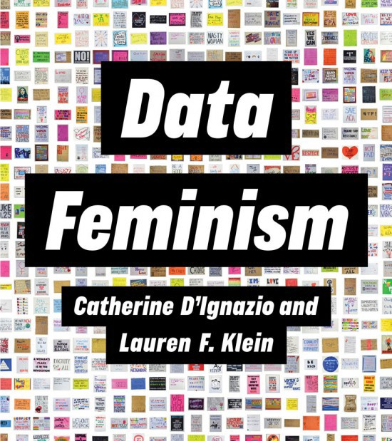**Author:** Catherine D’Ignazio and Lauren Klein **Publisher:** MIT Press, publication year: 2020 **ISBN-13:** 978-0-262-04400-4

**Available at:** [MIT Press (FREE!)](https://data-feminism.mitpress.mit.edu/)

# **Tentative Course Content**

**Week 1:**

Topic: Course Overview

1/22: Review syllabus

Read: N/A

HW: Read syllabus, make introductory PowerPoint slide

**Week 2:**

Topic: Examining Power Structures

1/27: In-class activity

1/29: Large Group Discussion

Read: DF Introduction, DF Ch. 1, Combahee River Collective

HW: Discussion Questions and Post 1, Sign up for discussion week

**Week 3:**

Topic: Introduction to Coding Basics and Reproducibility

2/3: Python Basics and GitHub

2/5: Group Coding Activity

Read: FAIR readings, Counterdata Introduction, Counting Feminicide Ch. 8

HW: Finish In-class activity 1 (Exercise 1)

**Week 4:**

Topic: Challenging Data Neutrality

2/10: In-class activity

2/12: Small group discussion on readings

Read: DF Ch. 2, Race After Technology Introduction

HW: Discussion Post 2

**Week 5:**

Topic: Data Collection (Pluralism)

2/17: In-class activity

2/19: Small group discussion on readings

Read: DF Ch. 5, Missing Data reading

HW: Discussion Post 3

**Week 6:**

Topic: Data Processing (Rethink Binaries)

2/24: In-class activity

2/26: Small group discussion on readings

Read: DF Ch. 4, Disability Data Collection and Usage reading

HW: Discussion Post 4, Final Project: Proposal

**Week 7:**

Topic: Data Analysis (Context)

3/3: In-class activity

3/5: Coding activity on data lifecycle

Read: DF Ch. 6

HW: Finish In-class activity 2 (Exercise 2)

**Spring Break (3/10 & 3/12)**

**Week 8:**

Topic: Algorithms

3/17: In-class activity

3/19: Algorithm Audit Coding Activity

Read: Algorithms of Oppression Introduction, Weapons of Math Destruction Introduction and Chapter 1

HW: Finish In-class activity 3 (Exercise 3)

**Week 9:**

Topic: Data Visualization (Emotion)

3/24: In-class activity

3/26: Small group discussion on readings

Read: DF Ch. 3, Visualization Rhetoric

HW: Discussion Post 5, Final Project: Data Description and Exploration

**Week 10:**

Topic: Collaborative Data (Labor)

3/31: In-class activity

4/2: Small group discussion on readings

Read: DF Ch. 7, Posner article

HW: Discussion Post 6

**Week 11:**

Topic: Artificial Intelligence Tenants

4/7: In-class activity

4/9: Group coding activity

Read: Data Feminism for AI, Artificial Unintelligence Ch. 11

HW: Finish In-class activity 4 (Exercise 4)

**Week 12:**

Topic: Communicating Results

4/14: In-class activity (final project peer feedback)

4/16: Group Coding Activity

Read: TBD

HW: Finish in-class activity 5 (Exercise 5), Final Project: Methods Analysis

**Week 13:**

Topic: Data Feminism in Action

4/21: In-class activity

4/23: Final Project Work

Read: DF Conclusion, DF Values

HW: None

**Week 14:**

Topic: Final Projects

4/28: Final Project Presentations

4/30: Final Project Presentations

Read: None

HW: Project Final Write-up and Presentations

**NOTE:** The above actual dates may be modified due to the requirements of the class. Also, the indicated dates may be moved backward or forward depending on class progress. **Exact dates and instructions will be announced on the course webpage**.

**Access Services**

Bryn Mawr College is committed to providing equal access to students with a documented disability. Students needing academic accommodation for a disability must first speak with Access Services. Students can email [accessservices@brynmawr.edu](mailto:accessservices@brynmawr.edu) to request an appointment to begin this confidential process. If eligible for accommodation as per Access Services, please let me know as soon as possible so that we can discuss and implement proposed accommodations. More information can be obtained from the Access Services website. (<http://www.brynmawr.edu/access-services/>)

Any student who has a disability-related need to record this class must first be found eligible to do so by Access Services and must share this eligibility with the instructor. Class members need to be aware that this class may be recorded.

**Academic Integrity**

Each student is expected to follow the Bryn Mawr Honor Code. It is expected that all submitted work is your own with all sources used cited in the text or code, including large language models (such as ChatGPT).

I highly encourage students to engage in collaborative learning throughout the course including the coding assignments. However, direct copying of another student’s code is prohibited. Focus on discussing concepts and problem-solving approaches with your peers but ensure all submitted work reflects your own understanding and effort. If you work with another student on a weekly assignment, please note that at the top of the assignment.

**AI Policy**

AI programs (e.g., ChatGPT) can be useful to help generate ideas, brainstorm, and simplify tasks. You should, however, note that the material generated by these programs may be inaccurate, incomplete, or otherwise problematic. Please beware that the use of AI may also stifle your own independent thinking and creativity. You may not submit any work generated by an AI program as your own.  If you include material generated by an AI program, it should be cited like any other reference material (with due consideration for the quality of the reference, which may be poor).  Any plagiarism or other form of cheating via AI will be considered a violation of the Bryn Mawr Honor Code.

**Attendance**

Regular attendance is strongly encouraged. In-class activities, discussions, and peer feedback are crucial components of this course and significantly enhance the learning experience.

* **Illness:** If you are unable to attend class due to illness, please notify me as soon as possible. I will work with you to provide any missed materials or assignments.
* **Religious Observances:** I respect the importance of religious observances. Please inform me in advance if you anticipate missing class due to a religious holiday, so we can make appropriate arrangements.

**The Writing Center**

Professional writers and scholars routinely seek feedback on their work from trusted peers. I encourage everyone to schedule conferences at the Writing Center to discuss, plan, or revise drafts. To schedule an appointment, go to <https://www.brynmawr.edu/inside/offices-services/writing-center> or click "Make a Writing Center Appt" from the Library and Academic Support dropdown menu at the top of every Moodle page.