Lab 2 - Analysis of RTK GPS

Introduction:
The Global Positioning System (GPS) and Real-Time Kinematic (RTK) are two commonly used technologies for positioning and navigation. Both GPS and RTK use satellites to determine the user's location, but they differ in terms of accuracy. This lab report presents a comparative analysis of GPS and RTK, as well as the effects of movement and occlusion on accuracy.

Methodology:
To compare GPS and RTK, we analyzed field data to compare the accuracy of GPS and RTK in different environments. This involved collecting data from open and occluded areas using both GPS and RTK, and the data were compared to the known coordinates of each location. Both moving and stationary data were collected to explore the effects of velocity metrics on the accuracy of both GPS and RTK.

RTK Results and Analysis
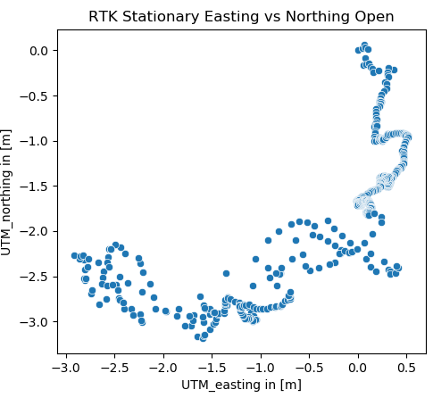
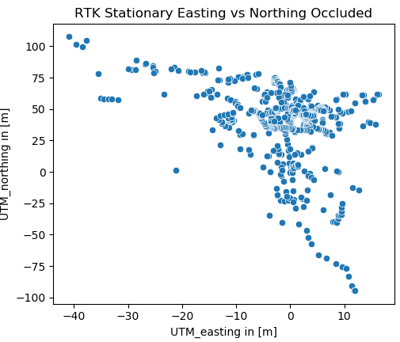

Fig. 1a. Occluded stationary easting vs northing Fig. 1b. Open moving easting vs northing

From figures 1a and 1b above, we can make preliminary observations from the data. The open data set shows a 3.5m spread of values in both the easting and northing measurements, whereas the occluded data has a much wider spread of 60m in the easting and 200m in the northing measurements. Here, we note that the occluded data has a large error unexpected for RTK. This is discussed later in the report and is assumed to be related to the fix quality.

The histograms in figures 2a and 2b show the error distribution of the data set. This error was calculated using the distance root mean squared formula below (DRMS), where the distance for x and y is the distance between the measured and actual easting and northing values.
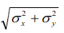

equation 1
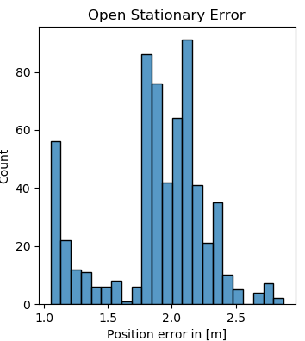
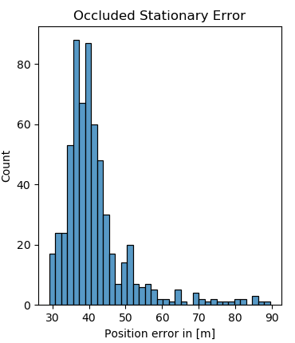

Fig. 2a. Open moving easting vs northing Fig. 2b. Occluded moving easting vs northing

The open data has visible peaks, while the occluded data shows one clear peak and a number of low-frequency trail values. As a result, the median of the errors was chosen for the open data set, and the mean was chosen for the occluded data set – 1.94m and 41.70m, respectively.

Comparing these errors to lab 1, we see that the open area RTK error is much lower than the error without RTK (1.94m RTK vs. 6.65m without RTK). This discrepancy could be explained in a number of ways. Firstly, the occluded data was not taken at the same location. The RTK data was taken next to the library and next to a tree, where there are multiple buildings (library, Snell Engineering, Curry, etc.) whereas the GPS data was taken outside of ISEC, meaning there was only one major building for interference. Additionally, we observed as a group that the orientation of the antennae introduced observable changes in the data stream, so there could have been hardware-related errors as well. All these sources of error affected the fix quality. We observed during data collection that the fix quality varied among single, float, and fixed.
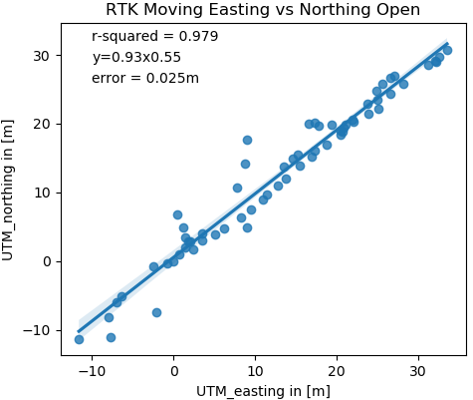
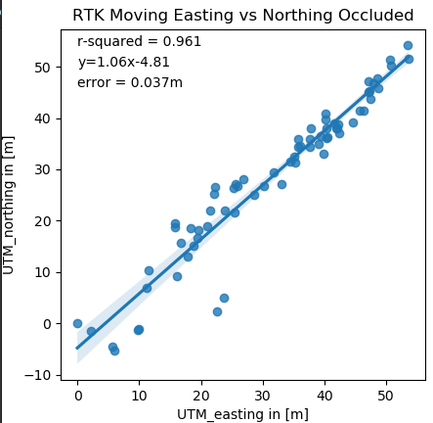

Fig. 3a. Open moving easting vs northing Fig. 3b. Occluded moving easting vs northing

Moving on to our moving data sets, we observe from figures 3a and 3b that the introduction of velocity as an additional parameter greatly increases the accuracy of the position estimate. Both graphs show a very good fit to the data with standard errors of 2.5cm and 3.7cm (obtained using the scipy[1] python library) for the open and occluded data sets, respectively. Again, we see that the open area error is lower than the occluded error as expected. These errors are much lower than the 97.7cm obtained in lab 1 for open area GPS without RTK.

In both cases of moving and stationary data, the error estimation for open data was lower than occluded data. Coupled with already discussed sources of error, we can attribute the discrepancy to the fix quality. RTK fix quality has 3 main values – single, float and fixed – where single is the least accurate and fixed is the most accurate. Single fix quality means that the GPS receiver had only one satellite signal, float indicates that the receiver had multiple signals for calculation but still left residual errors not corrected in real time, and fixed means that the receiver acquired multiple satellites the position was calculated using real time corrections from the base station (this is the true benefit of RTK). The open data set had a fix quality of 5 (which indicates fixed) for majority of the data collection whereas the occluded data set varied between all three but was float 60% of the time.

Conclusion:
The results show that GPS has an accuracy of around 5-10 meters for stationary data and around a meter for moving data, while RTK can achieve centimeter-level accuracy. This is because RTK uses a base station to provide real-time corrections to the GPS signal, which improves the accuracy of the position calculation. However, RTK requires a clear line of sight to the base station, which limits its application in areas with obstructions such as tall buildings or trees.

GPS is suitable for many applications, including navigation, mapping, and tracking. It is commonly used in vehicles, smartphones, and other consumer devices. RTK, on the other hand, is typically used in professional applications that require high accuracy, such as surveying, construction, and precision agriculture.

In conclusion, GPS and RTK are both valuable technologies for positioning and navigation, but they differ in terms of accuracy, cost, and application. GPS is less expensive and suitable for a wide range of applications, while RTK provides high accuracy but requires a clear line of sight and is more expensive. This is critical as signal obstructions from buildings, base location errors and hardware errors can greatly affect the accuracy of the position calculation. This means that the choice of technology should depend on both the specific application and the level of accuracy required.

