Version 1.0.0(Index) -15 May of 2019

INDEX

- Title Page
  - Game Name – Perhaps also add a subtitle or high concept sentence.
  - Copyright Information
  - Version Number, authors, date

- Game Overview
  - Game Concept
  - Genre
  - Target Audience
  - Environment
  - Game Flow Summary
– How does the player move through the game.
Both through framing interface and the game itself.
–Tutorial?
  - Look and Feel
– What is the basic look and feel of the game?
– What is the visual style?

- Game Interface
  - Visual Interface
    - HUD/WRAPPERS
– What approach?
– Passive or Active?
    - Menus
    - Components
      - Game World Interface
      - Characters Interface
      - Etc.
    - Help System

  - Physical Interface
    - Control System
– How does the game player control the game?
– What are the specific commands?
    - Audio
    - Music
    - Sound Effects

  - Interface Mechanics
–Think of it as a simulation of a world, how do all the pieces interact?
    - Physics
– How does the physical universe work?
    - Movement
      - General Movement
      - Other Movement
    - Objects
      - Picking Up Objects
      - Moving Objects
    - Actions
      - Switches and Buttons
      - Picking Up, Carrying and Dropping
      - Talking
      - Reading
    - Combat
– If there is combat or even conflict, how is this specifically modeled?

  - Menu interface Flow
    - Screen Flow Chart
– A graphical description of how each screen is related to every other
    - Screen Descriptions
– What is the purpose of each screen?
      - Main Menu Screen
      - Options Screen
      - Replaying and Saving
      - Etc.
- Development Process.
- References and research material

2. Game Overview

GAME CONCEPT
The user will define a path firstly, which the drone is going to follow sending information through his camera. While the user is playing, the user has to shoot many enemies that is going to be seen on the screen, the scenery is going to be a representation of the images taken by the camera.
GENRE
Shooter game in AR(Augmented Reality)
TARGET AUDIENCE
People older than 16, that’s because is not allowed a professional use of the drones in people younger than 18, so in this way we will focus on an audience which will have shown some interest on this matter for some longer time than younger ones.
ENVIRONMENT
As we exposed earlier, the action will be in a scene recreated by the images taken by the drone, likewise the user can interact and explores with the environment as he (or she) can play outside in a park for example.
GAME FLOW SUMMARY
– How does the player move through the game.
The player is going to start in the Title screen
The player through the controller (in this case the buttons of the screen) will move a cursor with is going to target the enemies and with another button will shoot them.
–Tutorial?
The tutorial will show information about the use of each page (map and run itself) and how interact with them.
LOOK AND FEEL
– What is the basic look and feel of the game?
It will try to simulate the layouts of the arcade machines.
– What is the visual style?
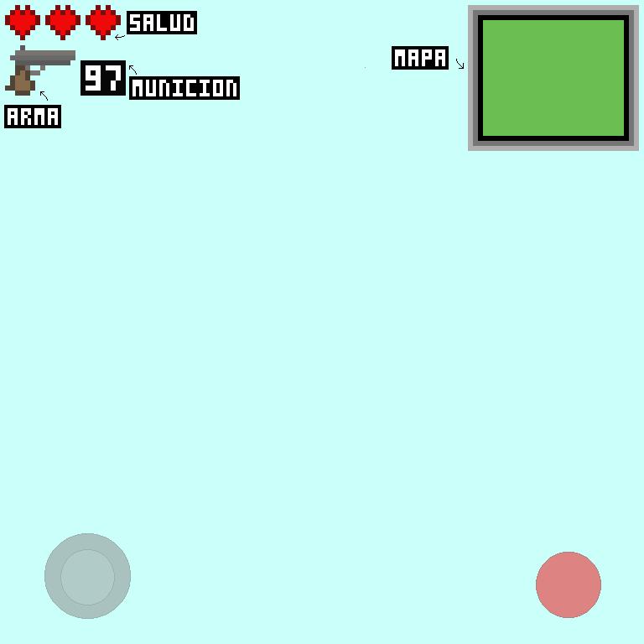

3. Game Interface
–Visual Interface
HUD/WRAPPERS
– What approach?
As we said earlier it will try to recreate the UI of the shooter games in arcade machines.
– Passive or Active?
Mainly passive (info of the HP, number of bullets and map), except for the controller joystick and buttons
Menus
It is going to be single with option to access to play, options and the tutorial, also to quit.

–Physical Interface
Use of GPS (for using the map, it will be more accurate) and connecting to the drone (for the images of the scenery).
–Audio
–Music
Depending of the time we will include or not but in case of being included it would be 8-bit music
–Sound Effects
When the user shoots it will reproduce a sound like when in space invaders you kill an enemy and when you draw the map.
Components
Game World Interface
Characters Interface
Etc.
Help System

Interface Mechanics
–Think of it as a simulation of a world, how do all the pieces interact?
Physics
How does the physical universe work?
Movement
General Movement
Other Movement
Objects
Picking Up Objects

Actions
Switches and Buttons
Picking Up, Carrying and Dropping
Talking
Reading

Menu interface Flow
-SCREEN FLOW CHART
This picture is going to show a chart of the pages that we will use for the UI:
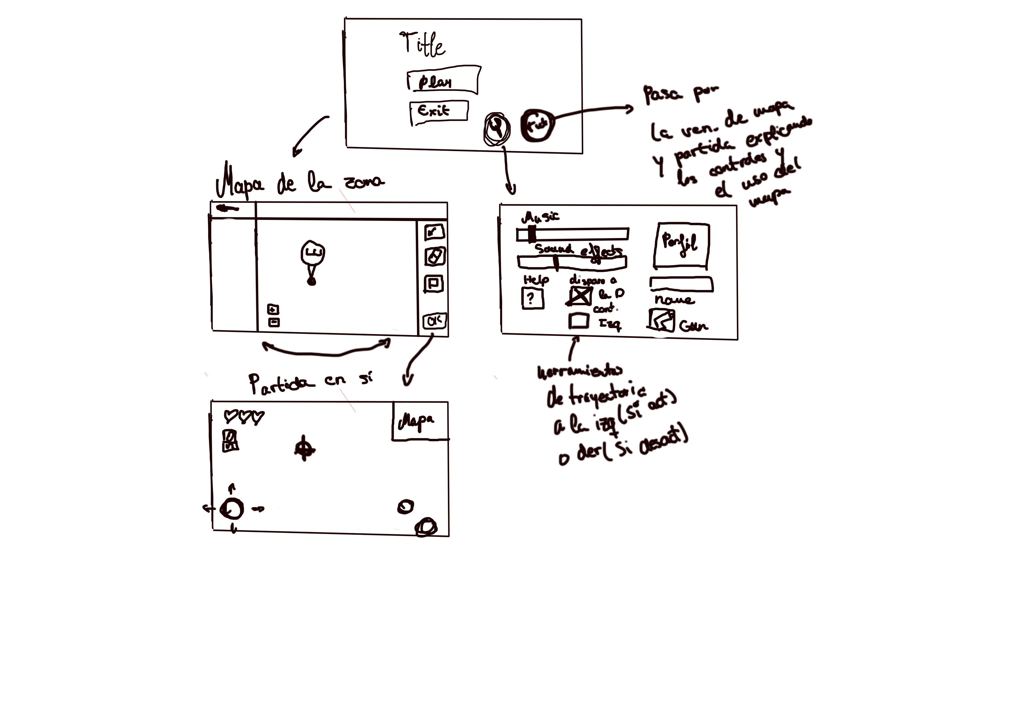
SCREEN DESCRIPTIONS
– What is the purpose of each screen?
- Main Menu Screen
The purpose is to show the Title of the game and give access to the Options screen and Play screen.
- Options Screen
The user will change the controls as he/she like, the user’s profile and the gun to kill the enemies.
- Map Screen
It will show the map where the user will be and the tools to draw a route.

Development Process.
References and research material

