Abstract Submission and Abstract Guidelines

First Name Last Name¹, First Name Last Name ², and First Name Last Name ^{1*}

¹ University of Evora , Evora, Portugal
² University of El Jadida, El Jadida, Morocco
* Email: of the corresponding author

In order to allow the flawless processing of submission, please limit your abstract to one page of A4 format, and submit your abstract in Word and PDF.
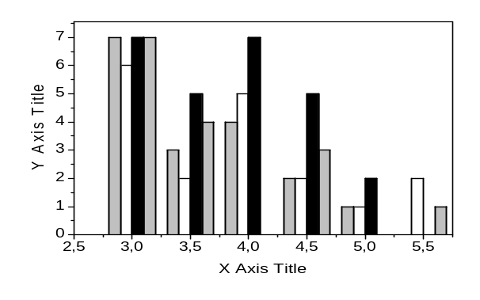
Fig.1 Caption
Your abstract may contain drawings, diagrams or photographs, but please note that illustrations have to be embedded in the abstract and cannot be submitted separately [2].
Please do not use the footnote functions of your word processor for references or footnotes.

You can as well use this template:
- Page size A4;
- left/right margin 3 cm;
- top/bottom margin 3 cm.
Please use the following formatting for your submission:
- Empty line, 12 pt;
- Title of the paper (Arial, bold face, centered, 14 pt, 12 pt line spacing);
- Empty line, 12 pt;
- Authors’ names, initials (Arial, centered, 10 pt, single spacing);
- Empty line, 10 pt;
- Affiliations (briefly), Country, Corresponding Author’s E-mail (Arial, centered, 9 pt, single spacing);
- Empty line, 9 pt;
- Contents of the abstract (Arial, 9 pt, justified, single line spacing, 3 pt after each paragraph, first line indent 0.5 cm);
- Empty line, 9 pt;
- References (Arial, 8 pt, line spacing 10 pt);
- Figure captions (Arial, 8 pt, centered, line spacing 10 pt)

Remark: as the Editorial team will make no revisions or corrections to the abstracts! The corresponding author should make all necessary revisions and/or corrections of his abstract before submission

[1] P. Yeh, J. Opt. Soc. Am. 72, 507 (1982)
[2] P. Yeh, C. Gu, Optics of Liquid Crystal Displays (John Wiley, New York, 1999)

