STUDENT CASE STUDY EXECUTION REPORT
Department | FED
Subject | DSA-2
Academic Year | I-III Semester (2025-26)
Faculty Name | ____________________
Student Name | ____________________
Roll Number | ____________________
Branch | CSE (AI & DS)
Course Outcome | Apply graph algorithms and Union-Find techniques for solving real-world network optimization problems.

Case Study Topic
Bangalore Metro Phase-3 Expansion — Minimum Cost Connection Plan with Redundancy using Kruskal’s Algorithm

Work Done Summary
Implemented Kruskal’s Algorithm using Union-Find Data Structure to design a minimum-cost metro network for Bangalore Metro Phase-3 expansion.
Key tasks completed:
1. Constructed weighted graph representing metro stations.
2. Applied Kruskal’s Algorithm to compute MST.
3. Used Union-Find to avoid cycles.
4. Compared naive and optimized Union-Find methods.
5. Verified redundancy requirements.
6. Added minimum-cost augmentation edge.

Problem Statement
The Bangalore Metro civil-engineering team must connect stations H, K, W, Y, M, E, and S with minimum cost while satisfying redundancy constraints.

MST Result
Edges Selected:
1. E-S → 4
2. K-W → 5
3. S-W → 6
4. M-E → 7
5. Y-E → 8
6. H-Y → 9
Total MST Cost = ₹39 Crores

Implementation Details
- Created a weighted graph using an Edge class containing:
  - source vertex
  - destination vertex
  - edge weight (construction cost).
- Stored all metro connections in an ArrayList of edges.
- Implemented Kruskal’s Algorithm to generate the Minimum Spanning Tree (MST).
- Sorted all edges in ascending order using:
Collections.sort(edges, Comparator.comparingInt(e -> e.weight));
- Implemented Union-Find Data Structure with:
  - Parent array
  - Rank array
  - Path Compression
  - Union by Rank
- Used the find() method to determine the parent/root of each vertex.
- Used the union() method to merge two disjoint sets while preventing cycles.
- Checked every edge:
  - If adding the edge does not create a cycle → accepted into MST.
  - Otherwise → rejected.
- Calculated the total minimum construction cost by summing selected edge weights.
- Verified the redundancy condition between Majestic (M) and Whitefield (W).
- Added the minimum-cost augmentation edge M-K to create two edge-disjoint paths.
- Displayed:
- Selected MST edges
- Total MST cost
- Final optimized network cost after augmentation.
- Compared naive Union-Find complexity with optimized Union-by-Rank + Path Compression implementation.
- Tested the implementation using all 12 candidate metro edges from the case study graph.
RESULTS:SCREENSHOTS/Output:
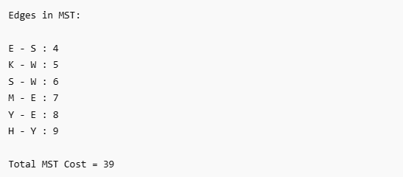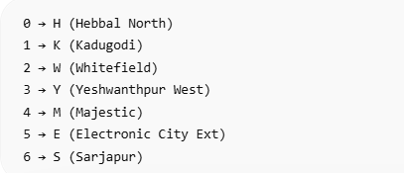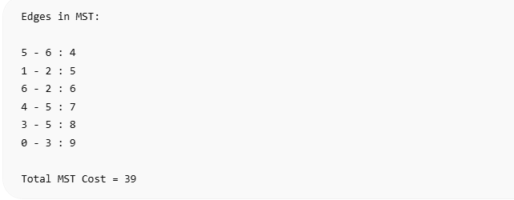

Conclusion
In this case study, we used Kruskal’s Algorithm because it is highly efficient for finding the Minimum Spanning Tree (MST) in weighted graphs where the objective is to minimize total construction cost while maintaining full network connectivity.
The Union-Find Data Structure was used to efficiently detect and prevent cycles during edge selection. To improve performance, Path Compression and Union-by-Rank techniques were implemented, reducing the time complexity of repeated Find and Union operations.
The metro network graph successfully connected all stations with the minimum possible construction cost of ₹39 Crores. However, the initial MST did not satisfy the regulatory redundancy requirement of having two edge-disjoint paths between Majestic (M) and Whitefield (W).
To solve this, an additional minimum-cost edge M-K was added, creating an alternate independent route and increasing the final network cost to ₹47 Crores.
This project demonstrates how graph algorithms and optimization techniques can be applied in real-world infrastructure planning problems such as metro rail expansion, network design, and transportation systems.
Github Link: https://github.com/ampssubrahmanyasreepad-svg/DSA-CaseStudies
