A PROJECT REPORT
ON
Heart Disease Prediction Using Machine Learning Classification Models
Project report submitted in partial fulfilment of the requirements for the Course
MACHINE LEARNING
BACHELOR OF TECHNOLOGY
in
COMPUTER SCIENCE AND ENGINEERING
A.Y.: 2026–27
By
A M P S SUBRAHMANYA SREEPAD 2520030152
G TEJ SAHITH 2520030606
Under the Esteemed Guidance of
Dr. N. Nirmala Jyothi
Associate Professor, CSE
Department of Computer Science and Engineering

Abstract
This project presents the design, implementation, and evaluation of a machine learning system for predicting the presence of heart disease using patient-related clinical attributes. The project follows a complete machine learning workflow consisting of dataset preparation, target-label conversion, data preprocessing, exploratory data analysis, feature selection, model development, training, cross-validation, hyperparameter tuning, evaluation, model comparison, and final prediction. The working dataset contains 900 records collected from four source groups represented in the combined data: Cleveland, Hungarian, Switzerland, and Long Beach VA. The original target variable, num, is converted into a binary classification problem where 0 represents no heart disease and values greater than 0 represent heart disease present. Thirteen selected features are used as inputs for developing the classification models.
Five baseline classification algorithms are implemented: Logistic Regression, K-Nearest Neighbors, Support Vector Machine, Decision Tree, and Random Forest. Random Forest is also evaluated after hyperparameter tuning. Two hyperparameter-search approaches are considered during the modelling process, while RandomizedSearchCV with stratified cross-validation is used for the final reported tuning experiment. The models are evaluated using Accuracy, Precision, Recall, F1-score, ROC-AUC, confusion matrices, classification reports, and ROC curves. The baseline Random Forest obtained an F1-score of 0.8750 on the held-out test set and is used for the final prediction demonstration. The project is an academic machine learning study and is not intended to function as a clinical diagnostic system.
Keywords: Heart Disease Prediction, Machine Learning, Binary Classification, Logistic Regression, K-Nearest Neighbors, Support Vector Machine, Random Forest, Hyperparameter Tuning, Model Evaluation

1. Introduction

1.1 Purpose of the Project
Heart disease is an important health-related problem in which multiple patient characteristics can be associated with the presence or absence of the disease. Clinical datasets contain attributes such as age, sex, chest-pain type, resting blood pressure, cholesterol, maximum heart rate, exercise-induced angina, and other diagnostic measurements. Analysing these attributes using machine learning can help identify patterns within the available data and develop predictive classification models. The purpose of this project is to study how different machine learning algorithms can be applied to a structured heart disease dataset to classify patients into two categories: no heart disease and heart disease present.
The project is also intended to provide practical understanding of the complete machine learning lifecycle. Instead of implementing only one algorithm, multiple classification techniques are developed and evaluated under a common experimental setup. This allows the effect of different modelling approaches to be studied using standard evaluation metrics. The project also includes preprocessing, feature selection, cross-validation, hyperparameter tuning, model comparison, and a final prediction demonstration so that the complete process from raw data to model-based prediction can be observed.

1.2 Problem Statement
The problem addressed in this project is a binary classification problem in which a machine learning model receives selected patient-related features as input and predicts whether the patient belongs to the no-heart-disease class or the heart-disease-present class. The original target variable contains multiple values and is transformed into a binary target, where a value of 0 represents no heart disease and a value greater than 0 represents the presence of heart disease. The expected output of the system is therefore a binary prediction corresponding to these two classes.

1.3 Existing Methods and Disadvantages
Various statistical and machine learning methods can be used for classification problems involving medical datasets. Simple classification approaches can provide a baseline for understanding the relationship between input features and the target class, while algorithms such as K-Nearest Neighbors, Support Vector Machine, Decision Tree, and ensemble methods can model different types of relationships within the data. However, the performance of a particular algorithm depends on the characteristics of the dataset, the quality of preprocessing, the selected features, and the chosen model parameters.
A single model may not provide the same performance across different datasets. Some models may be sensitive to feature scaling, while complex tree-based models may become overfitted if their complexity is not controlled. Model performance can also change significantly with hyperparameter values. Therefore, this project compares multiple classification algorithms using common evaluation metrics and the same held-out test dataset rather than relying on a single algorithm.

1.4 Proposed System
The proposed system implements an end-to-end machine learning pipeline for binary heart disease classification. The process begins with dataset inspection and target preparation, followed by missing-value treatment, exploratory analysis, feature selection, and an 80:20 stratified train-test split. Logistic Regression, K-Nearest Neighbors, Support Vector Machine, Decision Tree, and Random Forest are trained and evaluated. StandardScaler is applied through pipelines for models that require feature scaling, while tree-based models are trained without scaling. Two hyperparameter-search approaches are considered during the modelling process, with RandomizedSearchCV used for the final reported tuning experiment. The models are finally compared using Accuracy, Precision, Recall, F1-score, and ROC-AUC, followed by a final prediction demonstration.

1.5 Research Objectives
- To prepare and understand a suitable heart disease dataset for binary classification.
- To perform systematic data preprocessing and exploratory data analysis.
- To select relevant features and prevent data leakage during model development.
- To develop and train multiple machine learning classification models.
- To investigate hyperparameter-search approaches and perform controlled Random Forest tuning using cross-validation.
- To evaluate and compare the developed models using suitable classification metrics.
- To demonstrate the final model's prediction capability using new patient input data.

2. Literature Survey
Recent studies in heart disease and cardiovascular disease prediction demonstrate the use of classical machine learning, ensemble learning, deep learning, feature selection, and optimization methods. The following ten studies were selected for the literature survey based on their relevance to machine learning-based heart disease or cardiovascular disease prediction and their publication in 2024–2025.
S.No. | Title | Reference with DOI | Problem / Gap | Objective | Methods Used | Inference | Future Research
1 | Prediction of cardiovascular disease based on machine learning | Jiesi Li (2024), Applied and Computational Engineering, 46, 60–66. DOI: 10.54254/2755-2721/46/20241090 | Need for practical cardiovascular disease prediction and comparison of common algorithms. | Compare ML approaches for cardiovascular disease prediction. | DNN compared with eight traditional ML algorithms using accuracy, F1, precision-recall and ROC measures. | DNN was reported strongest in its experimental comparison. | Validate on additional datasets and populations.
2 | Comprehensive evaluation and performance analysis of machine learning in heart disease prediction | H.A. Al-Alshaikh, P. Prabu, R.C. Poonia et al. (2024), Scientific Reports, 14, 7819. DOI: 10.1038/s41598-024-58489-7 | Data imbalance, feature-selection challenges and robustness. | Develop a comprehensive prediction approach combining feature selection, balancing and optimized deep learning. | GA and RFE; balancing/oversampling; MLDCNN optimized with adaptive elephant herd optimization. | Reported 95.5% accuracy, 94.8% precision, 96.2% recall and 91.5% F-score during training; testing F-score about 89.6%. | Investigate broader conditions and real-world validation.
3 | Prediction of Cardiovascular Disease using Machine Learning Algorithms | M.K. Joshi, D. Dembla & S. Bhatia (2024), IJACSA, 15(3). DOI: 10.14569/IJACSA.2024.0150319 | Need to compare standard classifiers. | Evaluate common ML algorithms for cardiovascular prediction. | Decision Tree, SVC, RF, KNN, Logistic Regression and Naive Bayes. | Shows value of comparing multiple classical classifiers. | Extend with larger datasets and optimized hyperparameters.
4 | Heart Diseases Prediction Using machine learning and Deep learning Models | H. Phour, S. Pattanaik & K. Nayak (2024), 2024 Sixth International Conference on Computational Intelligence and Communication Technologies. DOI: 10.1109/CCICT62777.2024.00063 | Challenge of detecting disease from heterogeneous information. | Investigate ML and DL approaches. | Logistic Regression, Decision Tree, ensemble models, neural networks and CNNs. | Emphasizes dependence on data quality and representativeness. | Use larger datasets and strengthen interpretability and validation.
5 | A comprehensive review of deep learning-based models for heart disease prediction | C. Zhou, P. Dai, A. Hou et al. (2024), Artificial Intelligence Review, 57, 263. DOI: 10.1007/s10462-024-10899-9 | Lack of large, diverse datasets and limitations in existing DL studies. | Review DL and integrated approaches. | Review of 64 studies from 2018–2023 covering datasets, algorithms, metrics and limitations. | Identifies data scarcity and model improvement as major challenges. | Develop larger diverse datasets and interpretable approaches.
6 | Cardiovascular disease diagnosis: a holistic approach using the integration of machine learning and deep learning models | H. Sadr, A. Salari, M.T. Ashoobi & M. Nazari (2024), European Journal of Medical Research, 29, 455. DOI: 10.1186/s40001-024-02044-7 | Difficulty capturing complex patterns with one approach. | Develop combined ML and DL framework. | Two public datasets and one local dataset; CNN/LSTM with KNN/XGBoost and majority voting. | Combined modelling showed strong performance across evaluated datasets and metrics. | External validation and interpretability.
7 | SGO enhanced random forest and extreme gradient boosting framework for heart disease prediction | A. Naik, G.G. Tejani & S.J. Mousavirad (2025), Scientific Reports, 15, 18145. DOI: 10.1038/s41598-025-02525-7 | Need to improve RF and XGBoost through optimization. | Optimize RF and XGBoost using Social Group Optimization. | RF and XGBoost on Cleveland and Statlog with SGO optimization. | Optimized RF on Cleveland reported 95.08% accuracy and 95.26% ROC-AUC. | External validation and computational-cost analysis.
8 | A hybrid approach with metaheuristic optimization and random forest in improving heart disease prediction | G. Narasimhan & A. Victor (2025), Scientific Reports, 15, 10971. DOI: 10.1038/s41598-024-73867-x | Limitations in conventional performance and feature selection. | Improve RF using feature selection and optimization. | SelectKBest with GA, PSO and ACO applied to RF. | GA-optimized RF was reported strongest among evaluated optimization approaches on Cleveland. | External datasets and computational efficiency.
9 | Prediction of cardiovascular disease based on multiple feature selection and improved PSO-XGBoost model | K. Cao, C. Liu, S. Yang et al. (2025), Scientific Reports, 15, 12406. DOI: 10.1038/s41598-025-96520-7 | Redundant features and sensitivity to hyperparameters. | Combine feature selection with improved PSO for XGBoost. | Pearson correlation and XGBoost feature importance; improved PSO for tuning. | Reported 74.7% accuracy, 76.3% precision, 71.4% recall, 73.6% F1 and 80.8% AUC. | Investigate larger and multimodal datasets.
10 | Predicting Coronary Heart Disease Using Data Mining and Machine Learning Solutions | V.M. Moorthy, B.N. Dharamsoth, V. Muthukaruppan et al. (2025), Anais da Academia Brasileira de Ciências, 97(3), e20240811. DOI: 10.1590/0001-3765202520240811 | Need to combine complementary ML methods. | Develop ensemble approach using multiple ML methods. | Linear Regression, DT, RF and Gradient Boosting with Bayesian tuning on Framingham data. | Reported Gradient Boosting accuracy of 98.3% and Decision Tree accuracy of 94.26%. | Independent-population validation and calibrated/interpretable models.

3. Methodology

3.1 System Architecture / Workflow
The proposed system follows the sequence: Raw Dataset → Target Preparation → Data Cleaning → Missing-Value Treatment → Feature Selection → Train/Test Split → Model Training → Cross-Validation → Hyperparameter Tuning → Model Comparison → Final Model → New Patient Prediction.
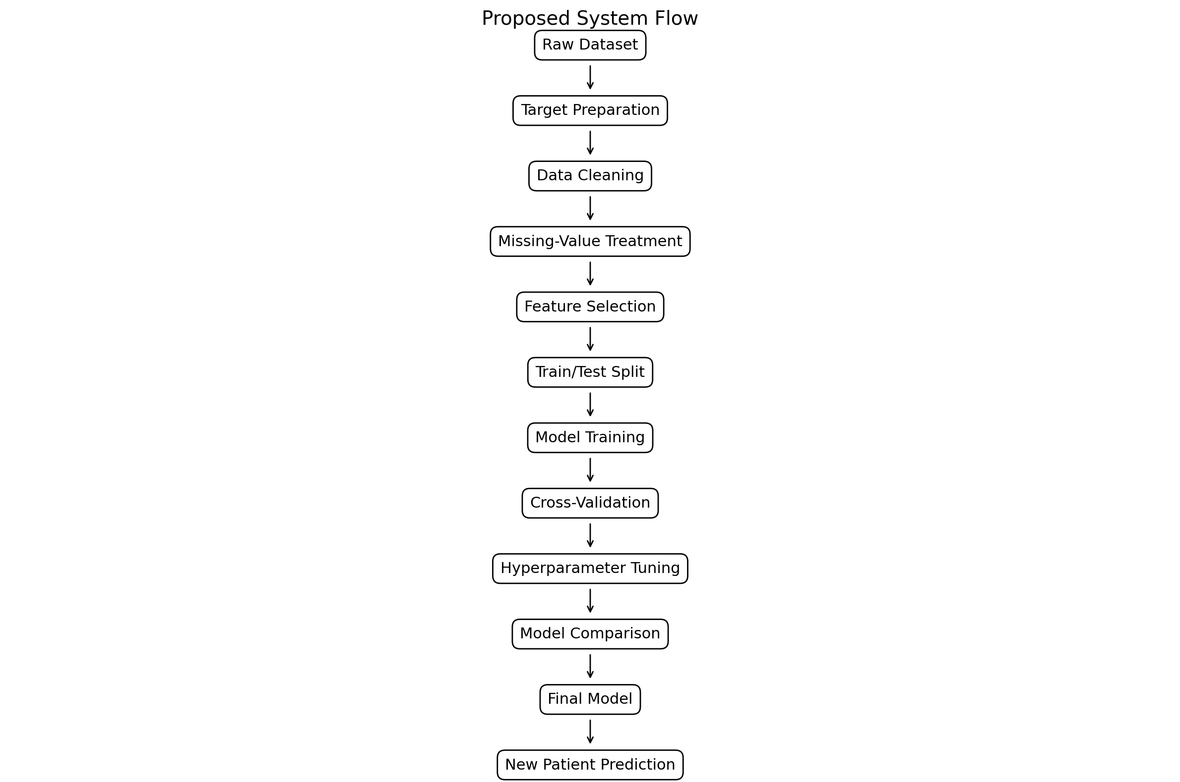
Figure 1. Proposed system workflow.

3.2 Dataset Description
The project uses the heart disease dataset stored in the file heart_disease_combined_raw(3).csv. The working dataset contains 900 records and 77 original columns. The data combines four source groups: Cleveland (283 records), Hungarian (294 records), Switzerland (123 records), and Long Beach VA (200 records). The original target variable is num. For this project, num is converted into a binary target where 0 represents no heart disease and values greater than 0 represent heart disease present.
Thirteen features are selected for modelling: age, sex, cp, trestbps, chol, fbs, restecg, thalach, exang, oldpeak, slope, ca, and thal. The dataset reference used for documentation is the UCI Machine Learning Repository Heart Disease dataset, DOI 10.24432/C52P4X.

3.3 Experimental Setup
The implementation uses Python in a Jupyter Notebook environment. Pandas and NumPy are used for data handling and numerical processing, Matplotlib is used for visualization, and scikit-learn is used for preprocessing, feature scaling, model training, cross-validation, hyperparameter tuning and evaluation. Joblib is used for model persistence. A fixed random state of 42 is used for reproducibility and an 80:20 stratified train-test split is used.

3.4 Data Preprocessing
The dataset is inspected for dimensions, column names, data types, target values and missing-value representations. The selected modelling features contain sentinel missing-value codes in the raw data; therefore, the corrected preprocessing treats -9 as a missing value and replaces missing numerical values using feature-wise median imputation. After this treatment, the 13 selected features contain no missing values.
The target is converted using num > 0. The resulting binary target contains 404 observations in the no-heart-disease class and 496 observations in the heart-disease-present class. The prepared data is split into 720 training records and 180 testing records using an 80:20 stratified split. StandardScaler is used for Logistic Regression, KNN and SVM through pipelines, while tree-based models use the prepared numerical features directly.

3.5 Exploratory Data Analysis
Exploratory Data Analysis was performed to understand class balance, feature distributions and relationships among the selected variables. The target distribution is 404 no-heart-disease records (44.89%) and 496 heart-disease-present records (55.11%). Descriptive statistics, feature distributions, box plots and a correlation matrix were used to inspect the data.
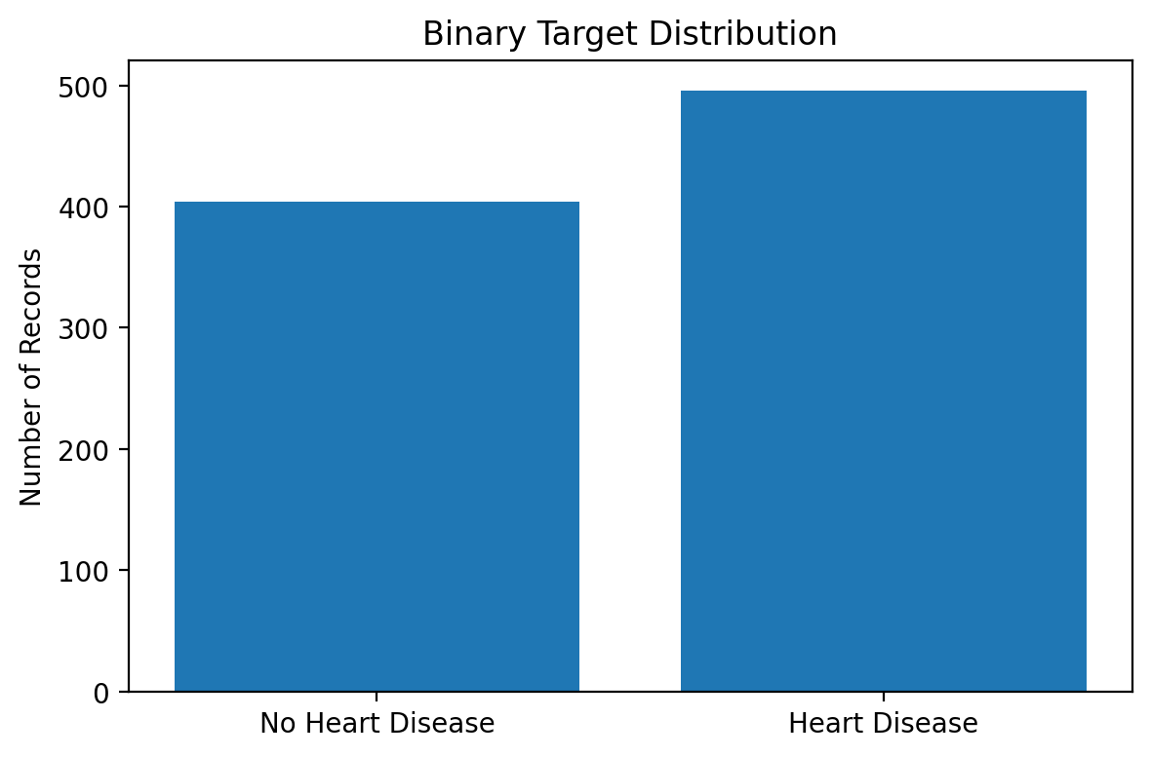
Figure 2. Binary target distribution.
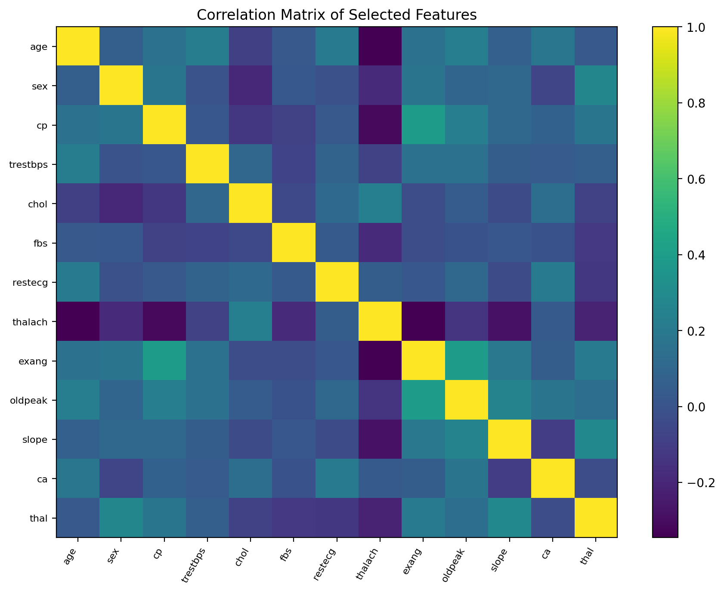
Figure 3. Correlation matrix of selected features.

3.6 Feature Engineering and Feature Selection
Feature selection was performed to create a consistent and manageable input space for all models. The final selected features are age, sex, cp, trestbps, chol, fbs, restecg, thalach, exang, oldpeak, slope, ca, and thal. Features outside this final set were excluded from model training to avoid unnecessary inputs and potential data-quality or leakage-related issues.

3.7 Model Building and Training
Five classification algorithms were developed: Logistic Regression, K-Nearest Neighbors, Support Vector Machine with an RBF kernel, Decision Tree and Random Forest. Logistic Regression provides a baseline linear classifier. KNN classifies observations according to their nearest training examples. SVM learns a nonlinear decision boundary using an RBF kernel. Decision Tree performs recursive feature-based splitting, while Random Forest combines multiple decision trees.
Logistic Regression, KNN and SVM use StandardScaler through pipelines, whereas Decision Tree and Random Forest do not require feature scaling. All models are trained on the training portion and evaluated on the same held-out test set.

3.8 Hyperparameter Tuning
Two hyperparameter-search approaches were considered during the model comparison stage. The first approach used a systematic parameter-search strategy to evaluate different Random Forest parameter combinations using cross-validation. The second approach used RandomizedSearchCV, in which selected parameter combinations were sampled from the defined search space and evaluated using stratified cross-validation on the training data.
RandomizedSearchCV was used for the final reported tuning experiment because it provides a practical way to explore multiple hyperparameter combinations while controlling computational cost. The search considered n_estimators, max_depth, min_samples_split, min_samples_leaf and max_features. The final experiment used 8 randomly selected parameter combinations with 3-fold stratified cross-validation. The best configuration was n_estimators=50, max_depth=None, min_samples_split=10, min_samples_leaf=2 and max_features=sqrt, with a mean cross-validation accuracy of 0.8222. The test dataset was kept separate and was not used for hyperparameter selection.

3.9 Model Evaluation
The classification models are evaluated using Accuracy, Precision, Recall, F1-score and ROC-AUC. Accuracy measures the proportion of correct predictions. Precision measures the correctness of positive predictions. Recall measures the proportion of actual positive cases identified. F1-score balances Precision and Recall. ROC-AUC measures discrimination between the two classes across thresholds. Confusion matrices, classification reports and ROC curves are also used to examine prediction errors and model behaviour. The same held-out test set is used for final comparison, with F1-score as the project selection criterion.

4. Results and Discussion

4.1 Preprocessing Results
The raw dataset contains 900 records and 77 columns. No exact duplicate records were found across the complete raw rows. The selected modelling features contained sentinel -9 values, which were treated as missing values before median imputation. After preprocessing, the 13 selected features contained no missing values. The final dataset was divided into 720 training records and 180 testing records using an 80:20 stratified split.

4.2 Model Performance
The following results were obtained on the same 180-record held-out test set after the corrected preprocessing procedure.
Model | Accuracy | Precision | Recall | F1-score | ROC-AUC
Logistic Regression | 0.8333 | 0.8165 | 0.8990 | 0.8558 | 0.9026
KNN | 0.8000 | 0.8119 | 0.8283 | 0.8200 | 0.8526
SVM | 0.8389 | 0.8241 | 0.8990 | 0.8599 | 0.9120
Decision Tree | 0.8389 | 0.8241 | 0.8990 | 0.8599 | 0.8899
Random Forest | 0.8556 | 0.8349 | 0.9192 | 0.8750 | 0.9155
Tuned Random Forest | 0.8500 | 0.8273 | 0.9192 | 0.8708 | 0.9087

The baseline Random Forest produced an accuracy of 0.8556, precision of 0.8349, recall of 0.9192, F1-score of 0.8750 and ROC-AUC of 0.9155. The tuned Random Forest produced an F1-score of 0.8708. Under the predefined F1-score selection criterion, the baseline Random Forest is used for the final prediction demonstration.
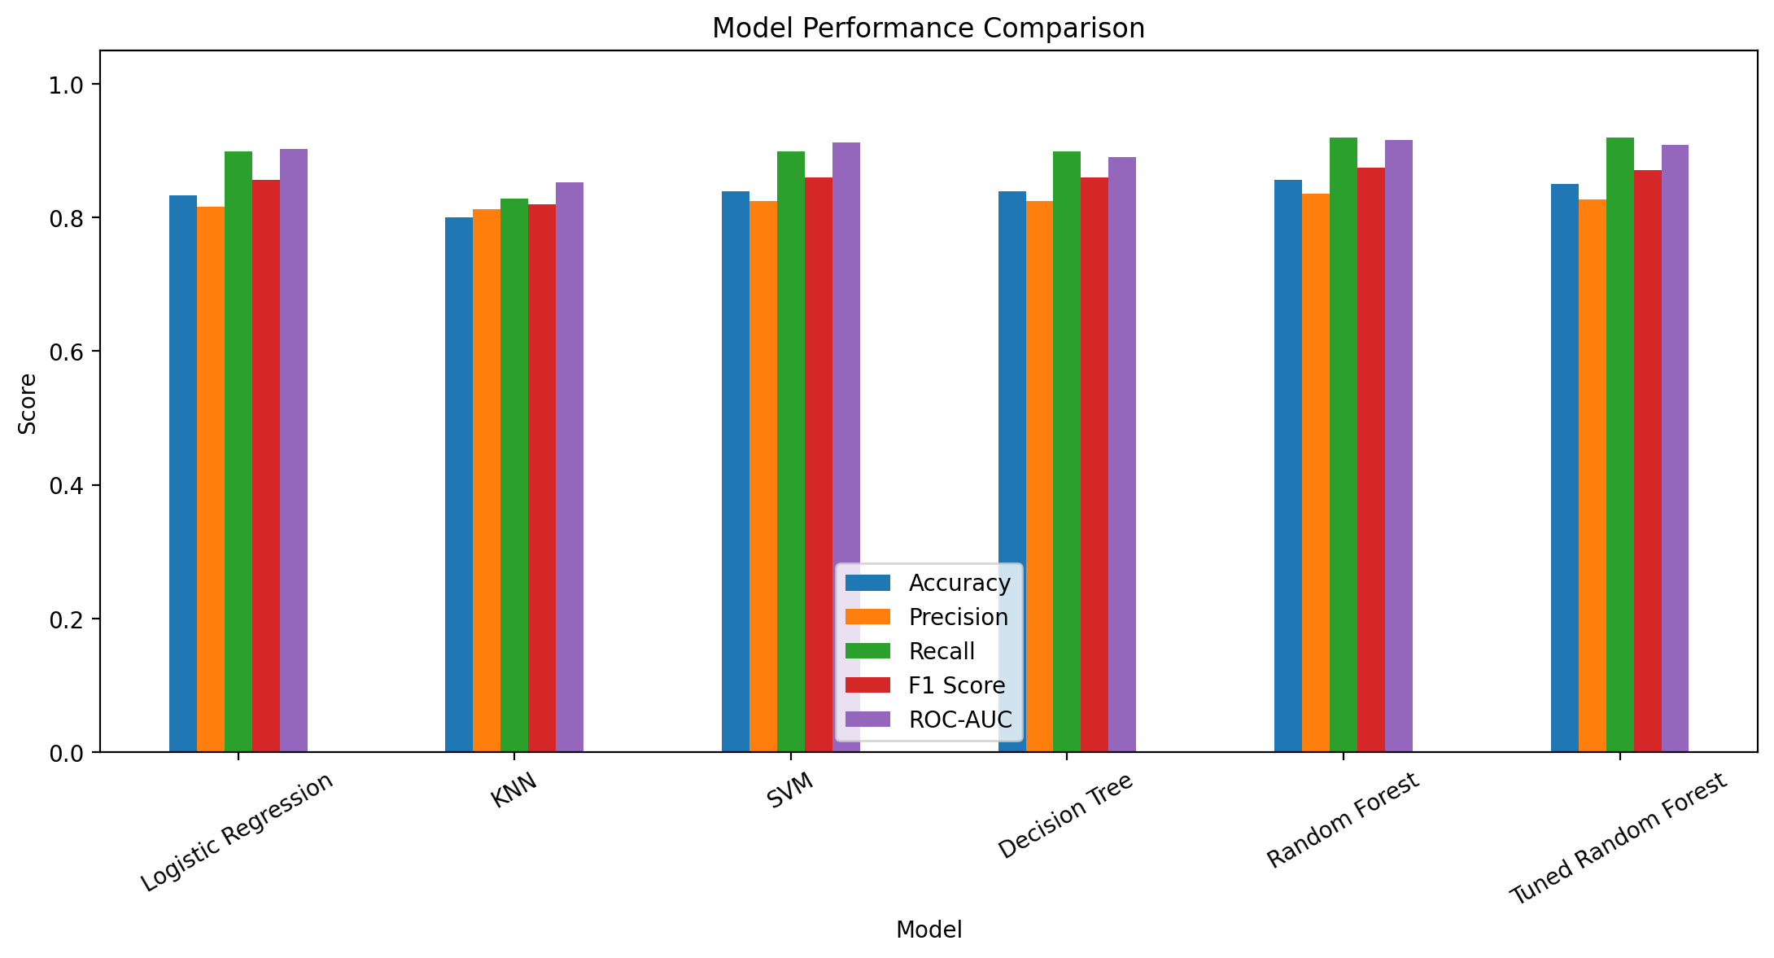
Figure 4. Model performance comparison.

4.3 Visual Results and Discussion
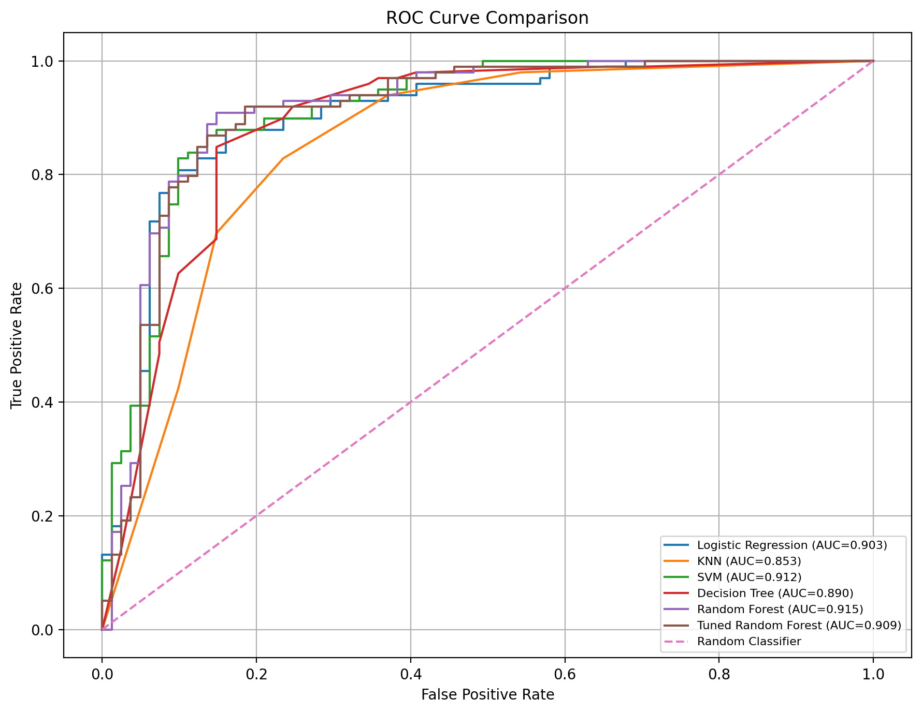
Figure 5. ROC curve comparison.
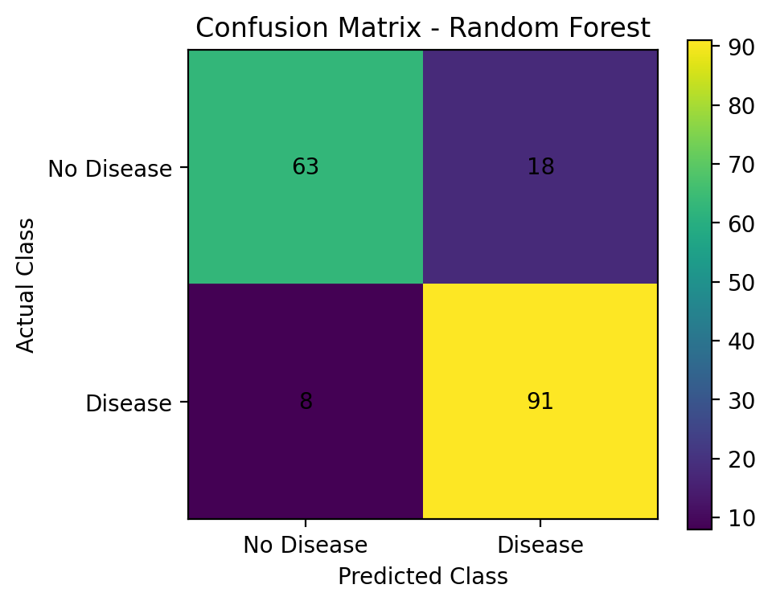
Figure 6. Random Forest confusion matrix.
The Random Forest confusion matrix contains 63 true negatives, 18 false positives, 8 false negatives and 91 true positives on the 180-record test set. The model correctly identified 91 heart-disease-present observations and missed 8 positive observations. It also correctly identified 63 no-heart-disease observations and produced 18 false positive predictions. These results describe model behaviour on the project dataset and should not be interpreted as clinical diagnostic evidence.
The ROC analysis provides a threshold-independent view of discrimination. Random Forest achieved ROC-AUC 0.9155, SVM 0.9120 and Logistic Regression 0.9026. Together with the model-performance table, these results show how the different classifiers behaved under the same test-set evaluation procedure.

5. Conclusion
This project developed an end-to-end binary heart disease classification workflow using a combined dataset of 900 records from four source groups. The workflow included target preparation, sentinel missing-value treatment, median imputation, exploratory analysis, feature selection, stratified train-test splitting, model development, cross-validation, hyperparameter tuning and final evaluation. Logistic Regression, KNN, SVM, Decision Tree, Random Forest and Tuned Random Forest were compared using Accuracy, Precision, Recall, F1-score and ROC-AUC.
The baseline Random Forest achieved an F1-score of 0.8750, accuracy of 0.8556, precision of 0.8349, recall of 0.9192 and ROC-AUC of 0.9155 on the held-out test set. The tuned Random Forest achieved an F1-score of 0.8708. Based on the predefined F1-score criterion, the baseline Random Forest was selected for the final demonstration. The project demonstrates a complete academic machine learning workflow from data preparation through model comparison and prediction and should not be used as a standalone medical diagnostic tool.

6. Future Work
- Use larger and more diverse heart disease datasets and independent external cohorts.
- Evaluate additional ensemble, boosting and calibrated classification algorithms.
- Explore additional hyperparameter optimization techniques, including systematic and randomized search strategies, while maintaining strict separation between training and test data.
- Investigate explainable AI methods such as SHAP for feature-level interpretation.
- Evaluate robustness, calibration and model drift on external datasets.
- Develop a deployable web or cloud-based demonstration application.
- Conduct prospective and multicenter validation before considering practical clinical use.

7. References
[1] Li, J. (2024). “Prediction of cardiovascular disease based on machine learning.” Applied and Computational Engineering, 46, 60–66. doi:10.54254/2755-2721/46/20241090.
[2] Al-Alshaikh, H. A., Prabu, P., Poonia, R. C., et al. (2024). “Comprehensive evaluation and performance analysis of machine learning in heart disease prediction.” Scientific Reports, 14, 7819. doi:10.1038/s41598-024-58489-7.
[3] Joshi, M. K., Dembla, D., & Bhatia, S. (2024). “Prediction of Cardiovascular Disease using Machine Learning Algorithms.” International Journal of Advanced Computer Science and Applications, 15(3). doi:10.14569/IJACSA.2024.0150319.
[4] Phour, H., Pattanaik, S., & Nayak, K. (2024). “Heart Diseases Prediction Using machine learning and Deep learning Models.” 2024 Sixth International Conference on Computational Intelligence and Communication Technologies. doi:10.1109/CCICT62777.2024.00063.
[5] Zhou, C., Dai, P., Hou, A., et al. (2024). “A comprehensive review of deep learning-based models for heart disease prediction.” Artificial Intelligence Review, 57, 263. doi:10.1007/s10462-024-10899-9.
[6] Sadr, H., Salari, A., Ashoobi, M. T., & Nazari, M. (2024). “Cardiovascular disease diagnosis: a holistic approach using the integration of machine learning and deep learning models.” European Journal of Medical Research, 29, 455. doi:10.1186/s40001-024-02044-7.
[7] Naik, A., Tejani, G. G., & Mousavirad, S. J. (2025). “SGO enhanced random forest and extreme gradient boosting framework for heart disease prediction.” Scientific Reports, 15, 18145. doi:10.1038/s41598-025-02525-7.
[8] Narasimhan, G., & Victor, A. (2025). “A hybrid approach with metaheuristic optimization and random forest in improving heart disease prediction.” Scientific Reports, 15, 10971. doi:10.1038/s41598-024-73867-x.
[9] Cao, K., Liu, C., Yang, S., et al. (2025). “Prediction of cardiovascular disease based on multiple feature selection and improved PSO-XGBoost model.” Scientific Reports, 15, 12406. doi:10.1038/s41598-025-96520-7.
[10] Moorthy, V. M., Dharamsoth, B. N., Muthukaruppan, V., et al. (2025). “Predicting Coronary Heart Disease Using Data Mining and Machine Learning Solutions.” Anais da Academia Brasileira de Ciências, 97(3), e20240811. doi:10.1590/0001-3765202520240811.
[11] Janosi, A., Steinbrunn, W., Pfisterer, M., & Detrano, R. (1989). Heart Disease [Dataset]. UCI Machine Learning Repository. doi:10.24432/C52P4X.

Signature of the Guide
Signature of the Course Instructor

