**ATMega32 Prototyping Board – Hardware**

**By Amr Ergawy, Dec 2015**

This is the hardware design documentation of my “Hackuino” ATMega32 Prototyping Board. I designed and simulated the board using Proteus VSM.

In section A, we include a design diagram with components listing. Then, in section B, we list the design calculations. After that, in section C, we list the ToDo list for improving push-buttons and adding JTAG interface. Finally, in section D, we list the design references.

1. **Design Overview**

In this section, we give an overview of the board hardware.

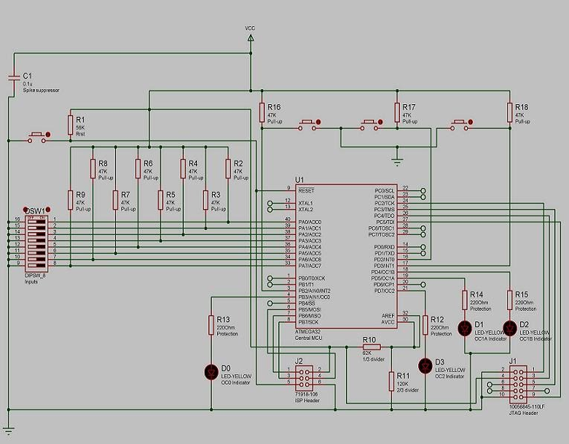

As illustrated in the diagram above, the board has the following details:

|  |  |
| --- | --- |
| D0 | A LED controlled by timer/counter0. |
| D1 | A LED controlled by timer/counter1, using OC1A. |
| D2 | A LED controlled by timer/counter1, using OC1B. |
| D3 | A LED controlled by timer/counter2. |
| DSW1 | It has 8 switches. Together with resistors R2-9, they form the board configurations input module [1]. |
| For Di | Switch (i*2)+1 is the Off/On configuration. |
| For Di | Switch (i*2)+2 is the Slow/Fast flashing configuration. A switch is configured to slow flashing when it is set to Off. |
| Push-buttons | From left to right, they RESET, Apply Configuration, Flasher test, and Emergency Shut down. They are all seen at the above of the circuit diagram. |
| J1 | This is the ISP programming header. Mainly, it is provided for programming lock/fuse bits. The AVR dragon was used for programming, and the interface is designed with reference to [5]. |
| J2 | This is the JTAG programming header. Mainly, it is provided for the application programming and debugging. |
| Clock source | The circuit is using the internal calibrated RC clock. XTAL1 and XTAL2 are left not connected [1 section 8.7] |
| AC | The analog comparator is disabled by software. AREF and AVCC are set to a voltage v, 2.7V < v < VCC [1 section 27.8]. |
| C1 | Spike suppressor with 16V rating. [1, 3]. |

**Note that**: for all not connected pins, except XTAL1 and XTAL2, the internal pull-up resistors are enabled by software.

1. **Design Calculations**

For all used resistor, it is assumed to have a 1/2W rating.

|  |
| --- |
| 1. Resistors R12-15, load protection resistors for the LEDs D0-3: |
| R = (Voh-Vr)/Ir [2, section 5.3.3]  Voh = 4.2V [1, section 27.2], Vr = 2V, Ir = 10mA [Proteus components library]  Then R = 220 Ohm. |
| 1. Resistors R2-9 and R16-18, I/O pin pull-up resistors for configurations inputs and control buttons: |
| 20 KOhm < R < 50 KOhm [1 section 27.2] |
| 1. Resistors R10-11, voltage level setters for the disabled analog comparator: |
| R10 : R11 = 1 : 2, they form a 1 to 2 voltage divider. AREF and AVCC are set to a voltage v, 2.7V < v < VCC [1 section 27.8]. |
| 1. Resistor R1, pull-up resistor for the RESET button: |
| A typical value of 60 KOhm [1 section 27.2] |

1. **ToDo: Improving the push-buttons and adding the JTAG interface**
2. We need to review how the push buttons handles spike noise, perhaps using some solution from [1].
3. We need to add the head and wires for the JTAG interface.
4. **Design references**
5. "Practical Electronics for Inventors", by Paul Scherz.
6. ATMega32 Datasheet.
7. avr-libc user manual.
8. ATMEL JTAG ICE user manual.
9. ATMEL AVR Dragon help.