CSE245: Design and Analysis of Algorithms – Spring 2026
Ain Shams University | Faculty of Engineering | Computer Engineering & Software Systems
Task [3] – [Tower of Hanoi variation]
[ e.g. Tromino Tiling | Knight's Tour | Hanoi 4-Peg … ]

Task Number | Task 3
Topic / Algorithm | Divide & Conquer + Dynamic programming
Assigned Members | Ahmed Samy, Anas Khaled
Difficulty | [ ⭐⭐⭐ Medium / ⭐⭐⭐⭐ Hard ]
Language | C++

1. Problem Description

1.1 Problem Statement
The problem is a variation of Tower of Hanoi with 8 disks and 4 pegs. The disks are placed on the first peg in the beginning where the smallest at the top and largest at the bottom. We should transfer the disks to other pegs using valid moves (one disk at a time and no larger disk is placed on a smaller disk at any time).

1.2 Objectives
- Apply Divide & Conquer to solve the problem.
- Determine if the problem can be solved in 33 moves using dynamic programming.
- If it can’t be solved, then write an algorithm that can do it.
- Using Dynamic programming, Solve the problem with n disks and 4 pegs.
- Analyze time complexity for the used algorithms.

1.3 Underlying Assumptions
- The number of disks is non-negative number
- There are exactly 4 pegs only.
- The cost of moves is the same and we want to minimize total number of moves.
- In D&C, k = sqrt(n) is valid in almost all cases, even large numbers.
- In DP, it may fail at very large values of n due to overflow problems
- It is required to print all the moves made but not take the print in consideration with complexity analysis.

2. Algorithm Design & Methodology

2.1 Approach Overview

2.1.1 Approach 1: Divide & Conquer
The idea is to divide the given problem into fewer sub-problems:
First, we move (n – k) disks from the top to a helper peg using all 4 pegs. Then, we move the remaining k disks to the destination peg using the 3 remaining pegs (Classical tower of Hanoi problem). Then, we move the (n - k) disks from the helper peg to the destination using all 4 pegs.
We determine the value of K using k = sqrt(2*n). This is better than talking half of n only since it limits the growth of the exponential value.

2.1.2 Approach 2: Dynamic programming
First, we move (n – k) disks from the top to a helper peg using all 4 pegs. Then, we move the remaining k disks to the destination peg using the 3 remaining pegs (Classical tower of Hanoi problem). Then, we move the (n - k) disks from the helper peg to the destination using all 4 pegs.
The difference here is that we determine the value of K using the following relation:
dp[n] = min_{(1 <= k < n)} (2*dp[n-k] + 2^{k} - 1)
When the value is minimum for current n, then we found the best value of k.

2.2 Step-by-Step Methodology

2.2.1 Approach 1: Divide & Conquer
- Step 1: If there are no disks then do nothing.
- Step 2: If the number of disks is 1 or 2 then move them directly.
- Step 3: For larger n, divide the disks into 2 groups: Top (n-k), bottom (k)
- Step 4: Recursively move (n-k) disks to helper peg using all 4 pegs.
- Step 5: Move the remaining k disks using the 3 remaining pegs to the destination peg.
- Step 6: Recursively move (n-k) disks to destination peg using all 4 pegs.

2.2.2 Approach 2: Dynamic programming
- Step 1: If there are no disks then do nothing.
- Step 2: If the number of disks is 1 then move it directly.
- Step 3: For larger n, try all possible value of k where 1 <= k < n
- Step 4: Compute the total number of moves using dp[n] = min_{(1 <= k < n)} (2*dp[n-k] + 2^{k} – 1)
- Step 5: Store the number of moves and k to use it later.
- Step 6: We recursively move the disks as before.

2.3 Pseudocode

2.3.1 Algorithm 1: [D&C]
Tower3_DnC(n, from, to, aux, offset)
If n == 0 → return
Call Tower3_DnC(n-1, from, aux, to, offset)
Print move disk (n + offset) from 'from' to 'to'
Call Tower3_DnC(n-1, aux, to, from, offset)

Tower4_DnC(n, from, to, aux1, aux2, offset)
If n == 0 → return
If n == 1
Print move disk (offset + 1) from 'from' to 'to'
return
If n == 2
Move disk (offset + 1) from 'from' to 'aux1'
Move disk (offset + 2) from 'from' to 'to'
Move disk (offset + 1) from 'aux1' to 'to'
return

k = √(2 * n)
Call Tower4_DnC(n-k, from, aux1, aux2, to, offset)
Call Tower3_DnC(k, from, to, aux2, offset + (n-k))
Call Tower4_DnC(n-k, aux1, to, from, aux2, offset)

2.3.2 Algorithm 2: [DP]
Tower3_DP(n, from, to, aux, offset)
If n == 0 → return
Call Tower3_DP(n-1, from, aux, to, offset)
Print move disk (n + offset) from 'from' to 'to'
Call Tower3_DP(n-1, aux, to, from, offset)

Tower4_DP(n, from, to, aux1, aux2, offset)
If n == 0 → return
If n == 1
Print move disk (offset + 1) from 'from' to 'to'
return

k = bestk[n]
Call Tower4_DP(n-k, from, aux1, aux2, to, offset)
Call Tower3_DP(k, from, to, aux2, offset + (n-k))
Call Tower4_DP(n-k, aux1, to, from, aux2, offset)

Compute_DP(n)
dp[0] = 0
dp[1] = 1
For i from 2 to n
dp[i] = ∞
For k from 1 to i-1
moves = 2 * dp[i-k] + (2^k - 1)
If moves < dp[i]
dp[i] = moves
bestk[i] = k

3. Implementation

3.1 Programming Language & Environment
Language: C++
Compiler: g++ (GNU)
Libraries: IOstream & cmath
Environment: VS code

3.2 Code Structure

3.2.1 Approach 1: Divide & Conquer
- Tower3()
Implements The classical 3 peg tower of Hanoi. We move K disks using it.
- Tower4()
Implements the divide and conquer solution for the 4 pegs. It splits the problem into smaller sub-problems using K. It calls the tower3 function to move the disks if needed.
- Main()
Initialize the value of disks and calls Tower4 functions to start the operation.

3.2.2 Approach 2: Dynamic Programming
- Tower3_DP ()
Implements The classical 3 peg tower of Hanoi. We move K disks using it.
- Tower4_DP ()
Implements the DP solution for the 4 pegs. It splits the problem into smaller sub-problems using bestk[] values. It calls the tower3 function to move the disks if needed.
- Bestk[]: Store the best value of k for each n disks.
- Dp[]: Stores the minimum number of moves required for each n disks
- Main()
Initialize the value of dp[] and bestk[] and fill them using DP. Then it calls Tower4_DP to start the operation.

3.3 Key Code Snippets

3.3.1 [tower4]
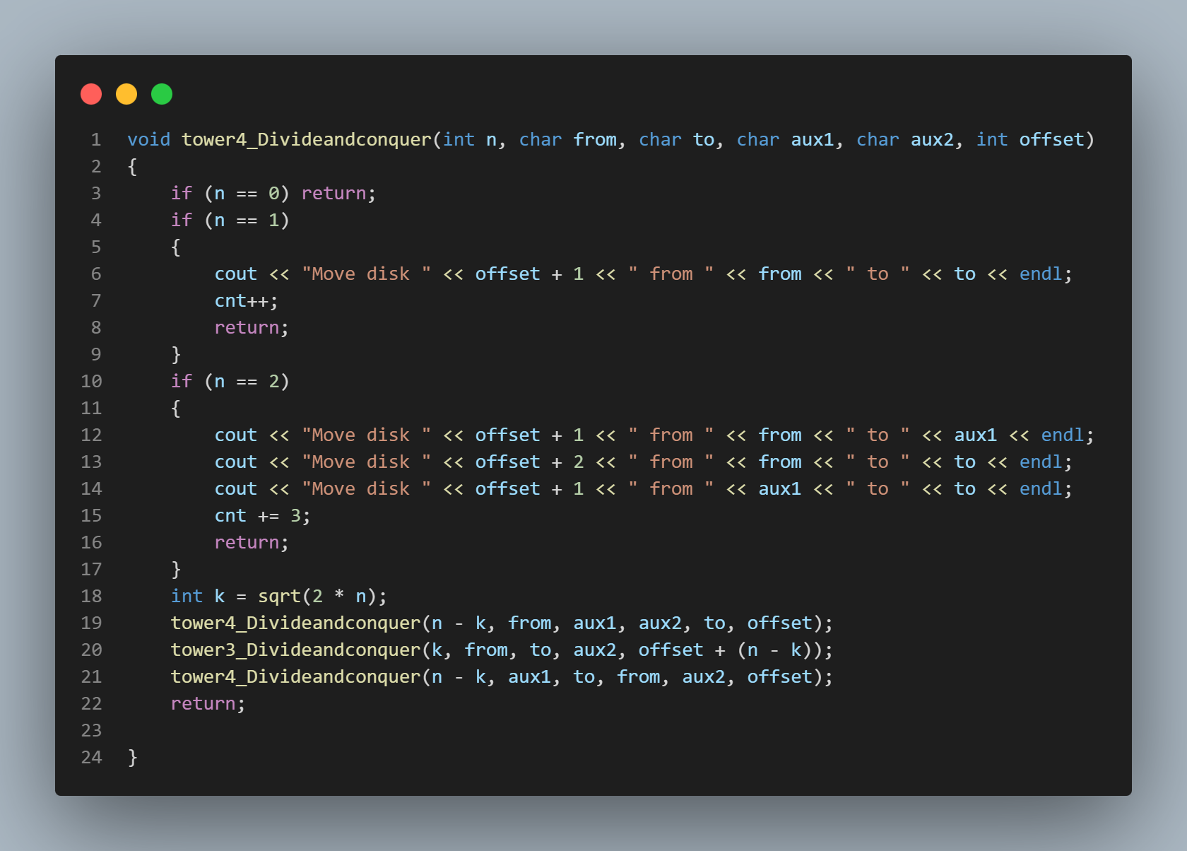

3.3.2 [tower3]
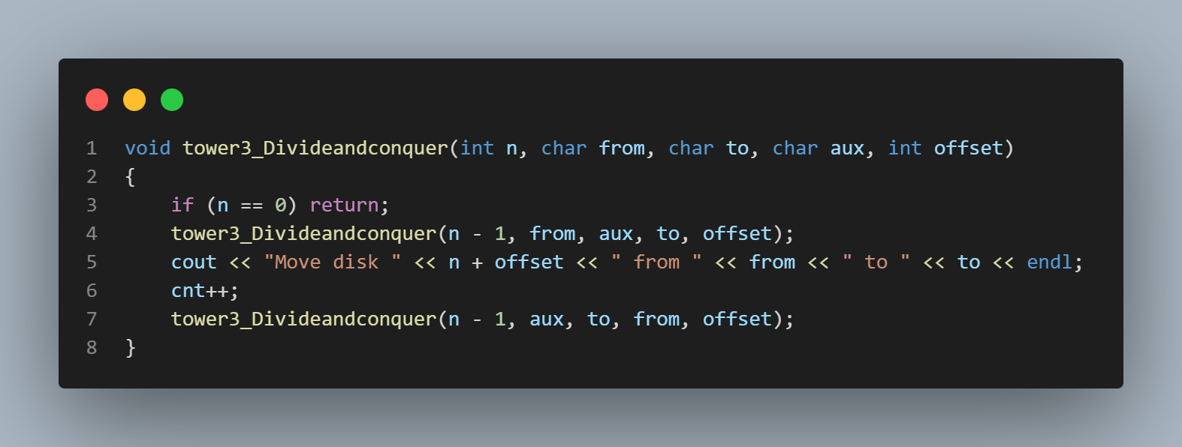

3.3.3 [tower4_DP]
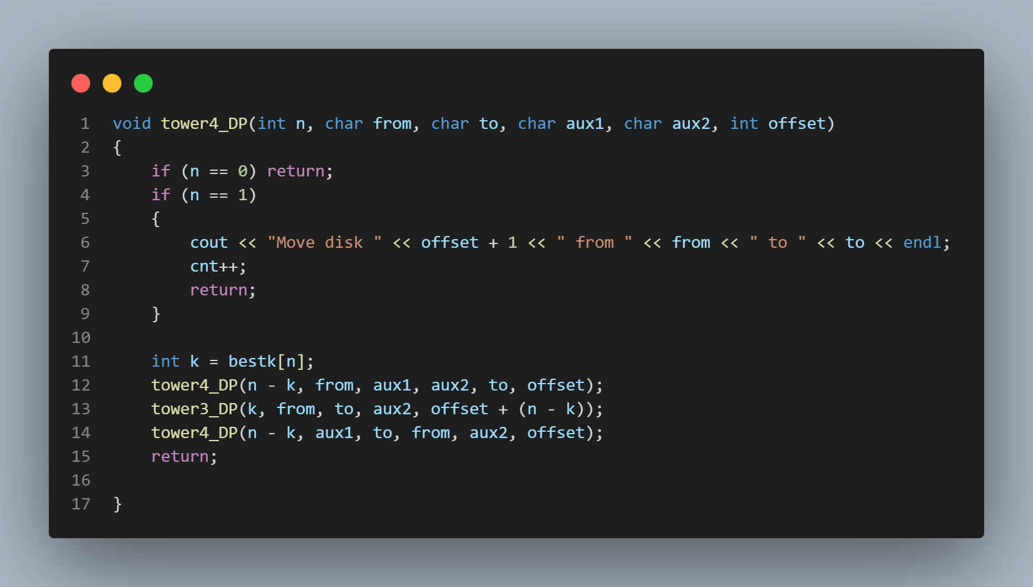

3.3.4 [check_k]
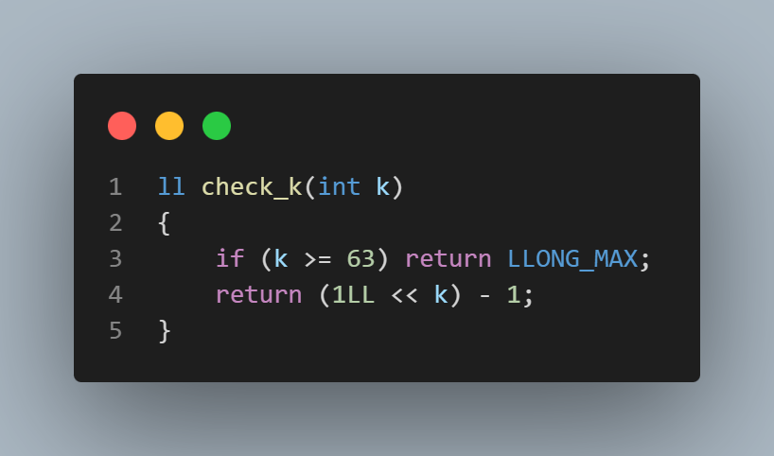

3.3.5 [DP initialization]
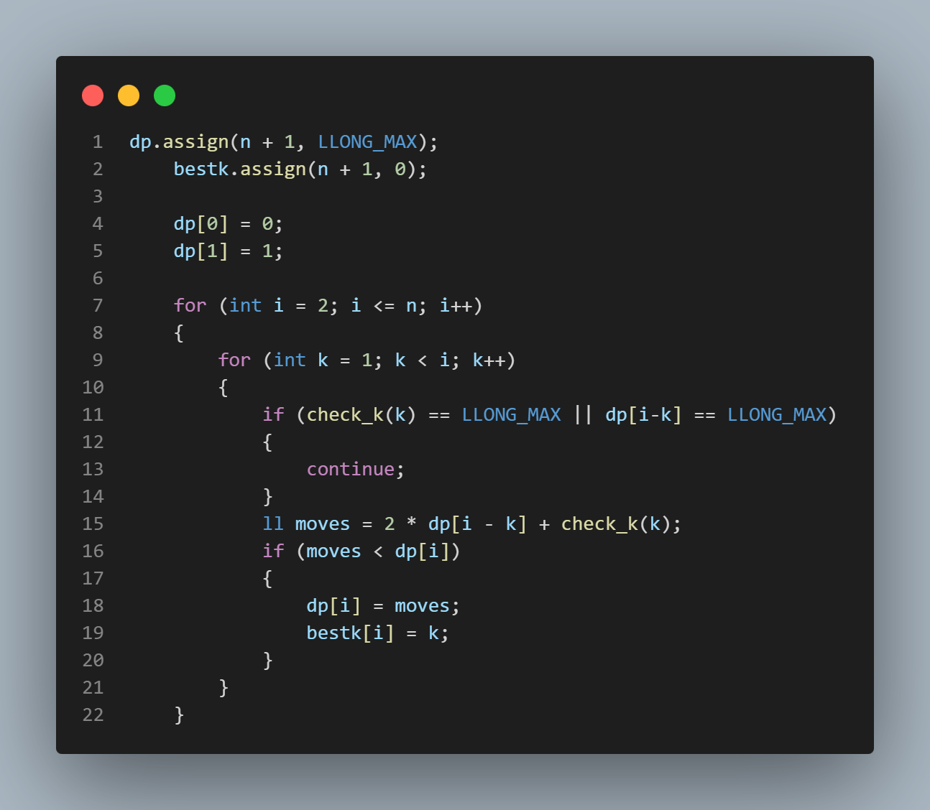

4. Complexity Analysis

4.1 Time Complexity

4.1.1 Algorithm 1: [Divide & Conquer]
Recurrence relation: T(n) = 2*T(n-k) + (2^{k} - 1)
Where T(n-k) is used twice to move the top (n-k) disks. The (2^{k} - 1) part is the cost of moving the bottoms k disks using classical 3 peg solution. K = floor(sqrt(2*n))
The exponential part contributes the most to the time so: T(n) ≈ 2^{sqrt(2*n)}
- Best case: O (1) when n = 0
- Average case: O (2^{sqrt(n)})
- Worst case: O (2^{sqrt(n)})

4.1.2 Algorithm 2: [Dynamic programming]
Recurrence relation: T(n) = min_{(1 <= k < n)} (2*T(n-k) + (2^{k} - 1))
The algorithms search for the best k from 1 to n-1. This process is repeated n times.
So, T(n) = O(n²)
- Best case: O (1) when n = 0
- Average case: O (n²)
- Worst case: O (n²)

4.2 Space Complexity

4.2.1 Algorithm 1: [ Divide & Conquer]
Both functions recursively call themselves. The worst case for tower3 will be calling itself with length n. Tower4 is smaller due to problem reduction. So:
- Total space complexity: O(n)
- Auxiliary space complexity: O(n)

4.2.2 Algorithm 2: [Dynamic programming]
The algorithm uses arrays to store the values along with the recursive calling(bestk[], dp[]).
- Total space complexity: O(n)
- Auxiliary space complexity: O(n)

4.3 Complexity Summary Table
Algorithm | Time – Best | Time – Worst | Space
Algorithm 1: [D&C] | O (1) | O (2^{sqrt(n)}) | O(n)
Algorithm 2: [DP] | O(1) | O(n²) | O(n)

5. Comparative Evaluation of Techniques

5.1 Comparison of Implemented Approaches
D&C:
- Uses k = sqrt(n)
- Simple and fast to implement
DP:
- Tries all possible values of K
- Guarantees minimum number of moves
- Requires more memory for storage

5.2 Alternative Approaches
We could have used Brute force to find all possible sequences of moves but:
- It would have been so slow because the number of moves grew fast
- It will take a lot of computing power at large n.

5.3 Are More Efficient Techniques Available?
Currently the most efficient one the one we implemented (Frame-Stewart algorithm) which is either implemented using D&C or DP as we did.

6. Sample Outputs & Testing

6.1 Test Case 1: [Small input]

Input
N = 1

Expected Output
Actual moves: 1
DP moves: 1

Actual Output
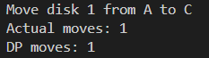

Explanation
With small inputs the solution is trivial and the program handles it.

6.2 Test Case 2: [Average input]

Input
N = 8

Expected Output
Actual moves: 33
DP moves: 33

Actual Output
Actual moves: 33
DP moves: 33
It also shows the moves made but the list is big.

Explanation
It computed the minimum moves correctly and moved correct number of times according to the actual moves made.

6.3 Test Case 3: [Stress test]

Input
N = 64

Expected Output
Actual moves: 18433
DP moves: 18433

Actual Output
Actual moves: 18433
DP moves: 18433
Along with all the moves made and from which peg to the other
Printing will take a lot more time than O(n²)

Explanation
The program can handle large values of n and display the minimum moves as expected.
It takes time with the output due to the print function.

7. Key Findings & Insights
Both DP and D&C produce optimal or near optimal solutions for the 4-peg problem. The number of moves increases very fast as n grows. DP keeps computing the best value of k while D&C uses a formula to find the efficient one. Printing affects the time of the output a lot.

8. Challenges Faced & Lessons Learned
It was challenging to understand the problem and decide how to go with the output needed. The problem with handling large inputs was annoying and took abit to deal with it.

9. References
This solution is based on Frame-Stewart method and online repos on GitHub.

