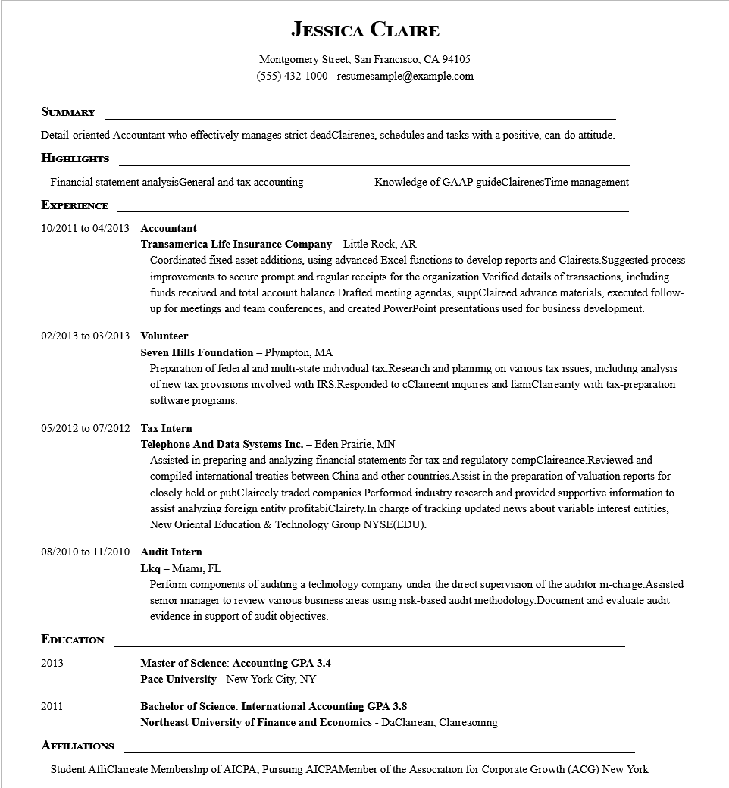
JESSICA CLAIRE
Montgomery Street, San Francisco, CA 94105
(555) 432-1000 - resumesample@example.com
SUMMARY
Detail-oriented Accountant who effectively manages strict deadClairenes, schedules and tasks with a positive, can-do attitude.
HIGHLIGHTS
Financial statement analysis General and tax accounting
Knowledge of GAAP guideClairenesTime management
EXPERIENCE
10/2011 to 04/2013 Accountant
Transamerica Life Insurance Company - Little Rock, AR Coordinated fixed asset additions, using advanced Excel functions to develop reports and Clairests. Suggested process improvements to secure prompt and regular receipts for the organization. Verified details of transactions, including funds received and total account balance Drafted meeting agendas, suppClaireed advance materials, executed follow- up for meetings and team conferences, and created PowerPoint presentations used for business development.
02/2013 to 03/2013 Volunteer
Seven Hills Foundation - Plympton, MA
Preparation of federal and multi-state individual tax. Research and planning on various tax issues, including analysis of new tax provisions involved with IRS.Responded to cClaireent inquires and famiClairearity with tax-preparation software programs.
05/2012 to 07/2012 Tax Intern
Telephone And Data Systems Inc. - Eden Prairie, MN
Assisted in preparing and analyzing financial statements for tax and regulatory compClaireance Reviewed and compiled international treaties between China and other countries. Assist in the preparation of valuation reports for closely held or pubClairecly traded companies Performed industry research and provided supportive information to assist analyzing foreign entity profitabiClairety. In charge of tracking updated news about variable interest entities, New Oriental Education & Technology Group NYSE(EDU).
08/2010 to 11/2010 Audit Intern
Lkq - Miami, FL
Perform components of auditing a technology company under the direct supervision of the auditor in-charge. Assisted senior manager to review various business areas using risk-based audit methodology.Document and evaluate audit evidence in support of audit objectives.
EDUCATION
2013
2011
Master of Science: Accounting GPA 3.4
Pace University - New York City, NY
Bachelor of Science: International Accounting GPA 3.8
Northeast University of Finance and Economics - DaClairean, Claireaoning
AFFILIATIONS
Student AffiClaireate Membership of AICPA; Pursuing AICPAMember of the Association for Corporate Growth (ACG) New York

