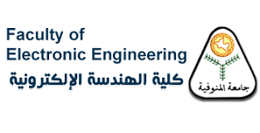

Faculty of engineering

Artificial intelligence

*Dr . Artificial intelligence*

*AI_Search Algorithm*

Name : Amr Mohamed Mousa & Mostafa Ahmed Shehata