SMART EXPENSE CATEGORIZER AND SPEND CLUSTERS

Description:
The Smart Expense Categorizer and Spend Clusters is a software solution developed to help an individual understand where their money actually goes, using nothing more than the statement their bank or UPI application already gives them. The system uses Machine Learning and Natural Language Processing techniques and uses a supervised text classification model built on TF-IDF features and a voting ensemble of Logistic Regression, Complement Naive Bayes and a calibrated linear Support Vector Machine, which is trained on a labelled dataset of transaction descriptions drawn from several statement formats. The system has a web application interface that allows people to upload their own statement in CSV form. The system then automatically reads the date, description and amount of every transaction, cleans the description of reference numbers and bank codes, and assigns each transaction one of eight spending categories, namely food, travel, shopping, entertainment, health, bills, rent and other, along with a confidence value that tells the user how certain the model is. Transactions that the model is unsure about are marked for review instead of being quietly guessed. Alongside the categories, the system detects fixed monthly commitments by finding merchants that are paid on a steady rhythm, and groups the remaining spending into behavioural clusters such as weekend splurges, routine weekday spends and big-ticket buys, using K-Means with the number of clusters chosen automatically. Additionally, the system provides a dashboard that shows a category summary, month-by-month spending, the list of recurring commitments, the discovered spending patterns and a searchable transaction table, and it accepts corrections from the user so that the model is refitted and similar merchants are updated at once. The project's aim is to reduce the manual effort of tagging hundreds of transactions in a spreadsheet, which takes a long time with a poor output rate, improve the visibility a person has over their own recurring outflows, and encourage informed personal financial decisions, therefore supporting financial literacy and technology-driven money management.
1. Description of Work:
Keeping track of personal spending is a problem faced by a large number of people in both urban and rural areas, due in part to the sheer volume of small digital payments that a single month now produces. With the spread of UPI and card payments, a typical statement carries several hundred rows, each described by a machine-generated string such as UPI/SWIGGY/ORDER482913/YESB rather than by anything a person would recognise at a glance. Because of the length of these strings, the reference numbers embedded in them, and the different formats used by different banks, it is difficult to tell at the end of a month how much was spent on food, how much on travel, and how much simply left the account on standing commitments. As a result of this poor visibility, people underestimate their recurring outflows, discover subscriptions they had forgotten, and find it hard to plan savings. Traditional expense tracking relies on manual tagging in a spreadsheet or on applications that demand direct access to bank credentials, which means that the effort is either too high to sustain or the privacy cost is too great. Therefore, an increased need for a technologically-oriented method to automatically read, label and summarise a statement exists.
The project is developing a Smart Expense Categorizer and Spend Clusters system that utilizes Machine Learning techniques and an unsupervised pattern discovery process to increase financial clarity. In this instance, the system uses a text classification methodology derived from TF-IDF vectorisation combined with an ensemble of three complementary classifiers. This methodology uses a trained model that has been fitted on a labelled dataset of about 1,400 transaction descriptions covering the eight categories across different statement formats, where word one-gram and two-gram features carry the merchant name and character two-gram to five-gram features absorb spelling drift such as NETFLIX COM or PG*ZOMATO*. Statements that are uploaded by the user go through basic text preprocessing steps, that is, lowercasing and the removal of reference numbers and transaction identifiers, before the descriptions are analysed by the trained classification algorithm. The averaged probability across the three voting models is reported as the confidence for the assigned label.
There is a web interface for analysing statements where users can upload a CSV export of their own account and the system automatically gathers the supporting information it needs, including the transaction date and the amount, handling both day-first and month-first date formats and treating amounts as absolute values so that a debit column of either sign is accepted. The uploaded file is sent to a server-side function where the categorisation model runs over every description, the recurring payment detector examines the timing of each merchant, and the clustering stage groups the transactions by behaviour. The results are returned as structured data and rendered on a dashboard that a person can read from top to bottom. The dashboard allows the user to filter by category, review the transactions the model was unsure about, and correct any label that is wrong, and that correction is fed straight back into the model so that every similar merchant is relabelled without further work.
The combination of automated categorisation and pattern discovery gives a viable way to understand a month of spending far more quickly than manual tagging. The approach moves personal budgeting from a retrospective and incomplete exercise to an immediate and complete one, and reduces the time between receiving a statement and understanding it from hours to seconds. The most significant impact of this type of system is the potential to surface the fixed commitments and habitual spending that would otherwise pass unnoticed. Because the statement is analysed in memory and no bank credentials are ever requested, it also allows a person to gain this understanding without surrendering access to their account, which is a decisive advantage over credential-linked alternatives.
2. Objective:
- Automatic expense categorization using machine learning: The idea is to make a system that can read raw bank and UPI transaction descriptions and assign each one a meaningful spending category using machine learning techniques, which is used in this project's approach. The main idea behind making this solution is to remove the manual effort of tagging hundreds of transactions by hand, an effort that most people abandon within a month.
- Building a text classification model for accurate categorization: In our approach, a TF-IDF and voting ensemble technique is used to identify the correct category from the transaction description alone. Our motive is to achieve accurate categorization across different banks, different statement formats and merchant names the model has never seen before, by combining word-level features that carry the merchant name with character-level features that survive spelling variation.
- Reporting confidence instead of guessing silently: The system reports a confidence value with every prediction and marks the low-confidence rows for review rather than presenting an uncertain guess as a fact. The idea is to make the limits of the model visible to the user, so that attention is directed only at the handful of rows that actually need a human decision.
- Detecting fixed monthly commitments automatically: The recurring payments in a statement, such as rent, subscriptions, electricity bills and loan instalments, are identified from the rhythm of the payments rather than from a fixed list of merchant names, so that the total amount committed every month before any discretionary spending happens is easy to see and traceable.
- Discovering spending patterns through unsupervised clustering: We aim to group the remaining transactions into behavioural clusters using K-Means over features that describe amount, day of the month, weekend behaviour and recurrence, with the number of clusters chosen automatically by silhouette score. This helps in revealing habits such as weekend splurges or routine weekday spends that a category total alone would hide.
- Learning from user corrections: It is made so that when a user corrects a wrongly assigned category, that correction is added to the training data and the model is refitted immediately, updating every similar merchant at once. Thus, allowing the system to adapt to the specific merchant strings used by the user's own bank and improve with use.
- Designing an accessible interface for everyday users: A web application built with Next.js, supported by a Python analysis function, together with a Streamlit application for local use, is developed for ordinary people to analyse their statements without writing any code. Figures are displayed with Indian digit grouping and the interface offers both a light and a dark theme for comfortable reading.
- Privacy-preserving personal finance: The overall objective is to contribute to safer and smarter personal financial management by analysing the uploaded statement in memory, without storing the file and without ever asking for bank credentials, thereby enabling insight through technology without creating a new privacy risk.
3. Flow diagram of SMART EXPENSE CATEGORIZER AND SPEND CLUSTERS:
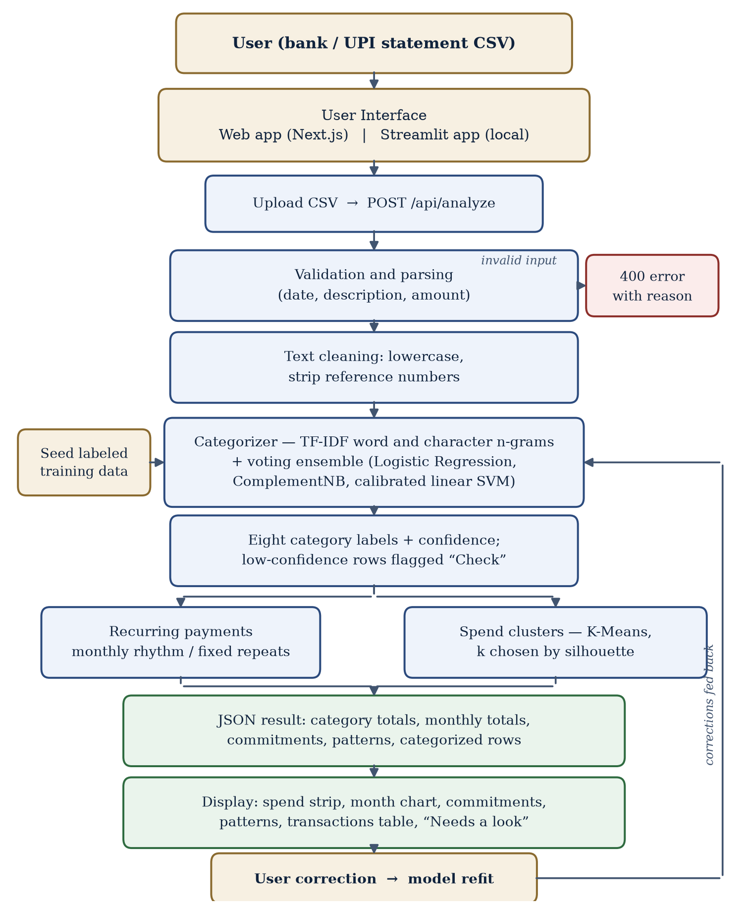
Fig 1: Flow diagram of system
Figure 1 shows Flow diagram of Smart Expense Categorizer and Spend Clusters. Detail explanation given below.
User Interface:
There are two interfaces given as below:
Web Application Interface for Users: The user interface is made with Next.js and React, a modern web application framework, which helps in maintaining consistent performance across desktop and mobile browsers without any installation. The application provides a simple and responsive user interface through which one can analyse a statement. The page begins empty and integrates a file upload control through which the user supplies their own bank or UPI statement in CSV form. Once a file is chosen, the system reads the date, description and amount columns, accepting extra columns and any header casing, and the file and its options are then sent to the backend analysis function through secure API communication. Before the results are displayed, the interface validates the file and returns a readable message when a column is missing, the file is empty or an amount cannot be read, naming the line at fault. After the analysis is returned, the page presents a sentence-led summary with the whole statement drawn as a single proportional strip that can be clicked to filter by category, a month-by-month view of spending, the list of fixed monthly commitments, the discovered spending patterns and a full transaction table. Rows the model was unsure about are marked for checking and collected together so they can be reviewed in one place. Changing a category re-runs the analysis with that correction included. The React-based interface ensures smooth navigation, responsive layouts, Indian digit grouping for all figures and a choice of light and dark themes.
Streamlit Application Interface for Local Use: The local interface is a Python application made using Streamlit, providing an easy-to-use platform for users who prefer to run the entire system on their own machine with no network involvement at all. The application fits the model in memory when it starts, so there is no saved model file that can go stale, and it exposes the same analysis over the same model code that the web application uses. It displays the categorized transactions, the category and monthly totals, the detected recurring payments and the cluster summaries, with charts rendered through Altair. A command line trainer is also provided for users who wish to measure the model on their own labelled data, reporting merchant-grouped cross-validation and held-out accuracy, so that the quality of the model on an individual bank's formats can be verified rather than assumed.
Thus, the web and local interfaces create an integrated upload-to-insight framework helping in faster reading, categorisation and understanding of a personal statement.
Foundation Framework
For the categorisation of transactions the suggested approach relies on a supervised machine learning model which has proven capabilities for accomplishing precise classification of short, noisy text in real time. The classification portion of this approach is accomplished using a labelled dataset that includes transaction descriptions from various statement formats across the eight spending categories. Data is received, processed, run through the classification model, and summarised according to a defined pipeline framework. Statement data, uploaded from the web application, is preprocessed prior to TF-IDF feature extraction. Preprocessing is done through lowercasing and the removal of reference numbers and transaction identifiers. The model's trained configuration is able to extract word and character n-gram features from the preprocessed data and predict the category of each transaction, with the averaged probability of the three voting estimators serving as the confidence. The generated results, including the detected recurring commitments and the K-Means spending clusters computed over amount, day-of-month, weekend and recurrence features, are forwarded to the interface for presentation. The backend support infrastructure, a Python analysis function deployed as a serverless endpoint, allows interaction between the web application, the trained model and the clustering stage, and accepts user corrections that refit the model on the next request. This infrastructure provides an enhanced ability to understand personal spending and can easily be integrated to support budgeting and financial planning systems on a larger scale.
4. Conclusion:
The volume of small digital payments has caused a major visibility problem for individuals, thereby creating a situation where a person cannot easily answer where their money went in a given month. Most of this difficulty arises from machine-generated transaction descriptions and from statement formats that differ from bank to bank. The current expense tracking mechanisms use outdated procedures relying on manual tagging of every transaction, or demand direct access to bank credentials, and neither allows for a quick and safe answer. Our solution is designed to assist in categorising such transactions automatically, flagging the ones it is unsure about, detecting the commitments that repeat every month and grouping the rest into recognisable spending patterns. In addition, we will provide a platform that learns from the corrections a user makes and never asks for bank credentials or stores the uploaded file. Utilizing this combined approach will improve the speed and honesty of personal financial reporting, and therefore increase the overall financial awareness of the user in the long run. This solution has been designed to help reduce unplanned spending and the recurring outflows that would otherwise go unnoticed.

