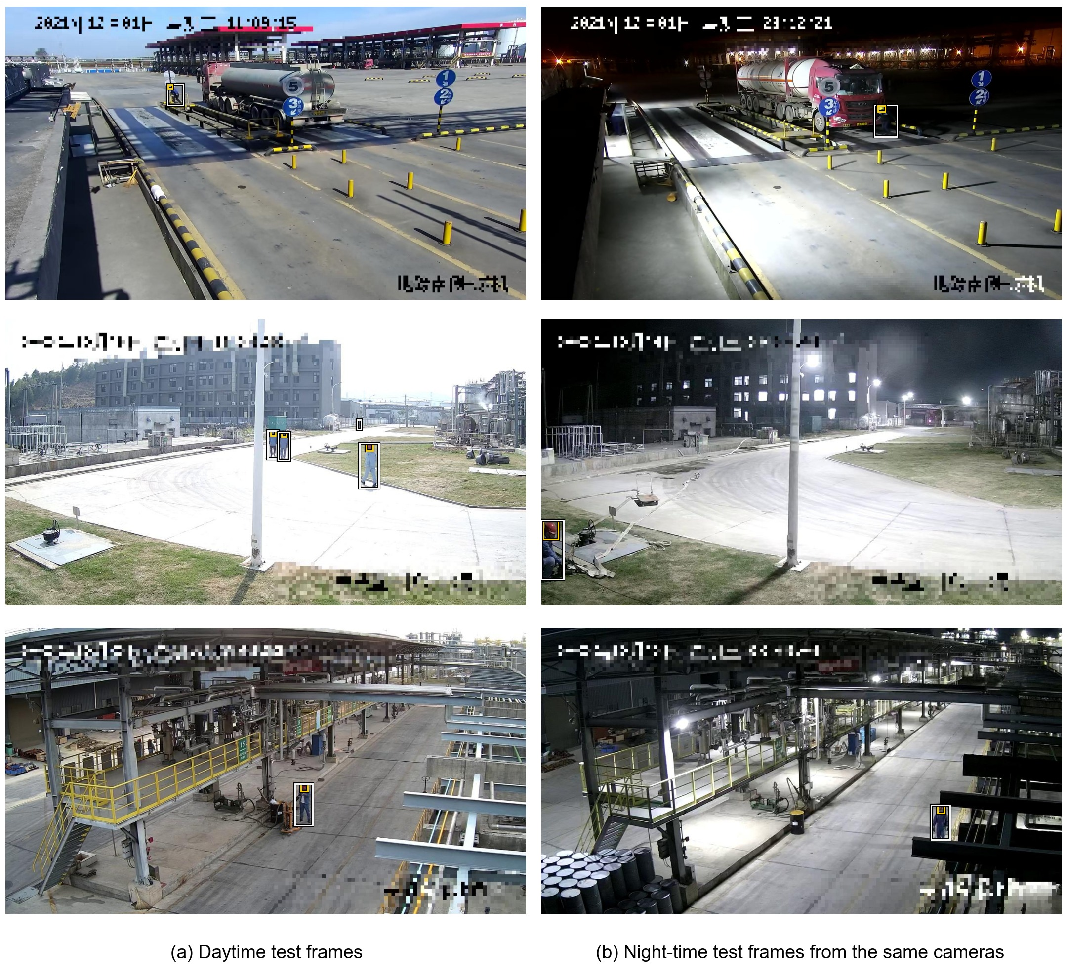
Figure S1 - Examples of the SFCHD test frames: (a) daytime and (b) night-time frames from the same three cameras, drawn at random, with their Person (white) and helmet (yellow) labels (Source: Authors’ own work using images from Yu et al. (2023))

Table S1 - Detection performance with a 50-epoch schedule for all detectors and the urban CycleGAN (mean ± standard deviation over seeds 0, 1 and 2) (Source: Authors’ own work)
Test set | Detector | Precision | Recall | F1-score | mAP@0.5 | mAP@0.5:0.95
Construction-PPE test (day, 11 classes) | Baseline Model | 0.601 ± 0.016 | 0.506 ± 0.018 | 0.549 ± 0.007 | 0.524 ± 0.006 | 0.263 ± 0.003
 | Size-matched control | 0.582 ± 0.012 | 0.522 ± 0.025 | 0.550 ± 0.010 | 0.518 ± 0.013 | 0.258 ± 0.003
 | Enhanced Model, urban CycleGAN | 0.646 ± 0.055 | 0.526 ± 0.010 | 0.579 ± 0.017 | 0.529 ± 0.003 | 0.262 ± 0.001
 | Change, control vs Baseline | −3.0% | +3.2% | +0.2% | −1.1% | −1.8%
 | Change, urban Enhanced vs Baseline | +7.6% | +3.9% | +5.4% | +1.0% | −0.2%
 | Change, urban Enhanced vs control | +11.0% | +0.7% | +5.2% | +2.1% | +1.6%
SFCHD day (Person, helmet) | Baseline Model | 0.288 ± 0.083 | 0.169 ± 0.018 | 0.207 ± 0.010 | 0.123 ± 0.024 | 0.027 ± 0.005
 | Size-matched control | 0.282 ± 0.086 | 0.158 ± 0.030 | 0.196 ± 0.016 | 0.111 ± 0.010 | 0.024 ± 0.003
 | Enhanced Model, urban CycleGAN | 0.314 ± 0.039 | 0.151 ± 0.014 | 0.203 ± 0.013 | 0.126 ± 0.008 | 0.029 ± 0.005
 | Change, control vs Baseline | −2.0% | −6.2% | −5.7% | −9.8% | −12.3%
 | Change, urban Enhanced vs Baseline | +9.1% | −10.4% | −2.1% | +2.7% | +7.7%
 | Change, urban Enhanced vs control | +11.3% | −4.5% | +3.8% | +13.9% | +22.9%
SFCHD night (Person, helmet) | Baseline Model | 0.339 ± 0.082 | 0.168 ± 0.016 | 0.222 ± 0.022 | 0.139 ± 0.018 | 0.032 ± 0.002
 | Size-matched control | 0.309 ± 0.037 | 0.148 ± 0.021 | 0.200 ± 0.026 | 0.099 ± 0.013 | 0.021 ± 0.003
 | Enhanced Model, urban CycleGAN | 0.309 ± 0.050 | 0.146 ± 0.021 | 0.196 ± 0.015 | 0.111 ± 0.013 | 0.026 ± 0.005
 | Change, control vs Baseline | −8.8% | −11.8% | −10.0% | −29.1% | −32.6%
 | Change, urban Enhanced vs Baseline | −8.9% | −13.1% | −11.8% | −20.1% | −16.9%
 | Change, urban Enhanced vs control | −0.1% | −1.5% | −2.0% | +12.7% | +23.3%
Note: With 50 epochs, the size-matched control and the Enhanced Model (2,264 images) received twice the parameter updates of the Baseline Model (1,132 images). Training used PyTorch 2.10; other settings as in Table 2.

Table S2 - Configuration selection on the night-time validation set (88 MOCS photographs, Person class, 171 instances; one training run per configuration) (Source: Authors’ own work)
Detector | CycleGAN | Epochs | Precision | Recall | mAP@0.5 | mAP@0.5:0.95 | Construction-PPE validation mAP@0.5:0.95
Baseline Model | None | 50 | 0.294 | 0.158 | 0.143 | 0.049 | 0.283
Size-matched control | None | 25 | 0.381 | 0.123 | 0.128 | 0.045 | 0.277
Enhanced Model, all translated images | Urban | 25 | 0.555 | 0.187 | 0.198 | 0.061 | 0.276
Enhanced Model, all translated images (selected) | Construction-night | 25 | 0.540 | 0.187 | 0.193 | 0.065 | 0.277
Enhanced Model, all translated images | Construction-night | 50 | 0.526 | 0.187 | 0.165 | 0.040 | 0.274
Enhanced Model, random half of translated images | Construction-night | 33 | 0.425 | 0.216 | 0.183 | 0.055 | 0.277
Enhanced Model, random half of translated images | Construction-night | 50 | 0.446 | 0.175 | 0.141 | 0.045 | 0.272
Note: Schedules of 25 epochs (all translated images, 2,264 training images) and 33 epochs (half, 1,698 training images) follow the update-matched rule of Equation 5, rounded to whole epochs. The last column gives the best value on the Construction-PPE validation split, which selects the checkpoint. The construction-night CycleGAN used for this selection was trained with the same settings as the one used for the reported results.

Table S3 - Per-seed mAP@0.5 and mAP@0.5:0.95 of the four detectors on the three test sets (Source: Authors’ own work)
Test set | Detector | Metric | Seed 0 | Seed 1 | Seed 2
Construction-PPE test (day, 11 classes) | Baseline Model | mAP@0.5 | 0.529 | 0.538 | 0.532
 |  | mAP@0.5:0.95 | 0.266 | 0.265 | 0.266
 | Size-matched control | mAP@0.5 | 0.533 | 0.532 | 0.537
 |  | mAP@0.5:0.95 | 0.266 | 0.263 | 0.270
 | Enhanced Model, urban CycleGAN | mAP@0.5 | 0.531 | 0.540 | 0.551
 |  | mAP@0.5:0.95 | 0.268 | 0.274 | 0.277
 | Enhanced Model, construction-night CycleGAN | mAP@0.5 | 0.542 | 0.537 | 0.542
 |  | mAP@0.5:0.95 | 0.267 | 0.273 | 0.274
SFCHD day (Person, helmet) | Baseline Model | mAP@0.5 | 0.130 | 0.110 | 0.106
 |  | mAP@0.5:0.95 | 0.028 | 0.022 | 0.024
 | Size-matched control | mAP@0.5 | 0.207 | 0.138 | 0.162
 |  | mAP@0.5:0.95 | 0.048 | 0.028 | 0.035
 | Enhanced Model, urban CycleGAN | mAP@0.5 | 0.174 | 0.162 | 0.190
 |  | mAP@0.5:0.95 | 0.038 | 0.036 | 0.045
 | Enhanced Model, construction-night CycleGAN | mAP@0.5 | 0.176 | 0.174 | 0.170
 |  | mAP@0.5:0.95 | 0.042 | 0.035 | 0.035
SFCHD night (Person, helmet) | Baseline Model | mAP@0.5 | 0.140 | 0.120 | 0.124
 |  | mAP@0.5:0.95 | 0.030 | 0.026 | 0.027
 | Size-matched control | mAP@0.5 | 0.185 | 0.152 | 0.144
 |  | mAP@0.5:0.95 | 0.046 | 0.034 | 0.034
 | Enhanced Model, urban CycleGAN | mAP@0.5 | 0.120 | 0.138 | 0.151
 |  | mAP@0.5:0.95 | 0.027 | 0.028 | 0.035
 | Enhanced Model, construction-night CycleGAN | mAP@0.5 | 0.174 | 0.162 | 0.146
 |  | mAP@0.5:0.95 | 0.042 | 0.035 | 0.034
Note: The values are those of the detectors in Table 2, whose means and standard deviations they give.

