The HTML test has successfully integrated with the PHP code. By including the following into the checkLogin, we realize a full communication integration from the user inputs and the user database that stores all credentials.

$servername = "localhost";

$username = "root";

$password = "";

// Create connection

$conn = new mysqli($servername, $username, $password, "StockDBPDO");

// Check connection

if ($conn->connect_error) {

die("Connection failed: " . $conn->connect_error);

}

//echo "Connected successfully";

$sql = "SELECT username, password FROM users";

if ($conn->query($sql) === TRUE) {

} else {

//echo "Error: " . $sql . "<br>" . $conn->error;

}

$username = array();

$password = array();

$result = $conn->query($sql);

if ($result->num_rows > 0) {

// output data of each row

while ($row = $result->fetch_assoc()) {

array_push($username,$row["username"]);

array_push($password,$row["password"]);

}

}

if (!empty($_GET['username'])

&& !empty($_GET['password'])) {

$temp1 = 0;

for ($i = 0; $i < count($username); $i++){

if ($_GET['username'] == $username[$i] &&

$_GET['password'] == $password[$i]) {

$temp1 = 1;

setcookie("cookieid",$_GET['username'], time()+3600);

echo '<meta HTTP-EQUIV="REFRESH" content="0; url=portfolio.php">';

}

}

if ($temp1 == 0)

echo '<script>alert("Wrong Username of Password")</script>';

}

$conn->close();

CheckLogin Testing:

*// $checklogin=fopen("checklogin.txt", or die("checklogin file unaccessible");*

*// $txt="Login class accessible\n";*

*// fwrite($checkloginFile, $txt); //This test will check username and password to see if they match the ones in our database and then let the user in.*

This is the code for unit testing on checklogin code. The code will check the username and password inputted by the user. The username and password will be first matched the the ones in the database. After that the code will see if the username and password match each other for the right user. Then the user will be allowed to move forward to the portfolio.

Prediction Page Testing

Screen Shot 2017-03-29 at 9.33.51 PM.png

This is an example of our unit testing code. It opens the file to check whether or not the file is accessible and working or will display whether it is not working. At the end of the php file the file closes and ensures the unit testing work. There are similar files for the testing spread throughout the code for other functions such as pattern checking and RSI.

Portfolio Test:

Our objective is to see if whether or not the checkLogin page successfully redirected the user to the myPortfolio page. In order to do so, we must develop a type of check at the very beginning of the portfolio code. If the user was able to successfully able to reach the myPortfolio HTML, the PortfolioIntegration.txt file will be created, with the following text: “Portfolio class accessible”. If the myPortfolio page is inaccessible, the Portfolio_integration file will not be created.

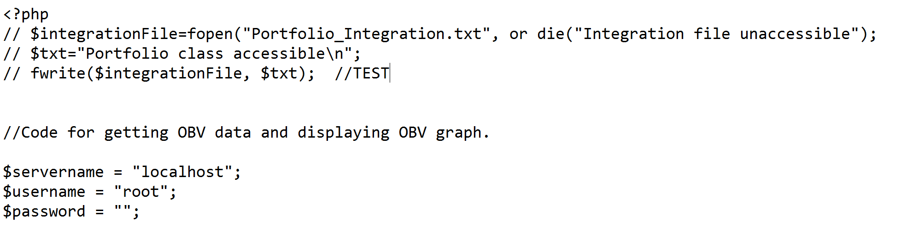

To run this code, just uncomment the code and any errors will show up.