NoSQL usage in MongoDB Atlas

- Adding reviews and ratings to products. Each review appears under the specific products’ review section and also shows which user placed the review. A user is able to delete their own review, and only view other people’s reviews.

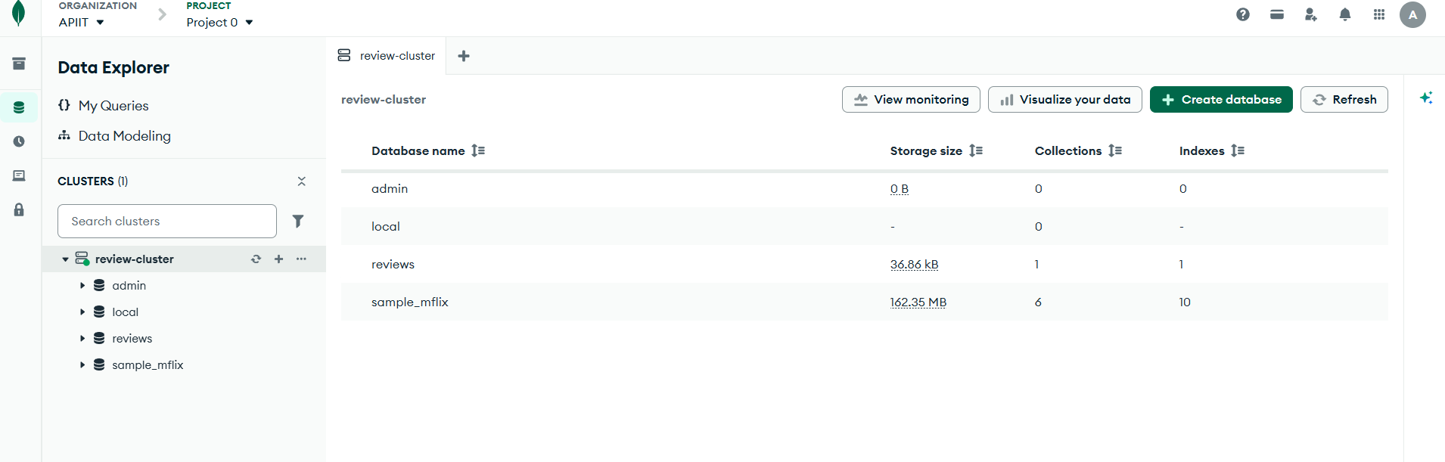

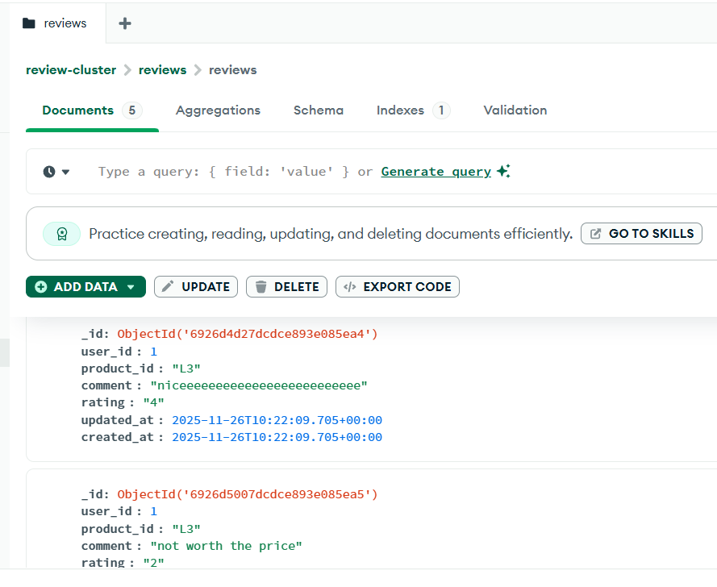

- Adding the contents and images for the ‘About Us’ section of the page.

