NGX-F215343: Rx Enabler (Arch) – Correct RX Access for Carved-out Members

# Feature Summary

This document defines the updated architecture for Correct RX Access for Carved-out Members within the Aetna Health ecosystem. It addresses the integration and display logic issues related to prescription claims within the CVS Consolidated Claims service, focusing on ensuring prescription claims and refills are only shown within valid coverage windows, aligned with plan effective dates and CVS attestation flags.

# Discovery

During discovery, multiple dependencies were identified across prescription claims, refills, and orders. Filtering must be applied consistently using pharmacy membership effective dates. Any prescription or refill outside the effective coverage window must be excluded. This ensures compliance with HIPAA and plan rules.

# Options

## Option 1: Centralized Eligibility & Display Logic Service

Centralize claim visibility rules in a middleware service that evaluates attestation flags, plan effective dates, and carve-out status before returning data to clients. This ensures consistency across all integrations (PLP, PDB, PlaceOrder, Ship Consent, i90) and eliminates undocumented front-end logic.

## Option 2: Distributed Logic in Clients

Embed a shared validation library in each integration (PLP, PDB, etc.) to enforce claim visibility rules locally. This offers independence but risks divergence over time.

**Selected: Option 1 – Centralized service approach for scalability and compliance.**

# Solution Sketch

The following diagram illustrates the updated Prescription List Flow with Effective Date Policy Filtering applied. It replaces the previous orchestration placeholder and demonstrates where effective date filtering is enforced.

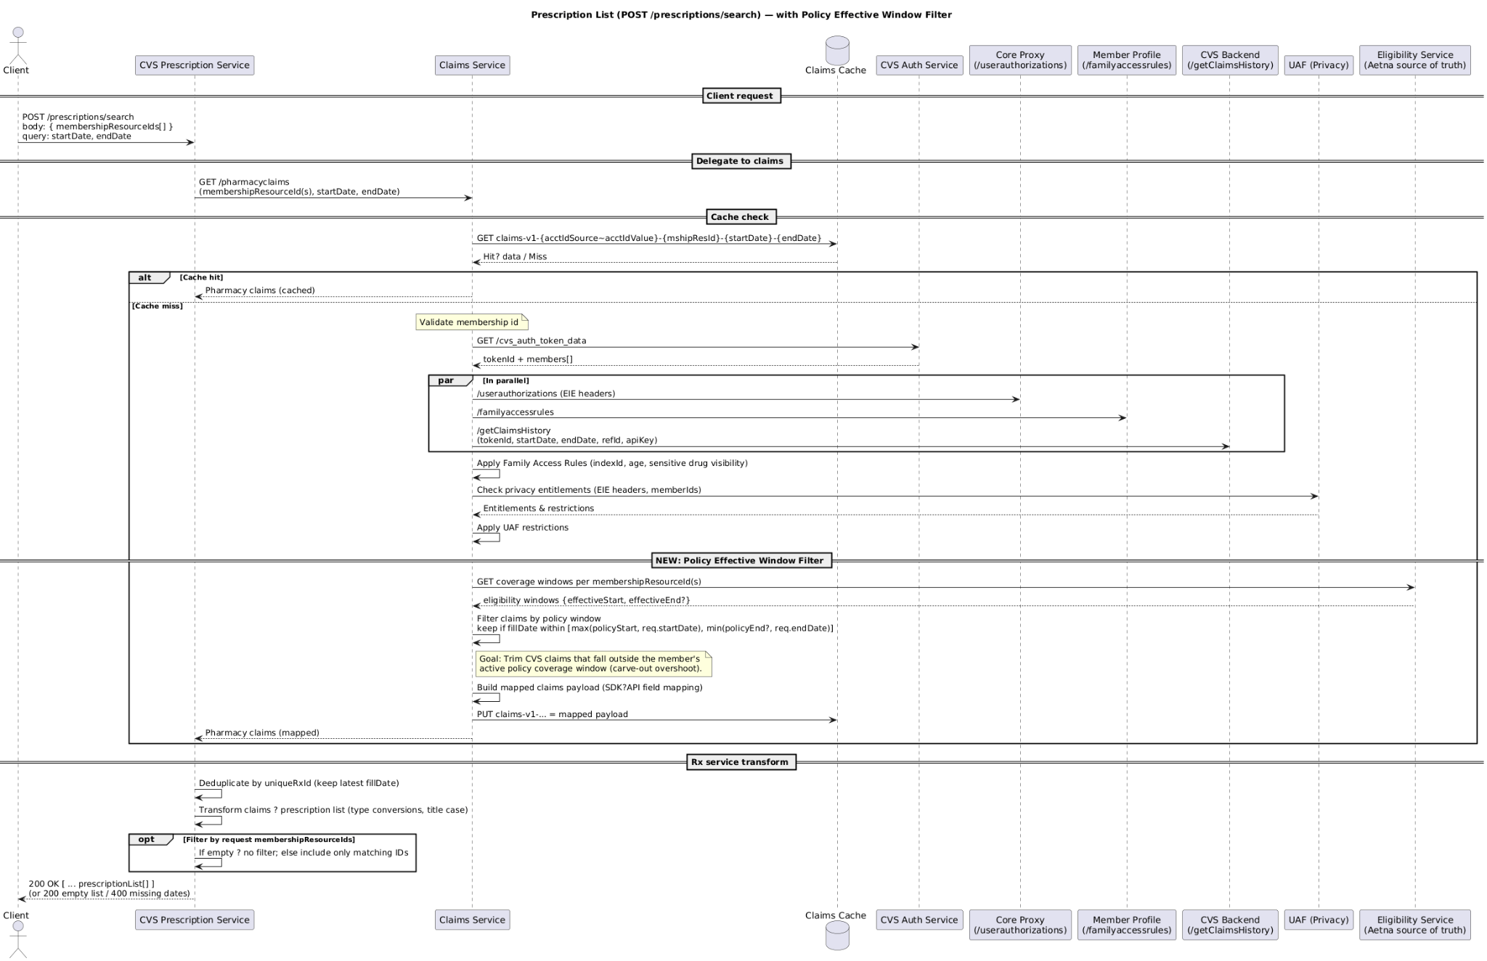

# Service Logic

The centralized eligibility service enforces claim visibility rules:  
- Validates attestation flags (CVS Carve-Out active).  
- Checks plan effective dates against claim fill dates.  
- Applies family access and UAF privacy restrictions.  
- Deduplicates prescriptions using uniqueRxId and latest fillDate.  
- Filters refills and orders that straddle outside coverage dates.  
The service ensures only claims within valid coverage periods are displayed to members.

# Services

Key services include:  
- CVS Auth Service (token exchange, patient profile).  
- CVS Consolidated Claims Service.  
- Prescription List Service (POST /prescriptions/search, GET /prescriptions/detail).  
- Order & Refill Service.  
- Family Access / UAF Rules enforcement.  
- Centralized Eligibility Middleware (Effective Date & Attestation Filtering).

# Non-Functional Requirements (NFR)

Performance: Response ≤ 200ms under normal load.  
Scalability: Must support 47 APIs and 5 major integrations.  
Caching: Utilize ElastiCache/DynamoDB for eligibility lookups.  
Observability: Log decision points (eligible/ineligible claims).

# Scenarios

1. Prescription claim before coverage effective date – excluded from view.  
2. Refill order with zero refills left – appropriate messaging displayed.  
3. Member without signed attestation – limited Caremark link shown.  
4. Member with signed attestation – full integration via APIs.  
5. Missing startDate/endDate – 400 Bad Request returned.  
6. Claims filtered for HIPAA-sensitive drugs based on UAF rules.

# Client Changes

The Aetna Health app (web, iOS, Android) must:  
- Integrate with centralized eligibility service.  
- Apply effective date filtering consistently.  
- Display user-friendly messages when prescriptions are hidden due to coverage.  
- Support SSO or Caremark cold-link depending on attestation.  
- Maintain consistent behavior across platforms.