**OpenPlatform - Plan Documents Access**

**Feature Summary**

This feature will enable OpenPlatform users to access their plan documents. The project involves creating a new BFF (Backend-for-Frontend) for the OpenPlatform, which will integrate with the existing AWS-based Benefits Service currently used by Aetna Health. The solution will handle scenarios for displaying single, multiple, or zero available documents and will include support for language preferences.

The primary goal is to route the plan document list and PDF retrieval through a new dedicated OpenPlatform BFF to the existing AWS services. This approach benefits from existing capabilities like caching, which reduces the load on core services and provides a more resilient and faster user experience. The solution must also account for potential gaps in upstream data, such as missing plan names or document descriptions, and handle them gracefully. Search functionality is not in scope for the initial release but is on the roadmap, and the architecture should not degrade performance for future search implementations.

**Discovery**

Several options were considered for fetching the plan document list and retrieving the PDFs. The primary challenge is balancing app startup performance, on-page performance, and implementation complexity, especially considering the known data inconsistencies.

**Architectural Options Analysis**

Here's a breakdown of the considered architectural options, their descriptions, and a "meatball" chart summarizing their pros and cons.

**Option 1: Adapt Existing On-Demand Architecture (Chosen Direction)**

**Description**: This approach mirrors the existing Aetna Health architecture. A new route will be created in a dedicated OpenPlatform BFF. When a user navigates to the Plan Documents page, the client calls the BFF, which in turn calls the backend Benefits Service to get the document list for that user. PDF retrieval follows the established pattern: the client requests a PDF via the BFF, which first checks an S3 cache and, if not present, retrieves it from the core endpoint and caches it for future requests.

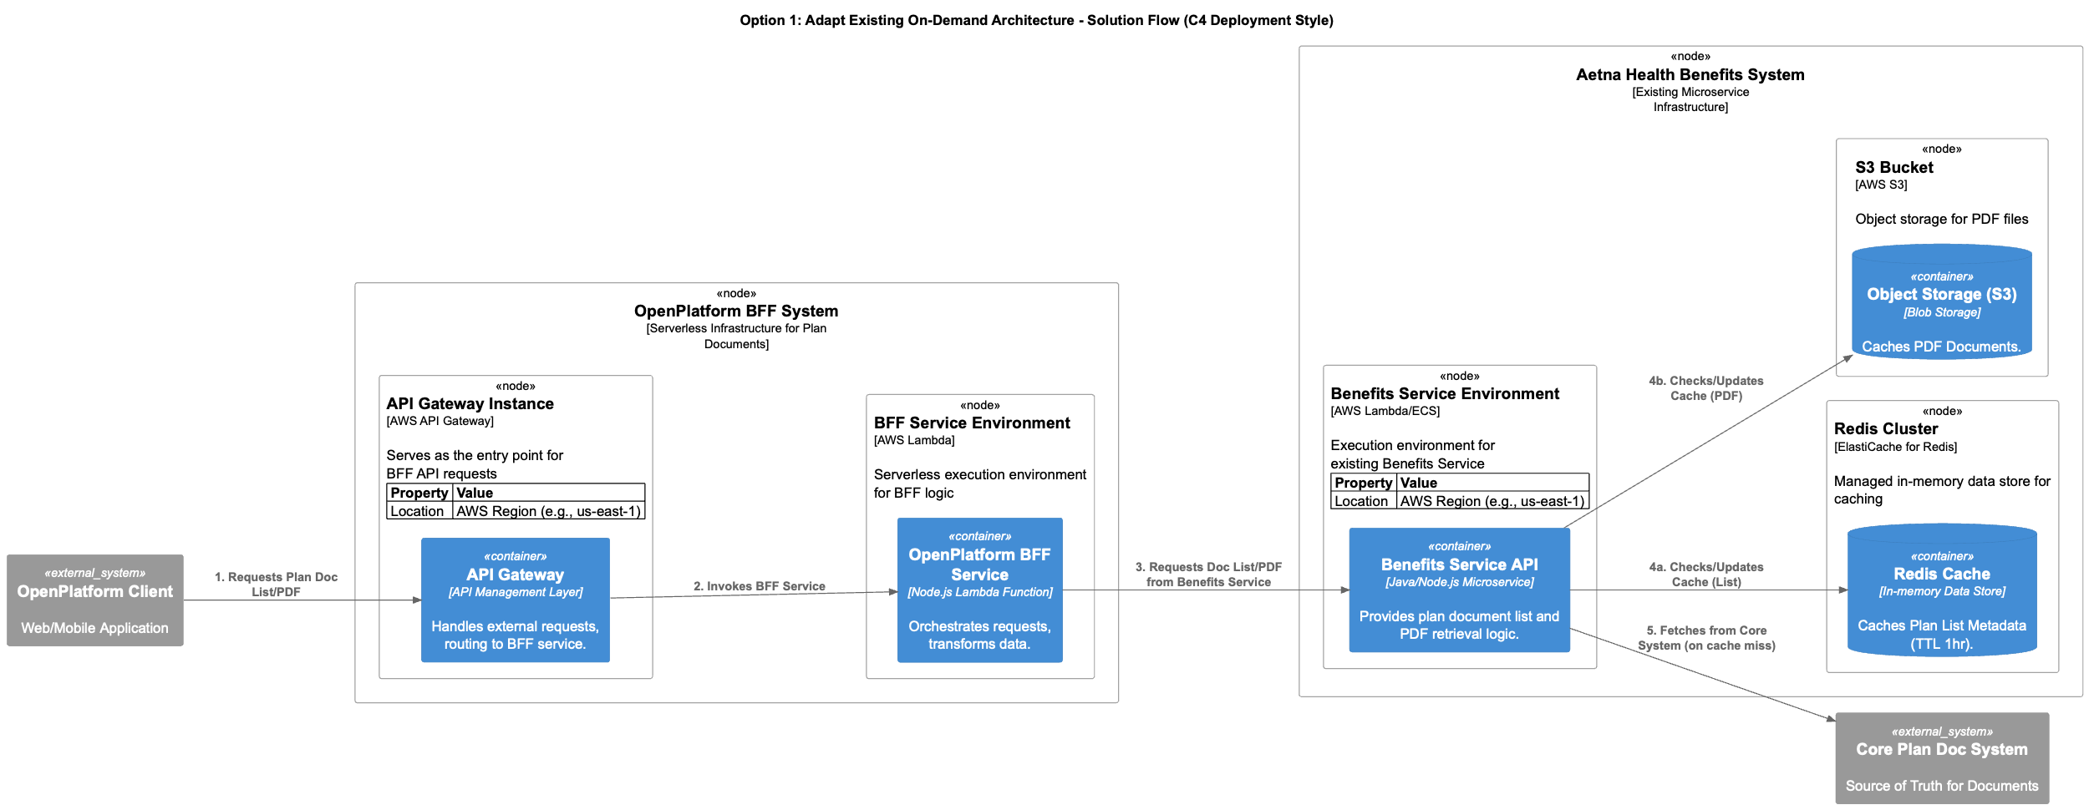

**Option 2: App Startup Pre-fetch**

**Description**: This option proposes fetching the plan document list when the application starts up, based on the observation that plan metadata is sometimes missing. The data would be sourced from a plan doc index or API and cached on the client or in the BFF for the duration of the user’s session. This would make the Plan Documents page load instantly.

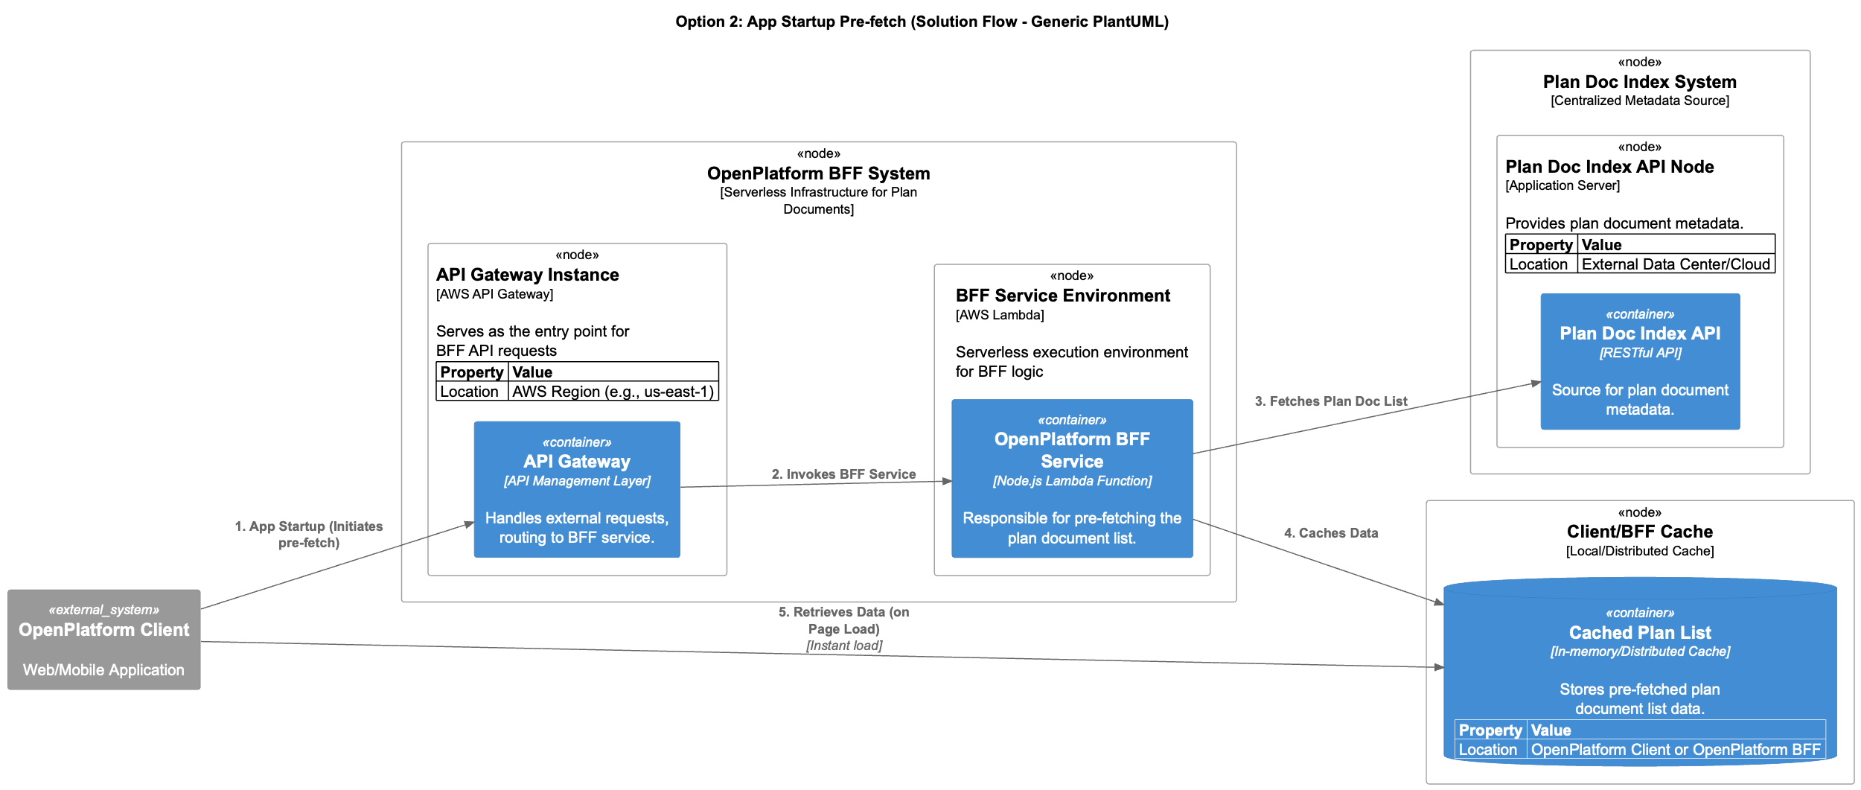

**Option 3: BFF-Centric Caching & Augmentation (Hybrid)**

**Description**: In this model, the OpenPlatform BFF takes on more responsibility. It follows the on-demand pattern of Option 1 but introduces an additional layer of caching within the BFF itself, tailored to the OpenPlatform's traffic patterns. The BFF would be responsible for calling the backend Benefits Service and then augmenting the response with metadata sourced from another service or a static cache (e.g., "sourcing from app startup" data loaded into the BFF) before returning the final payload to the client.

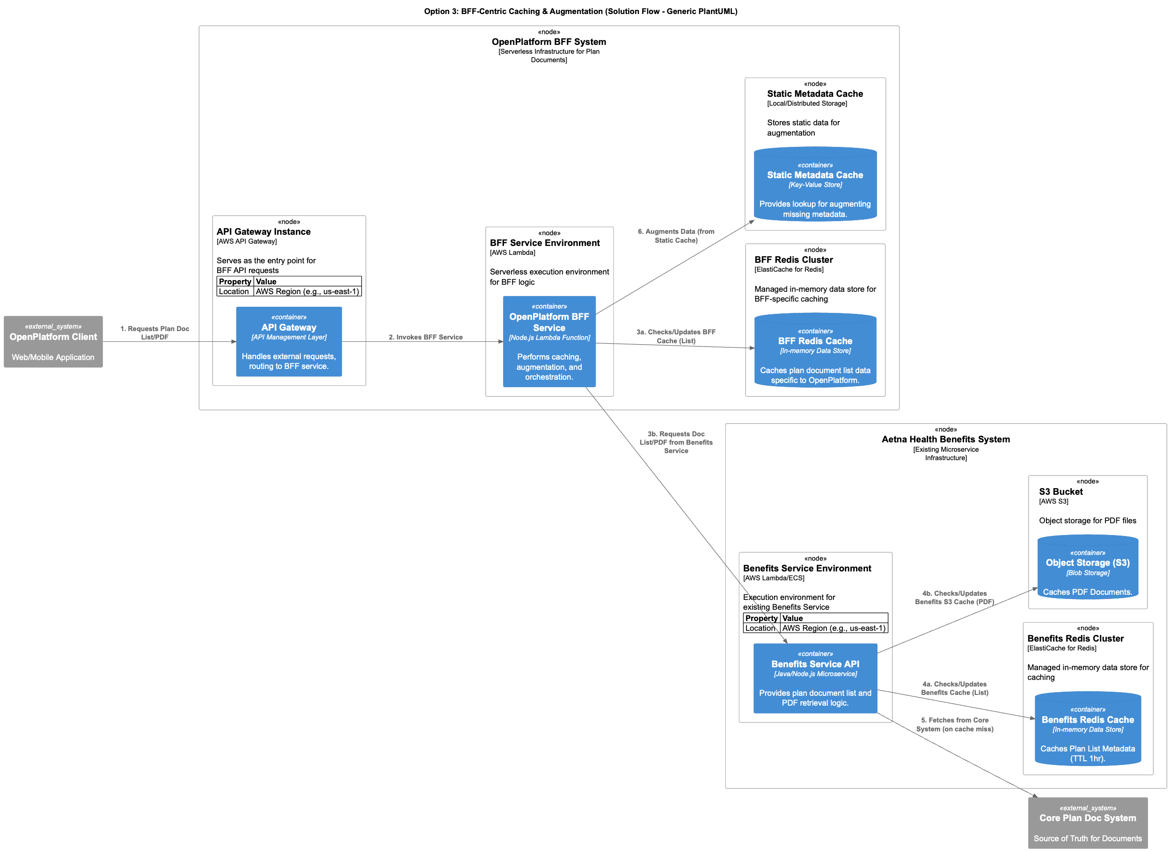

**Meatball Chart: Pros and Cons of Architectural Options**

| **Feature** | **Option 1: Adapt Existing On-Demand Architecture** | **Option 2: App Startup Pre-fetch** | **Option 3: BFF-Centric Caching & Augmentation** |
| --- | --- | --- | --- |
| **Pros** | - Reuses proven architecture | - Extremely fast user experience on page load | - Fast app startup |
|  | - Minimal app startup impact | - Augments missing metadata centrally at startup | - Robust data handling/augmentation |
|  | - Leverages existing caching |  | - Optimized caching for OpenPlatform |
|  | - Lower complexity |  | - Simplified client-side logic |
| **Cons** | - On-page performance dependent on real-time API call | - Increases app startup time | - Increased BFF complexity |
|  | - Requires BFF/client to handle data gaps | - Data can become stale | - Potential for slight latency |
|  |  | - Increased complexity for app startup data fetching |  |

Export to Sheets

**Chosen Direction**

**Option 1** is the chosen direction due to its simplicity and direct reuse of existing, proven infrastructure. This aligns with best practices by prioritizing a phased approach, starting with a lean, functional solution that leverages existing, well-tested components. It reduces initial development time and risk by building upon a stable foundation.

To mitigate the risk of missing data, the OpenPlatform BFF will incorporate a **limited augmentation capability** (as described in Option 3) to normalize the data before it reaches the client. This hybrid approach ensures that critical display fields are present, without adding the complexity of full BFF-side caching in the initial phase. This approach aligns with the principle of "start small, iterate fast" while still addressing known data quality concerns.

**Option: Narrative**

I will provide a step-by-step narrative for "Option 1: Adapt Existing On-Demand Architecture" and then a PlantUML flowchart illustrating its logic. This is based on the information in the provided Canvas.

**Option 1: Adapt Existing On-Demand Architecture - Step-by-Step Narrative**

Details the flow for accessing Plan Documents, covering both the retrieval of the document list and individual PDFs.

**A. Plan Document List Retrieval Flow**

1. **User Action**: An **OpenPlatform User** navigates to the Plan Documents page within the **OpenPlatform Client** (mobile or web application).
   * *Reasoning*: This action initiates the need to display the user's plan documents.
2. **Client Request**: The **OpenPlatform Client** sends a request to the **OpenPlatform BFF Service** (via an API Gateway) to retrieve the list of plan documents. This request includes profile and plan identifiers (e.g., id, idType, planId).
   * *Reasoning*: The BFF acts as a dedicated intermediary, simplifying client-side logic and allowing for potential transformations.
3. **BFF Orchestration**: The **OpenPlatform BFF Service** receives the request and, in turn, calls the existing **Benefits Service API**'s /plan-document-list/retrieve endpoint.
   * *Reasoning*: The BFF routes the request to the appropriate backend service.
4. **Benefits Service - List Cache Check**: The **Benefits Service API** initiates a cache check for the plan document list.
   * *Reasoning*: Caching reduces load on core systems and improves response times.
   * **4.a. Is the plan document list in the Redis Cache?**
     + **YES**: The **Benefits Service API** retrieves the cached list from the **Redis Cache** (valid for 1 hour TTL).
       - *Reasoning*: Fast retrieval from cache.
     + **NO**: The **Benefits Service API** proceeds to fetch the list from the **Core Plan Doc System**.
       - *Reasoning*: Cache miss requires fetching from the ultimate source of truth.
5. **Benefits Service - Core API Call (on cache miss)**: If the list was not found in the cache, the **Benefits Service API** fetches the plan document list from the **Core Plan Doc System**.
   * *Reasoning*: Ensures data completeness from the authoritative source.
6. **Benefits Service - Cache Update (on core fetch)**: If the list was fetched from the **Core Plan Doc System** (i.e., a cache miss occurred), the **Benefits Service API** stores the retrieved list in the **Redis Cache**.
   * *Reasoning*: Populates the cache for future requests, improving subsequent performance.
7. **Benefits Service Response**: The **Benefits Service API** returns the plan document list (either from cache or core API) to the **OpenPlatform BFF Service**. This response may include raw data, potentially with missing documentDescription or planName.
   * *Reasoning*: The Benefits Service provides the requested data.
8. **BFF Response Transformation & Augmentation**: The **OpenPlatform BFF Service** receives the response from the **Benefits Service API**. It then transforms this raw response into the format required by the **OpenPlatform Client**, including:
   * Creating the appropriate JSON structure for zero, single, or multiple documents.
   * Appending language to the document name (e.g., "Plan Document (Spanish)").
   * Gracefully ensuring that fields like documentDescription or planName are *not shown* if they are missing from the upstream response.
   * *Reasoning*: The BFF ensures the data is correctly structured and presented for the client, addressing data inconsistencies before they reach the UI.
9. **BFF Response to Client**: The **OpenPlatform BFF Service** sends the transformed and augmented document list back to the **OpenPlatform Client**.
   * *Reasoning*: The client receives the display-ready data.
10. **Client Display**: The **OpenPlatform Client** displays the plan document list to the **OpenPlatform User** according to the number of documents received (e.g., direct PDF view for one, a list for multiple, a "no documents" message for zero).
    * *Reasoning*: The user can now view their plan documents.

**B. Plan Document PDF Retrieval Flow**

1. **User Action**: From the displayed list or direct view, the **OpenPlatform User** taps on a specific plan document to view its PDF.
   * *Reasoning*: This action triggers the need to retrieve the PDF content.
2. **Client Request**: The **OpenPlatform Client** sends a request to the **OpenPlatform BFF Service** (via an API Gateway) to retrieve the specific PDF, providing the documentId.
   * *Reasoning*: The BFF acts as a dedicated intermediary for PDF retrieval.
3. **BFF Orchestration**: The **OpenPlatform BFF Service** receives the request and, in turn, calls the existing **Benefits Service API**'s /plan-document/retrieve endpoint with the documentId.
   * *Reasoning*: The BFF routes the request.
4. **Benefits Service - PDF Cache Check**: The **Benefits Service API** initiates a cache check for the specific PDF.
   * *Reasoning*: Caching PDFs in S3 improves performance and resilience.
   * **4.a. Is the PDF in the S3 Bucket cache?**
     + **YES**: The **Benefits Service API** streams the cached PDF directly from the **Object Storage (S3)**.
       - *Reasoning*: Fast retrieval from S3.
     + **NO**: The **Benefits Service API** proceeds to fetch the PDF from the **Core Plan Doc System**.
       - *Reasoning*: Cache miss requires fetching from the ultimate source.
5. **Benefits Service - Core API Call (on cache miss)**: If the PDF was not found in the cache, the **Benefits Service API** fetches the PDF from the **Core Plan Doc System**.
   * *Reasoning*: Ensures data completeness from the authoritative source.
6. **Benefits Service - Cache & Error Check (on core fetch)**: If the PDF was fetched from the **Core Plan Doc System** (i.e., a cache miss occurred), the **Benefits Service API** performs two checks:
   * **6.a. Is the retrieved PDF file size 0 bytes?**
     + **YES**: The **Benefits Service API** returns an error (e.g., 500) and *does not* cache the empty file.
       - *Reasoning*: Prevents caching of corrupt or empty documents.
     + **NO**: The **Benefits Service API** stores the retrieved PDF in the **Object Storage (S3)** for subsequent requests.
       - *Reasoning*: Populates the cache for future requests.
7. **Benefits Service Response**: The **Benefits Service API** returns the PDF file (either from S3 cache or core API, or an error for empty files) to the **OpenPlatform BFF Service**.
   * *Reasoning*: The Benefits Service provides the requested PDF.
8. **BFF Response to Client**: The **OpenPlatform BFF Service** streams the PDF content to the **OpenPlatform Client**.
   * *Reasoning*: The client receives the PDF data.
9. **Client Display**: The **OpenPlatform Client** displays the PDF to the **OpenPlatform User** within its PDF viewer.
   * *Reasoning*: The user can now view the document.

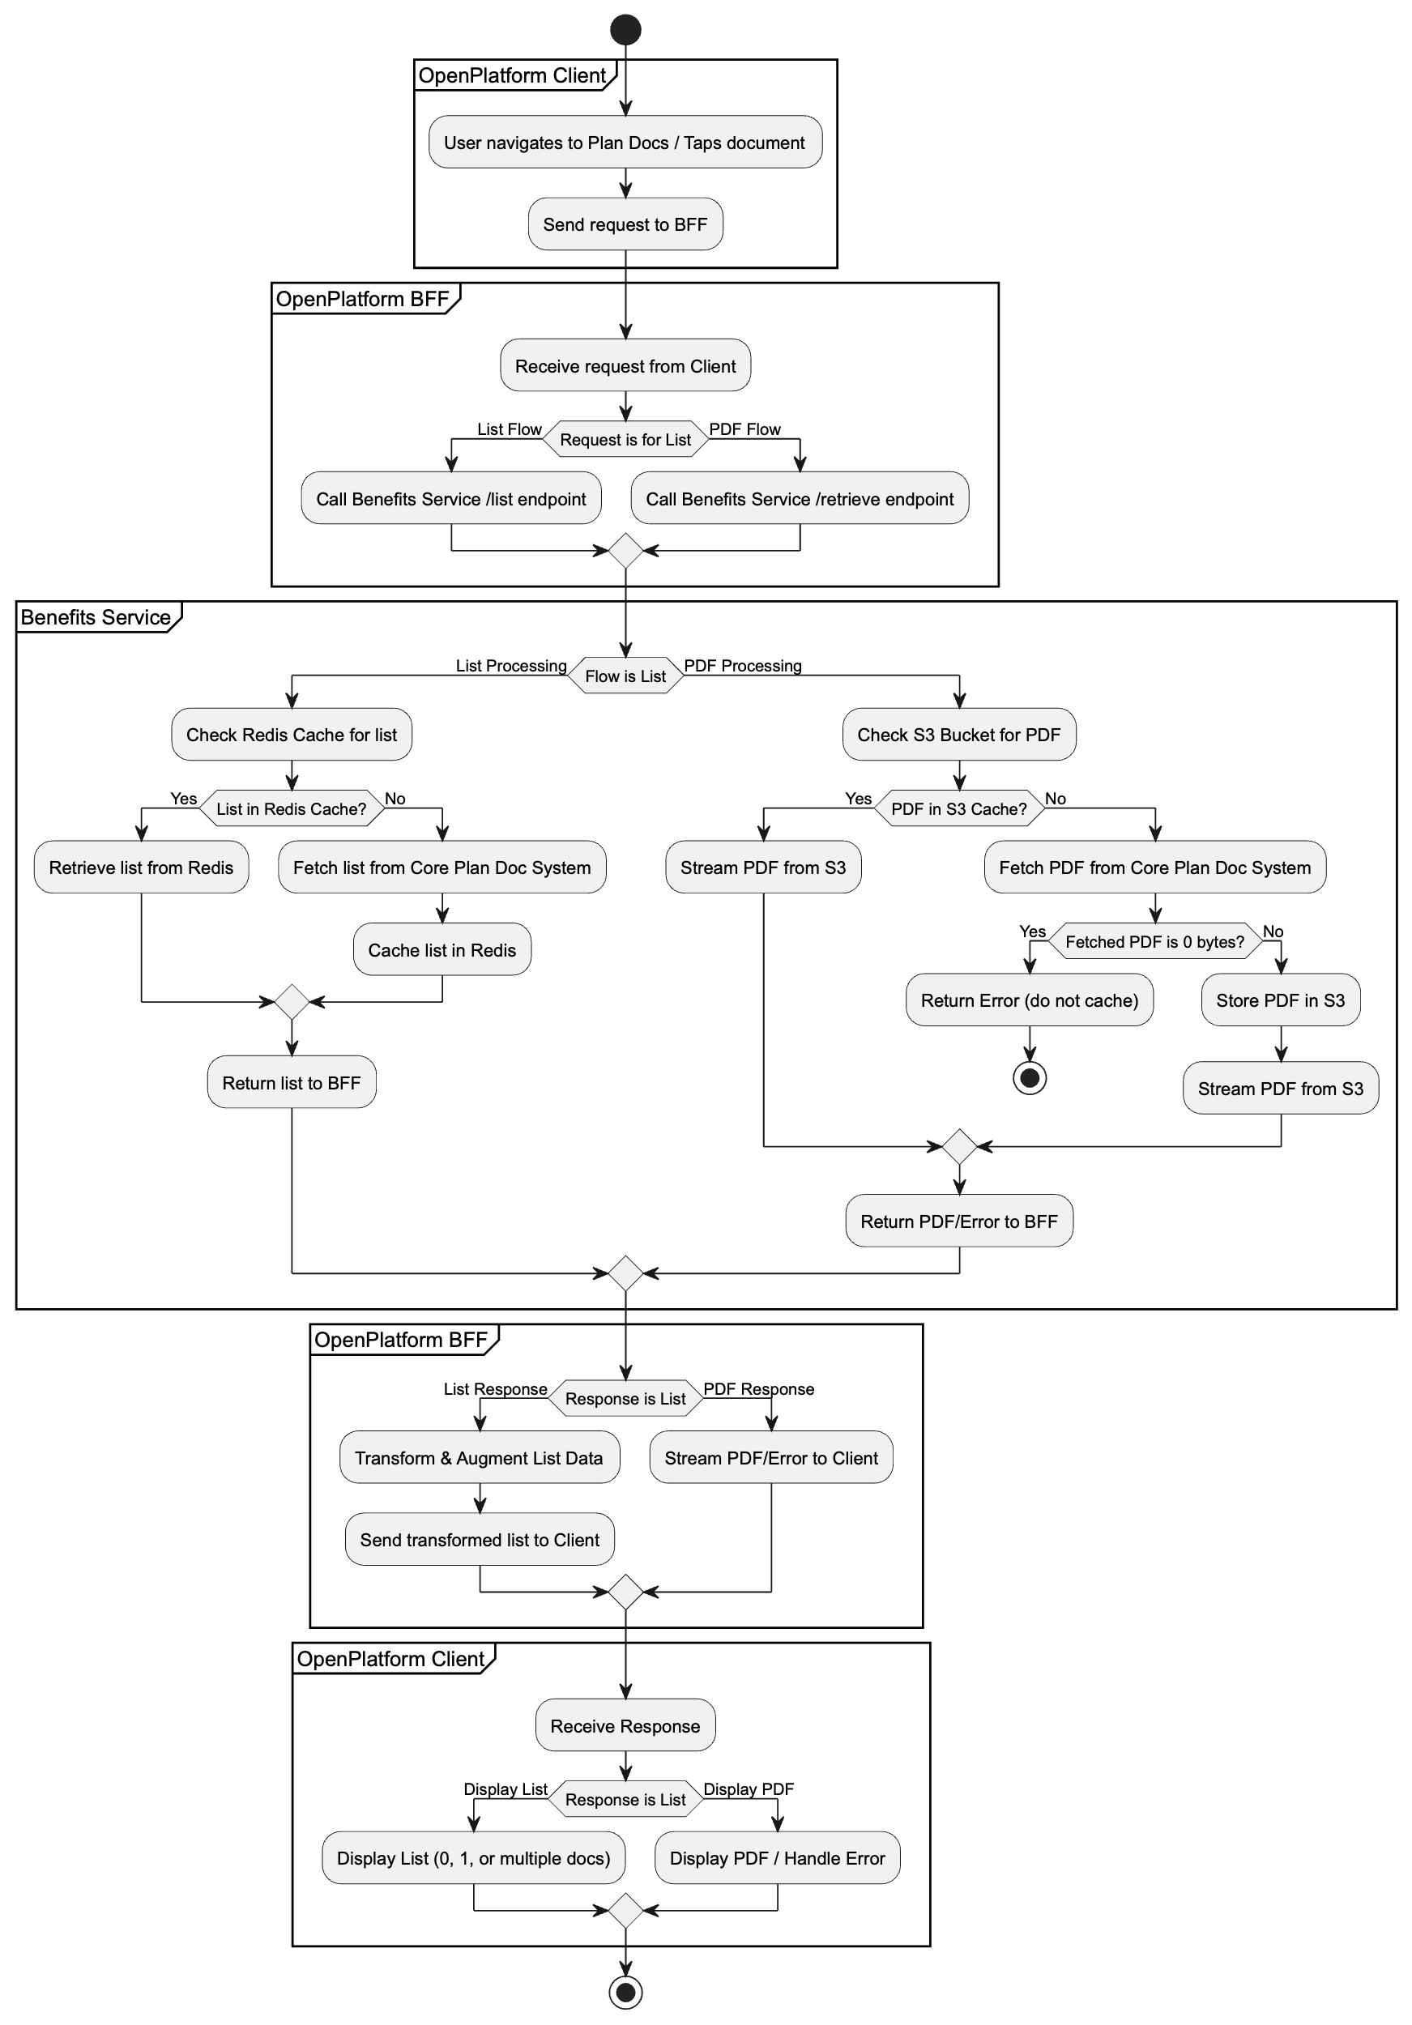

**Solution Specific Buildout**

Breakdown of the development versus existing components for Option 1:

**I. Components/Aspects to be Developed (New)**

These are the elements that are new or require significant modification/creation to support the "OpenPlatform - Plan Documents Access" feature.

1. **OpenPlatform BFF (Backend-for-Frontend):**
   * **New Service:** This is a completely new microservice specific to the OpenPlatform.
   * **New Endpoints:**
     + POST /v1/cvs/plan-documents/list: To retrieve the list of plan documents.
     + POST /v1/cvs/plan-documents/retrieve: To retrieve a specific PDF.
   * **Service Logic (within BFF):**
     + Receiving requests from the OpenPlatform client.
     + Calling the backend Benefits Service endpoints.
     + **Response Transformation:** Crucially, transforming the raw Benefits Service response into the OpenPlatform client's required format. This includes:
       - Creating the appropriate JSON structure (zero, single, multiple documents).
       - Appending language to the documentName.
       - Gracefully handling and *not showing* missing documentDescription or planName fields.
     + Streaming PDF content to the client.
   * **API Contract/Swagger:** A new OpenAPI (YAML) specification for the OpenPlatform BFF endpoints.
   * **Deployment:** Setting up the new microservice on the AWS platform with CI/CD pipelines.
   * **Observability:** Implementing specific logging, monitoring, and alerting for this new BFF.
2. **OpenPlatform Client-Side Logic:**
   * **Integration with new BFF endpoints:** The mobile/web clients need to be updated to call the new BFF endpoints instead of any previous direct calls.
   * **UI/UX Logic for document display:**
     + Handling "zero documents" scenario gracefully.
     + Directly opening PDF for "single document" scenario.
     + Displaying a list for "multiple documents" scenario.
     + Providing "Share" and "Print" UI options for PDFs.
     + Ensuring UI/UX consistency ("chrome") with other app document views.
     + Potentially implementing as a full page (not a sheet).
   * **Field Mapping:** Adapting the client to display the documentName and conditionally display documentDescription.
   * **Language Attribute:** Including logic to use language attributes for potential future filtering.
3. **Test Data Preparation:**
   * Creating specific test users and plan configurations (zero, single, multiple docs, multi-language, varying family coverages, HHL Not Signed scenarios) that might not already exist.

**II. Components/Aspects that Already Exist (Leveraged/Reused)**

These are existing components and functionalities that the new solution will integrate with or depend upon, requiring minimal to no modification from their current state.

1. **AWS Benefits Service (Existing):**
   * **Core Logic for List Retrieval:** The underlying logic for plan-document-list/retrieve including Redis cache checks (based on complex keys for Medicare/Commercial/IFP) and calls to core APIs.
   * **Core Logic for PDF Retrieval:** The underlying logic for plan-document/retrieve including S3 cache checks, fetching from core API on cache miss, storing in S3, and handling 0-byte PDFs.
   * **Caching Mechanisms:**
     + **Redis:** The existing Redis cache used by the Benefits Service for plan document lists (metadata) with its 1-hour TTL.
     + **AWS S3:** The existing S3 buckets used by the Benefits Service for caching PDF documents.
   * **Existing Rate Limits:** The established rate limits for the Benefits Service API endpoints (950/min for list, 2333/min for PDF).
   * **Resilience & Error Handling:** The existing Benefits Service's mechanisms for returning standard HTTP error codes and handling specific HHL Not Signed reason codes.
2. **Core Plan Doc API (Existing):**
   * This remains the ultimate "source of truth" for plan documents. The Benefits Service will continue to interact with it as it currently does.
3. **AWS Infrastructure (Existing):**
   * **AWS APIc (API Gateway):** The existing AWS API Gateway that the Benefits Service is exposed through. The OpenPlatform BFF will communicate *through* this.
   * **General AWS platform:** Leveraging existing AWS services (Lambda, S3, Redis, etc.) as the underlying infrastructure.
4. **Security Review Framework:**
   * The *process* of conducting a security review and validating mechanisms (authentication/authorization, encryption, access controls) is existing, though the review itself will be new for the BFF.
5. **Deployment Tools/Practices:**
   * Existing CI/CD pipelines and infrastructure-as-code practices for deploying microservices on AWS.
6. **Rollback Plan Framework:**
   * Existing automated deployment tools and the concept of stateless BFFs for quick rollbacks.

The primary development effort is focused on the new OpenPlatform BFF and the corresponding client-side updates to integrate with it. The existing Benefits Service and its underlying data stores (Redis, S3, Core API) are leveraged as-is, with the BFF acting as an intelligent proxy and a critical transformation layer.

**Solution Sketch**

The high-level flow involves the OpenPlatform client communicating with a new OpenPlatform BFF. This BFF will act as a proxy to the existing AWS-based backend infrastructure.

* **List Retrieval**: The client calls a new endpoint on the OpenPlatform BFF. The BFF calls the existing Benefits Service /plan-document-list/retrieve endpoint, which checks its cache or calls core APIs to get the document list. The response is returned to the BFF, which may augment it before sending it to the client.
* **PDF Retrieval**: The client requests a specific document via the BFF. The BFF calls the Benefits Service /plan-document/retrieve endpoint. This service first attempts to get the PDF from an S3 bucket. If it's a cache miss, the service retrieves the document from the core API, stores it in S3 for subsequent requests, and returns it.

**Orchestration Diagram (Conceptual)**

(For IA work/EDB Service Updates Only) This work involves creating a new BFF but leverages existing EDB service updates. The orchestration will be:

OpenPlatform -> OpenPlatform BFF OpenPlatform BFF -> AWS APIc -> Benefits Service Benefits Service -> Redis Cache (for list) Benefits Service -> S3 Bucket (for PDF) Benefits Service -> Core Plan Doc API (on cache miss)

**APIs/Swagger**

A new API contract will be defined for the OpenPlatform BFF based on the specific needs of the OpenPlatform.

**New OpenPlatform BFF Endpoints**

* **Get Document List**: POST /v1/cvs/plan-documents/list
  + **Description**: Retrieves the list of plan documents for the user.
  + **Request Body**: The client will send profile and plan identifiers.

JSON

|  |
| --- |
| { |
| "data": { |
| "id": "299814797", |
| "idType": "AETNA_IM_PROFILE_ID_TYPE", |
| "planId": "751133+BA+2" |
| } |
| } |

* + **Response Body**: The response is a JSON object containing a data array of documents, tailored for the OpenPlatform.
    - **Zero Documents Example**:

JSON

|  |
| --- |
| { |
| "data":[] |
| } |

* + - **Single Document Example**:

JSON

|  |
| --- |
| { |
| "data":[{ |
| "planId" : "751133+BA+2", |
| "documentName":"Plan Document (Spanish)" , |
| "documentId":"70023~13910995", |
| "documentUrl" :"/v1/cvs/plan-documents/retrieve" |
| }] |
| } |

* + - **Multiple Documents Example**:

JSON

|  |
| --- |
| { |
| "data":[{ |
| "planId" : "751133+BA+2", |
| "documentName":"Plan Document" , |
| "documentId":"70023~13910995", |
| "documentUrl" :"/v1/cvs/plan-documents/retrieve" |
| }, { |
| "planId" : "751133+BA+2", |
| "documentName":"Plan Document (Spanish)" , |
| "documentId":"70023~13910996", |
| "documentUrl" :"/v1/cvs/plan-documents/retrieve" |
| }] |
| } |

* **Get Document PDF**: POST /v1/cvs/plan-documents/retrieve
  + **Description**: Retrieves a specific plan document PDF. All documents are expected to be PDFs.
  + **Request Body**:

JSON

|  |
| --- |
| { |
| "documentId": "70023~13910995" |
| } |

* + **Response**: The raw PDF file (application/pdf).

**OpenAPI (YAML) Specification**

YAML

|  |
| --- |
| openapi: 3.0.3 |
| info: |
| title: OpenPlatform - Plan Documents BFF |
| description: Provides plan document list and PDF retrieval for the CVS SuperApp. |
| version: 1.0.0 |
| paths: |
| /v1/cvs/plan-documents/list: |
| post: |
| summary: Retrieves the list of plan documents for a user. |
| requestBody: |
| required: true |
| content: |
| application/json: |
| schema: |
| $ref: '#/components/schemas/PlanDocListRequest' |
| responses: |
| '200': |
| description: Successful retrieval of document list. |
| content: |
| application/json: |
| schema: |
| $ref: '#/components/schemas/PlanDocListResponse' |
| '400': |
| description: Bad request |
| content: |
| application/json: |
| schema: |
| $ref: '#/components/schemas/Error' |
| '500': |
| description: Internal Server Error |
| content: |
| application/json: |
| schema: |
| $ref: '#/components/schemas/Error' |
| /v1/cvs/plan-documents/retrieve: |
| post: |
| summary: Retrieves a specific plan document PDF. |
| requestBody: |
| required: true |
| content: |
| application/json: |
| schema: |
| $ref: '#/components/schemas/PlanDocRetrieveRequest' |
| responses: |
| '200': |
| description: Success - PDF file returned. |
| content: |
| application/pdf: |
| schema: |
| type: string |
| format: binary |
| '400': |
| description: Bad request |
| content: |
| application/json: |
| schema: |
| $ref: '#/components/schemas/Error' |
| '500': |
| description: Internal Server Error |
| content: |
| application/json: |
| schema: |
| $ref: '#/components/schemas/Error' |
| components: |
| schemas: |
| PlanDocListRequest: |
| type: object |
| properties: |
| data: |
| type: object |
| required: |
| - id |
| - idType |
| - planId |
| properties: |
| id: |
| type: string |
| example: '299814797' |
| idType: |
| type: string |
| example: 'AETNA_IM_PROFILE_ID_TYPE' |
| planId: |
| type: string |
| description: 'In Aetna this field is called policy id' |
| example: '751133+BA+2' |
| PlanDocListResponse: |
| type: object |
| properties: |
| data: |
| type: array |
| items: |
| $ref: '#/components/schemas/DocumentMetadata' |
| DocumentMetadata: |
| type: object |
| properties: |
| planId: |
| type: string |
| example: '751133+BA+2' |
| documentName: |
| type: string |
| example: 'Plan Document (Spanish)' |
| documentId: |
| type: string |
| example: '70023~13910995' |
| documentUrl: |
| type: string |
| description: 'Nice to have' |
| example: '/v1/cvs/plan-documents/retrieve' |
| PlanDocRetrieveRequest: |
| type: object |
| required: |
| - documentId |
| properties: |
| documentId: |
| type: string |
| description: 'Corresponds to communicationContentResourceId in the backend' |
| example: '70023~13910995' |
| Error: |
| type: object |
| properties: |
| httpCode: |
| type: string |
| example: '400' |
| httpMessage: |
| type: string |
| example: 'Bad Request' |
| moreInformation: |
| type: string |
| example: 'planId is a required field.' |

**NFR (Non-Functional Requirements)**

* **Performance**: The solution must not degrade app performance. Caching at the Benefits Service (TTL 1 hour) and S3 layer will be leveraged to ensure fast responses.
* **Rate Limiting**: Existing rate limits for the backend services will be used. The Plan Doc List endpoint is 950/min, and the PDF endpoint is 2333/min. These will be monitored for the new OpenPlatform traffic.
* **Future-proofing**: The architecture must not prevent the future implementation of search functionality.
* **Scalability**: The chosen architecture (Option 1) reuses existing, scalable AWS services (API Gateway, Lambda, S3, Redis), ensuring that the solution can handle anticipated growth in OpenPlatform user traffic.
* **Observability**: Comprehensive logging, monitoring, and alerting will be implemented for the new OpenPlatform BFF, providing visibility into its performance, errors, and traffic patterns. This will include integration with existing APM (Application Performance Monitoring) tools.

**Services**

**Service Logic**

* **OpenPlatform BFF**:
  + Receives a request from the OpenPlatform client for the document list.
  + Calls the backend Benefits Service's /plan-document-list/retrieve endpoint.
  + Receives the document list from the backend.
  + Transforms the backend response into the format required by the OpenPlatform client, as defined in the API section. This includes:
    - Creating the appropriate JSON structure for the zero, single, or multiple document scenarios.
    - Appending the language to the document name for display purposes (e.g., "Plan Document (Spanish)").
    - Ensuring that if a description is not available, the field is not shown.
* **Benefits Service (Existing)**:
  + **List**: Logic remains as-is. It checks a Redis cache based on a complex key (considering Medicare vs. Commercial, ANOC, etc.) before calling the core API. The cache has a TTL of one hour.
  + **PDF**: Logic remains as-is. It checks an S3 bucket for the PDF. On a miss, it fetches from the core API, streams it to S3 for caching, and returns the document. It will also check the byte size of the file from core and return an error if it is 0 to avoid caching empty files.

**Server Stories (Backend)**

* **As an OpenPlatform BFF, I want to retrieve a list of plan documents for a given user profile and plan, so that I can provide it to the OpenPlatform client.**
  + **Acceptance Criteria:**
    - The BFF successfully calls the /plan-document-list/retrieve endpoint on the Benefits Service.
    - The BFF handles various response scenarios from the Benefits Service (e.g., success, no documents, errors).
    - The BFF correctly transforms the Benefits Service response into the OpenPlatform API contract format (e.g., documentName with language, documentUrl).
    - The BFF gracefully handles cases where documentDescription or planName are missing from the upstream response by not including them in the final payload to the client.
* **As an OpenPlatform BFF, I want to retrieve a specific plan document PDF by its documentId, so that I can deliver it to the OpenPlatform client.**
  + **Acceptance Criteria:**
    - The BFF successfully calls the /plan-document/retrieve endpoint on the Benefits Service with the provided documentId.
    - The BFF correctly streams the PDF content received from the Benefits Service to the OpenPlatform client.
    - The BFF handles error responses (e.g., 400, 500) from the Benefits Service and propagates appropriate error codes to the client.
* **As the Benefits Service, I want to use Redis as a cache for plan document lists, so that I can reduce load on core APIs and improve response times.**
  + **Acceptance Criteria:**
    - The Benefits Service checks Redis for cached planDocListResponse based on a composite key (dateAsOf + policyResourceId + additional Medicare-specific identifiers).
    - If a cache hit occurs, the cached response is returned.
    - If a cache miss occurs, the core API is called, and the successful response is cached in Redis with a 1-hour TTL before being returned.
* **As the Benefits Service, I want to use S3 as a cache for plan document PDFs, so that I can reduce load on core APIs and improve response times.**
  + **Acceptance Criteria:**
    - The Benefits Service checks the configured S3 bucket for the requested PDF using communicationContentResourceId as the key.
    - If the PDF exists in S3, it is streamed directly to the BFF.
    - If the PDF is not in S3, it is retrieved from the core API, stored in S3 for future requests, and then streamed to the BFF.
    - The Benefits Service verifies the byte size of the retrieved PDF; if 0 bytes, it returns an error and does not cache the empty file.
* **As the Benefits Service, I want to ensure my APIs are resilient and return appropriate errors for various scenarios.**
  + **Acceptance Criteria:**
    - The /plan-document-list/retrieve and /plan-document/retrieve endpoints return standard HTTP error codes (e.g., 400, 403, 404, 500, 503, 504) with consistent error schemas.
    - The service correctly handles and propagates HHL Not Signed reason codes from upstream systems.

**Service Components**

* **New OpenPlatform BFF (Backend-for-Frontend)**: A new service specific to the OpenPlatform, responsible for handling client requests and communicating with the backend services.
* **AWS Benefits Service (Existing)**: The existing microservice that contains the business logic for fetching plan documents.
* **AWS S3 (Existing)**: Used for caching PDF documents to improve performance and resilience.
* **Redis (Existing)**: Used by the Benefits Service for caching the plan document list (metadata).
* **Core APIs (Existing)**: The source of truth for plan documents when they are not in cache.

**Client Changes**

**Client Side Logic**

The client will integrate with the new OpenPlatform BFF endpoints.

* When the user accesses the feature, the client will call the BFF to get the list of documents.
* Based on the number of documents in the response array (data.length):
  + If 0, the client must handle the "zero document" scenario gracefully.
  + If 1, the client should directly open the PDF view upon the user's initial tap.
  + If >1, the client will display a list of the available documents for the user to choose from.
* The client will need to provide UI options for viewing, sharing, and printing the selected PDF document.
* The UI/UX should follow the same design and behavior ("chrome") as other document views in the app.
* The feature may need to be implemented as a full page rather than a sheet for better usability.

**UX Stories (Frontend)**

* **As an OpenPlatform user, when I navigate to the Plan Documents section and there is only one plan document available, I want the PDF to open directly upon my initial tap, so I can quickly view it.**
  + **Acceptance Criteria:**
    - The client displays a "Plan Document" link/button.
    - Upon tapping, the PDF viewer opens immediately with the single document.
    - The PDF viewer chrome (design and behavior, e.g., share, print options) is consistent with other document views in the app.
* **As an OpenPlatform user, when I navigate to the Plan Documents section and there are multiple plan documents available, I want to see a list of documents with their names, so I can choose which one to view.**
  + **Acceptance Criteria:**
    - The client displays a list of documents.
    - Each item in the list shows the documentName (including language, e.g., "Plan Document (Spanish)").
    - If a documentDescription is provided by the API, it is displayed for the corresponding document.
    - If documentDescription is *not* provided by the API, the field is not displayed.
    - Tapping on a document in the list opens its PDF in the viewer.
    - The PDF viewer offers options such as share and print.
    - All displayed documents are PDFs.
* **As an OpenPlatform user, when I navigate to the Plan Documents section and there are no documents available, I want to see a clear message indicating that, so I understand the situation.**
  + **Acceptance Criteria:**
    - The client displays a user-friendly message indicating no plan documents are available.
    - The UI handles the "zero document" scenario gracefully, avoiding errors or blank screens.
* **As an OpenPlatform user, if I have documents in multiple languages, I want to see the language indicated (e.g., in parentheses) so I can easily identify the correct version.**
  + **Acceptance Criteria:**
    - The documentName displayed in the list includes the language in parentheses (e.g., "Plan Document (Spanish)").
    - The client includes attributes to allow for future filtering by language.
* **As an OpenPlatform user, I want the plan document viewing experience to be consistent in design and behavior, so I have a seamless user experience across the app.**
  + **Acceptance Criteria:**
    - The UI/UX for plan document access (e.g., buttons, layout, PDF viewer) adheres to the established OpenPlatform design guidelines ("chrome").
    - The feature may be implemented as a full page instead of a sheet for optimal usability.

**Field Mapping**

* The client will display the documentName from the API response for each document.
* A document description field will be displayed if it is present in the response; otherwise, it will be hidden.
* An attribute for language should be included to allow for filtering.
* The documentId will be sent back to the BFF to retrieve the specific PDF.

**Any differences between platforms**

The logic and documentation must be consistent across Aetna and CVS implementations, and by extension, across Web, iOS, and Android platforms.

**Scenarios**

* **Single Document**: User has exactly one plan document. Tapping the link opens the PDF directly.
* **Multiple Documents**: User has more than one document. A list is displayed showing the title and description (if available).
* **Zero Documents**: User has no documents available. The UI must handle this case clearly.
* **Missing Metadata**: A document is returned from the service without a description or planName. The UI should hide these fields gracefully.
* **Multi-language**: A user has documents in multiple languages. The list should display the language, and the user should be able to filter by it.

**Deployment Strategy (Brief)**

The new OpenPlatform BFF will be deployed as a microservice on the AWS platform, leveraging existing CI/CD pipelines and infrastructure-as-code practices. Deployments will be phased, starting with development and QA environments, followed by production.

**Rollback Plan (Brief)**

In the event of critical issues post-deployment, a rollback to the previous stable version of the OpenPlatform BFF will be initiated using automated deployment tools. The stateless nature of the BFF (with caching externalized) facilitates quicker rollbacks.

**Security Review**

A security review should be conducted, particularly as a new BFF is being introduced as an entry point into the AWS ecosystem. While the backend service patterns are being reused, the BFF's exposure, rate limiting, and authentication/authorization mechanisms need to be validated by the security team. This includes reviewing API security best practices, data encryption in transit and at rest, and access controls for the new BFF endpoints.

**Testing**

The solution should be tested to ensure all scenarios (zero, single, multiple documents) are handled correctly on the client and in the BFF. Testing should verify that missing metadata is handled gracefully and does not cause UI errors. End-to-end testing from the OpenPlatform client through the new BFF to the existing backend services is required. Performance testing is required to ensure the new BFF does not introduce significant latency and that the overall experience does not degrade performance.

**Detailed Testing Plan**

1. **Test Data Preparation:**
   * **User Profiles:** Create a diverse set of test users covering various scenarios:
     + **Zero Documents:** Users with no plan documents available.
     + **Single Document:** Users with exactly one plan document.
     + **Multiple Documents:** Users with several plan documents.
     + **Multi-language Users:** Users with documents available in different languages (e.g., English, Spanish).
     + **Users with Missing Metadata:** Users whose documents are known to have missing description or planName fields from the upstream service.
   * **Plan Types & Coverage:**
     + **Medical-only:** Users covered only under a medical plan.
     + **Dental-only:** Users covered only under a dental plan.
     + **Vision-only:** Users covered only under a vision plan.
     + **Combined Plans:** Users with combinations (e.g., Medical + Dental, Medical + Vision, Medical + Dental + Vision).
     + **Varying Family Coverages:** Create scenarios where different members under the same plan have varied coverages:
       - **Example 1:** Plan holder has Medical, Dental, and Vision. Dependent children only have Medical and Dental (no Vision).
       - **Example 2:** Plan holder has Medical. Spouse has Medical and Dental.
       - **Example 3:** Different enrollment dates or policy periods impacting document availability for various family members.
     + **HHL Not Signed Scenarios:** Test users associated with self-insured plans where the Hold Harmless Letter (HHL) has not been signed, ensuring the system returns an empty list with the appropriate reason code.
2. **Functional Testing:**
   * **End-to-End Flow:**
     + Verify the complete user journey from navigating to the Plan Documents section to viewing/downloading a PDF.
     + Confirm correct routing from the OpenPlatform client through the new BFF to the existing backend services.
   * **Scenario Validation:**
     + **Zero Documents:** Verify the UI clearly communicates that no documents are available.
     + **Single Document:** Confirm direct PDF opening behavior and proper PDF viewer display.
     + **Multiple Documents:** Validate accurate display of the document list, including names and descriptions (if present).
     + **Language Display:** Verify that language (e.g., "(Spanish)") is correctly appended to the document name in the list.
     + **Missing Metadata Handling:** Confirm that description and planName fields are gracefully hidden if not provided by the Benefits Service.
     + **PDF Actions:** Test "Share" and "Print" functionalities for PDF documents.
   * **Error Handling:**
     + Test various API error responses (e.g., 400 Bad Request, 403 Forbidden, 404 Not Found, 500 Internal Server Error, 503 Service Unavailable, 504 Timeout) from the Benefits Service and ensure the BFF translates and the client displays user-friendly messages.
     + Verify that 0-byte PDFs from core APIs are correctly handled (not cached, appropriate error returned).
3. **Performance Testing:**
   * **Latency Impact:** Measure response times for both list and PDF retrieval through the new BFF.
   * **Scalability:** Conduct load tests to ensure the BFF and backend services can handle anticipated OpenPlatform traffic volumes without degradation.
   * **Caching Effectiveness:** Monitor cache hit/miss ratios for Redis and S3 to confirm caching mechanisms are reducing load on core services as expected.
4. **Security Testing:**
   * Validate authentication and authorization mechanisms for the new BFF endpoints.
   * Conduct penetration testing to identify vulnerabilities.
   * Verify data encryption in transit (HTTPS) and at rest (for cached data in S3).

**Contacts and Impacted Teams/People**

* **CVS Contact**: Rohit Puri
* **Architecture**: Jenn Tang
* **Plan Doc Search**: Jesse Jackman
* **Product Management**: Darlene Scarola
* **AEI Team**: Wizards
* **Front-end Teams**: Wolf and Moonlight
* **Facets Contact**: Alan Chamberlain
* **Other Contacts**: Harshal Patel

**Diagrams To Place in Document If Needed**

