F167030 – RX - Release Payment Holds
The F167030 – RX Release Payment Holds capability introduces a production-ready architecture that enables member self-service release of PBM mail-order “Payment Hold” directly from Aetna’s front-end portals. This solution leverages PBM Experience API (REST) calls and integrates seamlessly with CVS Caremark systems to deliver a frictionless experience for members while reducing operational overhead.

Purpose and Objective
The primary goal is to identify prescriptions currently on hold and eligible for self-service release, eliminating the need for manual escalation through EDS or SLP systems. This capability is part of the i90 architecture, which powers the CVS Prescription Details Page and related services. By enabling instant release, the solution accelerates revenue recognition, improves customer satisfaction, and reduces administrative costs.

Service Design & Flow
The architecture follows a structured flow:
- Eligibility Check – Determines if a payment hold exists (reason code 54).
- Consent Dialog – Presents the user with an approval interface to authorize the release.
- Resolve & Refresh – Posts to CVS, updates order status, purges cache, and logs audit trails.
- UX Behavior – Displays call-to-action only for eligible holds, with success notifications and robust error handling.

Scope & Integration
- In-Scope: Mail-order payments initiated via portal and PBM that carry reason code 54.
- Out-of-Scope: EBDS and SLP flows remain excluded.
- Integration Approach: No new endpoints are introduced; the service mirrors existing CVS processes for simplicity and reliability.

Sizing & Potential Impact
The solution targets high-value orders, which are often placed on hold for explicit approval. These scenarios typically arise when:
- Multiple payment attempts occur (e.g., IVR and portal).
- Orders involve significant total cost, requiring manual intervention. By automating this release process, the service unlocks substantial windfall potential by accelerating revenue recognition and preventing customer attrition.

Operational Benefit
Currently, releasing a payment hold demands manual escalation through EDS or SLP systems, consuming time and resources. The new service introduces instant capability, reducing administrative overhead and enhancing customer satisfaction through a frictionless experience.

Step 1 - Get Prescription List with Status
The first step in enabling this capability is retrieving the member’s prescription list along with their current status. This involves:
- Request Context: Querying CVS/Caremark (CMK) integration environment for all prescriptions tied to the member.
- Purpose: Identify prescriptions flagged as on hold and eligible for self-service release.
- Outcome: Provide the front-end with actionable data to display release options only for eligible prescriptions, ensuring accuracy and compliance.
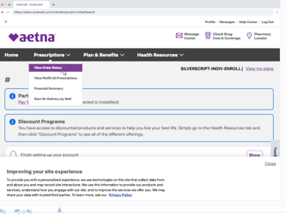

Request Prescription List w/On Hold Orders
In the CVS/Caremark (CMK) integration environment, managing prescriptions on hold efficiently is vital. Self-service hold release via the various FEs significantly improves l, especially when enabling self-service release mechanisms. This document provides a detailed guide on leveraging the CVS services to provide the same capability to Aetna products. This capability is currently available by escalation via EDS or SLP systems. The new service provides instant capability, reducing administrative overhead and improving customer experience.
Method: POST
Path: /v1/list-prescriptions
The API returns comprehensive prescription information essential for implementing the business rules and UI logic tailored to Aetna’s needs.
{
"lineOfBusinessName": "Commercial",
"planSponsorId": "0000000092504745",
"relationshipToSubscriber": "Self",
"memberId": "300013286700",
"startDate": "2025-10-20",
"endDate": "2025-10-20",
"rxStatusFilter": [
"Due for refill",
"Inactive"
],
"patientIdFilter": [
955203962
],
"refillTypeFilter": "ALL",
"prescribedByFilter": [
{
"firstName": "John",
"lastName": "Doe"
}
]
}
This payload filters for prescriptions that are currently on hold, which is the first step in identifying payment-related issues.

Example API Response for an Eligible Prescription on Hold
This response showcases a prescription that is on hold due to high total cost, with the appropriate subStatus for member action:
{
"data": {
"getLinkedMemberPatients": [
{
"linkedIDs": [
{
"lookupId": null,
"prescriptionforPatient": [
{
"drugInfo": {
"drug": {
"name": "MAOX 420MG TAB",
"formName": "TAB",
"formStrengthName": "420MG",
"gcnSequenceNumber": "4093",
"genericCodeNumber": "4093"
},
"drugProperties": {
"isControlledSubstances": false
}
},
"isHiddenByUser": false,
"prescribedName": "PBM_READY_FILL",
"fulfilledBy": "CVS Caremark",
"fills": [
{
"fillStatus": "On Hold",
"fillStatusCode": "14",
"rxStatus": {
"ruled": "onhold_rc14",
"parentStatus": "Not filled",
"status": "We need your help",
"subStatus": "Your order has a high total cost. We need you to approve the order before we can ship.",
"rxActivityDate": "Apr 08, 2025",
"rxActivityLabel": "Received "
},
"rxSubscriptions": [
{
"status": "ELIGIBLE",
"subStatus": "null",
"nextPickupDate": null
}
],
"memberType": "primary",
"patient": {
"relationshipToSubscriber": "Self",
"firstName": "AZALEE",
"lastName": "PECK",
"id": "955203962",
"phoneNumbers": [
{
"value": "0268588166"
}
]
}
}
]
}
],
"allRxStatuses": [
"Due for refill",
"Inactive",
"On the way",
"Scheduled"
],
"cta": {
"viewDetails": {
"text": "View Details"
},
"addToCart": {
"text": "Add to Cart"
},
"addedToCart": {
"text": "Added to Cart"
},
"removeFromCart": {
"text": "Remove from Cart"
},
"viewOrder": {
"text": "View Order"
},
"trackOrder": {
"text": "Track Order"
}
}
}
}
}

Filtering Prescriptions for Self-Service Release
Developers should apply filters to identify prescriptions on hold (fillStatus: "On Hold") that are eligible for self-service release, indicated by a specific subStatus message and the subscription status ELIGIBLE. The process involves parsing the rxStatus field to facilitate efficient prescription management and member satisfaction.

Understanding rxStatus Fields
The rxStatus field encapsulates the current state and required actions for prescriptions. Key values for ruled, status, and subStatus include:
- ruled: Indicates the specific hold reason, e.g., 'onhold_rc14' for high cost holds.
- status: Represents the overall state, like 'We need your help', signaling a requirement for member intervention.
- subStatus: Provides actionable guidance for the member, such as changing payment methods for high cost orders.
Integration and Logic Considerations
Custom UI logic may override or enhance the default rxStatus values to provide a more informative message to the member. For example, if a prescription is on hold due to a high total cost, the subStatus might explicitly state, "Your order has a high total cost. We need you to approve the order before we can ship.", guiding the member through necessary actions.

Assumptions
- Appropriate permissions and access for API interactions are inherent.
Conclusion
By understanding and utilizing the rxStatus fields effectively, and filtering prescriptions based on their eligibility for self-service release, developers can significantly enhance the member experience. This approach ensures timely resolutions of prescription holds, improving satisfaction and streamlining prescription fulfillment processes within Aetna's digital platforms.

Key Fields That Indicate Self-Service Release Eligibility
To determine whether a prescription is eligible for self-service release due to a payment hold, you must inspect the following fields:
Field | Expected Value | Meaning
fillStatusCode | "14" | Indicates the prescription is on hold, typically due to payment issues.
rxStatus.ruleId | "onhold_rc14" | Internal rule identifier confirming the hold is payment-related.
rxSubscriptions[].status | "ELIGIBLE" | Confirms the prescription is eligible for self-service actions.
rxStatus.status | "We need your help" | User-facing message indicating action is needed.
rxStatus.subStatus | "Please call the Customer Care number..." | Further guidance to the member.
These fields together confirm that the prescription is:
- Held due to a payment issue.
- Eligible for release via the portal.
- Actionable by the member without manual intervention.

Additional Considerations
Scope & Goals (PBM-Only, REST-Only)
- Goal: Allow a member to clear a PBM mail-order RX payment hold when eligible.
1.1. Detect eligibility via Experience API (REST)
1.2. Submit payment + consent via Experience API (REST).
1.3. Resolve the payment hold via Experience API (REST)
1.4. Refresh the order, purge cache, and audit.
Constraint: No new PBM endpoints. Use only existing Experience API routes.
2) Actors & Components
- Member (Portal Web/Mobile) — the end user.
- Aetna Portal — UI; calls Experience API; manages cache & audit locally.
- PBM Experience API (REST) — CVS Caremark APIs.
- Aetna Transient Cache — short-TTL RX/order cache (to be purged after action).
- Aetna Audit Store — append-only log of member actions and results.
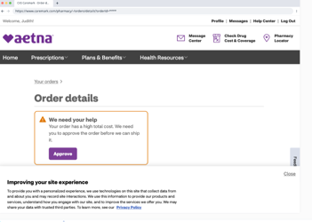

Step 2 - Consent to Payment (release hold)
- Member confirms/enters a payment instrument and provides consent (Y/N):
Method: POST
Path: /v1/list-prescriptions
Body:
{
"orderId": "ORD-10001",
"rx": [
{
"rxNumber": "1234567",
"consentResponse": "Y"
}
],
"paymentInstrument": {
"token": "pm_..."
},
"memberId": "M-12345",
"traceId": "<traceId>"
}

API Response
{
"status": "accepted",
"consentReference": "CONS-9f2c3"
}

Failure at Consent Layer
No Aetna screen available - CVS Example
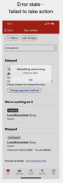

Step 3 - Resolve Payment Hold (authoritative action)
Step 3 — Resolve the payment hold (authoritative action)
Portal calls:
Method: POST
Endpoint: /experience/orders/{orderId}/resolve-payment-hold
{
"rx": [
{
"rxNumber": "1234567"
}
],
"memberId": "M-12345",
"consentReference": "CONS-9f2c3",
"traceId": "<traceId>"
}
API responds with
{
"result": "released",
"auditId": "AUD-20251010-001"
}
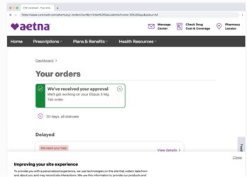
Step 4 — Hygiene & confirmation
- Portal purges the transient RX/order cache.
- Portal writes an audit entry with actor, IDs, traceId, and the provider-returned auditId.
- Portal calls GET /experience/orders/{orderId} and confirms the hold is gone.
- UI shows success: “Payment hold released. Your order will continue processing.”
- On any error, UI shows provider message and enables retry.
Error Handling & Edge Cases
- Eligibility false/changed: Don’t show CTA; re-check on page refresh or after order changes.
- Consent rejected: Show provider message; allow retry. Log an audit entry with status.
- Resolve failed: Persist failure audit; present readable message & retry.
- Idempotency: Replays with same Idempotency-Key must not double-apply actions.
- Multiple RX: Support array of rxNumber; only release the RX the member authorized.
Non-Functional Requirements
- Transport: REST only (Experience API).
- Availability: Portal remains usable (read-only) when actions are unavailable.
- Latency targets: p95 GET ≤ 300 ms; p95 POST ≤ 600 ms.
- Security: payment instruments are tokenized; minimum identifiers in payloads.
- Observability: X-Trace-Id propagated; dashboards for success/error rates, retry counts, and time-to-release.
- Compliance: Append-only audit for every attempt (success or failure).
- Rate limiting: Client-side throttles to avoid accidental hammering on repeated retries.
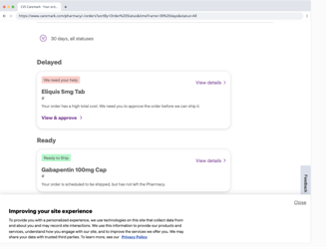

CVS Experience

CVS
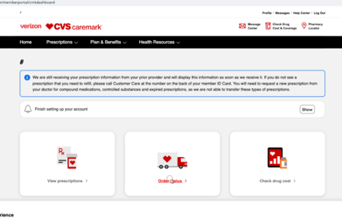

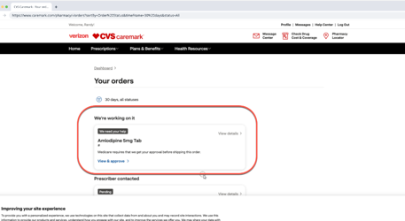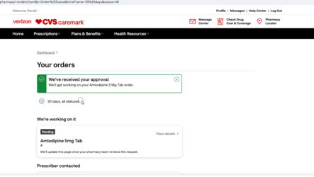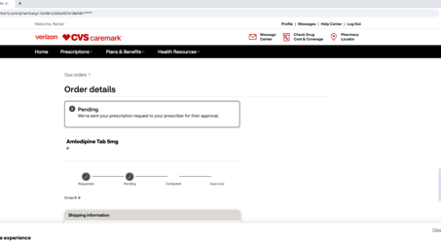

Attachments
Origin | Contents | Link
In Catalog | Prescription Status Codes/Descriptions | https://aetnao365-my.sharepoint.com/:x:/g/personal/hahns_aetna_com/EQa7Uh9FnrZHmI3W2NQAOPYBzo8LjAN_VhDngcpGK8DSRg?CID=671b1188-b946-55c5-b1ce-9577cd3bdfde
From YAML | /list-prescriptions API | https://apiforge.cvshealth.com/apis/editor/Microservices/i90_list-prescriptions/0.0.5
FROM YAML | /orders/shipconsent API | https://apiforge.cvshealth.com/apis/editor/Microservices/i90_shipconsent/1.0.0
MOCKUP | /orders/resolve-payment-hold - MOCKUP | https://apiforge.cvshealth.com/apis/editor/Microservices/i90_resolve-payment-hold/1.0.0
CVS | CMK Self-Service Holds Figma | https://www.figma.com/design/47dnUs2oMH7EbtZAI9o5RC/CMK-Self-Serve-Holds?node-id=10450-75777&p=f&t=FMHY0cnXjya4fWfR-0

