Solutions Architecture Document: Retail-to-Mail Prescription Transfer

1. Executive Summary
The Retail-to-Mail Prescription Transfer initiative enables Aetna members to transfer eligible prescriptions from retail to CVS Mail Order through a fully digital flow. The chosen architecture leverages CVS Caremark’s new Retail-to-Mail API set, ensuring minimal provider involvement and significantly improving success rates compared to the traditional FastStart flow.

Chosen Solution
The implemented solution integrates Aetna’s application front end and domain services with AWS-managed platform capabilities (feature toggles, observability) and CVS Caremark APIs (Eligibility, External Transfer, RxConnect). The system first checks eligibility and then performs the transfer automatically if allowed. If a prescription is not eligible, it reverts to a provider approval (FastStart) path.

Enhanced Eligibility Rules
- Prescription is not a controlled substance.
- Prescription has at least 90 days’ supply remaining.
- Prescription is not currently on hold for purchase.
- Prescription is not a specialty pharmacy medication.
- Prescription is refillable, active, and not restricted by plan.

2. Problem Statement & Business Need
The existing “New Mail Order Request” process allows members to request a mail-order prescription, triggering a provider reauthorization (FastStart). This approach succeeds in only about 60% of cases due to provider delays, manual steps, and miscommunication. As a result, members experience frustration and long wait times, generating over 240,000 annual support calls.
The Retail-to-Mail solution replaces this process with a direct digital transfer between Aetna and CVS Caremark, allowing eligible prescriptions to move from retail to mail order instantly without provider intervention.

Goals
- Digitize prescription transfers and eliminate provider friction.
- Reduce call volume by at least 30%.
- Improve OSAT/CSAT metrics by 15%.
- Provide Medicare-compliant, multi-platform coverage (Web, iOS, Android).

Scope & Dependencies
- In Scope: All LOBs, all platforms, English/Spanish localization, Medicare compliance, UI redesign.
- Out of Scope: CVS-to-non-CVS transfers.
- Dependencies: CVS API readiness, Adobe tagging, Figma UX finalization.

3. Logical Architecture
The architecture consists of three tiers — Aetna Experience Layer, AWS Platform Services, and CVS Caremark APIs.
Aetna Layer: Frontend and BFF services handle eligibility and transfer orchestration.
AWS Layer: Provides feature toggling, telemetry, and analytics integration.
CVS Layer: Exposes GraphQL and REST APIs for eligibility, transfer, and inactivation.

4. Key Eligibility Criteria
Eligibility is determined by CVS's Eligibility API using the following checks. These conditions ensure compliance and operational accuracy before a prescription can be transferred:
- Prescription is not a controlled substance.
- Prescription has at least 90 days’ supply remaining.
- Prescription is not currently on hold for purchase.
- Prescription is not a specialty pharmacy medication.
- Prescription is refillable, active, and not restricted by plan.

5. End-to-End Flow
The system follows a two-path logic: an automatic transfer for eligible prescriptions and a FastStart fallback for ineligible cases.
The diagrams below outline the high-level sequence and component interactions.
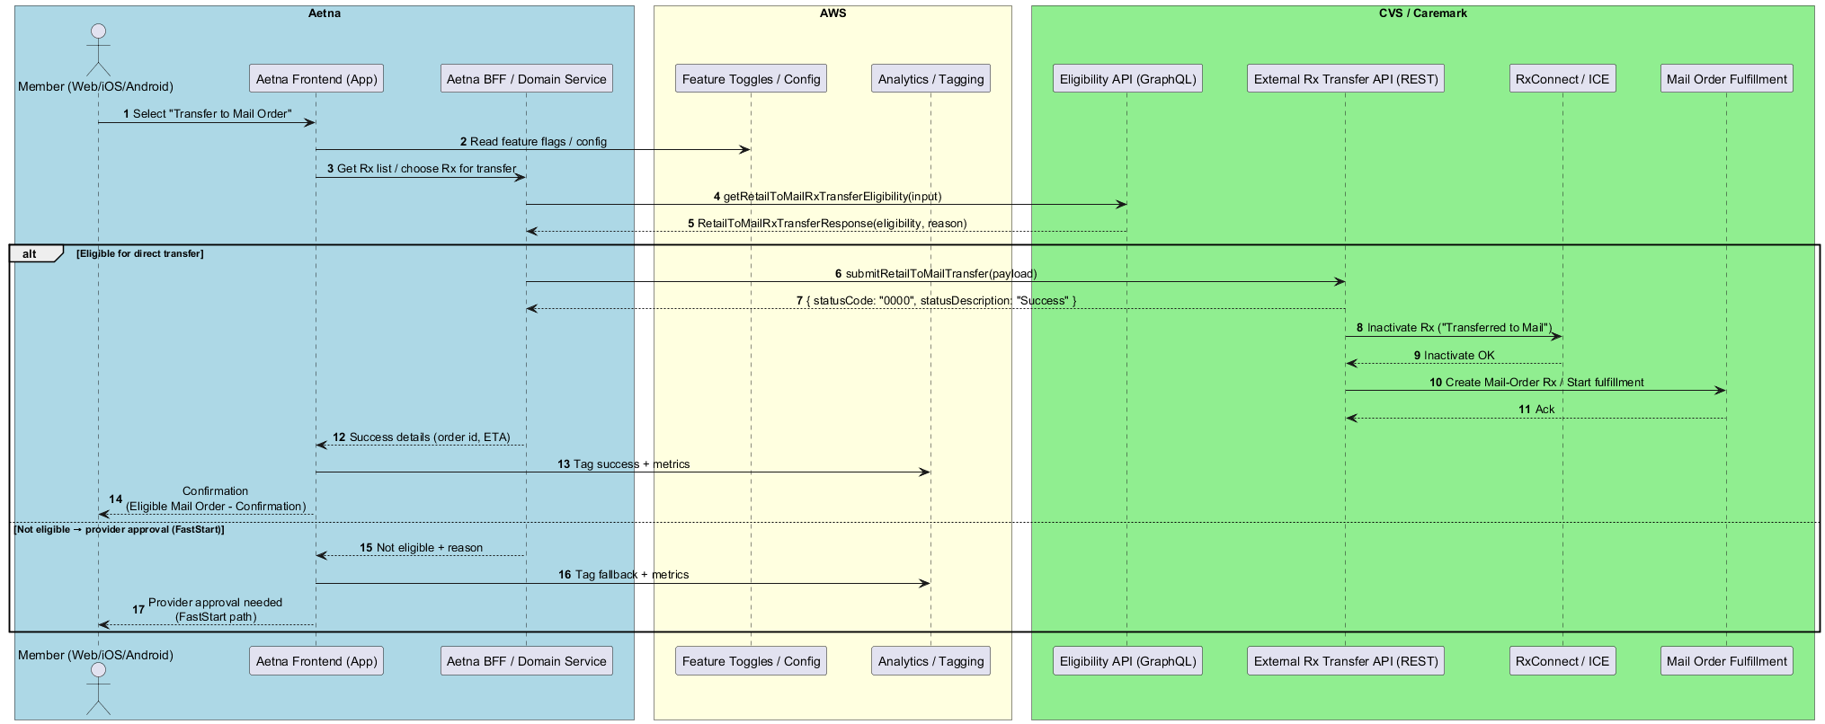
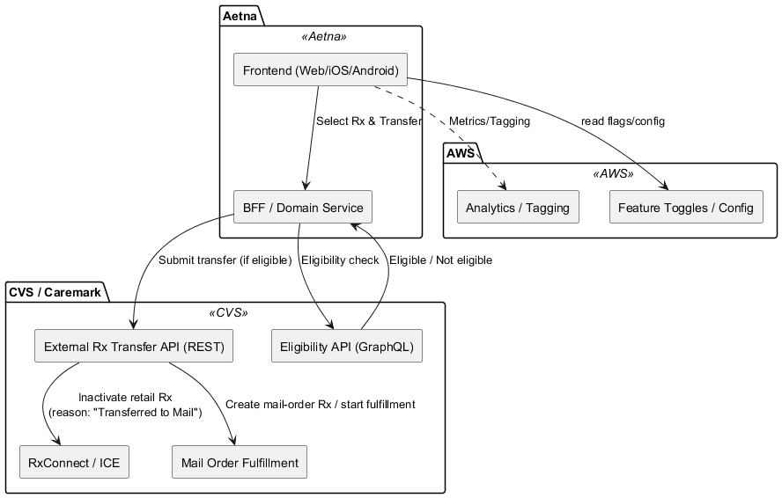

6. Non-Functional Requirements
Category | Requirement
Security | TLS 1.2+, mTLS between Aetna and CVS; PHI redaction in logs.
Performance | Eligibility <600ms, Transfer <1.5s end-to-end.
Availability | 99.9% uptime with AWS failover and feature flag control.
Localization | Support for English and Spanish.
Accessibility | WCAG 2.1 AA compliance.
Observability | Adobe + CloudWatch integration with trace correlation.

7. Traceability Matrix
ID | Requirement | Source | Implementation Component
RQ-01 | Enable Retail-to-Mail digital transfer | Problem Statement | Aetna FE, BFF, CVS APIs
RQ-02 | Not a controlled substance | Key Eligibility Checks | CVS Eligibility API
RQ-03 | ≥90 days remaining | Key Eligibility Checks | CVS Eligibility API
RQ-04 | Not on hold | Key Eligibility Checks | CVS Eligibility API
RQ-05 | Not a specialty drug | Key Eligibility Checks | CVS Eligibility API
RQ-06 | Provider approval fallback | Flow Narrative | Aetna FE/BFF
RQ-07 | Analytics for all outcomes | Success Metrics | AWS + Adobe
RQ-08 | Secure communication | NFRs | TLS/mTLS via Aetna Gateway

Appendix: Design/Flow

FLOW-1: Dashboard or Menu Flow
1.1 Prescription Dashboard
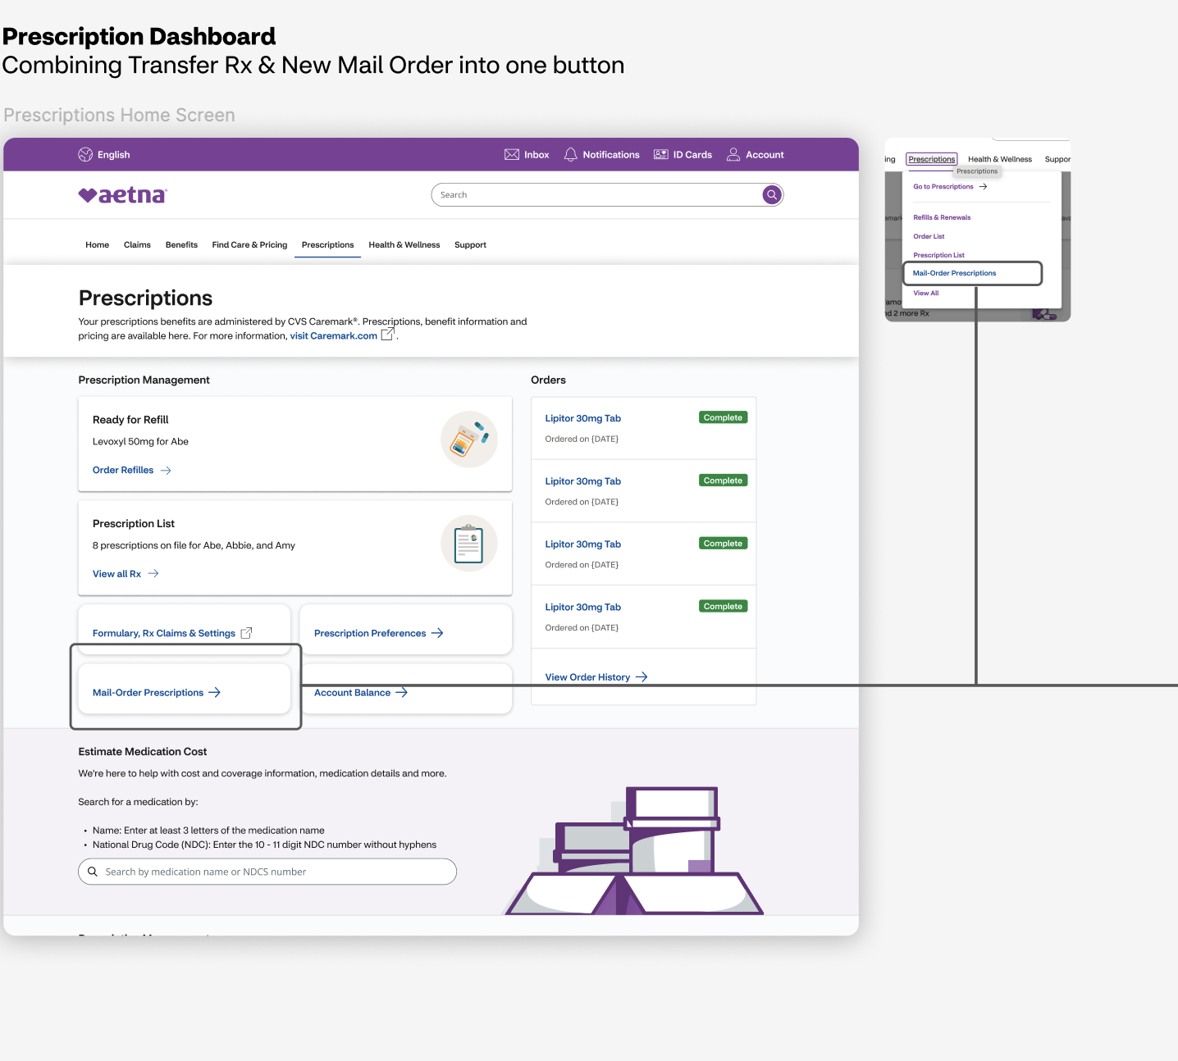
1.2. Mail Order Prescription Selection accessed from “Prescriptions” top level menu
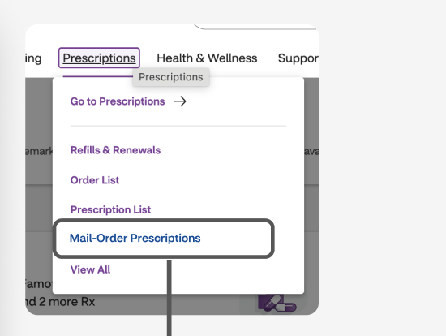

FLOW-2: Select or Request New Prescription Flow
2. New Mail Order Selection Page (whether accessed through 1.0 button or 1.a menu item)
2.a. New Mail Order Selection Page – Prescriptions ready to transfer but nothing selected yet
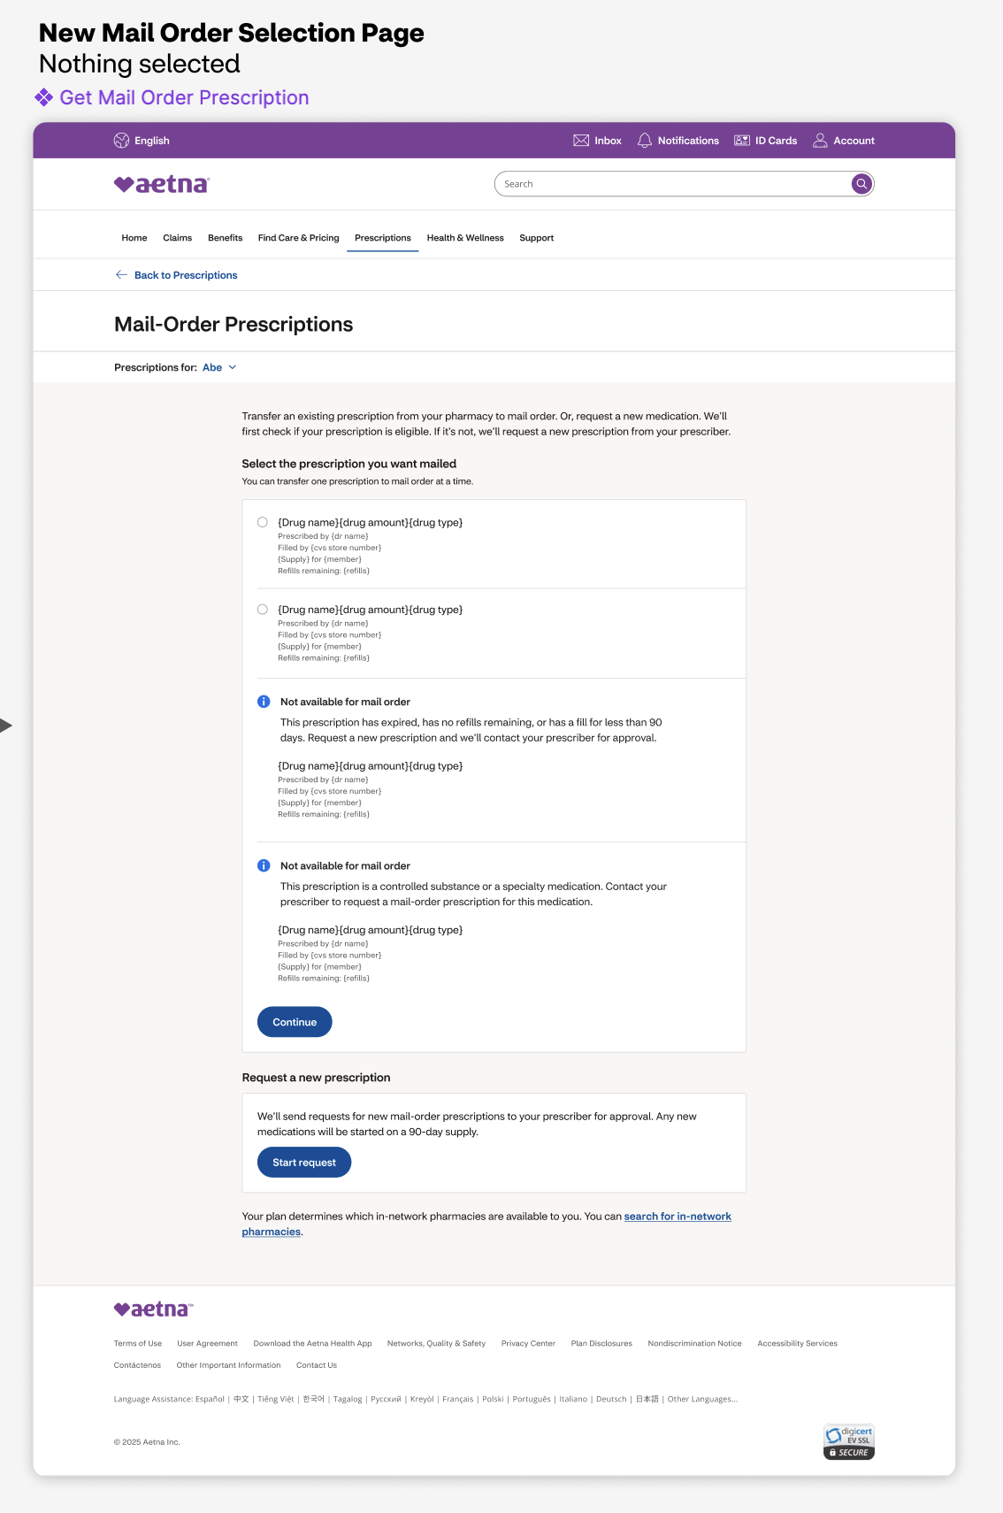
2.1.1. Connector: Select Existing Prescription. New Mail Order Selection Page. Existing prescription selected
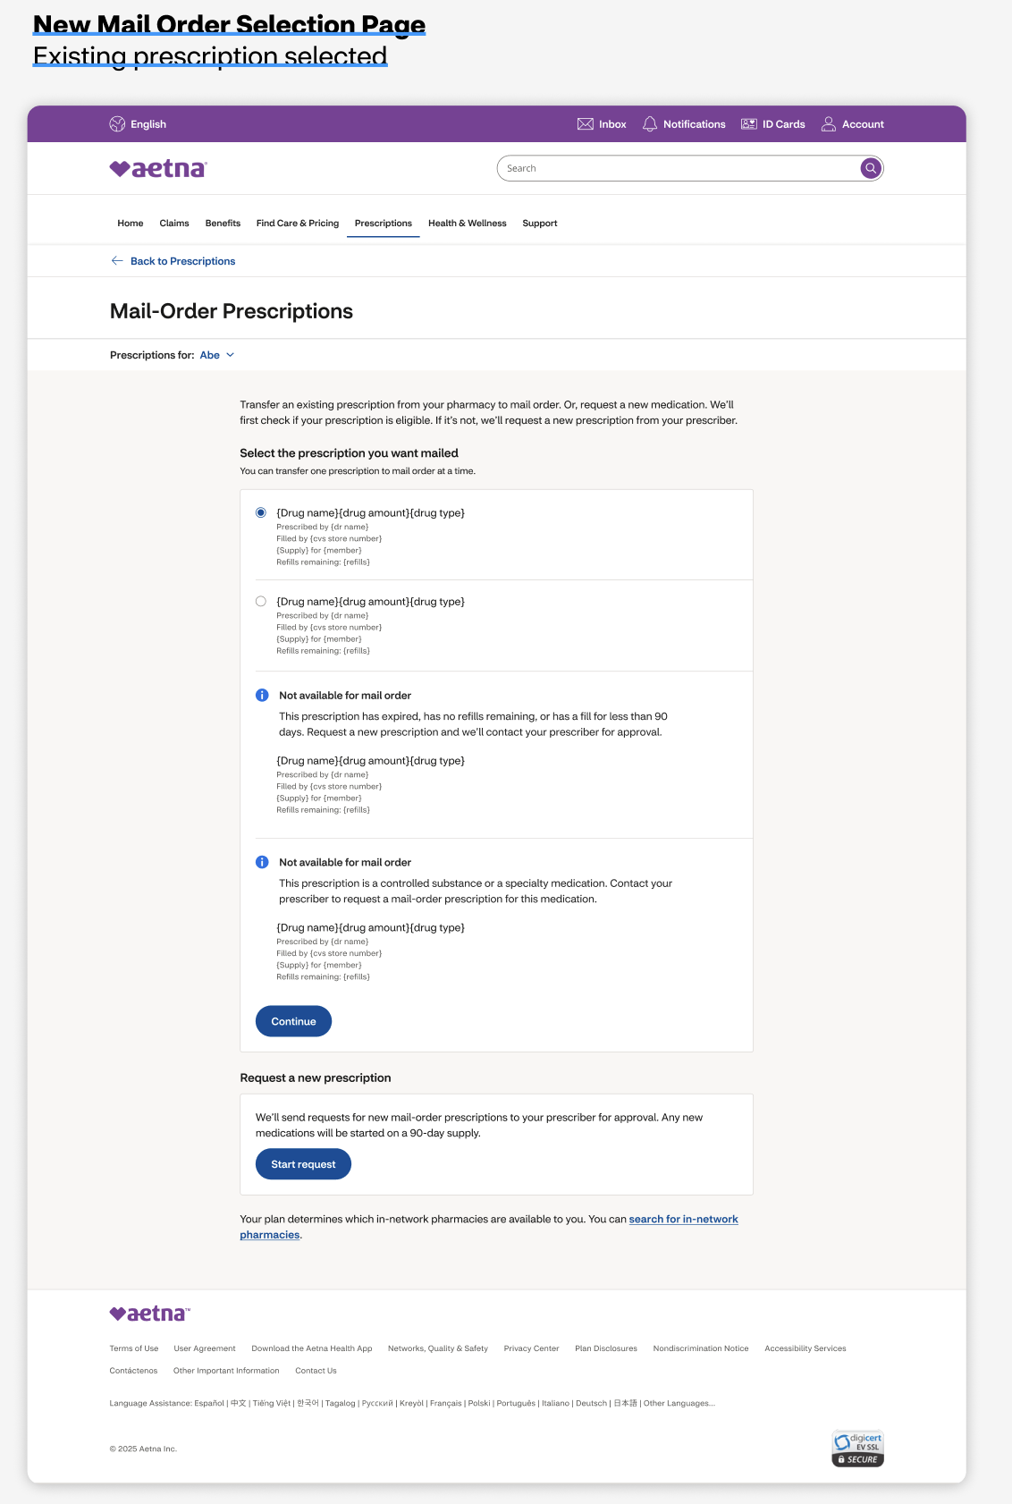

2.2. [Connector: none] New Mail Order Selection Page. No existing prescriptions. (gives option to add a medication)
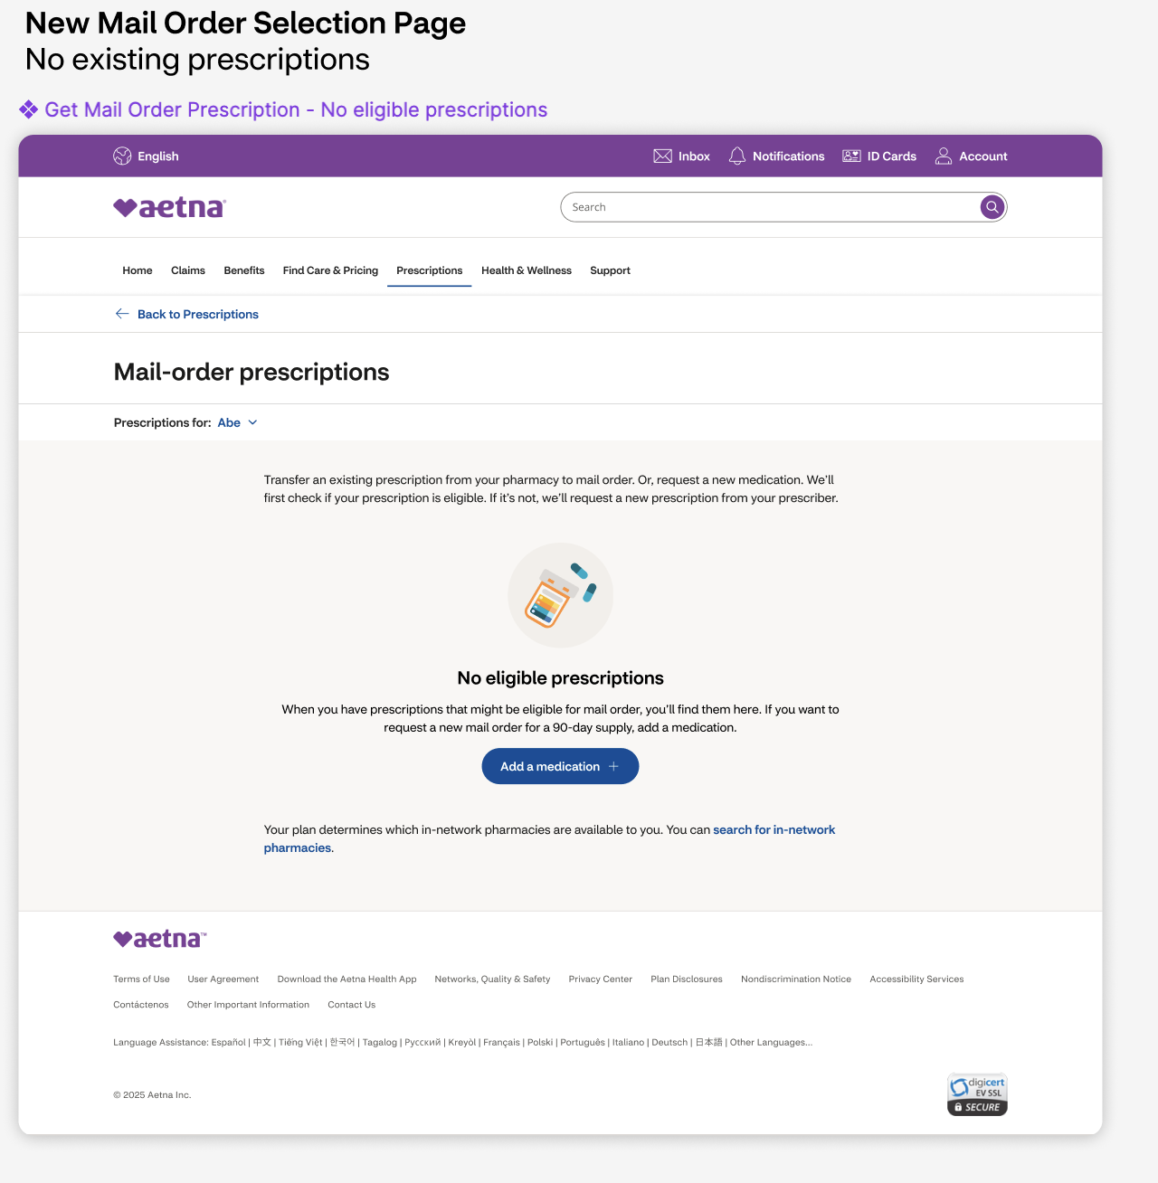

FLOW-3: Add New Prescription Flow (either from select existing or no existing pages)
3. [Connector: none] Add New Prescription Flow (new functionality alert & link if member requests medication they already have)
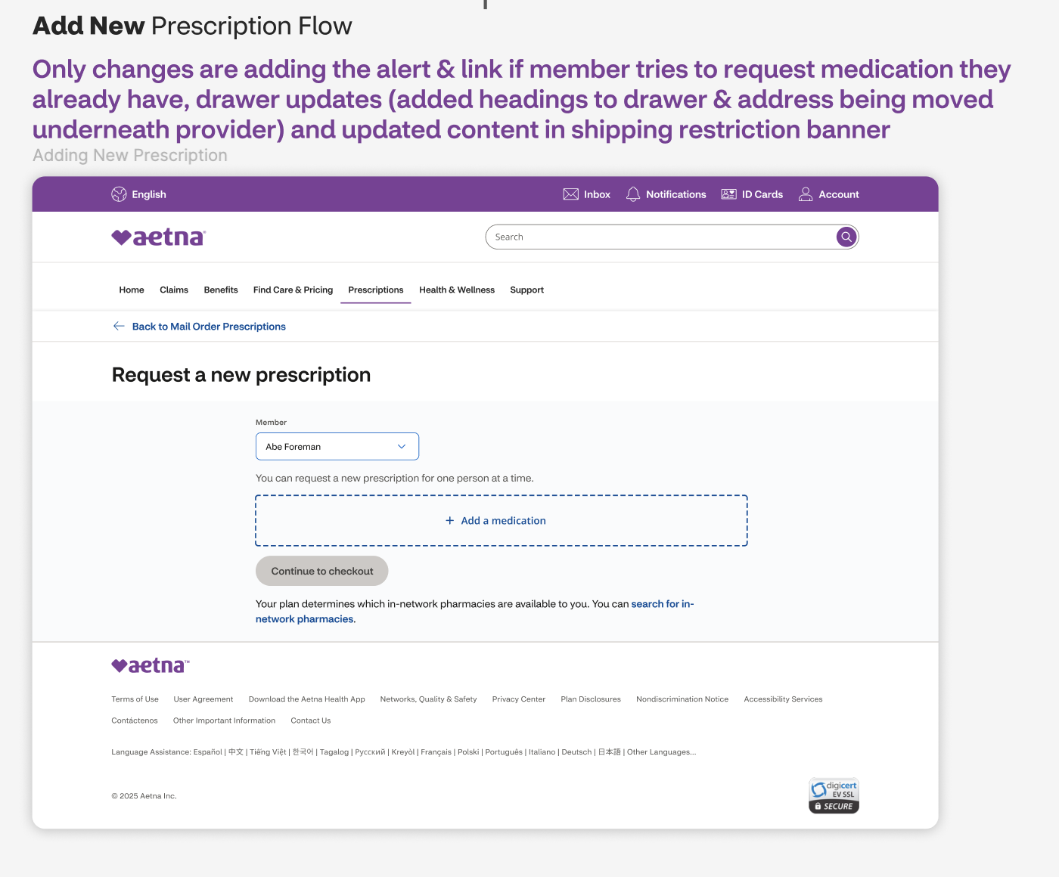

3.1. [Connector: none] Member tries to request medication they already have
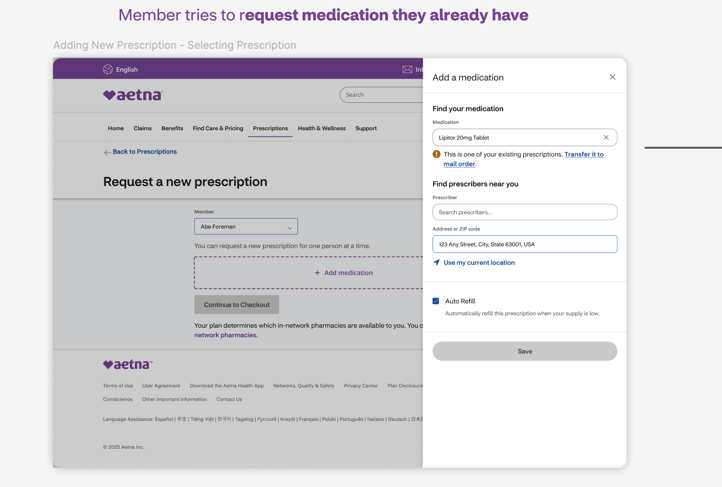

3.2. Adding New Prescription – Selecting Prescription
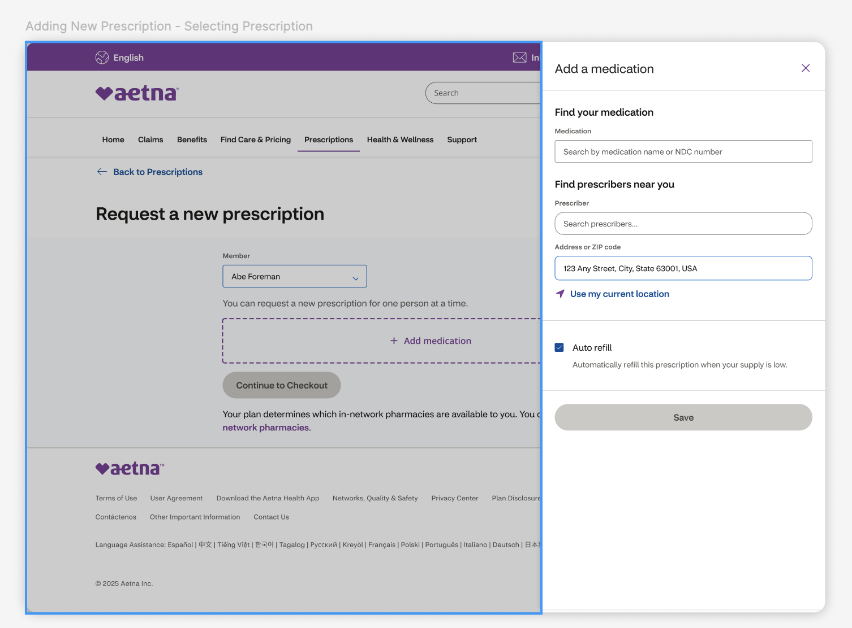
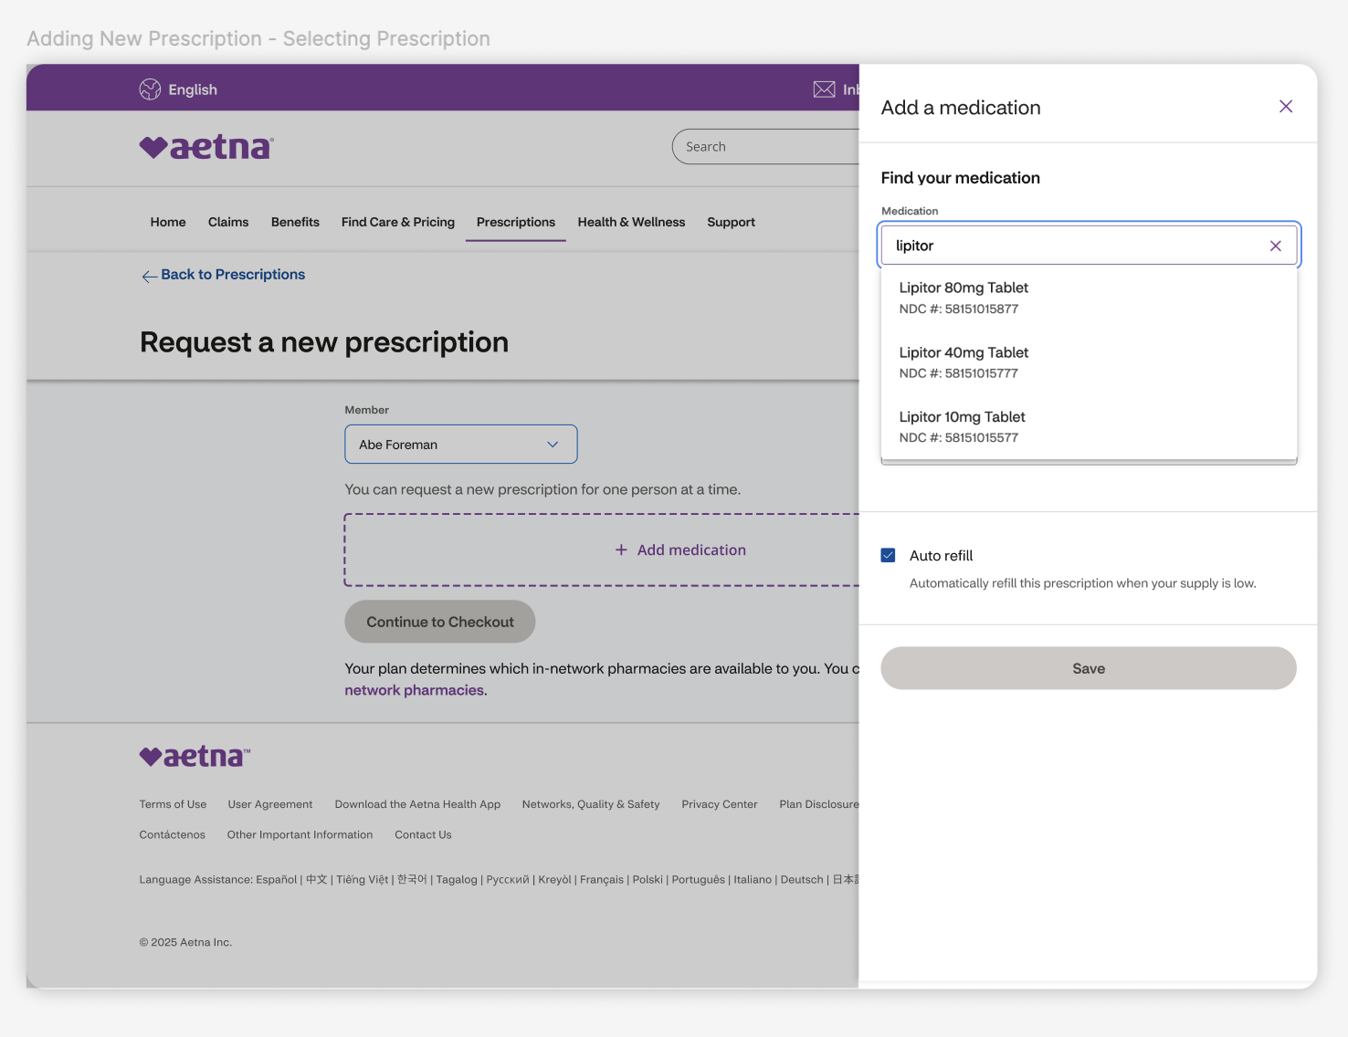

3.2. Adding New Prescription – Selecting Provider
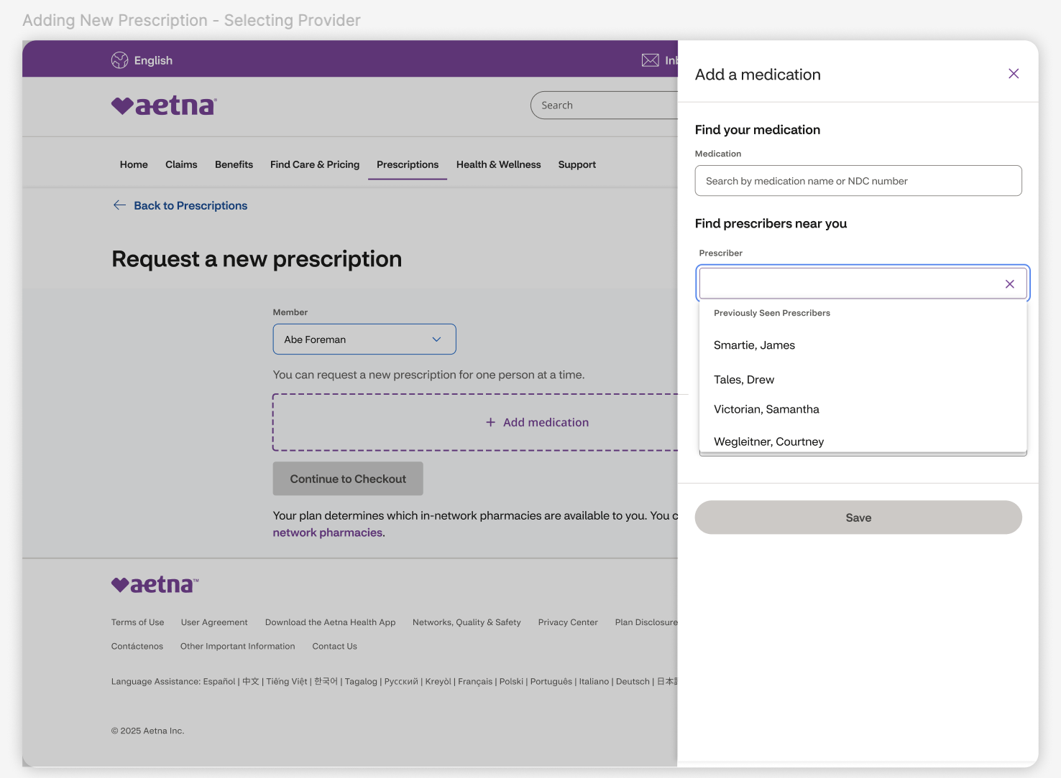

3.3. Adding New Prescription - Save
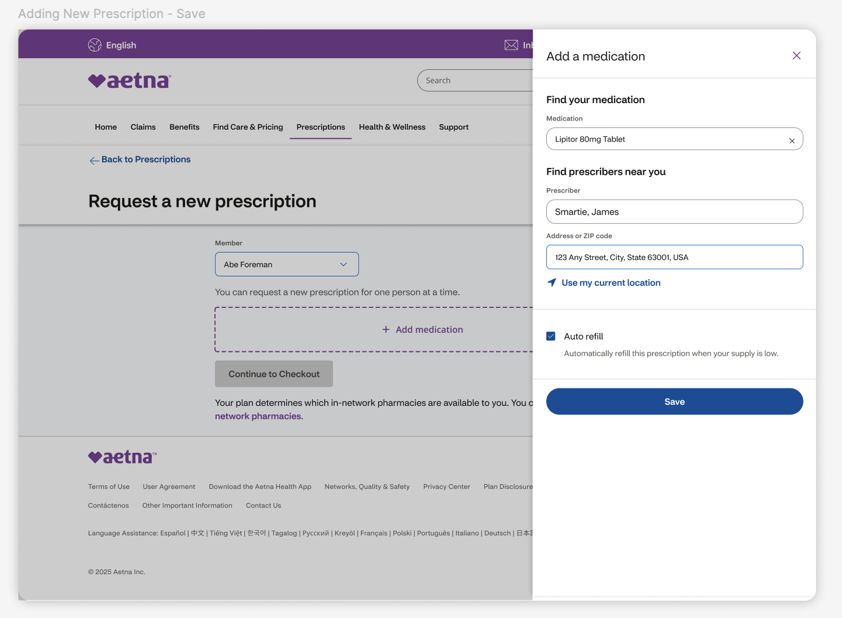

3.4. Adding New Prescription - Continue
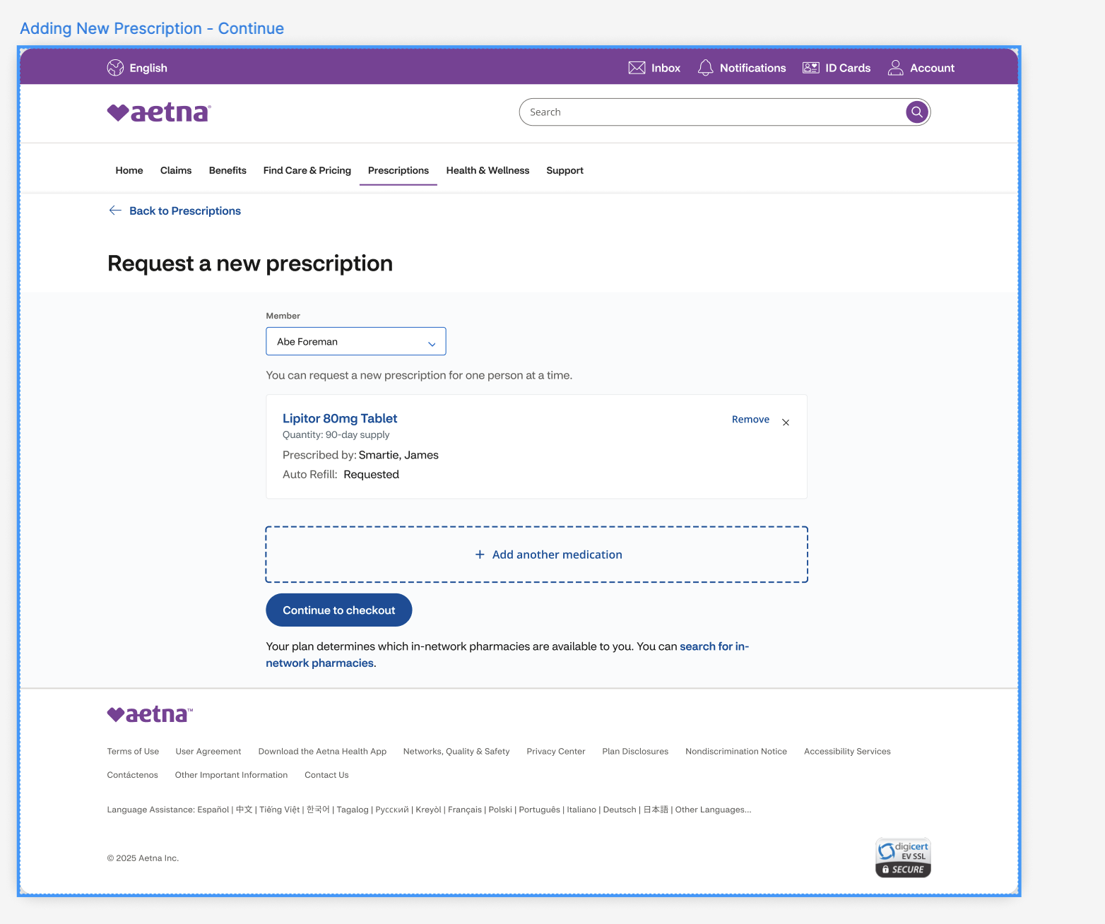
3.5. Jump to Flow-4 Transfer Eligibility Flow

FLOW-4: Transfer Eligibility Flow
4. Connector: API check happens here
4.1. [Connector: Transfer Eligible] Eligible Mail Order – Checkout
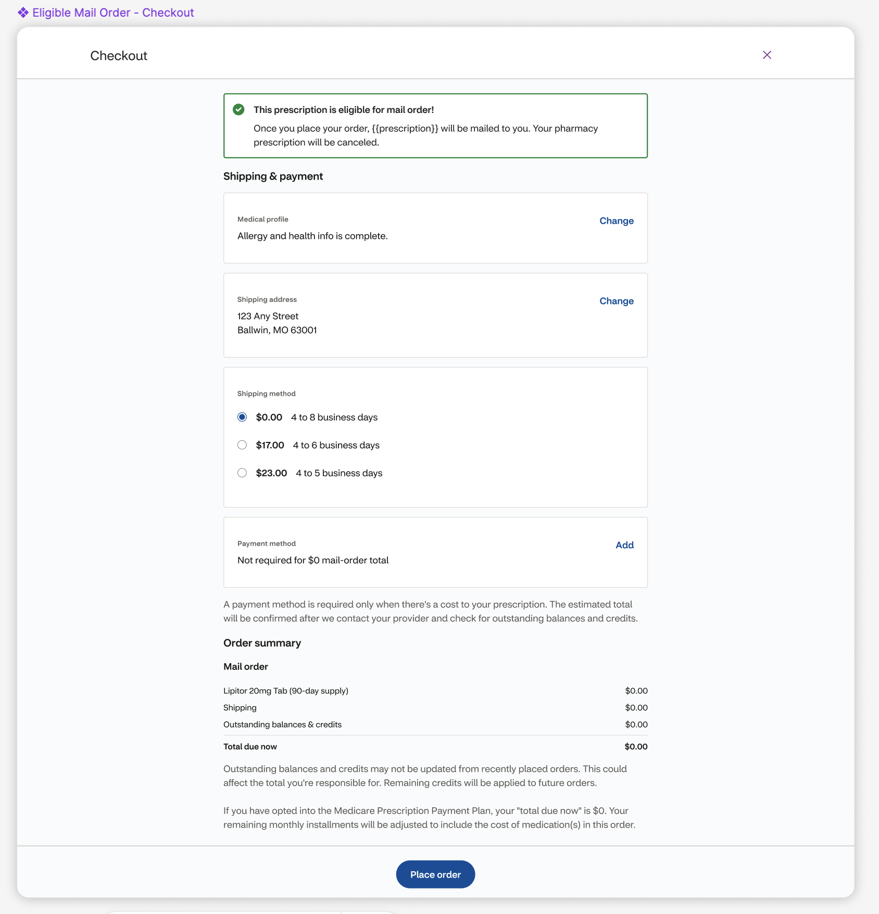

4.1.1. [Connector: no text] Eligible Mail Order – Confirmation
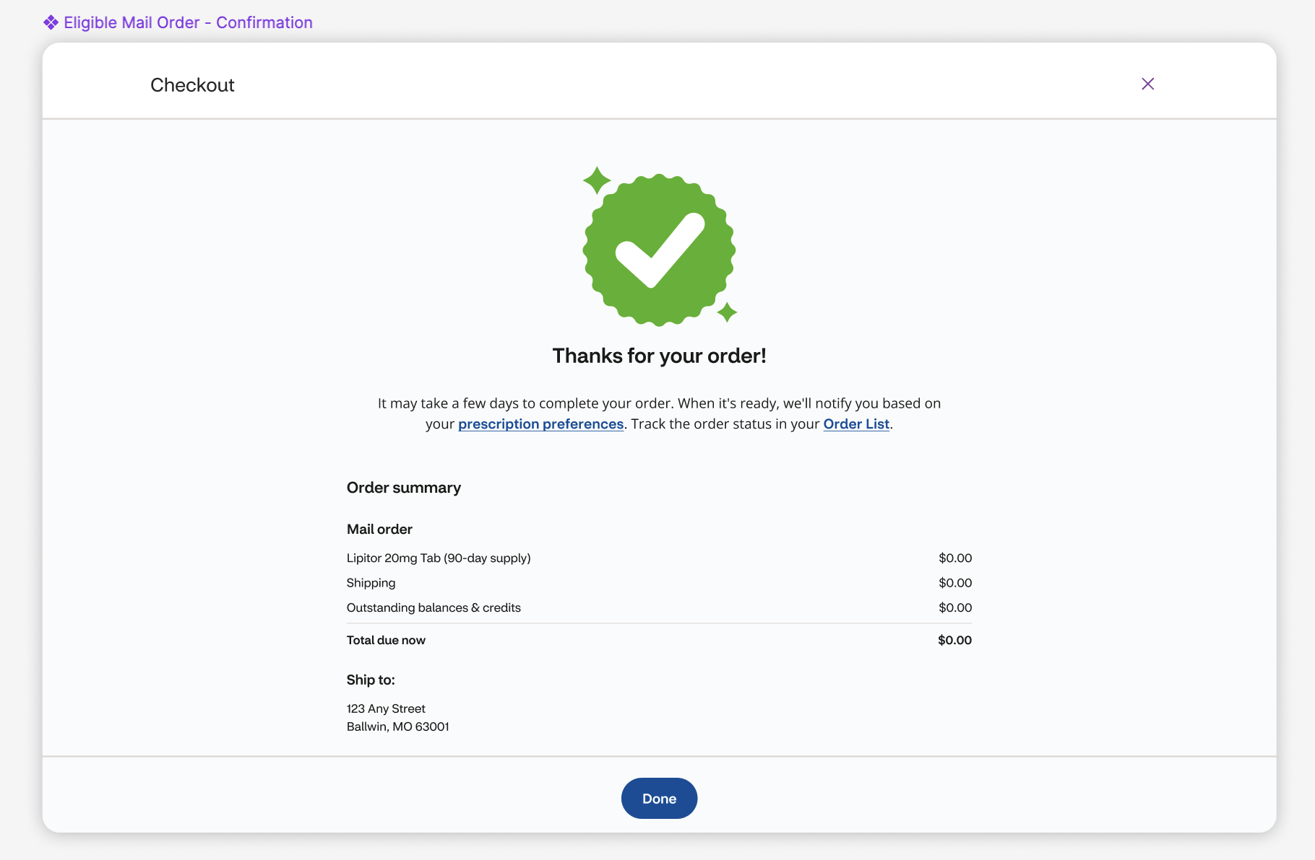

4.2. [Connector: Transfer Not Eligible (Provider Request Needed – FastStart)] Provider Approval Needed - Checkout
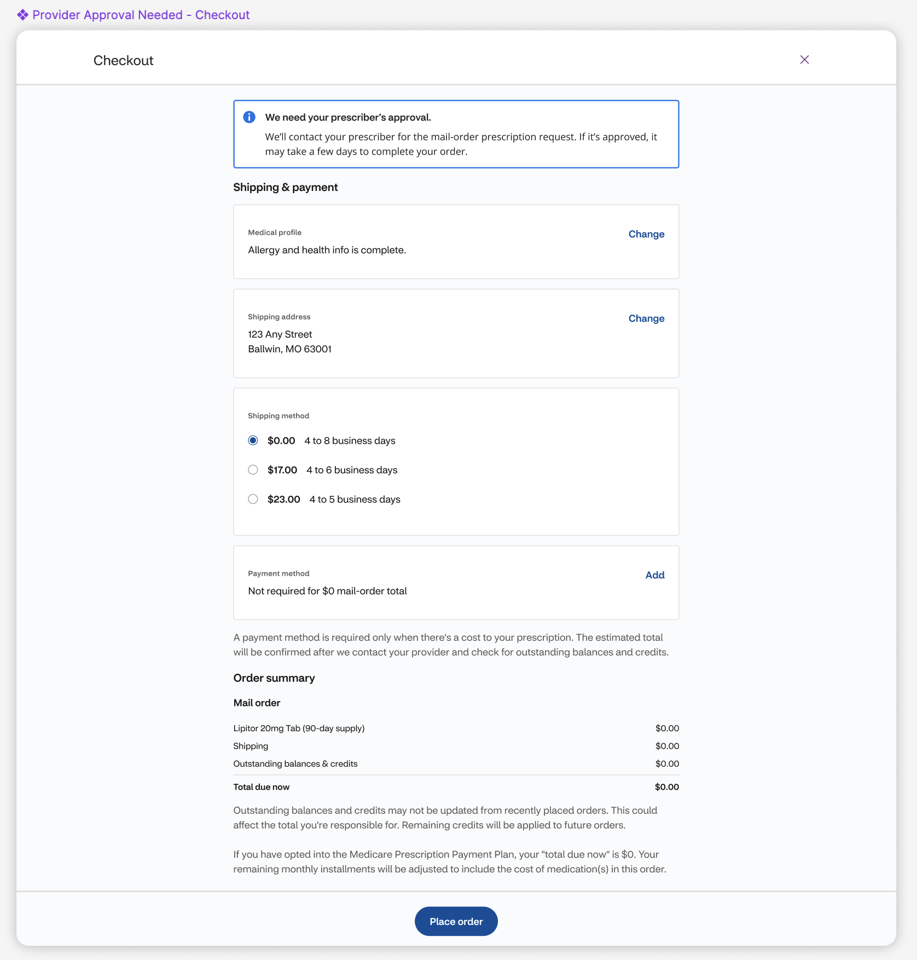

4.2.1 [Connector: none] Provider Approval Needed – Confirmation
