IIT Testimonial Management System

SE-801: Software Project Lab-3

**Submitted by**

Amran Hossain

BSSE 0917

**Supervised by**

Md.Saeed Siddik

Assistant Professor

Institute of Information Technology

University of Dhaka

**Submitted To**

SPL-III co-ordinators



Institute of Information Technology

University of Dhaka

Submission Date:16-01-2021

Table of Contents

Motivation 3

Problem Description 3

Quality Function Deployment 3

Tools and Technologies: 4

TimeLine: 5

IIT Testimonial Management System

# Motivation

Getting a testimonial is a lengthy process in our Department. Manually student should write an application, pay money to bank and then they get a testimonial. It is a time-consuming process. So, I will try to build a system where student will get testimonial easily. Whole process of getting a testimonial into a system. I want to make a user-friendly system for this purpose.

# Problem Description

Testimonial management system is a such kind of system where student get testimonial easily.

There are two types of users in this system. These are Admin and applicant/student.

Students enter into the application by giving his Personal details into the Application form. Students should give his Name, Father’s Name, Mother’s Name, University Registration Number, Date of Birth, Phone, Session, Current year for the application. After completing his details, they transact the money with bKash.

Admin can see the details of applicant. Admin can accept or reject the application. Applicant will inform about his application’s status. Admin accept the application and inform to the applicant for taking his testimonial copy.

# Quality Function Deployment

I will develop a restful web application. There will be two main services one is server and the other is client. The server part will contain all the backend logic and necessary algorithms. It will expose some API. On the other hand, the client will contain the frontend part of the project. It will communicate with the backend server API for sending and receiving data.

There are three types of requirement. Normal requirement, Expected requirement and Exciting requirement. Here are my project requirements in details.

**Normal requirement:**

* Applications form for applicant
* Admin login
* Admin logout
* Applicant profile view
* Admin and applicant list view & edit

**Expected requirement**:

* The client of this work is IIT. So, admin can accept or reject the application.
* Application’s status
* Testimonial processing and notify the applicant’s
* Payment gateway

**Exciting requirement**:

* Storing applicant’s application uniquely.
* Super admin and normal admin role. Super admin control whole the system and given role to normal admin to control the applications process.
* Real transaction process with cost.

# Tools and Technologies:

I will make a website for this system. The main feature of this system will be application form, transaction system, admin control, applicant status etc.

**Environment**: Website.

**Language**: PHP, JavaScript, HTML, CSS, Bootstrap.

**Framework**: Laravel.

**Database**: MySQL.

**Front-end Development:** Laravel

**Backend Development**: Laravel

**Tools**: Visual Studio Code, Postman.

# TimeLine:

Here is the time line diagram.

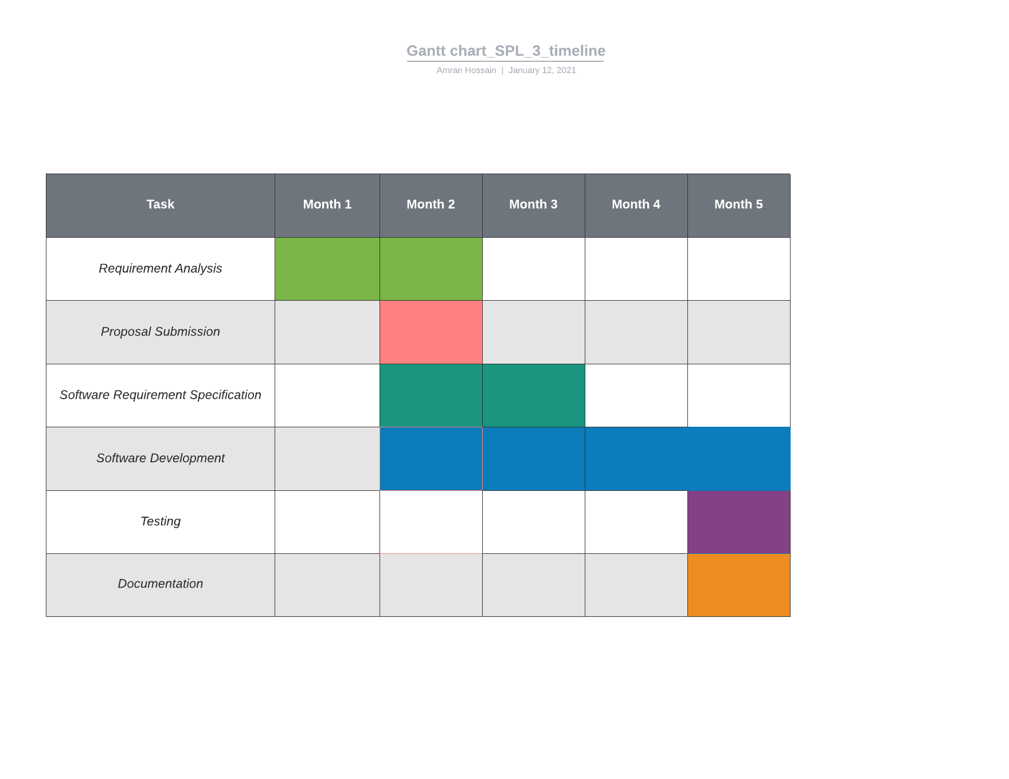

Figure: TimeLine diagram