SPL-1 Project Report

Code Metric Analysis

Course : SE – 305 course name: Software Project Lab -1

Submitted by:
Amran Hossain
BSSE 0917
Session : 2017-18

Submitted to:

Dr. B.M. Mainul Hossain
Associate Professor
IIT,DU

Supervised by:
Md. Saeed Siddik
Lecturer
IIT,DU



Institute of Information Technology
University of Dhaka.
Date: 30-05-18

Table of contents

1.Introduction
1.1 Importance of code metrics
1.2 Broad Domain
1.3 Background of study
2 Challenges
3. Project overview
4. User manual
4.1 Software
4.2 Functional manual
5.Conclusion
6.Appendix
7.References

Table of figures

1.3.1. reading from file procedure
1.3.2. snippet count total line
1.3.3. snippet strcmp function for pritive type variables
1.3.4. single and multiline comment
1.3.5. snippet of method checking
1.3.6 snippet of parameter checking
1.3.7 coupling and cohesion
3.1 timeline diagram 1
3.2 timeline diagram 2
6.1 java input file
Acknowledgement:

At first I would like to thank almighty Allah for helping me accomplish my goals.

I would like to express our deepest gratittude to all those who provide us the possibility to complete this project. A special thanks to my supervisor of Software Project Lab – 1, Md.Saeed Siddik, who inspired me to do this project and gave me
valuable lessosns to do this project.

I would also like to thank our respected teahers Dr. B.M Mainul Hossain and Nadia Nahar for giving us guidelines.

I also grateful to Institute of Information Technology for giving me the opportunity to do this project.

Lastly,I would like to thank my classmates for assisting me and provided valuable insights throughout the project.

Sincerely,
Amran

1. Introduction:

This project analyze about the code metric .Code metrics can be produced by static code analysis tools to determine complexity and non-standard practices. Here analysis the code metric , which is covering a huge part in computer science . I have completed some of task of code metric . These are given below,

* lines of code

* number of variables

* blank lines of code

* number of comment lines

* number of methods

* number of parameters

* coupling

* cohesion etc.

1.1 Importance of Code metrics:

Code metric help the developers/programmers to find out the problem base code that may need to refactor the code.

1.2 Broad Domain:

The project was developed in c++ platform . For this metrics is quantitative measure of the degree to which a system, component, or process possesses a given attribute.[1] code metrics is such kind of form. It has to analyzed by any softare measurement tools.
1.3 Background of study:

To complete this project I have done it in raw coding. As I had no idea before this project ,it was totally new . So I needed more to learn about c++ language. About the built in function which are needed in the code I have to known about it. Such as to read from file <fstream> header file to be used and written ifstream for input from file .

#include <fstream>
………………
……………...

ifstream ifile; // ifile is the file name

figure 1.3.1: reading from file procedure

Also reading file from line by line than I used counter variable after each line read increasing the counter finally I got the total line of code. Here is the snippet

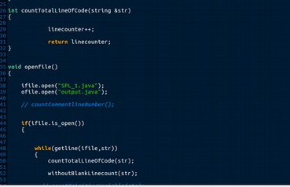

figure 1.3.2: snippet total line count .

next I have counted how many variables in a code . This overview I had to know about the variables . Hence I have to know about which variables are primitive type and which are the object type . For this condition I had used strcmp function for matching the primitive type variables. That means string matching
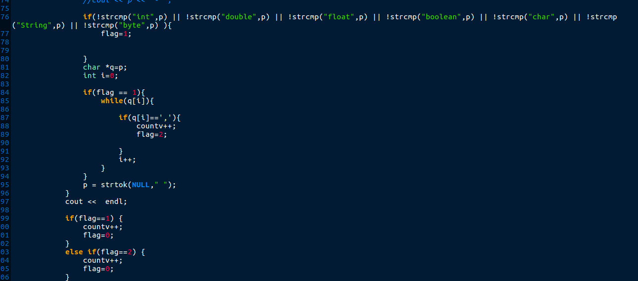
figure 1.3.3: snippet code strcmp function for primitive type variables.

Next I have count comment line of number. For this purposes , I have to know derails abouts the comments.There are two kinds of comments. 1. Single line comments (//) 2. Multi line comments .(/*… */)

/*
void EventLoop();
void EventLoop();
/**/

// This comment will also comment the following line

fig 1.3.4: multi line comment and single line comment [2]

Next I have check method and count the number of method . For this I have to know first the method . A method has a name and return type. For this purposes I have checked ‘(’ opening bracket in line. Thus I have to check method and lastly I have not count the default method. Like for() ,if() , main () etc.
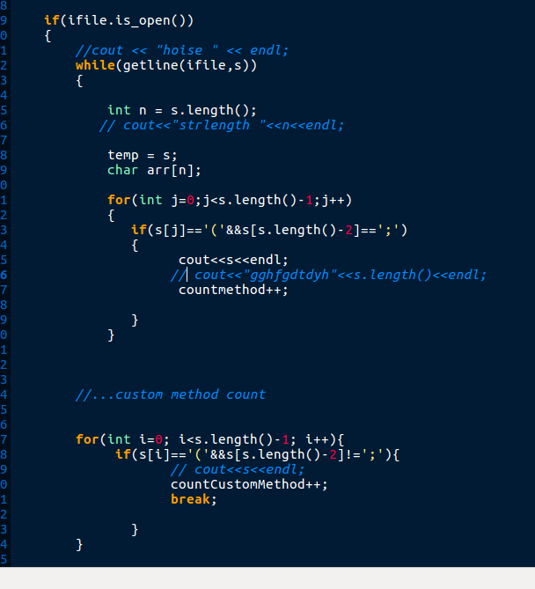

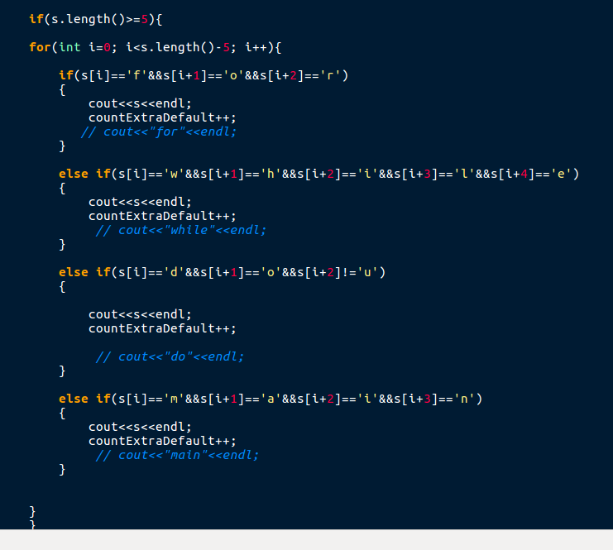

fig 1.3.5: snippet code of method checking

then parameter checking I have to work method code than checking inside the methods parameter comma separated.

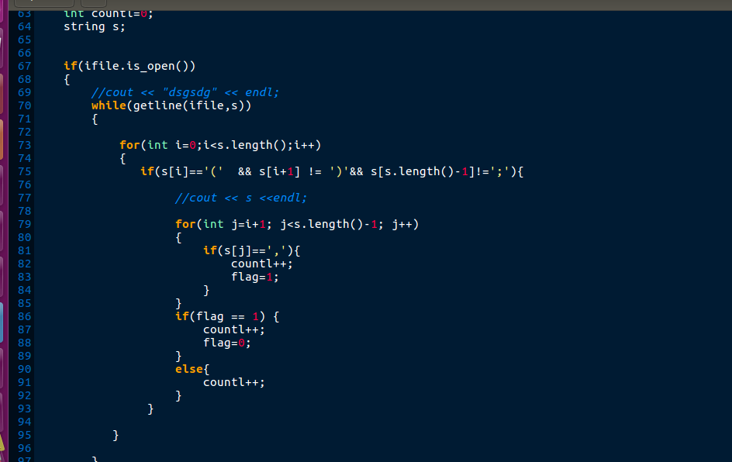

Fig:1.3.6: snippet code of parameter check.
Lastly coupling and cohesion. These are the new term.So I have read more about it. Coupling is relation among the class/interface and cohesion is relation within the class. Such as,
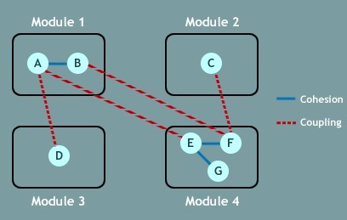

fig. 1.3.7: coupling and cohesion module [3]
2.Challenges:

As a beginner my project has some challenging part to do. When I extract variables in object type it is challenging part to do . For object type variables when I got ‘=’ sign than new..() than I encounter this is a variable. Also in method checking some methods are by default . Such like as for () , if() , else.. if(),main (),some instance of objects and others. So I have to check only creating methods by own . Also the main challenging part of this project is coupling and cohesion check from the java file . I had no basic idea about the coupling and cohesion before . I read it than execute my programmes. As I know coupling is the relation between two or more classes and cohesion is only own classes relationship. For this my supervisor helped me much and I have to read more internet sites for known to well about these topics . After knowing overviews from these topics then I have tried to implemented into the code .After a long term ,I had succeded about its.
By the way, this project has helped me improving coding skill. Also thinking skill. I learnt many of new things whatever I didn’t know before . So taking many of challenging part is very helpful to me.
3.Project Overview :

Now this time the project task which is given by a diagram below. Here my progessive view has given that.Here timeline graph:

 | Month 1 | Month 2 | Month 3 | Month 4 | Month 5
Requirement analysis
Proposal submission
Coding
Testing
Report and powerpoint presentation

Fig 3.1: timeline diagram1

Here is overview of my project part by part complete in monthly view,

Tasks\Months | January | February | March | April | May
countLine |  | ✓
numberOfvariables |  | ✓
countComment Line number
countMethd |  |  |  | ✓
countParameter |  |  |  | ✓
coupling |  |  |  |  | ✓
cohesion |  |  |  |  | ✓

Fig 3.2: timeline diagram 2
4.User manual:

There are some requirements for developing the project and running the code as far as possible.
4.1 Software :

The code is implemented in C++ platform . Source code/file is taken on a java file . For this, the code will be run in codeblocks , any text editor for c/c++ platform like (gedit) .

The code run in windows(7,8,10),linux,linux mint, ubuntu (any version) in desktop or laptop.

Also needs 1.0 MB space for running the code.

4.2 Functional manual:

To see the result of task you can see the result in terminal of codeblocks or any text editor terminal . Also can see the result in another java file as a output of the programme . As code is written in c++ platform it’s need to g++ compiler.

5.Conclusion:

I have learned a lot through this project. This project has sharpened my coding skill . Also helping me analyzing the code. I learned from this project how can extract code . Yet before, I had no idea about this or any thing of this project. Infact code metrics is a huge part in the code analysis.
Also remain Maintainability Index,Cyclomatic complexity, Depth Inheritance,Number of fields,Type rank, Method rank,Instability and abstractness etc.[4] Next I will try to find out this metrics from the code so that I can complete analyze the whole code metrics. For knowing better and improve myself in coding and thinking skill.

6.Appendix:

Actually I had read a java file means a file which is written in java format. Like this given a sample java file as a input file, which was analyzed and find out this methods,parameters,variables etc.

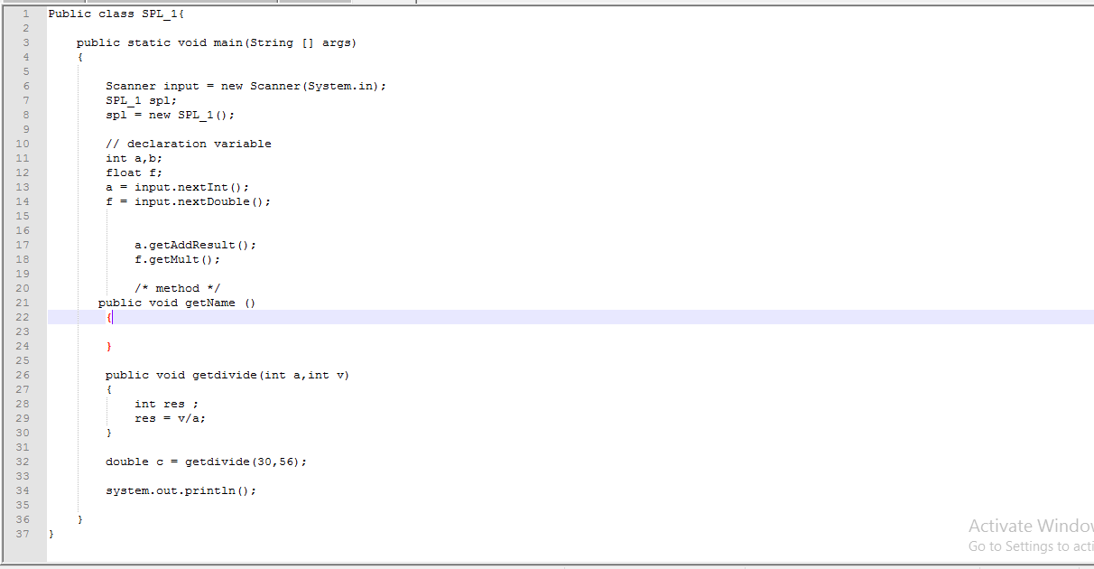

Fig 6.1: java input file

7.References:

- www2.southeastern.edu/Academics/Faculty/galkadi/285/notes/Chapter15.doc last access 28.05.18 at 1.30 a.m

- https://en.wikibooks.org/wiki/C%2B%2B_Programming/Code/Style_Conventions/Comments last access 25.05.18 7.25 p.m

- https://www.google.com/search?q=coupling+and+cohesion+in+java&client=firefox-b-ab&source=lnms&tbm=isch&sa=X&ved=0ahUKEwjA3vTclKnbAhVMtI8KHRwUD38Q_AUICygC&biw=1138&bih=538#imgrc=-4VDczDyyjxDOM: last access 25.05.18 9.27 p.m

- https://ardalis.com/static-code-analysis-and-quality-metrics last access 28.05.18 12.30 a.m

