**Aws Task Lab 3**

**The Solutions:**

1 - Click on Create VPC and enter Sprints as the name and 10.0.0.0/16 as the CIDR block then click create vpc.

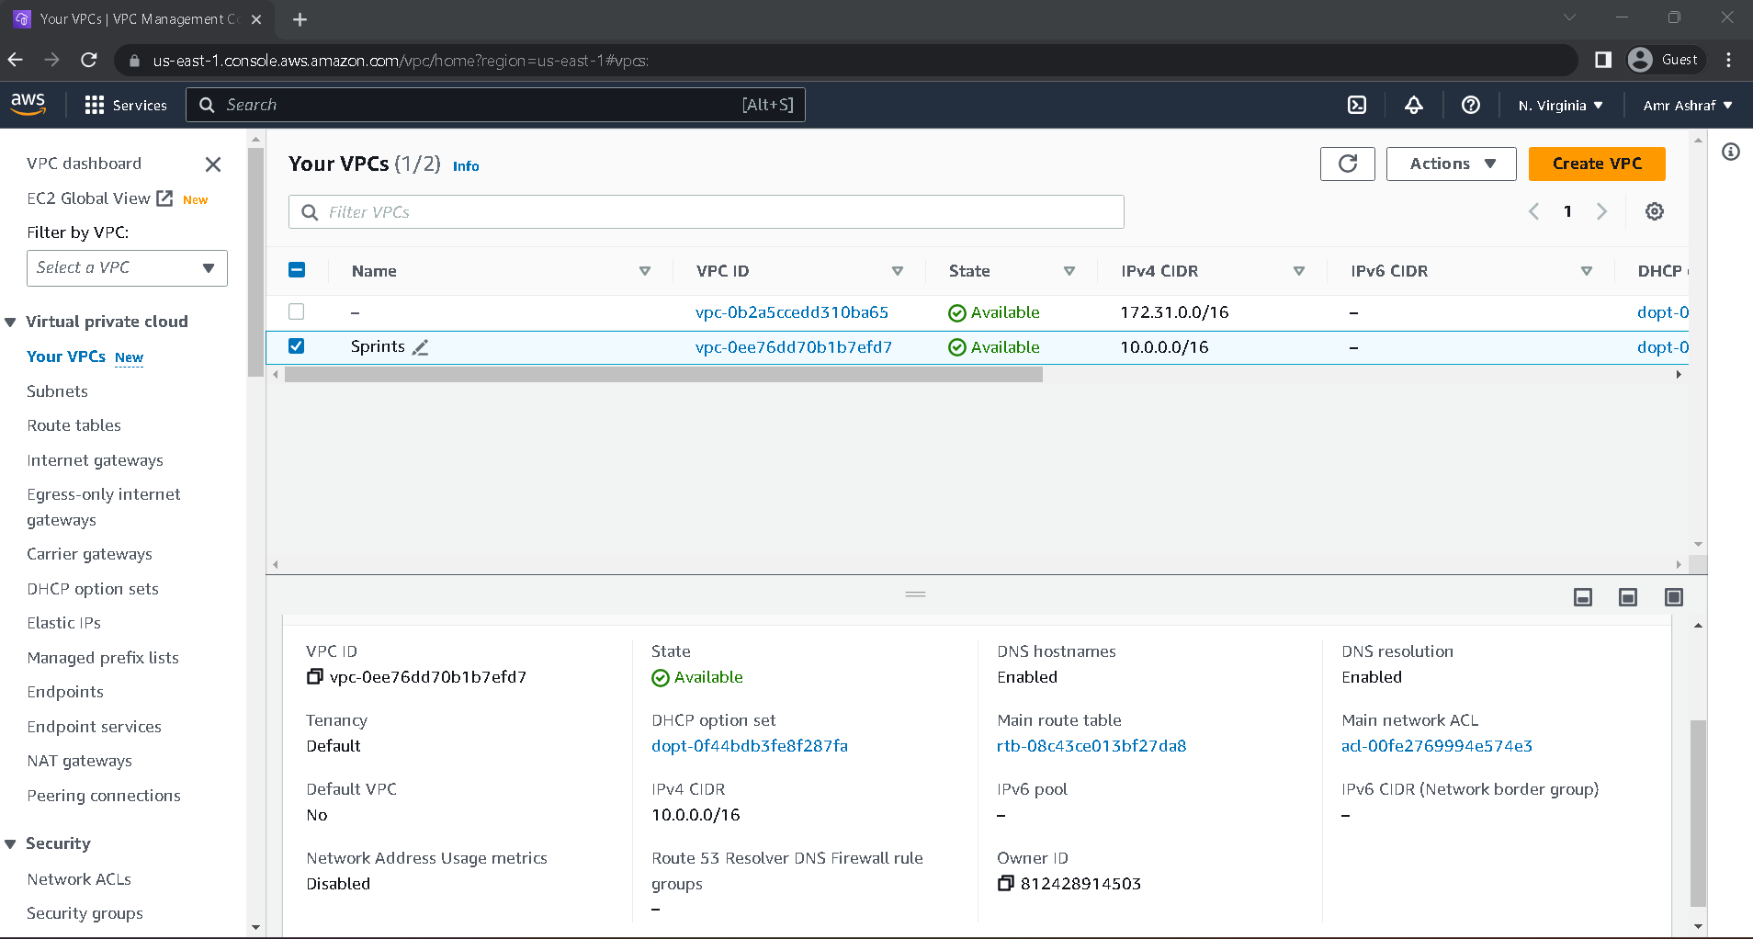

2 - Click on "Create Subnet" and enter "Public_Sub_Sprints" as the name, "10.0.0.0/24" as the CIDR block, and select the sprints VPC.

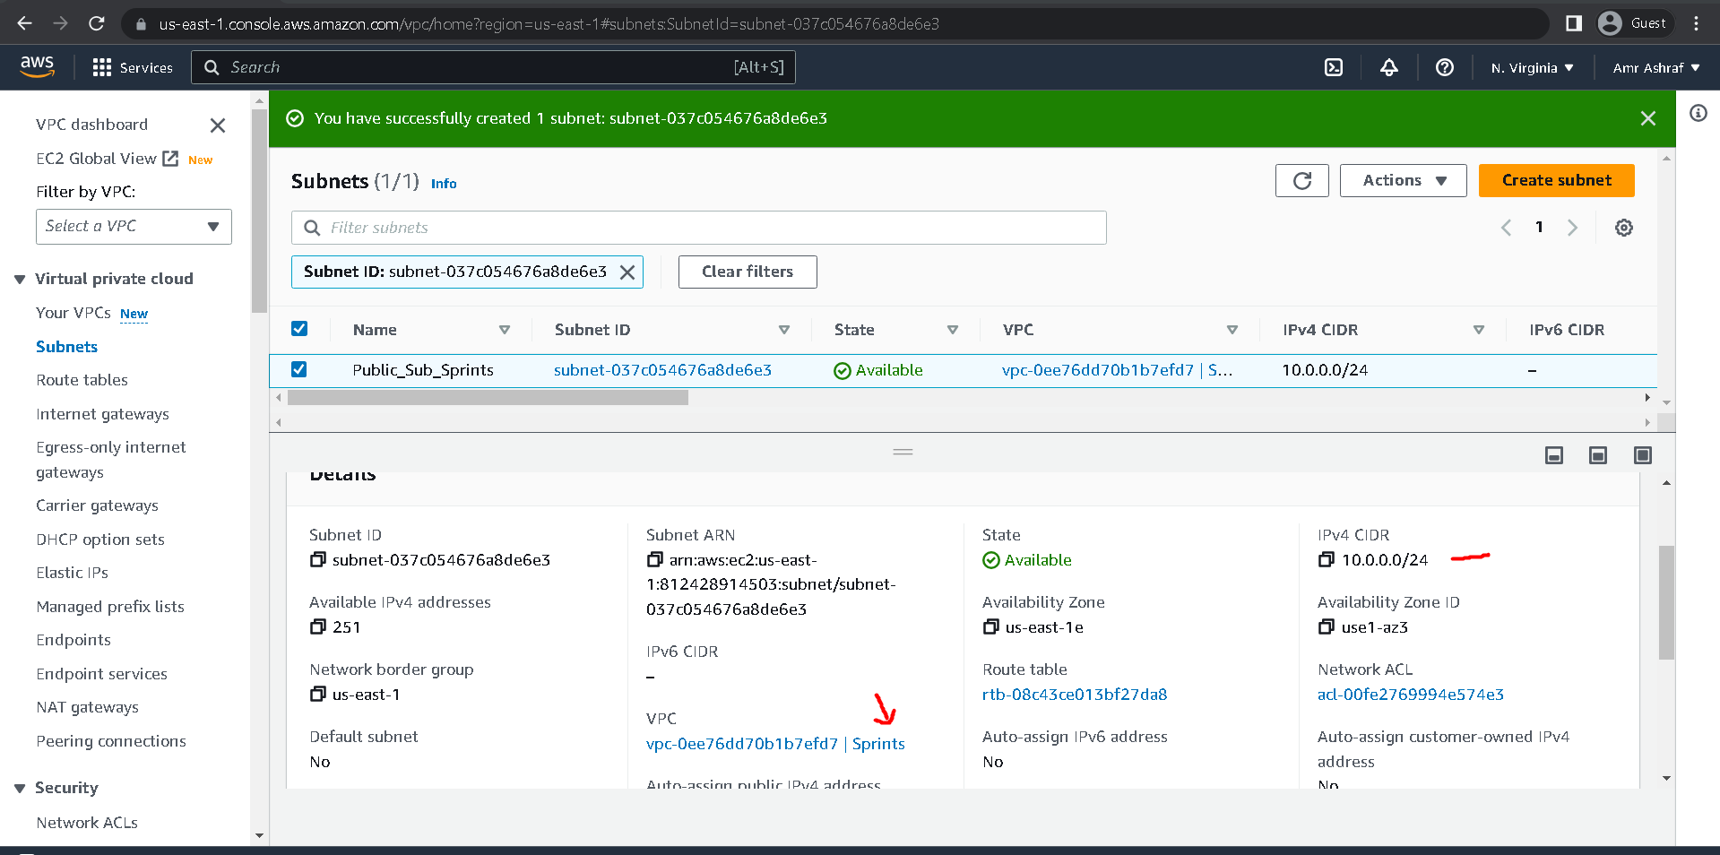

3 - Click on "Create Subnet" and enter "Private_Sub_Sprints" as the name, "10.0.1.0/24" as the CIDR block, and select the sprints VPC.

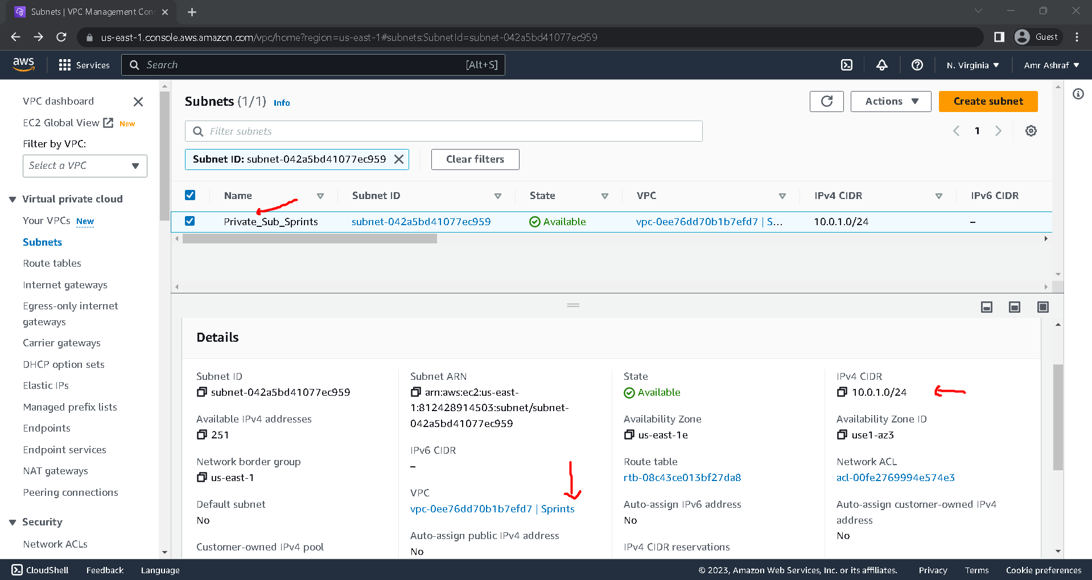

4 - Create Internet Gateway Then Put "Sprints-IGW" as the name and click on "Create" Then Click On Action And select "Attach to VPC". Choose Sprints click on "Attach".

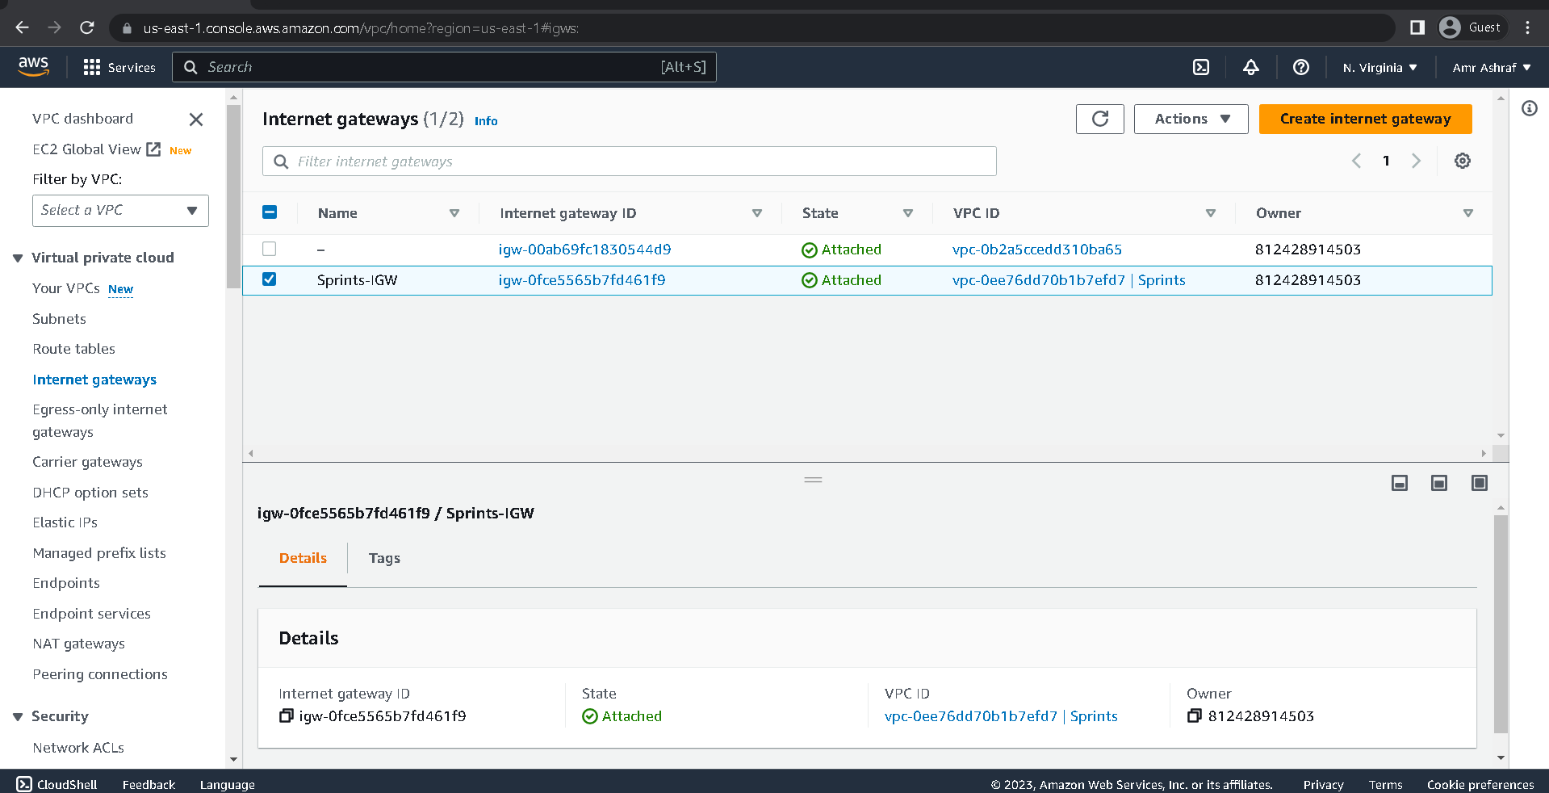

5 - Create NAT Gateway And Put “Sprints-NAT “ as the name Then Choose Sprints-IGW as the gateway, select Public_Sub_Sprints as the subnet, and choose Allocate Elastic IP address Then Create Nat Gateway

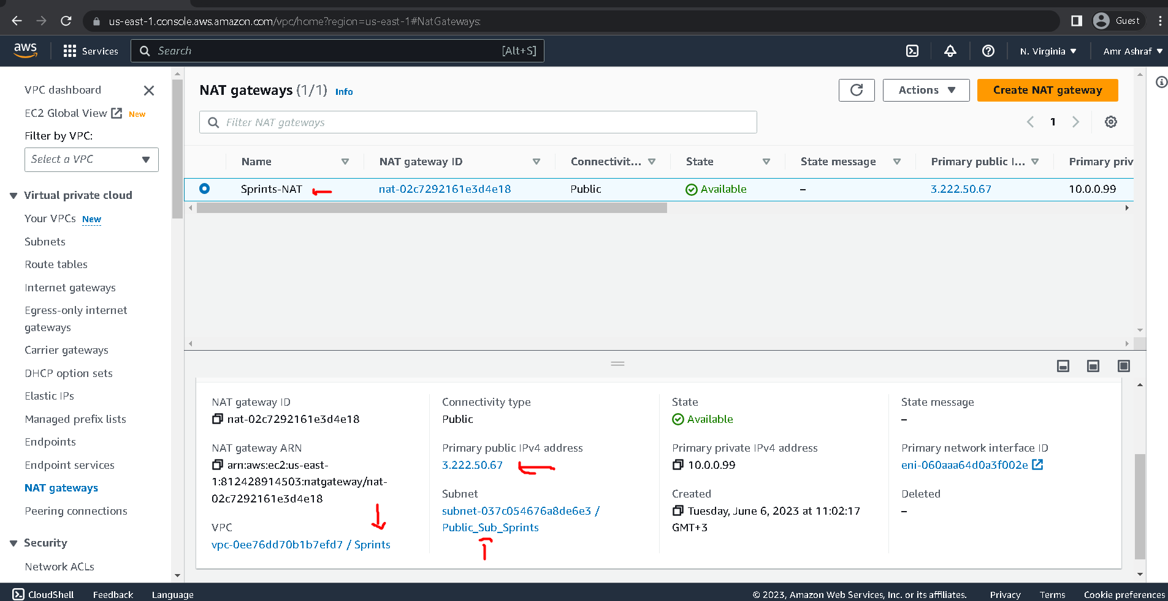

6 - Create Route Table And Put "Public-RT" as the name, select Sprints VPC, and click on Create.

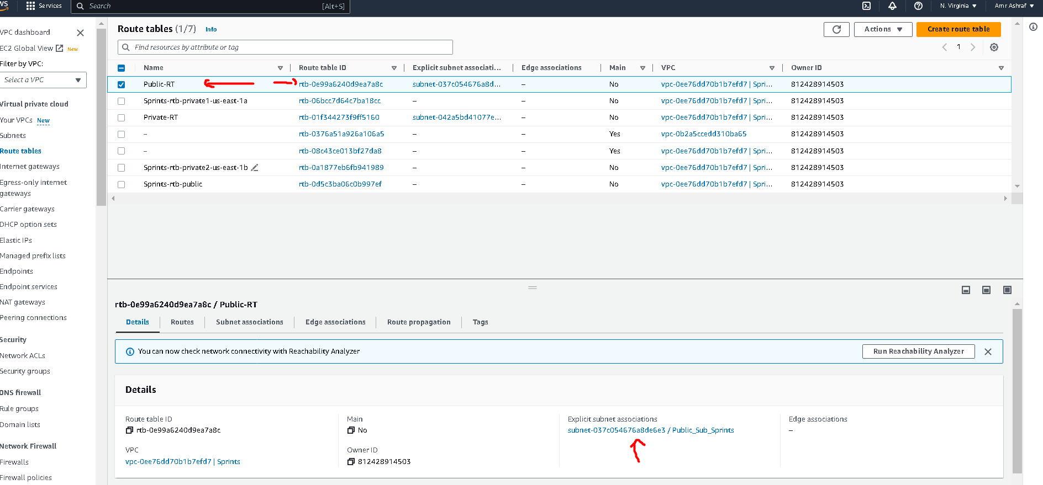

7 - Select Public-RT from the list of route tables, click on Edit routes, add a new route with destination 0.0.0.0./0, target Sprints-NAT gateway, save changes.

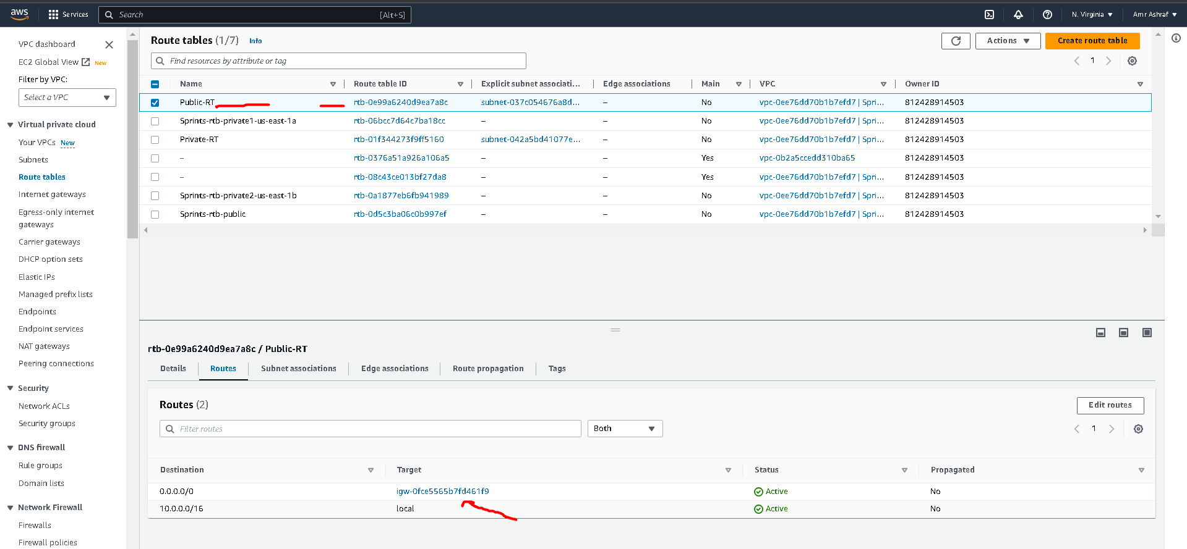

8 - Create Route Table And Put "Private-RT" as the name, select Sprints VPC, and click on Create

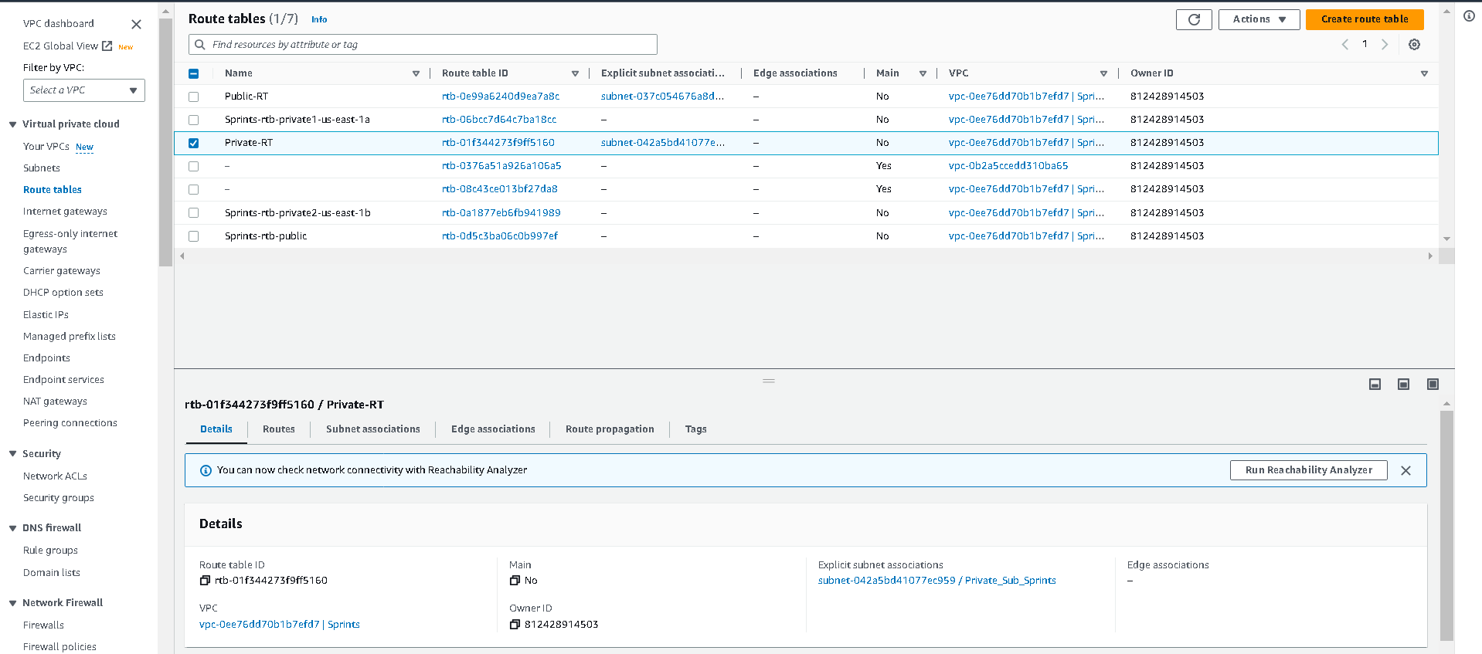

9 - Select Private-RT from the list of route tables, click on Edit routes, add a new route with destination 0.0.0.0./0, target Sprints-NAT gateway, save changes.

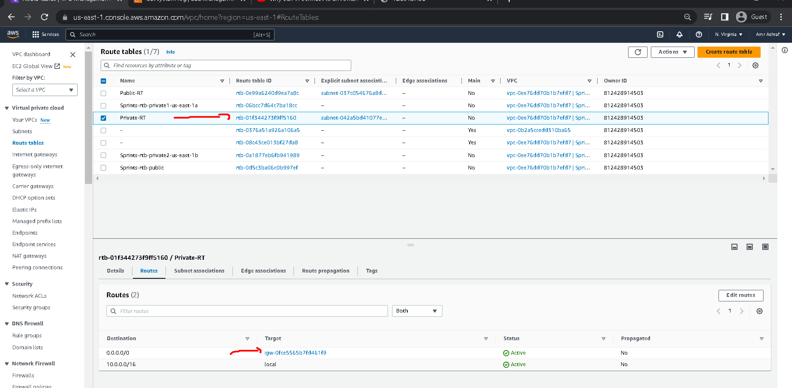

10 – Create 1 Security Group and Put “Security_Sprints_Public” as name and add inbound rules to allow traffic to the instances.  
 A - Allow HTTP traffic from anywhere (0.0.0.0/0) for the public instance [ Instance1_Public ]

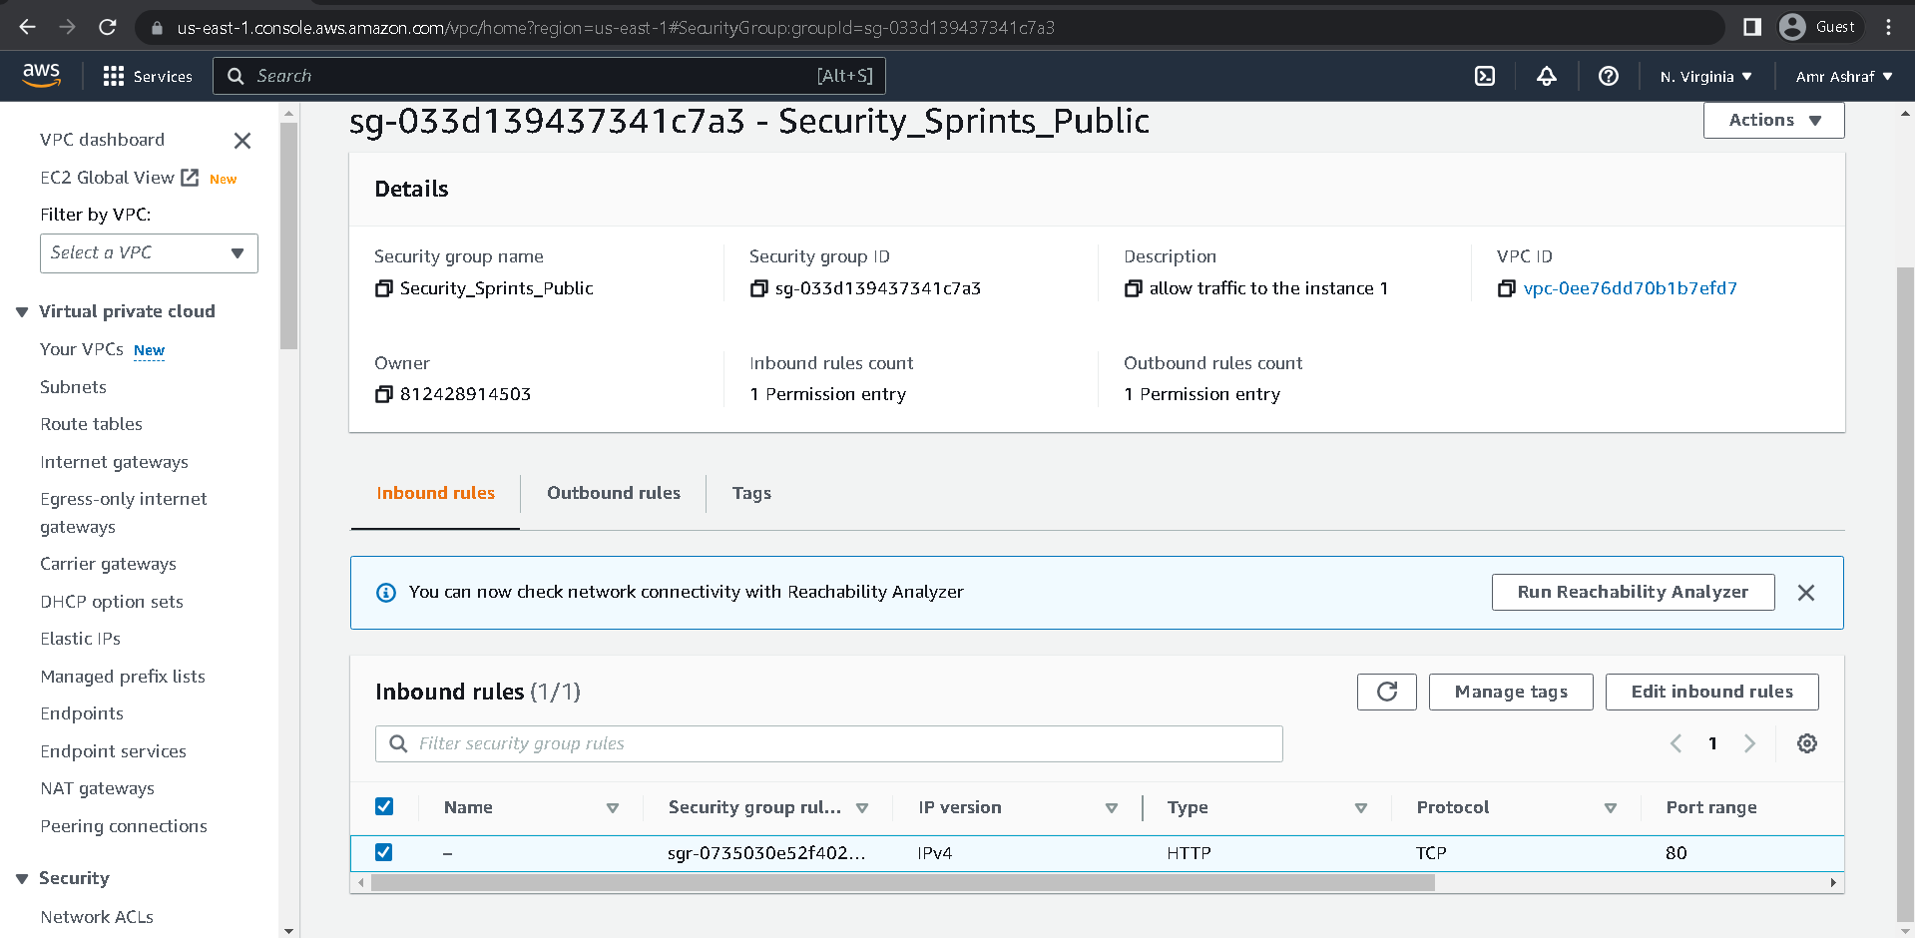

11 – Create 1 Security Group and Put “Security_Sprints_Private” as name and add inbound rules to allow traffic to the instances.

A - Allow SSH traffic from my IP address for the private instance. [ Instance1_Public ]

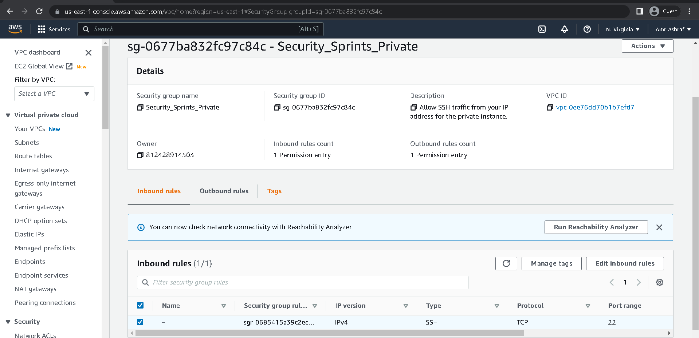

12 - Launch Instance And Put “Instance1_Public” as name of instance and choose an Ubuntu as image.

A – Choose Sprints VPC B – Choose Public_Sub_Sprint C - Choose Security_Sprints_Public

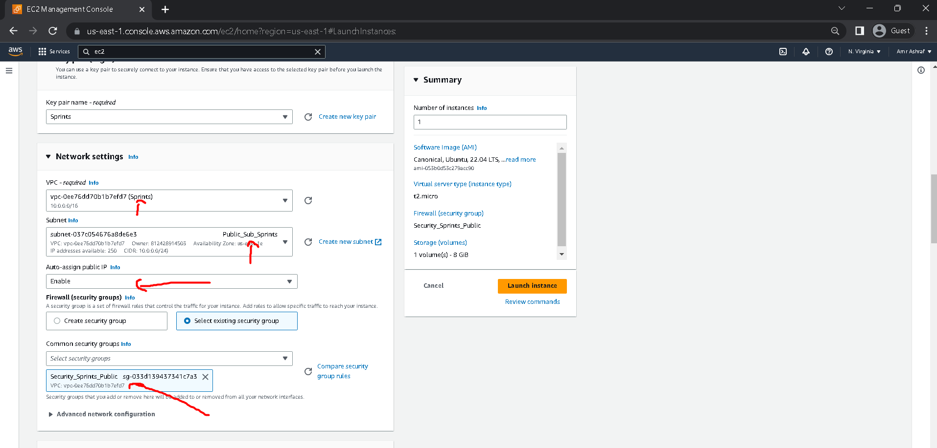

13 - Launch Instance And Put “Instance1_Private” as name of instance and choose an Ubuntu as image.

A – Choose Sprints VPC B – Choose Private_Sub_Sprint C - Choose Security_Sprints_Private

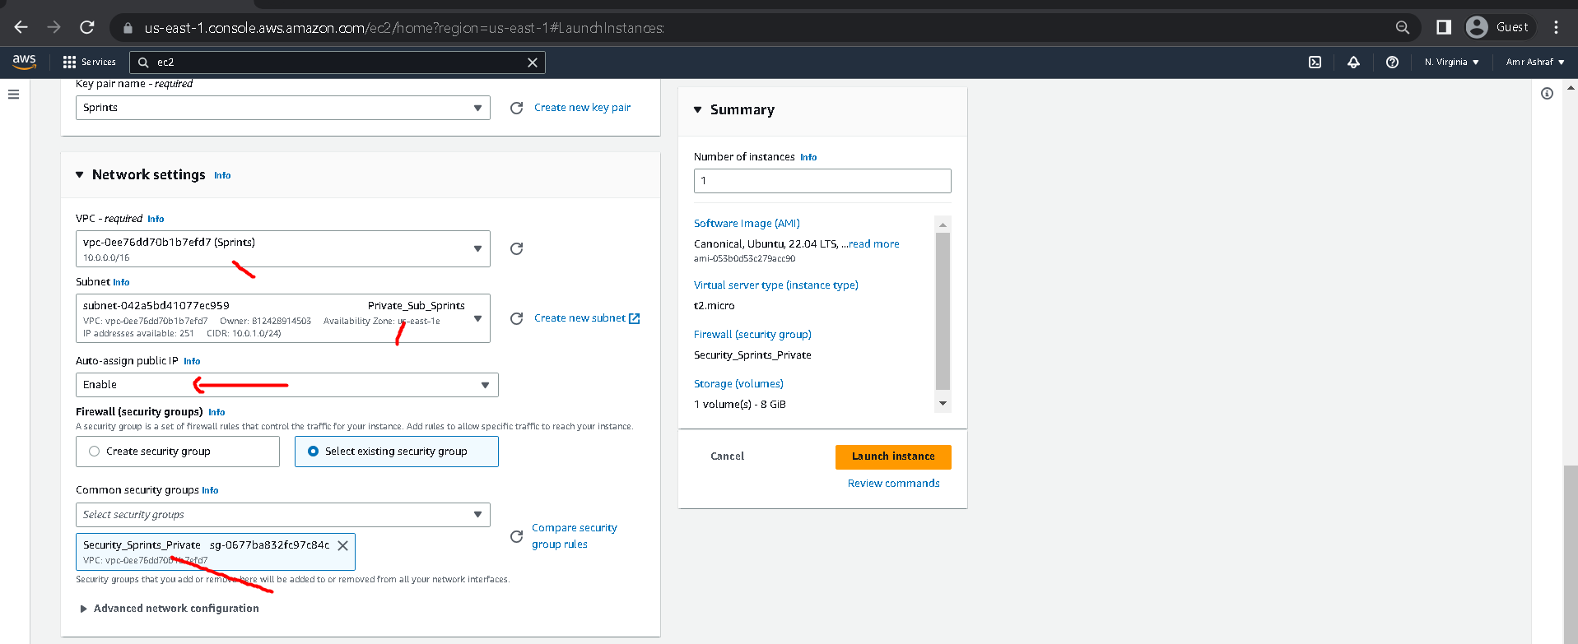

14 – Connect For First Instance [ Instance1_Public ]

Commands : 1 – sudo apt-get update -y  
 2 – sudo apt-get install apache2 -y  
 3 – sudo systemctl start apache2  
 4 – sudo systemctl status apache2

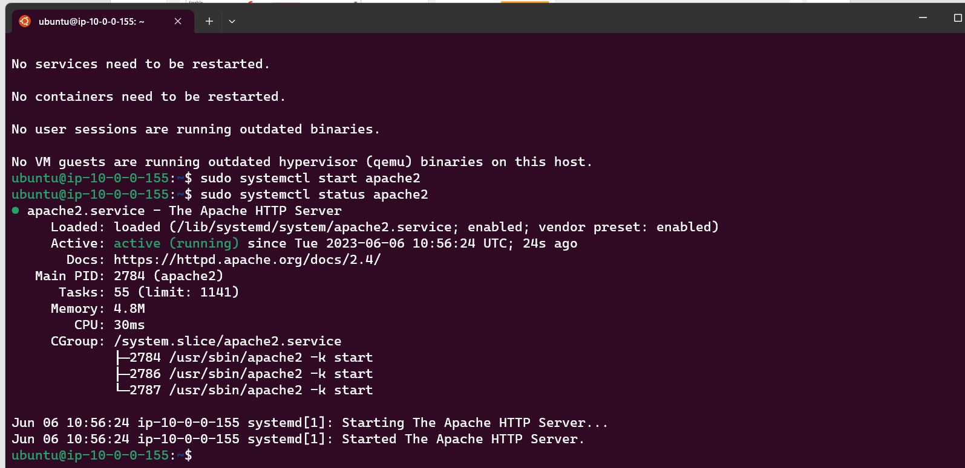

Check The Page Results

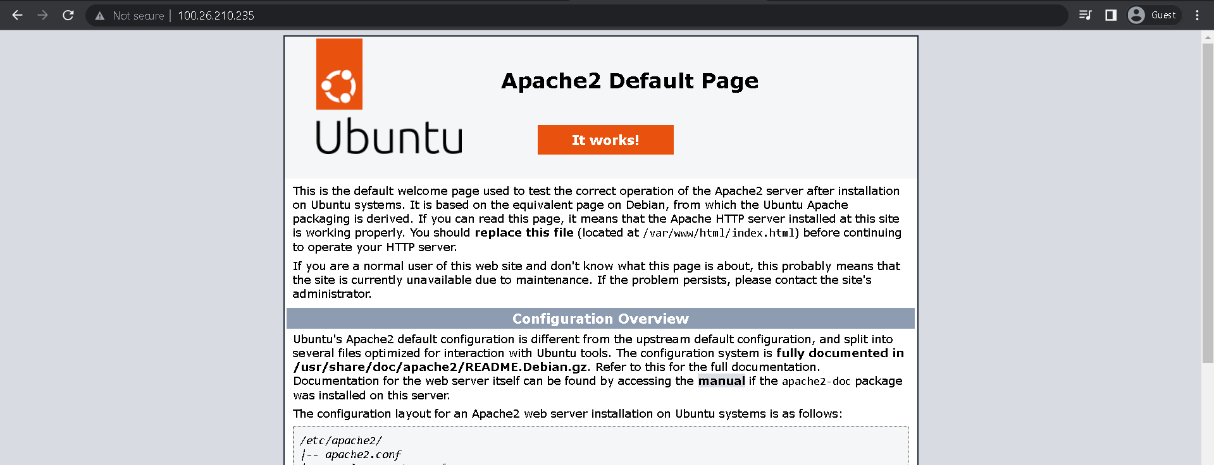

14 – Connect For Second Instance [ Instance1_Private ]

Commands : 1 – sudo apt-get update -y  
 2 – sudo apt-get install apache2 -y  
 3 – sudo systemctl start apache2  
 4 – sudo systemctl status apache2

