Arab Academy for Science, Technology & Maritime Transport
College of Computing and Information Technology

 | Course: CIT4103 – Professional Training In Soft. Test. Iii - VB
 | Student Name: | Registration ID:

Question 1 — Environment Variables (5 Marks)
Task 1 — Create an Environment (2 Marks)
- Create a new Postman environment.
- Name the environment using your full name.
  - Example: Maha_Talaat_Env
- Add the variables Value to be the dummyjson website:
Deliverable:
Screenshot : Your environment showing your name + the baseUrl variable.
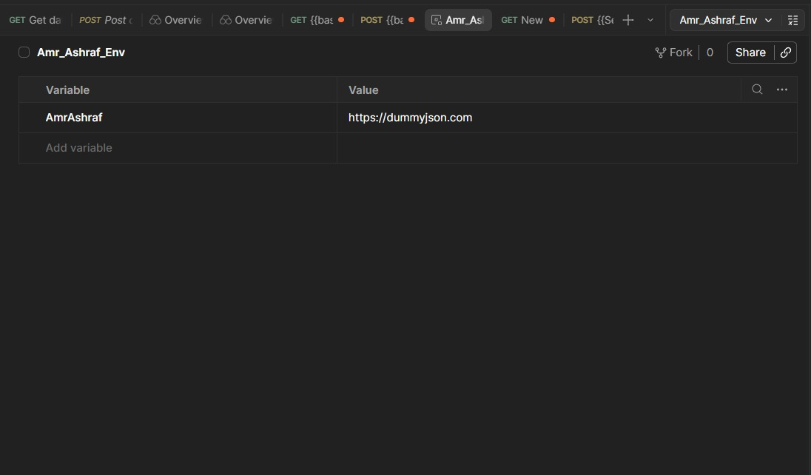

Task 2 — Use the Environment Variable (3 Marks)
Create a request:
- Method: GET
- URL: {{baseUrl}}/products/1
Deliverable:
Screenshot 2: The request using {{baseUrl}} and the response body.
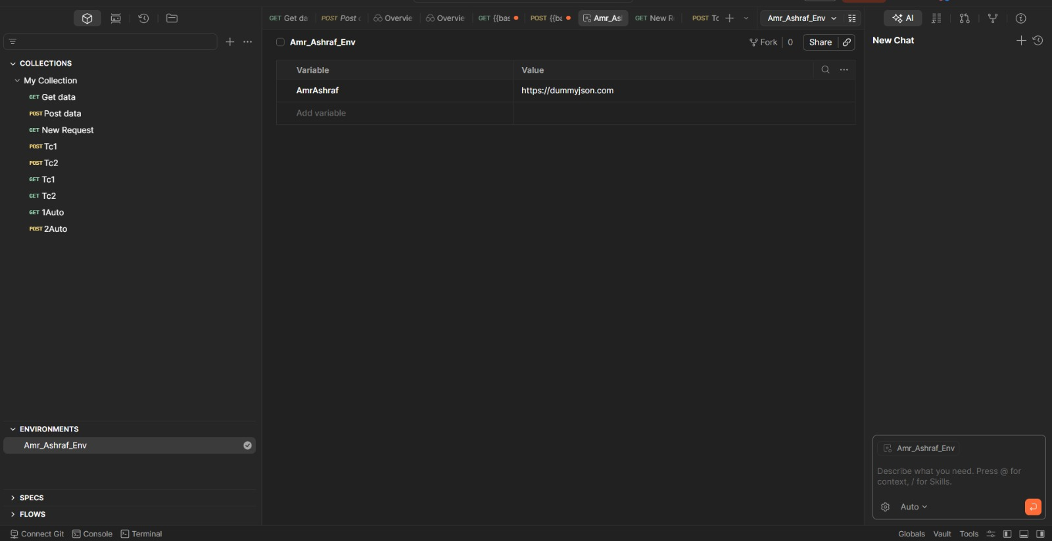
Question 2 — Manual Test Cases (15 Marks)
Write 6 manual test cases for the following APIs:
- API 1 — GET
  - Write 3 test cases.
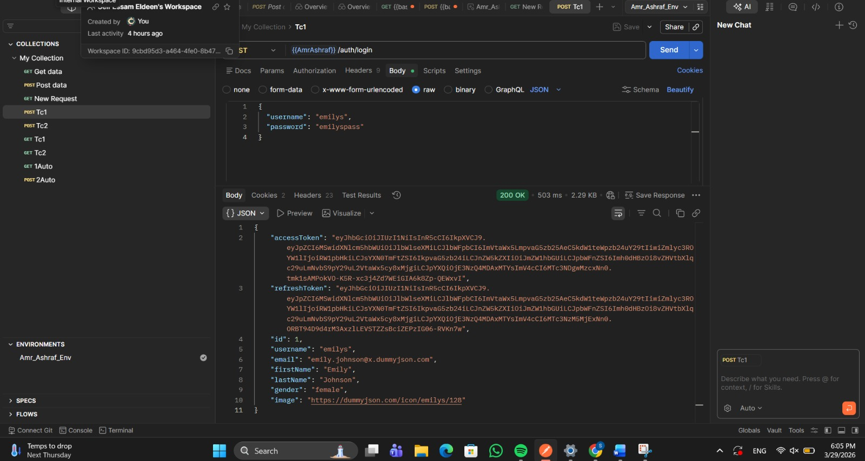
- 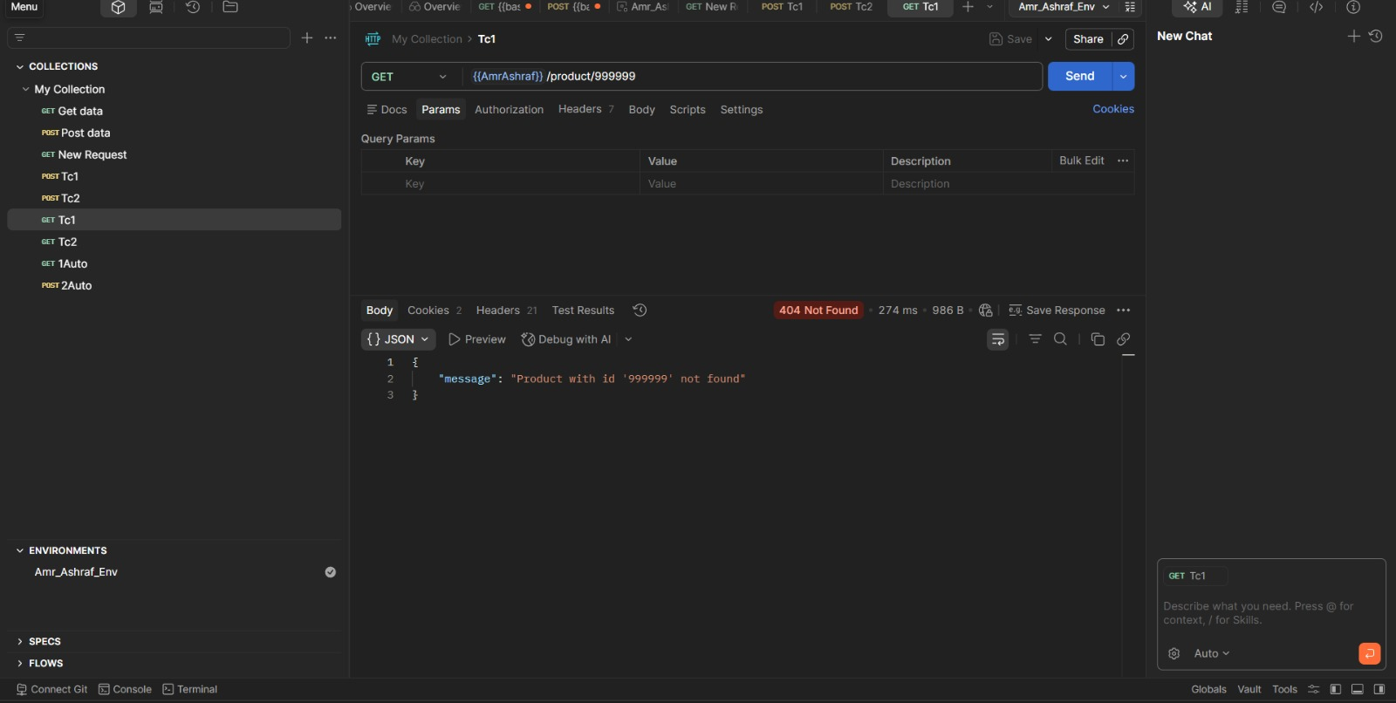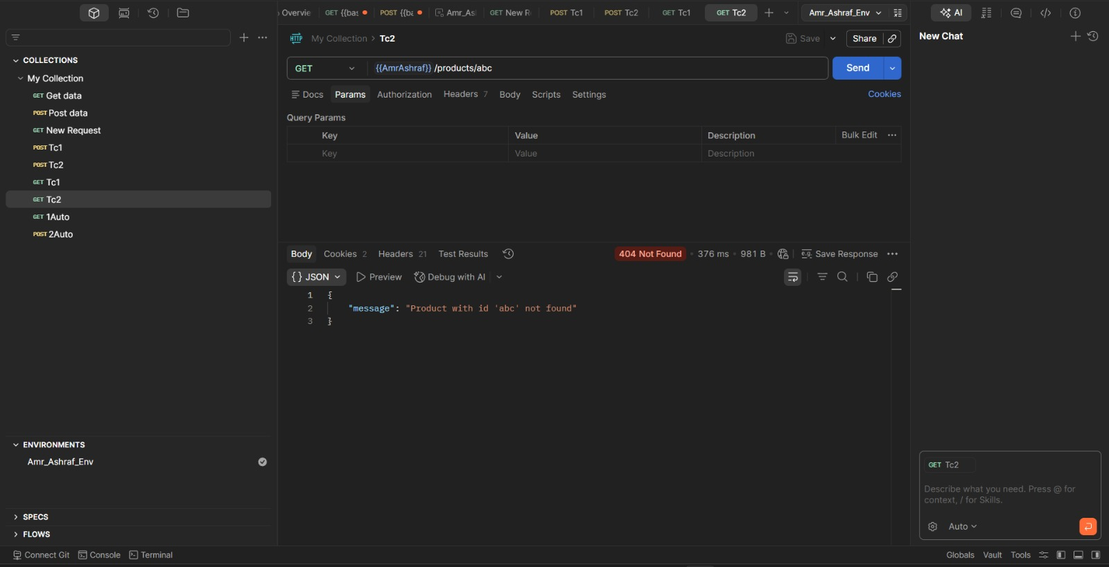
- API 2 — POST {{baseUrl}}/auth/login
  - Write 3 test cases.

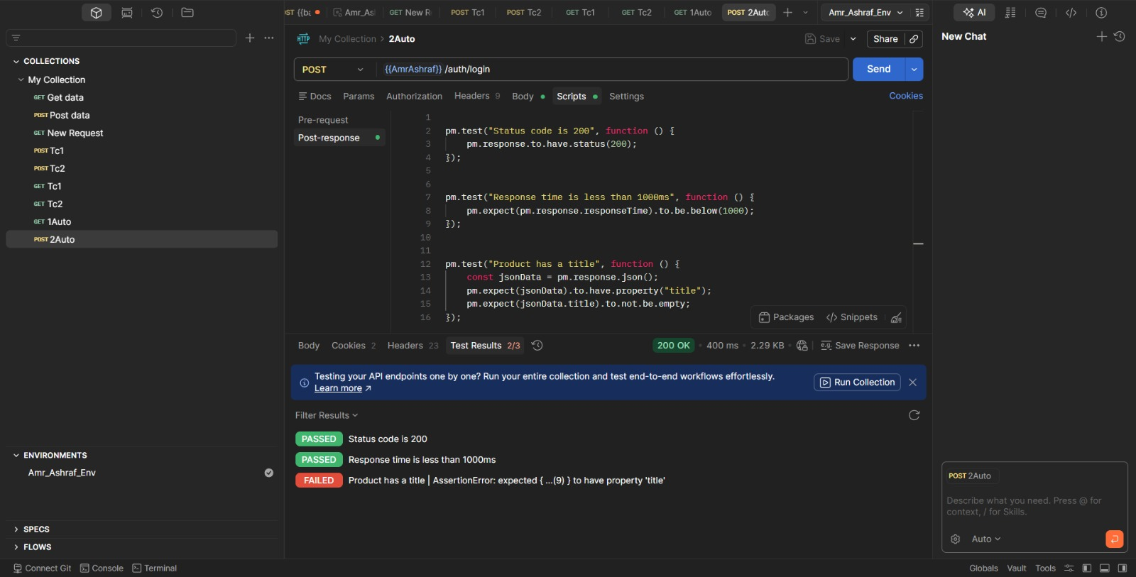
- 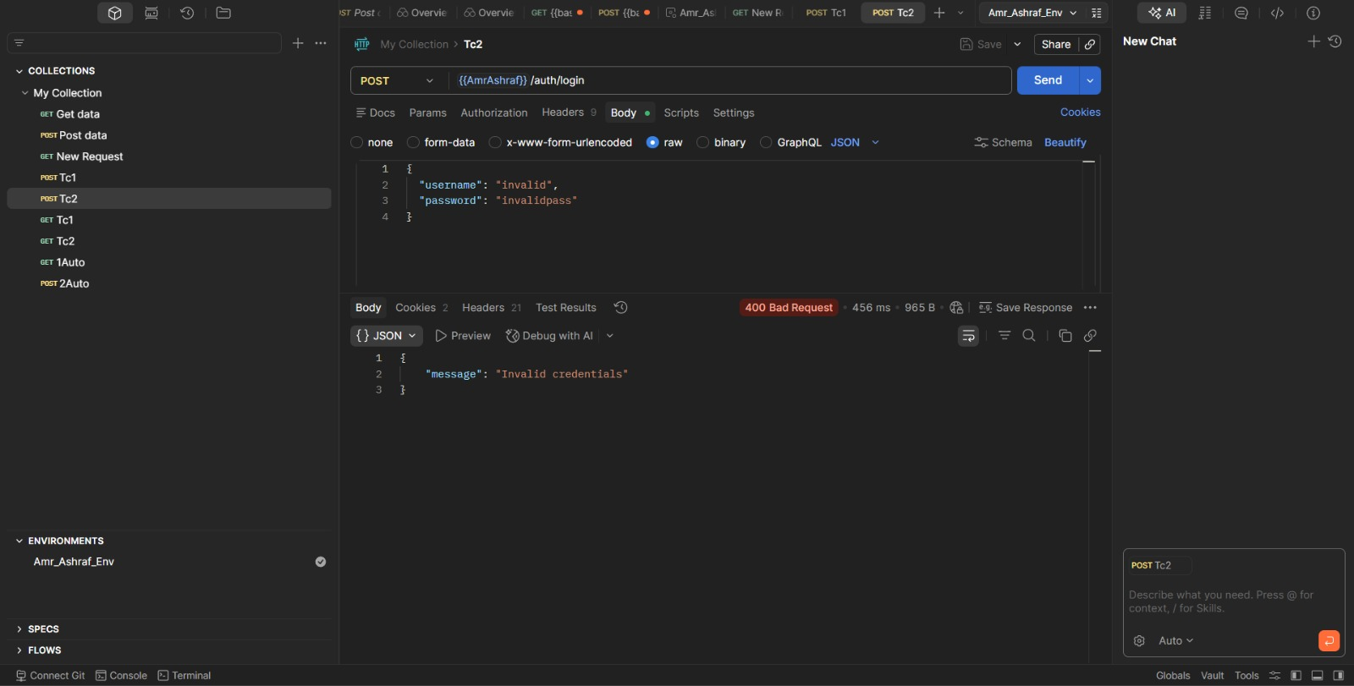

Each test case must include:
- Test Case ID
- Test Case Title
- Pre-conditions
- Steps
- Expected Result
- Test Type (Functional, Negative, Boundary, Performance, Security, etc.)

Question 3 — Automation Test Cases (7 Marks)
Write automation scripts in Scripts
API 1 — GET {{baseUrl}}/products/1
Write 3 automated tests:
- Status code = 200
- Response time < 1000ms
- Product has a title

API 2 — POST {{baseUrl}}/auth/login
Write 2 automated tests:
- Login successful (status = 200)
- Token exists
Deliverable:
Screenshot 3: Test Results tab showing PASS/FAIL.
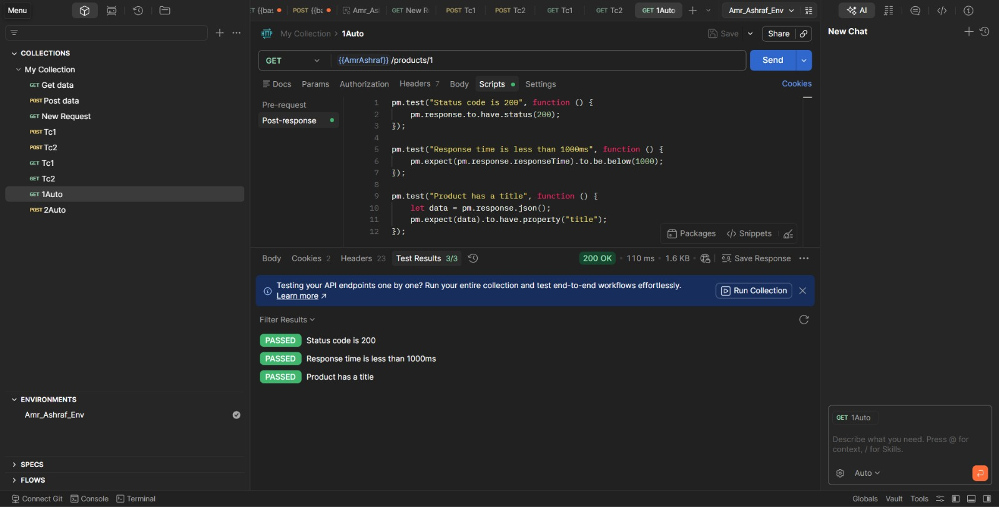
Screenshot 4: Your Post-response script.


Question 4 — Bug Reports (3 Marks)
Write 3 bug reports for three different bugs you discovered while testing DummyJSON.
If you didn’t find real bugs, you may write hypothetical bugs based on incorrect responses, missing fields, wrong data types, etc.
Bug 1
- Title: Login fails using documented credentials
- Description: The credentials provided in the documentation do not authenticate successfully
- Expected: User logs in with valid credentials
- Actual: API returns invalid credentials error

Bug 2
- Title: No validation for empty login fields
- Description: The API processes requests even when username and password are empty
- Expected: API should reject the request with a validation error
- Actual: Request is accepted or not properly handled

Bug 3
- Title: Inconsistent token field in response
- Description: The login response sometimes returns different field names for the token
- Expected: Response should always use a consistent field name
- Actual: Field name varies between responses

