**Project Description**

**Bug Tracking System**

**Project consists of 4 module :-**

**1-Tester Module**

a. Enables tester to define bug name, bug type, priority, bug level, project name, bug date, status.

b. Enables tester to assign bug to developer.

c. Enables tester to attach screenshot of bug.

d. Enables tester to monitor open and closed bugs

e. System will send email automatically to assigned developer with bug details.

**2-Developer Module**

a. Enables developer to view assigned bugs

b. Enables developer to change status of bug after finishing it.

c. System will send email automatically to tester when developer changed status of bug to complete

**3-Project Manager Module**

a. Enables PM to check performance of developers and testers.

b. Enables PM to monitor open and closed bugs.

**4- Admin Module**

a. Enables admin to view all bugs of project.

b. Enables admin to add / update / delete users with different roles.

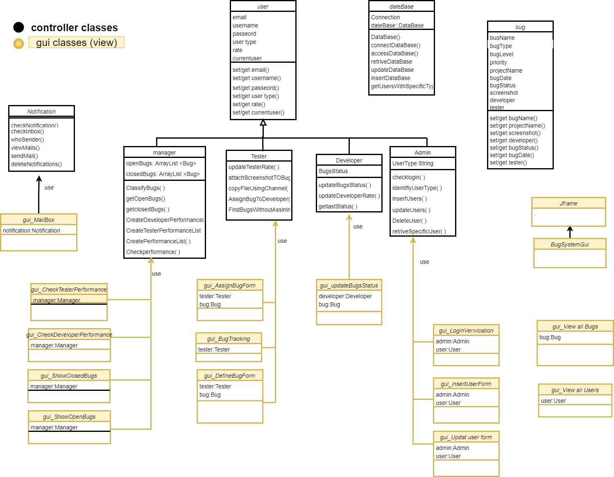**Class diagram**

**Selected design pattern**

**Creational : singleton pattern**

**Context:**

For class should only one instance exist ( singleton ) . .

**Problem:**

How do you ensure that it is never possible to create more than one instance of a (ADMIN CLASS) And provide a global point of access to it .

**Forces:**

*The use of a private constructor cannot guarantee that no more than one instance willcreated

*The singleton instance must also be accessible to all classes that require it , therefore it must often be public .

**Solution :**

**•**Have the admin class constructor private to ensure that no other class will be able to create an instance of the admin class .

• Define a public static method called GetInstance() , The first time this method is called , it creates the single instance of the class " Admin " and stores a reference to that object in a static private variable CALEED admin

