**1.Implementation of Singleton Pattern:**

Logger.java  
public class Logger {

    private static Logger instance;

    private Logger() {

        System.out.println("Logger Initialized");

    }

    public static Logger getInstance() {

        if (instance == null) {

            instance = new Logger();

        }

        return instance;

    }

    public void log(String message) {

        System.out.println("Log: " + message);

    }

}

Main.java( Test Class)

public class Main {

    public static void main(String[] args) {

        Logger logger1 = Logger.getInstance();

        logger1.log("Hello from logger1");

        Logger logger2 = Logger.getInstance();

        logger2.log("Hello from logger2");

        if (logger1 == logger2) {

            System.out.println("Same Logger instance");

        } else {

            System.out.println("Different Logger instances");

        }

    }

}

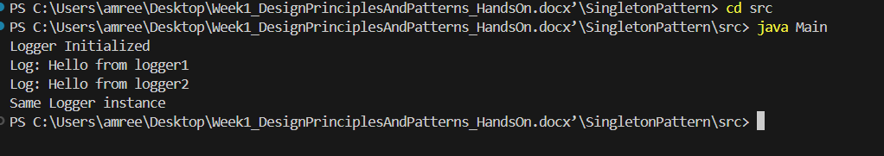Output:

**2.Implementation of Factory Method Pattern:**

Document.java (Interface)

public interface Document {

void open();

}

**Concrete Document Classes:**

WordDocument.java

public class WordDocument implements Document {

public void open() {

System.out.println("Opening Word Document");

}

}

ExcelDocument.java

public class ExcelDocument implements Document {

public void open() {

System.out.println("Opening Excel Document");

}

}

DocumentFactory.java (Abstract Factory)

public abstract class DocumentFactory {

public abstract Document createDocument();

}

**Concrete Factory Classes:**

WordDocumentFactory.java

public class WordDocumentFactory extends DocumentFactory {

public Document createDocument() {

return new WordDocument();

}

}

PdfDocumentFactory.java

public class PdfDocumentFactory extends DocumentFactory {

public Document createDocument() {

return new PdfDocument();

}

}

ExcelDocumentFactory.java

public class ExcelDocumentFactory extends DocumentFactory {

public Document createDocument() {

return new ExcelDocument();

}

}

Main.java (Test Class)

public class Main {

public static void main(String[] args) {

// Create and open a Word document

DocumentFactory wordFactory = new WordDocumentFactory();

Document wordDoc = wordFactory.createDocument();

wordDoc.open();

// Create and open a PDF document

DocumentFactory pdfFactory = new PdfDocumentFactory();

Document pdfDoc = pdfFactory.createDocument();

pdfDoc.open();

// Create and open an Excel document

DocumentFactory excelFactory = new ExcelDocumentFactory();

Document excelDoc = excelFactory.createDocument();

excelDoc.open();

}

}

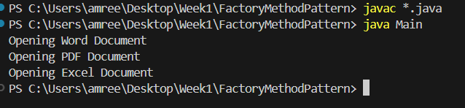**Output:**