**Exercise 1**:

Logging Error Messages and Warning Levels

Task:

Write a Java application that demonstrates logging error messages and warning levels using SLF4J.

Add SLF4J and Logback dependencies to your `pom.xml` file

<!-- SLF4J API -->

<dependency>

<groupId>org.slf4j</groupId>

<artifactId>slf4j-api</artifactId>

<version>2.0.13</version>

</dependency>

<!-- Logback as the implementation -->

<dependency>

<groupId>ch.qos.logback</groupId>

<artifactId>logback-classic</artifactId>

<version>1.4.14</version>

</dependency>

Create a Java class that uses SLF4J for logging:

**DemoApplication.java:**

package com.example.demo;

import org.springframework.boot.SpringApplication;

import org.springframework.boot.autoconfigure.SpringBootApplication;

import org.slf4j.Logger;

import org.slf4j.LoggerFactory;

@SpringBootApplication

public class DemoApplication {

// Logger declaration

private static final Logger logger = LoggerFactory.getLogger(DemoApplication.class);

public static void main(String[] args) {

SpringApplication.run(DemoApplication.class, args);

// Logging examples

logger.error("This is an ERROR level log");

logger.warn("This is a WARN level log");

logger.info("This is an INFO level log");

logger.debug("This is a DEBUG level log"); // May not show unless log level is DEBUG

}

}

**Output:**

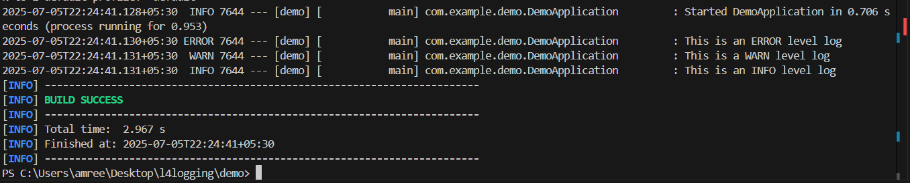

2025-07-05T22:24:41.130+05:30 ERROR 7644 --- [demo] [ main] com.example.demo.DemoApplication : This is an ERROR level log

2025-07-05T22:24:41.131+05:30 WARN 7644 --- [demo] [ main] com.example.demo.DemoApplication : This is a WARN level log

2025-07-05T22:24:41.131+05:30 INFO 7644 --- [demo] [ main] com.example.demo.DemoApplication : This is an INFO level log