**Week3 Handson**

**Spring Data JPA with Spring Boot,Hibernate**

**Spring Data JPA - Quick Example**   
   
Create a Eclipse Project using Spring Initialize

* Change Group as “com.cognizant”
* Change Artifact Id as “orm-learn”
* In Options > Description enter "Demo project for Spring Data JPA and Hibernate"
* Click on menu and select "Spring Boot DevTools", "Spring Data JPA" and "MySQL Driver"
* Click Generate and download the project as zip
* Extract the zip in root folder to Eclipse Workspace
* Import the project in Eclipse "File > Import > Maven > Existing Maven Projects > Click Browse and select extracted folder > Finish"
* Create a new schema "ormlearn" in MySQL database. Execute the following commands to open MySQL client and create schema.

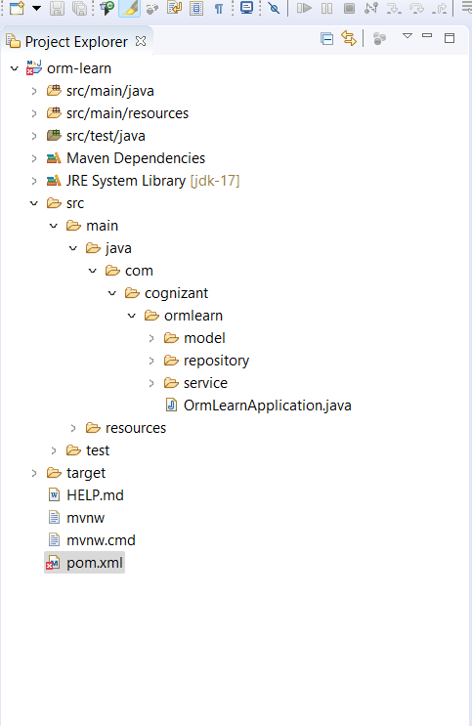application.properties

spring.application.name=orm-learn

# Logging

logging.level.org.springframework=info

logging.level.com.cognizant=debug

logging.level.org.hibernate.SQL=trace

logging.level.org.hibernate.type.descriptor.sql=trace

logging.pattern.console=%d{dd-MM-yy} %d{HH:mm:ss.SSS} %-20.20thread %5p %-25.25logger**{25}** %25M %4L %m%n

# DB Config

spring.datasource.driver-class-name=com.mysql.cj.jdbc.Driver

spring.datasource.url=jdbc:mysql://localhost:3306/ormlearn

spring.datasource.username=root

spring.datasource.password=password

# Hibernate

spring.jpa.hibernate.ddl-auto=validate

spring.jpa.properties.hibernate.dialect=org.hibernate.dialect.MySQLDialect

In model:

Country.java

**package** com.cognizant.ormlearn.model;

**import** jakarta.persistence.*;

@Entity

@Table(name = "country")

**public** **class** Country {

@Id

@Column(name = "co_code")

**private** String code;

@Column(name = "co_name")

**private** String name;

// Getters and Setters

**public** String getCode() {

**return** code;

}

**public** **void** setCode(String code) {

**this**.code = code;

}

**public** String getName() {

**return** name;

}

**public** **void** setName(String name) {

**this**.name = name;

}

// toString

@Override

**public** String toString() {

**return** "Country [code=" + code + ", name=" + name + "]";

}

}

In repository

CountryRepository.java

**package** com.cognizant.ormlearn.repository;

**import** org.springframework.data.jpa.repository.JpaRepository;

**import** org.springframework.stereotype.Repository;

**import** com.cognizant.ormlearn.model.Country;

@Repository

**public** **interface** CountryRepository **extends** JpaRepository<Country, String> {

}

In service

CountryService.java

**package** com.cognizant.ormlearn.service;

**import** java.util.List;

**import** jakarta.transaction.Transactional;

**import** org.springframework.beans.factory.annotation.Autowired;

**import** org.springframework.stereotype.Service;

**import** com.cognizant.ormlearn.model.Country;

**import** com.cognizant.ormlearn.repository.CountryRepository;

@Service

**public** **class** CountryService {

@Autowired

**private** CountryRepository countryRepository;

@Transactional

**public** List<Country> getAllCountries() {

**return** countryRepository.findAll();

}

}

**OrmLearnApplication.java**

**package** com.cognizant.ormlearn;

**import** java.util.List;

**import** org.slf4j.Logger;

**import** org.slf4j.LoggerFactory;

**import** org.springframework.boot.SpringApplication;

**import** org.springframework.boot.autoconfigure.SpringBootApplication;

**import** org.springframework.context.ApplicationContext;

**import** com.cognizant.ormlearn.model.Country;

**import** com.cognizant.ormlearn.service.CountryService;

@SpringBootApplication

**public** **class** OrmLearnApplication {

**private** **static** **final** Logger ***LOGGER*** = LoggerFactory.*getLogger*(OrmLearnApplication.**class**);

**private** **static** CountryService *countryService*;

**public** **static** **void** main(String[] args) {

ApplicationContext context = SpringApplication.*run*(OrmLearnApplication.**class**, args);

***LOGGER***.info("Inside main");

*countryService* = context.getBean(CountryService.**class**);

*testGetAllCountries*();

}

**private** **static** **void** testGetAllCountries() {

***LOGGER***.info("Start");

List<Country> countries = *countryService*.getAllCountries();

***LOGGER***.debug("countries={}", countries);

***LOGGER***.info("End");

}

}

pom.xml

<?xml version=*"1.0"* encoding=*"UTF-8"*?>

<project xmlns=*"http://maven.apache.org/POM/4.0.0"*

xmlns:xsi=*"http://www.w3.org/2001/XMLSchema-instance"*

xsi:schemaLocation=*"http://maven.apache.org/POM/4.0.0 https://maven.apache.org/xsd/maven-4.0.0.xsd"*>

<modelVersion>4.0.0</modelVersion>

<parent>

<groupId>org.springframework.boot</groupId>

<artifactId>spring-boot-starter-parent</artifactId>

<version>3.2.4</version> <!-- Stable release -->

<relativePath/> <!-- lookup parent from repository -->

</parent>

<groupId>com.cognizant</groupId>

<artifactId>orm-learn</artifactId>

<version>0.0.1-SNAPSHOT</version>

<name>orm-learn</name>

<description>Demo project for Spring Data JPA and Hibernate</description>

<properties>

<java.version>17</java.version>

</properties>

<dependencies>

<!-- Core Spring Boot -->

<dependency>

<groupId>org.springframework.boot</groupId>

<artifactId>spring-boot-starter</artifactId>

</dependency>

<!-- Spring Data JPA -->

<dependency>

<groupId>org.springframework.boot</groupId>

<artifactId>spring-boot-starter-data-jpa</artifactId>

</dependency>

<!-- MySQL Driver -->

<dependency>

<groupId>com.mysql</groupId>

<artifactId>mysql-connector-j</artifactId>

<scope>runtime</scope>

</dependency>

<!-- DevTools for hot reload -->

<dependency>

<groupId>org.springframework.boot</groupId>

<artifactId>spring-boot-devtools</artifactId>

<scope>runtime</scope>

</dependency>

<!-- Testing -->

<dependency>

<groupId>org.springframework.boot</groupId>

<artifactId>spring-boot-starter-test</artifactId>

<scope>test</scope>

</dependency>

</dependencies>

<build>

<plugins>

<!-- Spring Boot Plugin -->

<plugin>

<groupId>org.springframework.boot</groupId>

<artifactId>spring-boot-maven-plugin</artifactId>

</plugin>

<!-- Maven Clean Plugin (compatible with 3.6.2) -->

<plugin>

<groupId>org.apache.maven.plugins</groupId>

<artifactId>maven-clean-plugin</artifactId>

<version>3.1.0</version>

</plugin>

</plugins>

</build>

</project>

**Country table creation**

Create a new table country with columns for code and name. For sample, let us insert one country with values 'IN' and 'India' in this table.

create table country(co_code varchar(2) primary key, co_name varchar(50));

* Insert couple of records into the table

insert into country values ('IN', 'India');

insert into country values ('US', 'United States of America');

This has to be done in mysql command line

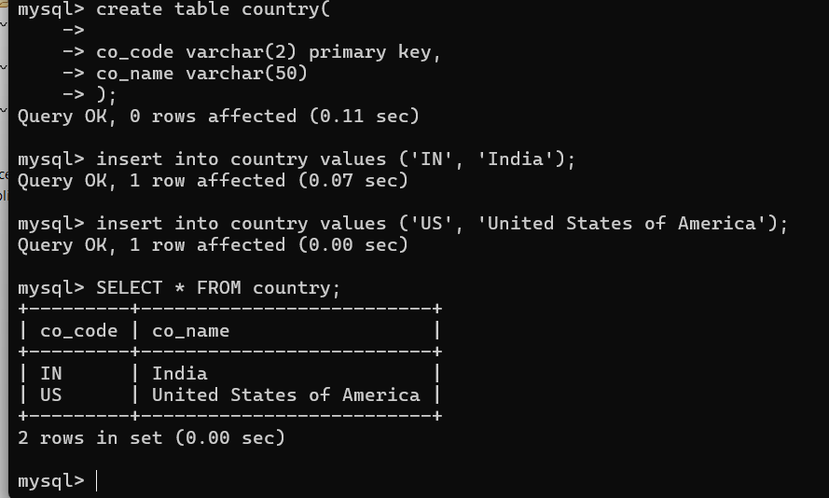

SpringBoot successfully initialized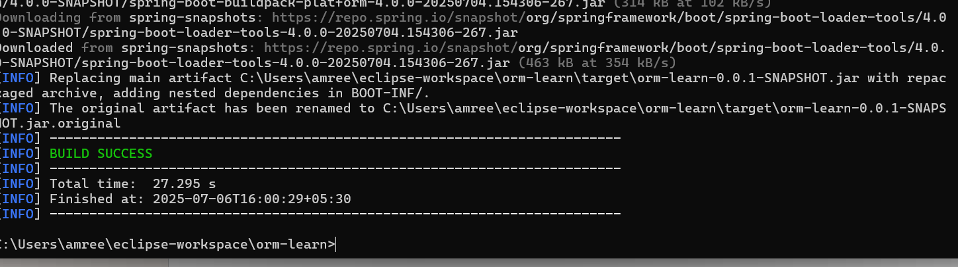

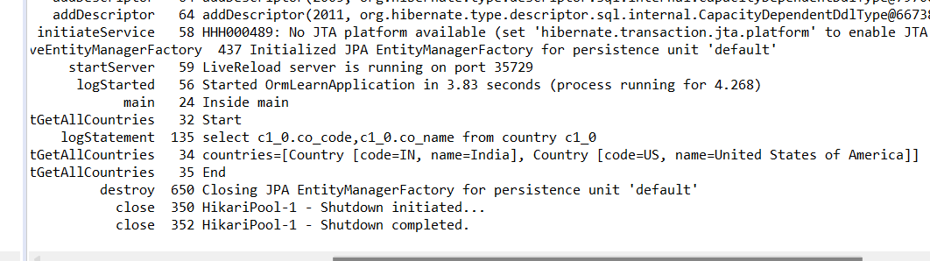

Hence, mysql is connected to Spring Boot and the data is fetched from there.

**Task:** Fetch entries from the country table using Spring Data JPA

* Implemented Country entity and JPA repository
* Configured OrmLearnApplication to fetch and print all countries on startup.
* Verified output in console:

countries=[Country [code=IN, name=India], Country [code=US, name=United States of America]]

* Application started using Spring Boot 3.2.4 and Java 17
* Database connection was successful via HikariCP.

**Difference between JPA, Hibernate and Spring Data JPA** 

Java Persistence API (JPA)

* JSR 338 Specification for persisting, reading and managing data from Java objects
* Does not contain concrete implementation of the specification
* Hibernate is one of the implementation of JPA

Hibernate

* ORM Tool that implements JPA

Spring Data JPA

* Does not have JPA implementation, but reduces boiler plate code
* This is another level of abstraction over JPA implementation provider like Hibernate
* Manages transactions.

Hibernate Approach

/* Method to CREATE an employee in the database using Hibernate */

public Integer addEmployee(Employee employee) {

Session session = factory.openSession();

Transaction tx = null;

Integer employeeID = null;

try {

tx = session.beginTransaction();

employeeID = (Integer) session.save(employee);

tx.commit();

} catch (HibernateException e) {

if (tx != null) tx.rollback();

e.printStackTrace();

} finally {

session.close();

}

return employeeID;

}

**Spring Data JPA Approach**

EmployeeRepository.java

import org.springframework.data.jpa.repository.JpaRepository;

import org.springframework.stereotype.Repository;

import com.cognizant.ormlearn.model.Employee;

@Repository

public interface EmployeeRepository extends JpaRepository<Employee, Integer> {

}

EmployeeService.java

import org.springframework.beans.factory.annotation.Autowired;

import org.springframework.stereotype.Service;

import org.springframework.transaction.annotation.Transactional;

import com.cognizant.ormlearn.model.Employee;

import com.cognizant.ormlearn.repository.EmployeeRepository;

@Service

public class EmployeeService {

@Autowired

private EmployeeRepository employeeRepository;

@Transactional

public void addEmployee(Employee employee) {

employeeRepository.save(employee);

}

}

**Expected Output:**

* A new **row is inserted** into the employee table in the MySQL database.
* The method returns the **auto-generated primary key ID** of the inserted employee (e.g., 1, 2, etc.).
* Console/log output will show Hibernate-generated SQL like:

Hibernate: insert into employee (name, salary) values (?, ?)

**Expected Output:**

* The employee is also **inserted into the database**, same as Hibernate.
* The save() method of JpaRepository handles both insert and update.
* No need to return the ID explicitly unless you want to.
* Console/log (with logging enabled) shows:
* Hibernate: insert into employee (name, salary) values (?, ?)

Employee emp = new Employee();

emp.setName("Alice");

emp.setSalary(30000);

Row inserted: (id=1, name='Alice', salary=30000)