**Week 5 Handson**

**Microservices with Spring Boot 3 and Spring Cloud**

Microservices with API gateway

**Creating microservices for account and loan:**

Creation of Folders:

In D drive, I have created these folders

D:\g5\microservices

Create Account Microservice:

Generation of Project from Spring Initializr

Group: com.cognizant

Artifact: account

Name: account

Adding dependencies:

Spring Web

Spring Boot DevTools

After that I generated it and downloaded a zip file which is ‘account’ folder.

I have also moved the account folder to

D:\123456\microservices

So, now to build the project in command prompt:

I have navigated to the folder:

D:\123456\microservices\account

mvn clean package

This is executed and I have build the required project.

I need to create two microservices:

AccountController

LoanController

**AccountController.java**

**package** com.cognizant.account;

**import** org.springframework.web.bind.annotation.GetMapping;

**import** org.springframework.web.bind.annotation.PathVariable;

**import** org.springframework.web.bind.annotation.RequestMapping;

**import** org.springframework.web.bind.annotation.RestController;

**import** java.util.Map;

@RestController

@RequestMapping("/accounts")

**public** **class** AccountController {

@GetMapping("/{number}")

**public** Map<String, Object> getAccountDetails(@PathVariable String number) {

**return** Map.*of*(

"number", number,

"type", "savings",

"balance", 234343

);

}

}

When I run this :

<http://localhost:8080/accounts/00987987973432>

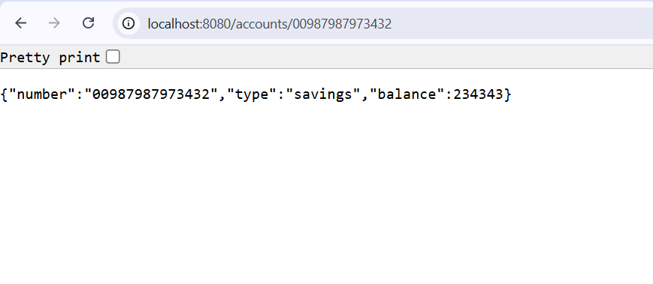Output:

Second microservice is for Loan:

**LoanController.java**

package com.cognizant.account;

import org.springframework.web.bind.annotation.GetMapping;

import org.springframework.web.bind.annotation.PathVariable;

import org.springframework.web.bind.annotation.RequestMapping;

import org.springframework.web.bind.annotation.RestController;

import java.util.Map;

@RestController

@RequestMapping("/loans")

public class LoanController {

@GetMapping("/{number}")

public Map<String, Object> getLoanDetails(@PathVariable String number) {

return Map.*of*(

"number", number,

"type", "car",

"loan", 400000,

"emi", 3258,

"tenure", 18

);

}

}

When I run this,I get:

**http://localhost:8081/loans/H00987987972342**

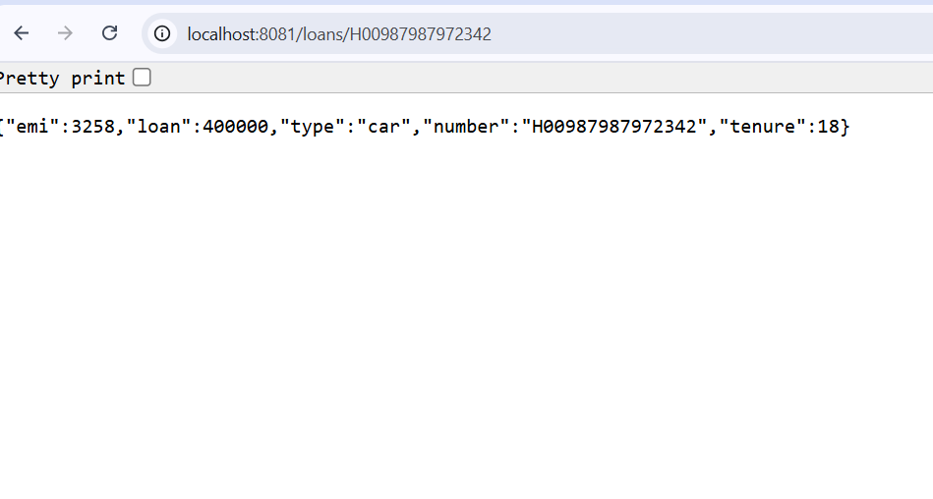**AccountApplication.java**

package com.cognizant.account;

import org.springframework.boot.SpringApplication;

import org.springframework.boot.autoconfigure.SpringBootApplication;

@SpringBootApplication

public class AccountApplication {

public static void main(String[] args) {

SpringApplication.run(AccountApplication.class, args);

}

}

In this way,I have created two microservices individually.

Also

In application.properties:

spring.application.name=account

server.port=8081

For another microservice for loan,

I have used server port number 8081 to get no conflict.