**Week-7 Handson**

**React**

**9.ReactJS-HOL**

Created an application named “cricketapp” with the following components:

1. ListofPlayers

*Declare an array with 11 players and store details of their names and scores using the map feature of ES6

*Filter the players with scores below 70 using arrow functions of ES6.

// src/components/ListofPlayers.js

import React from "react";

const ListofPlayers = () => {

  const players = [

    { name: "Virat", score: 80 },

    { name: "Rohit", score: 45 },

    { name: "Rahul", score: 90 },

    { name: "Dhawan", score: 60 },

    { name: "Pant", score: 100 },

    { name: "Jadeja", score: 30 },

    { name: "Ashwin", score: 75 },

    { name: "Shami", score: 65 },

    { name: "Bumrah", score: 40 },

    { name: "Chahal", score: 50 },

    { name: "Kohli", score: 85 },

  ];

  // Filter players with score < 70 using arrow function

  const filteredPlayers = players.filter(player => player.score < 70);

  return (

    <div>

      <h2>All Players</h2>

      <ul>

        {players.map((player, index) => (

          <li key={index}>

            {player.name} - {player.score}

          </li>

        ))}

      </ul>

      <h2>Players with Score below 70</h2>

      <ul>

        {filteredPlayers.map((player, index) => (

          <li key={index}>

            {player.name} - {player.score}

          </li>

        ))}

      </ul>

    </div>

  );

};

export default ListofPlayers;

2.IndianPlayers

*Display the Odd Team Player and Even Team players using the Destructuring features of ES6

*Declare two arrays T20players and RanjiTrophy players and merge the two arrays and display them using the Merge feature of ES6

// src/components/IndianPlayers.js

import React from "react";

const IndianPlayers = () => {

  const oddTeam = ["Virat", "Rahul", "Pant", "Ashwin", "Chahal"];

  const evenTeam = ["Rohit", "Dhawan", "Jadeja", "Shami", "Bumrah", "Kohli"];

  // Destructuring example

  const [odd1, odd2, ...restOdd] = oddTeam;

  const [even1, even2, ...restEven] = evenTeam;

  const T20Players = ["Virat", "Rohit", "Pant"];

  const RanjiPlayers = ["Sundar", "Pujara", "Iyer"];

  // Merging using spread

  const allPlayers = [...T20Players, ...RanjiPlayers];

  return (

    <div>

      <h2>Odd Team Players</h2>

      <ul>

        <li>{odd1}</li>

        <li>{odd2}</li>

        {restOdd.map((player, index) => (

          <li key={index}>{player}</li>

        ))}

      </ul>

      <h2>Even Team Players</h2>

      <ul>

        <li>{even1}</li>

        <li>{even2}</li>

        {restEven.map((player, index) => (

          <li key={index}>{player}</li>

        ))}

      </ul>

      <h2>All Players (Merged)</h2>

      <ul>

        {allPlayers.map((player, index) => (

          <li key={index}>{player}</li>

        ))}

      </ul>

    </div>

  );

};

export default IndianPlayers;

**Output:**

When Flag=true

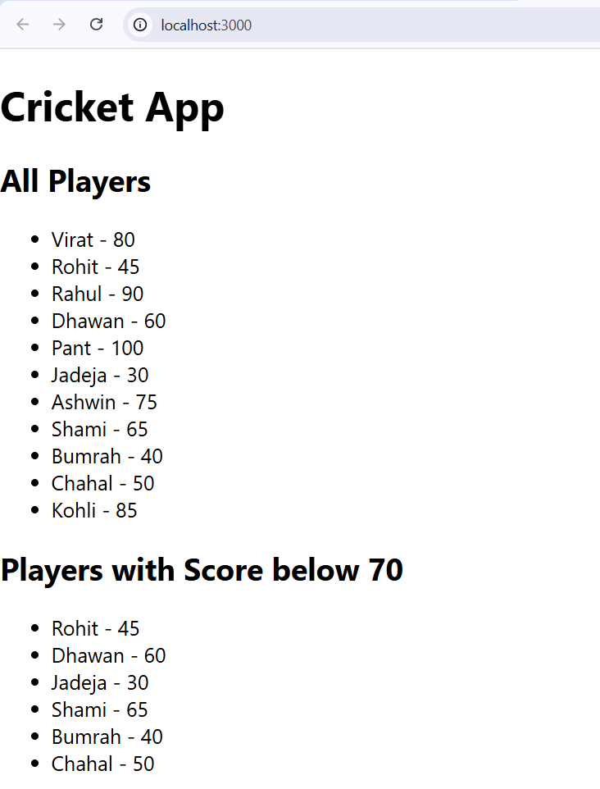

Output:  
flag=false;

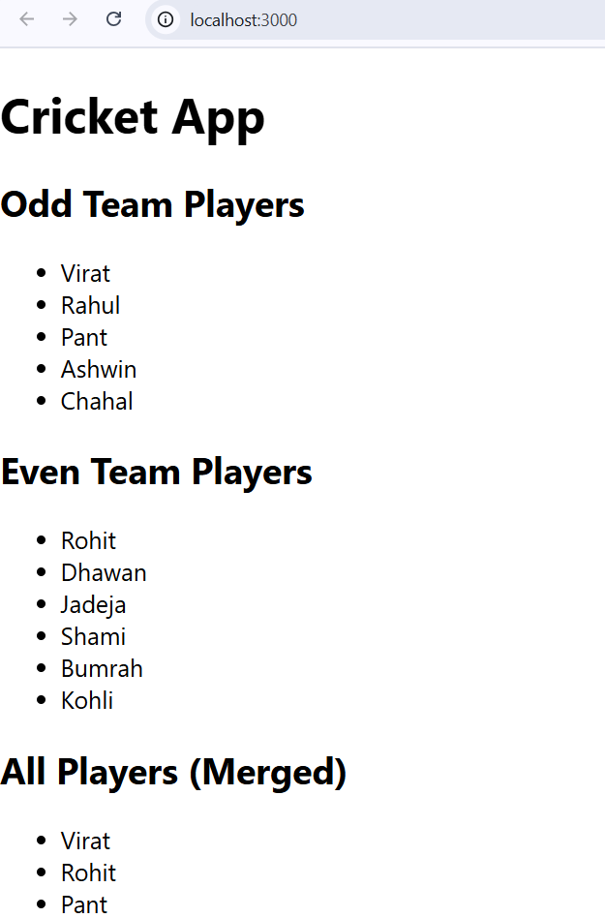

**10.ReactJS-HOL:**

Created a React Application named “officespacerentalapp” which uses React JSX to create elements, attributes and renders DOM to display the page.

Created an element to display the heading of the page.

Attribute to display the image of the office space

Create an object of office to display the details like Name, Rent and Address.

Create a list of Object and loop through the office space item to display more data.

To apply Css, Display the color of the Rent in Red if it’s below 60000 and in Green if it’s above 60000.

In src/components:

**OfficeList.js:**

import React from 'react';

import './OfficeList.css';

const offices = [

  {

    name: "Galaxy Towers",

    rent: 55000,

    address: "Banjara Hills, Hyderabad",

    image: "/images/img1.jpg"

  },

  {

    name: "Tech Hub",

    rent: 75000,

    address: "Hitech City, Hyderabad",

    image: "/images/img2.jpg"

  }

];

const OfficeList = () => {

  return (

    <div className="container">

      <h1>Office Space Rental App</h1>

      <div className="card-container">

        {offices.map((office, index) => (

          <div key={index} className="card">

            <img src={office.image} alt={office.name} />

            <h2>{office.name}</h2>

            <p><strong>Address:</strong> {office.address}</p>

            <p className={office.rent < 60000 ? 'red' : 'green'}>

              <strong>Rent:</strong> ₹{office.rent}

            </p>

          </div>

        ))}

      </div>

    </div>

  );

};

export default OfficeList;

OfficeList.css

.container {

  text-align: center;

  font-family: Arial, sans-serif;

  margin-top: 20px;

}

h1 {

  font-size: 28px;

  margin-bottom: 30px;

}

.card-container {

  display: flex;

  justify-content: center;

  flex-wrap: wrap; /* allows wrapping on smaller screens */

  gap: 20px;       /* space between cards */

}

.card {

  border: 1px solid #ccc;

  border-radius: 10px;

  padding: 16px;

  width: 300px;        /* fixed width for cards side by side */

  box-shadow: 0 4px 8px rgba(0,0,0,0.1);

  text-align: left;

  background-color: #fff;

}

.card img {

  width: 100%;

  height: 180px;

  object-fit: cover;

  border-radius: 10px;

}

.card h2 {

  margin-top: 12px;

  margin-bottom: 8px;

  font-size: 20px;

}

.card p {

  margin: 4px 0;

  font-size: 16px;

}

.red {

  color: red;

  font-weight: bold;

}

.green {

  color: green;

  font-weight: bold;

}

**App.js:**

// src/App.js

import React from "react";

import OfficeList from "./components/OfficeList";

function App() {

  return (

    <div className="App">

      <h1> </h1>

      <OfficeList />

    </div>

  );

}

export default App;

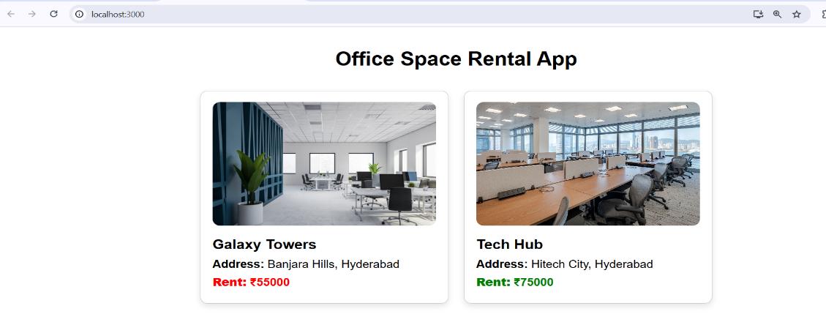Output:

**11.ReactJS-HOL:**

Created a React Application “eventexamplesapp” to handle various events of the form elements in HTML.

1. Create “Increment” button to increase the value of the counter and “Decrement” button to decrease the value of the counter. The “Increase” button should invoke multiple methods.
   1. To increment the value
   2. Say Hello followed by a static message.

App.js:

import React, { Component } from 'react';

import CurrencyConvertor from './CurrencyConvertor';

import './App.css'; // Import the CSS for styling

class App extends Component {

  constructor(props) {

    super(props);

    this.state = {

      counter: 0,

    };

  }

  increment = () => {

    this.setState((prevState) => ({

      counter: prevState.counter + 1,

    }), () => {

      this.sayHello("Have a great day!");

    });

  };

  decrement = () => {

    this.setState((prevState) => ({

      counter: prevState.counter - 1,

    }));

  };

  sayHello = (message) => {

    console.log("Hello! " + message);

  };

  sayWelcome = (msg) => {

    alert("Message: " + msg);

  };

  handleClick = (event) => {

    alert("I was clicked");

    console.log("Synthetic event object:", event);

  };

  render() {

    return (

      <div className="container">

        <h1>Event Handling in React</h1>

        <h2>Counter: {this.state.counter}</h2>

        <div className="button-row">

          <button onClick={this.increment}>Increment</button>

          <button onClick={this.decrement}>Decrement</button>

        </div>

        <div className="button-row">

          <button onClick={() => this.sayWelcome("welcome")}>Say Welcome</button>

          <button onClick={this.handleClick}>OnPress</button>

        </div>

        <CurrencyConvertor />

      </div>

    );

  }

}

export default App;

CurrencyConvertor.js:

import React, { useState } from 'react';

function CurrencyConvertor() {

  const [rupees, setRupees] = useState('');

  const [euro, setEuro] = useState('');

  const handleSubmit = () => {

    const rate = 0.011; // ₹1 = €0.011 (example rate)

    const converted = parseFloat(rupees) * rate;

    setEuro(converted.toFixed(2));

  };

  return (

    <div style={{ marginTop: '30px' }}>

      <h2>Currency Converter:</h2>

      <input

        type="number"

        value={rupees}

        onChange={(e) => setRupees(e.target.value)}

        placeholder="Enter INR"

      />

      <button onClick={handleSubmit} style={{ marginLeft: '10px' }}>

        Convert

      </button>

      {euro && <p>Converted: €{euro}</p>}

    </div>

  );

}

export default CurrencyConvertor;

Output:

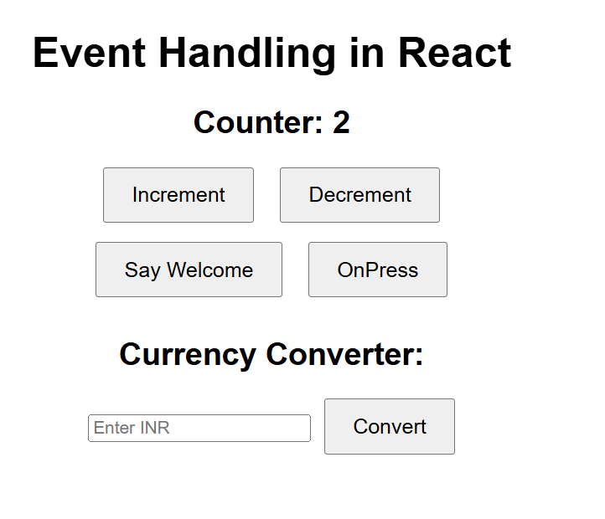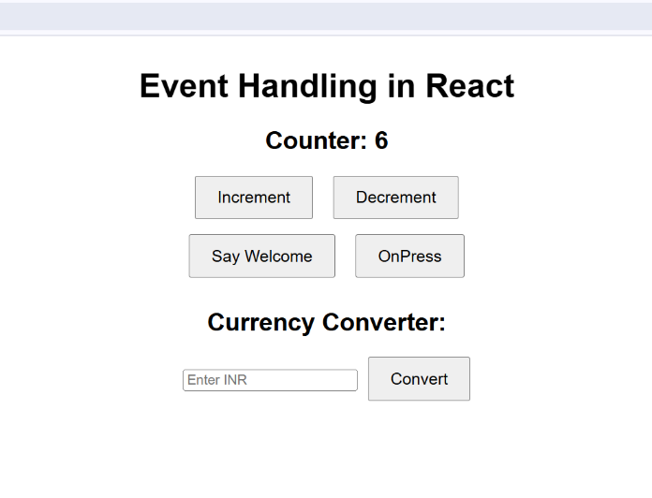

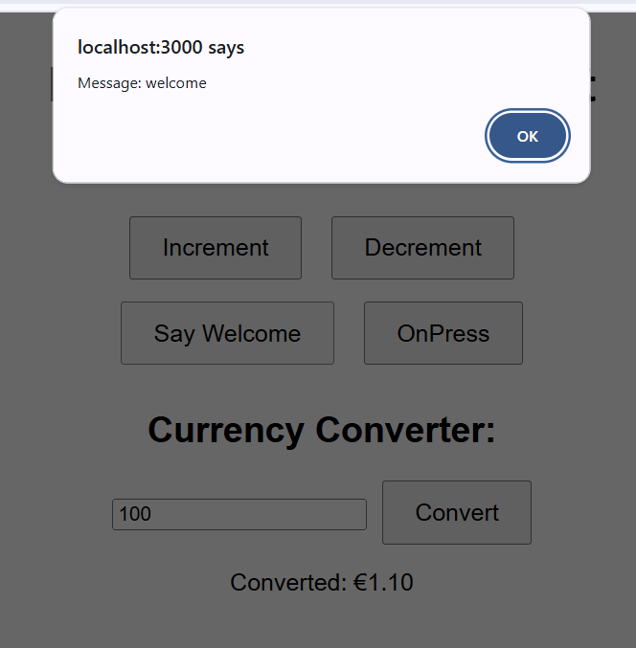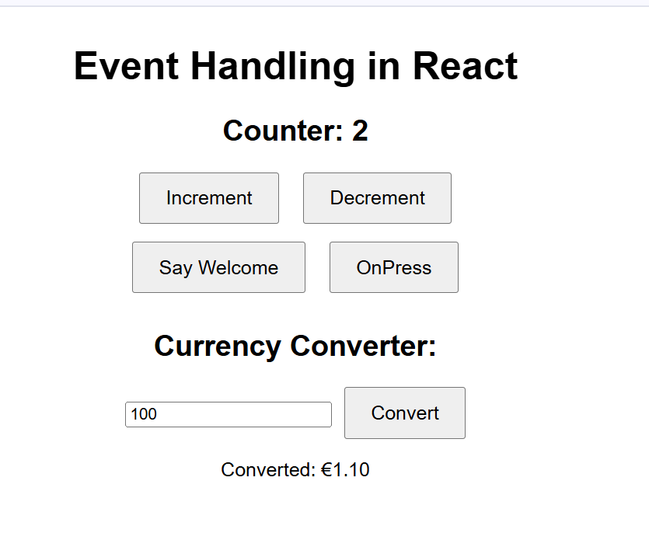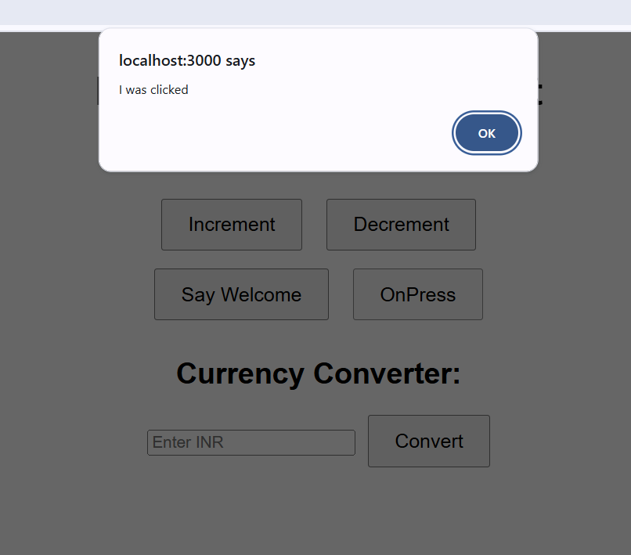

**12.ReactJS-HOL:**

Created a React Application named “ticketbookingapp” where the guest user can browse the page where the flight details are displayed whereas the logged in user only can book tickets.

The Login and Logout buttons should accordingly display different pages. Once the user is logged in the User page should be displayed. When the user clicks on Logout, the Guest page should be displayed.

**App.js**

import React, { useState } from 'react';

import GuestPage from './GuestPage';

import UserPage from './UserPage';

import './App.css';

function App() {

  const [isLoggedIn, setIsLoggedIn] = useState(false);

  const handleLogin = () => {

    setIsLoggedIn(true);

  };

  const handleLogout = () => {

    setIsLoggedIn(false);

  };

  let page;

  if (isLoggedIn) {

    page = <UserPage onLogout={handleLogout} />;

  } else {

    page = <GuestPage onLogin={handleLogin} />;

  }

  return (

    <div className="app-container">

      <h1>Flight Ticket Booking App</h1>

      {page}

    </div>

  );

}

export default App;

**App.css**

.app-container {

  text-align: center;

  font-family: Arial, sans-serif;

  margin-top: 30px;

}

.page {

  border: 1px solid #ccc;

  padding: 20px;

  margin: 30px auto;

  width: 60%;

  border-radius: 10px;

  box-shadow: 0 0 10px #ddd;

}

button {

  margin-top: 15px;

  padding: 10px 20px;

  font-size: 16px;

  cursor: pointer;

}

**GuestPage.js:**

import React from 'react';

function GuestPage({ onLogin }) {

  return (

    <div className="page">

      <h2>Welcome, Guest!</h2>

      <p>You can browse flight details below.</p>

      <ul>

        <li>Flight A: Hyderabad → Delhi</li>

        <li>Flight B: Mumbai → Bangalore</li>

      </ul>

      <button onClick={onLogin}>Login to Book Tickets</button>

    </div>

  );

}

export default GuestPage;

**UserPage.js:**

import React from 'react';

function UserPage({ onLogout }) {

  return (

    <div className="page">

      <h2>Welcome, User!</h2>

      <p>You are logged in. You can now book tickets:</p>

      <ul>

        <li>✅ Booked: Flight A (Hyderabad → Delhi)</li>

        <li>✅ Booked: Flight B (Mumbai → Bangalore)</li>

      </ul>

      <button onClick={onLogout}>Logout</button>

    </div>

  );

}

export default UserPage;

**Output:**

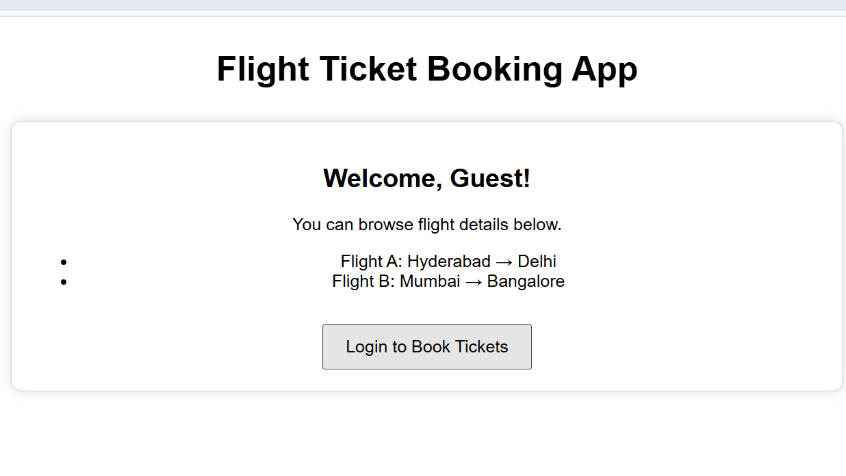

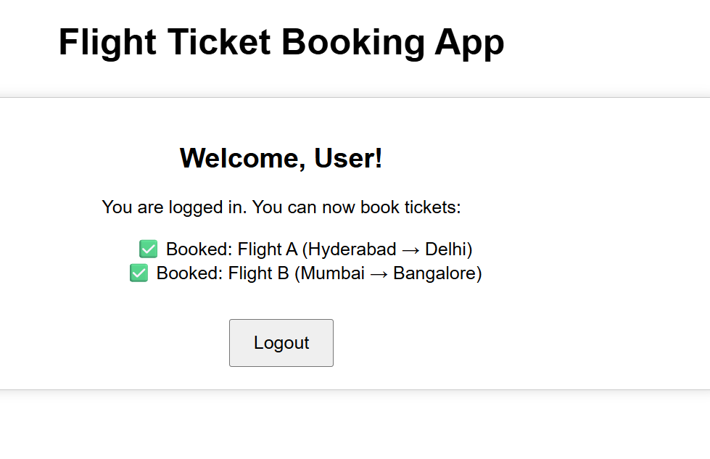

**13.ReactJS-HOL**

Created a React App named “bloggerapp” in with 3 components.

1. Book Details
2. Blog Details
3. Course Details

Implement this with as many ways possible of Conditional Rendering.

App.js:

import React from 'react';

import BookDetails from './BookDetails';

import BlogDetails from './BlogDetails';

import CourseDetails from './CourseDetails';

import './App.css';

function App() {

  return (

    <div className="container">

      <h1>Blogger App</h1>

      <div className="card-row">

        <BookDetails />

        <BlogDetails />

        <CourseDetails />

      </div>

    </div>

  );

}

export default App;

**BlogDetails.js:**

import React from 'react';

const blogs = [

  { id: 101, title: "React Best Practices" },

  { id: 102, title: "Understanding Redux" }

];

function BlogDetails() {

  return (

    <div className="card">

      <h2>Blog Details</h2>

      {blogs.map((blog) => (

        <p key={blog.id}>📝 {blog.title}</p>

      ))}

    </div>

  );

}

export default BlogDetails;

**BookDetails.js**

import React from 'react';

const books = [

  { id: 1, title: "Clean Code", author: "Robert C. Martin" },

  { id: 2, title: "The Pragmatic Programmer", author: "Andy Hunt" }

];

function BookDetails() {

  return (

    <div className="card">

      <h2>Book Details</h2>

      {books.map((book) => (

        <p key={book.id}><strong>{book.title}</strong> by {book.author}</p>

      ))}

    </div>

  );

}

export default BookDetails;

**CourseDetails.js**

import React from 'react';

const courses = [

  { id: 'C1', name: 'ReactJS Essentials' },

  { id: 'C2', name: 'Advanced JavaScript' }

];

function CourseDetails() {

  return (

    <div className="card">

      <h2>Course Details</h2>

      <ul>

        {courses.map((course) => (

          <li key={course.id}>🎓 {course.name}</li>

        ))}

      </ul>

    </div>

  );

}

export default CourseDetails;

Output:

