**Frontend react application**

**Flight-Connection-System**

**ReadMe file:**

IDE to use:

**### Visual Basic**

Pre-requisite:

**### Backend service should be up and running (SpringBoot project)**

Installation

**### 'npm install --save google-map-react'**

In the project directory, you can run using:

**### `npm start`**

Application will appear on below url:

**### http://localhost:3000/**

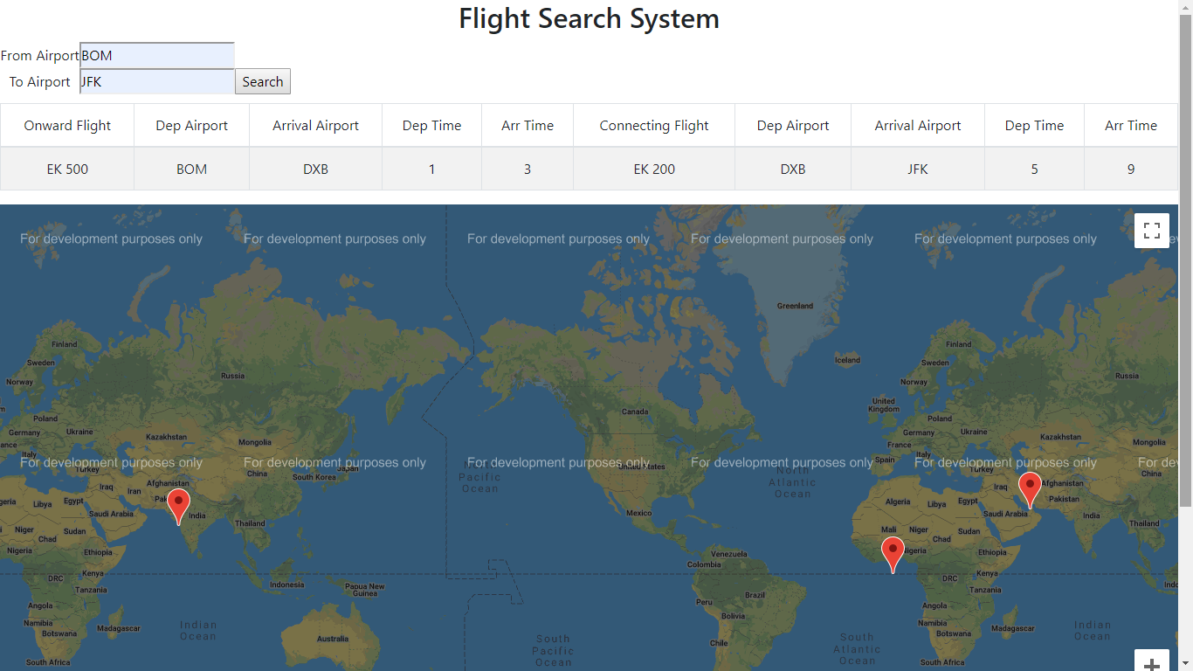

**Backend Application (amreen-zaidi-flight-connection-builder)**

**ReadMe File:**

**amreen-zaidi-flight-connection-builder**

This project explains flight connection operations using spring boot and H2 in-memory database. In this app we are using Spring Data JPA for built-in methods to do CRUD operations.  
@EnableJpaRepositories annotation is used on main class to Enable H2 DB related configuration, which will read properties from application.properties file.

**Prerequisites**

* Java
* [Spring Boot](https://spring.io/projects/spring-boot)
* [Maven](https://maven.apache.org/guides/index.html)
* [H2 Database](https://www.h2database.com/html/main.html)

**Tools**

* Eclipse or IntelliJ IDEA (or any preferred IDE) with embedded Gradle
* Maven (version >= 3.6.0)
* Postman (or any RESTful API testing tool)

**Build and Run application**

*GOTO >* **~/absolute-path-to-directory/amreen-zaidi-flight-connection-builder**  
and try below command in terminal

**mvn spring-boot:run** it will run application as spring boot application

or

**mvn clean install** it will build application and create **jar** file under target directory

Run jar file from below path with given command

**java -jar ~/path-to-amreen-zaidi-flight-connection-builder/target/amreen-zaidi-flight-connection-builder-0.0.1-SNAPSHOT.jar**

Or

run main method from FlightConnectionBuilderApplication.java as spring boot application

**Flight Services:**

1. **Get All Flight Service**

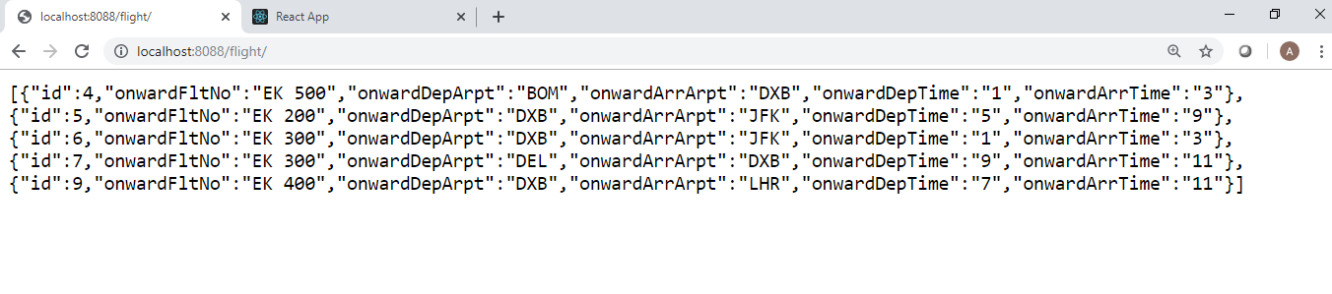

1. **Get Connecting Flights as per “from” and “to”**

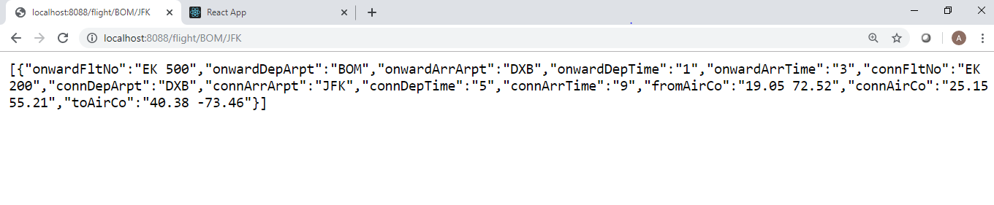

1. Add new Flight

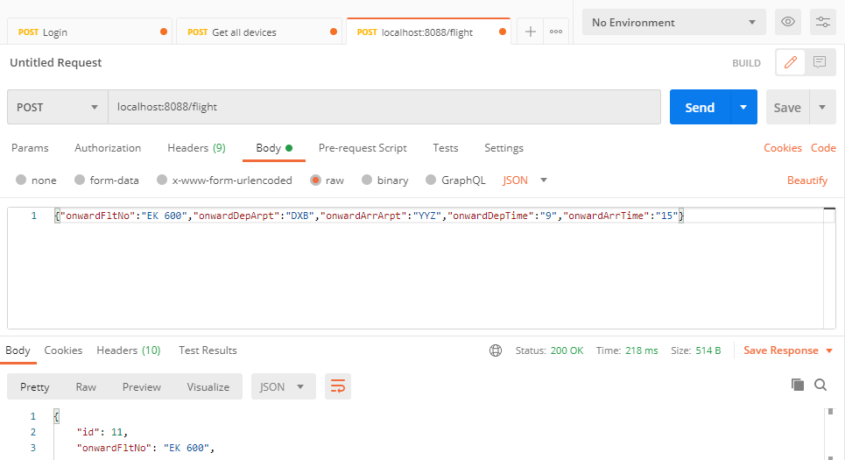

1. Update a flight service

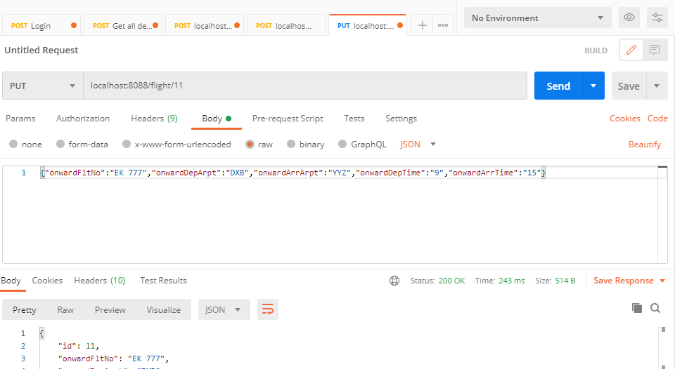

1. Delete a flight service

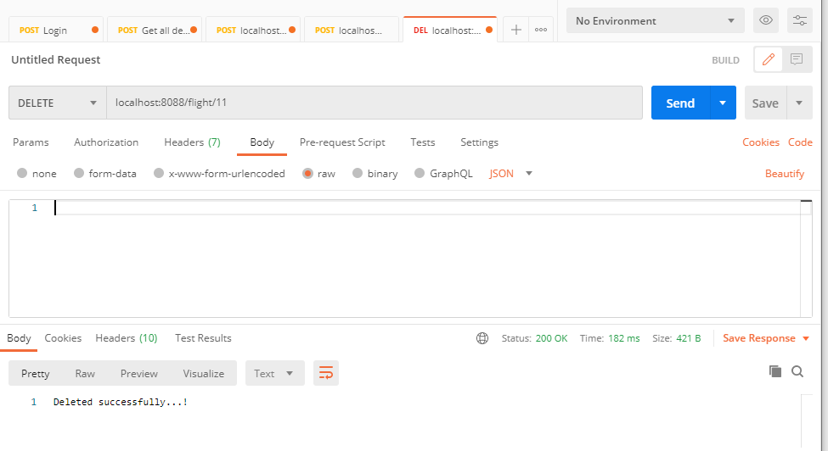

Airport Services:

1. Get All Airports

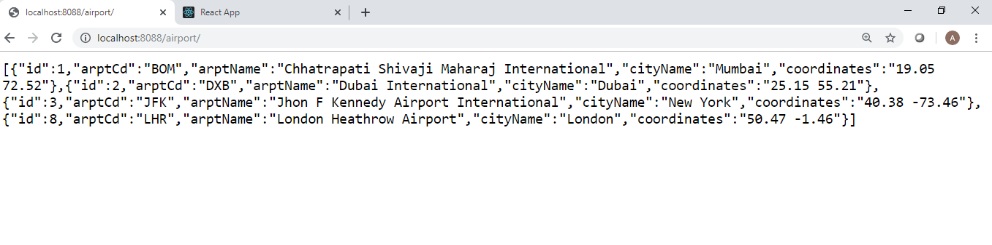

1. Add New Airport Service

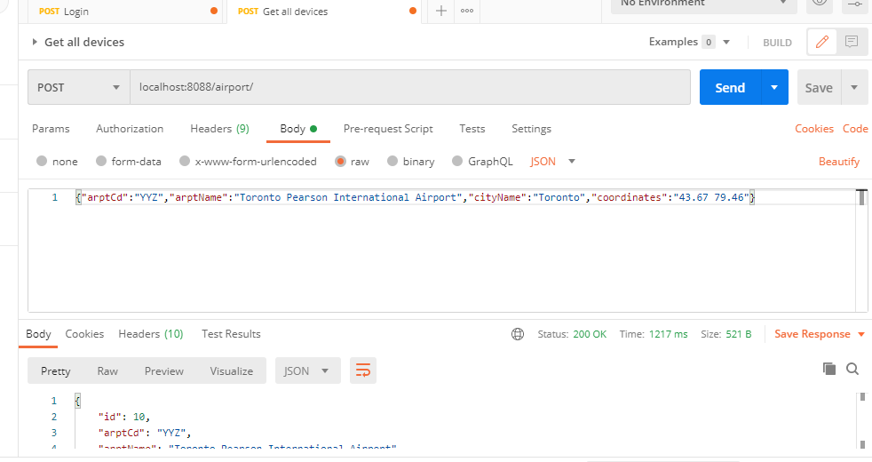

1. Update Airport Detail Service

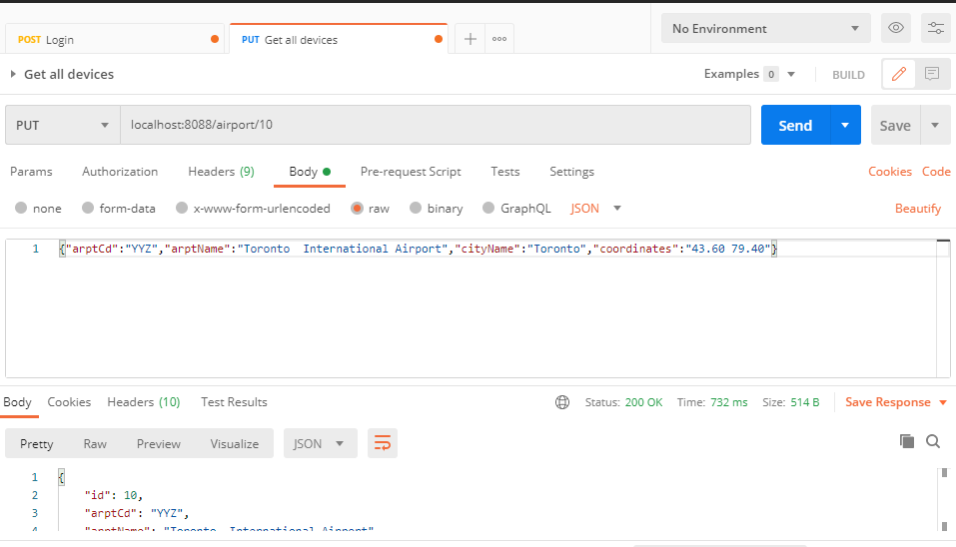

1. Delete Airport Service

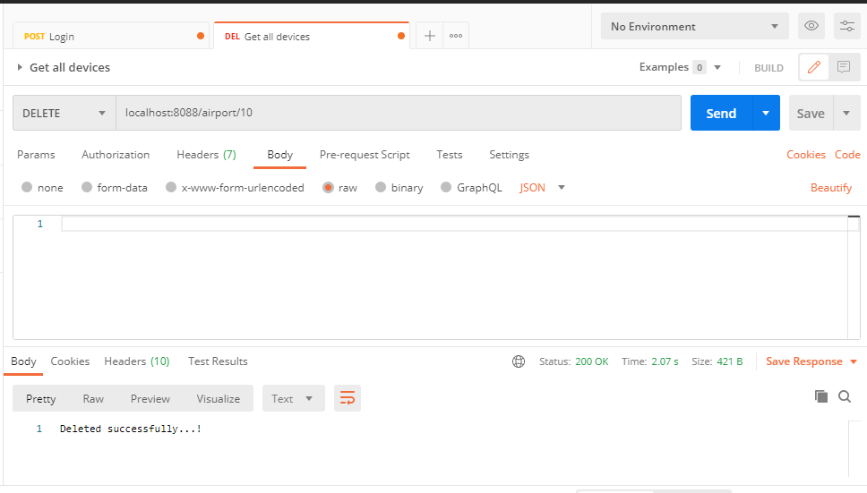

Testing:

Jacoco Code coverage:

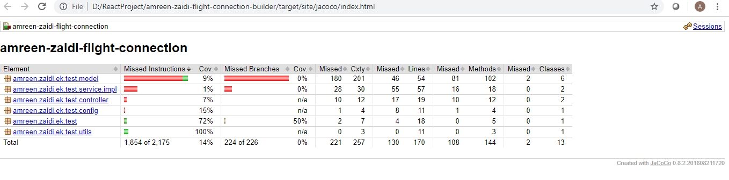

Junit Test Cases for Airport and flight:

