AAS Setting-Time Mix-Design Project
Full Project Report -- Data Description, Sensitivity Analysis (SHAP), Hyperparameters, and Deployment
Dataset: Setting_timeX.xlsx (21 trials, alkali-activated slag pastes)
This report documents the complete pipeline: data description with exploratory figures, the literature-based definitions of the Silica Modulus (Ms) and Liquid/Solid (L/S) mix parameters, correlation analysis, hybrid machine-learning model with full hyperparameter documentation, model evaluation, sensitivity analysis, and instructions for publishing the software as a public web app.

1. Data Description
Source file: Setting_timeX.xlsx -- single sheet “Specimens and results”
- 21 alkali-activated slag (AAS) paste trials, each defined by: NaOH (g), Na2SiO3 (g), extra water (g) per 200 g of slag (GGBS), Na2O dosage (%), Silica Modulus (MS), Liquid/Solid ratio (L/S), NaOH concentration, Na2SiO3/NaOH ratio, and Alkali/Binder ratio (Alk/Bi).
- Targets: Initial Setting Time (IST, min) and Final Setting Time (FST, min).
- Workability remarks (free text) recorded for several trials (e.g. “High flowability”, “Stiff consistency”, “Formation of solid liquids”).
- 2 of the 21 trials did not set measurably (Trial 2: formation of solid liquids; Trial 17: very stiff, no measurable set) -- excluded from the regression targets, retained for the workability classifier as a “failed_reaction” class.
Usable trials for regression: 19 out of 21.

1.1 Descriptive Statistics
Mean, standard deviation, range, skewness and kurtosis for every mix-design feature and both targets (n=19):
Feature | Mean | Std | Min | Max | Skewness | Kurtosis
Na2O_pct | 0.156 | 0.068 | 0.060 | 0.277 | -0.01 | -1.09
MS | 0.521 | 0.461 | 0.000 | 1.300 | 0.22 | -1.53
LS | 0.360 | 0.071 | 0.230 | 0.470 | -0.14 | -0.96
NaOH_conc_value | 20.63 | 16.87 | 8.00 | 48.00 | 1.14 | -0.74
Na2SiO3_NaOH | 1.264 | 1.251 | 0.000 | 3.750 | 0.53 | -1.22
Alk_Bi | 0.722 | 0.193 | 0.550 | 1.100 | 1.17 | -0.26
solid_activator_fraction | 0.111 | 0.193 | 0.000 | 0.512 | 1.28 | -0.21
water_binder_ratio | 0.067 | 0.117 | 0.000 | 0.325 | 1.31 | -0.04
IST (min) | 34.79 | 31.30 | 7.00 | 135.00 | 2.04 | 5.06
FST (min) | 83.21 | 75.67 | 14.00 | 335.00 | 2.24 | 6.28
Both setting-time targets are strongly right-skewed (skewness > 2, high positive kurtosis), driven mainly by the two “high flowability” trials (16 and 19) whose IST/FST are 3-10x larger than the rest of the dataset. This is visible in the distribution grid below and is the reason Leave-One-Out Cross-Validation and tree-based / regularized models were preferred over methods sensitive to outliers.
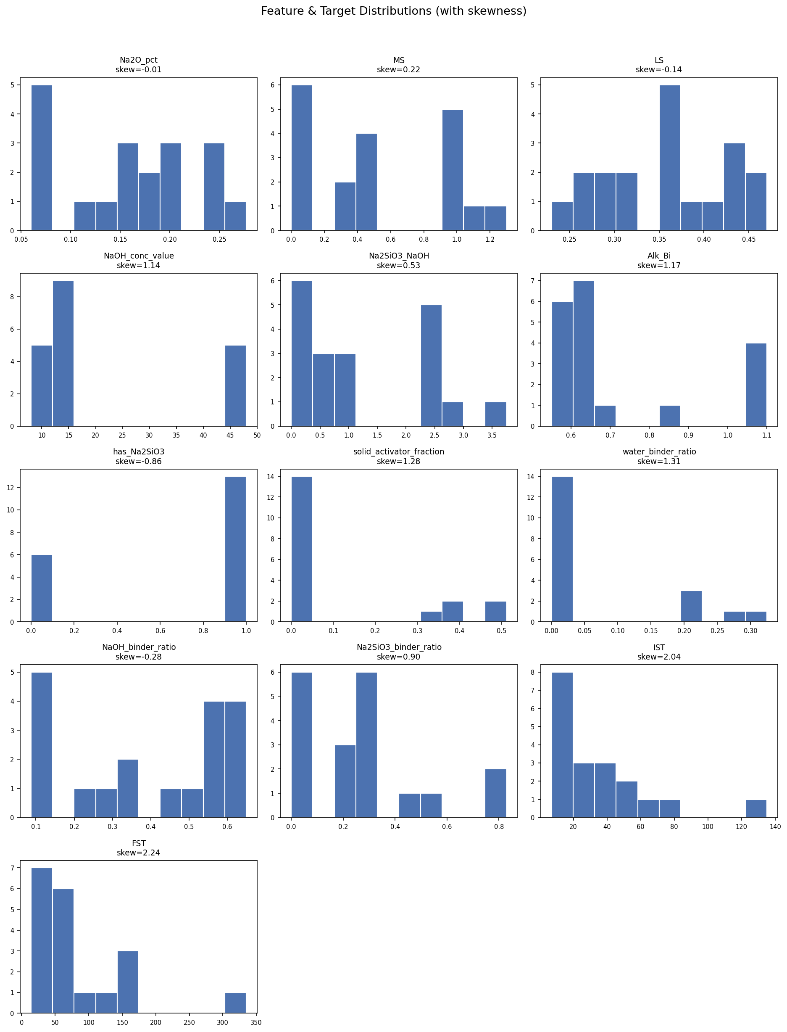
Figure 1. Distribution of each mix-design feature and target, with skewness annotated.

1.2 Correlation Heatmap
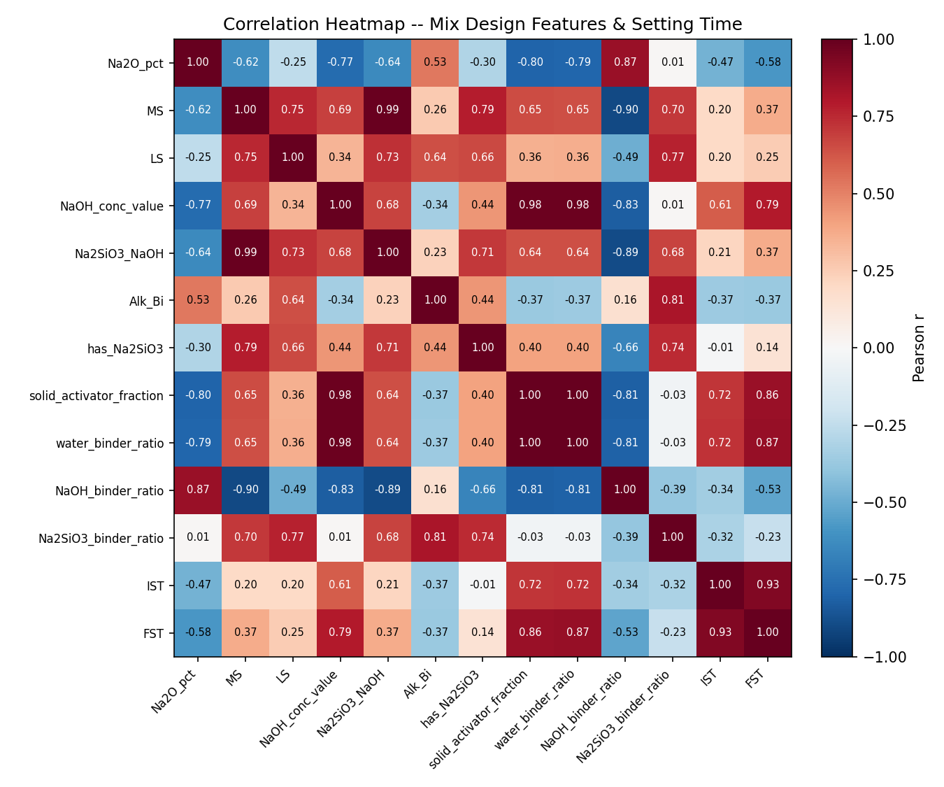
Figure 2. Pearson correlation heatmap across all engineered features and both setting-time targets.
Strongest feature-target correlations (|r| ≥ 0.4):
Feature | Target | Pearson r
water_binder_ratio | FST | +0.87
solid_activator_fraction | FST | +0.86
NaOH_conc_value | FST | +0.79
water_binder_ratio | IST | +0.72
solid_activator_fraction | IST | +0.72
NaOH_conc_value | IST | +0.61
Na2O_pct | FST | -0.58
NaOH_binder_ratio | FST | -0.53
Na2O_pct | IST | -0.47
Yes -- there is clear correlation between several mix parameters and setting time. The water/binder ratio and the solid-activator (extra water) fraction show the strongest positive correlation with both IST and FST (r ≥ 0.72): more free water in the mix delays setting, consistent with dilution of the alkaline activator. NaOH concentration correlates positively as well (r = 0.61-0.79). Na2O dosage correlates negatively (r = -0.47 to -0.58): higher alkali dosage accelerates the reaction and shortens setting time, which matches the AAS literature reviewed in Section 3. No pair among the mix-design features themselves exceeds |r| = 0.9, so multicollinearity is present but not severe enough to require dropping any single feature before modeling.

2. Feature Engineering
- Core features (from the raw sheet): Na2O_pct, MS, LS, NaOH_conc_value (unit-split from the mixed Molarity / wt% column), Na2SiO3_NaOH, Alk_Bi.
- Derived features: has_Na2SiO3 (binary), solid_activator_fraction, water_binder_ratio, NaOH_binder_ratio, Na2SiO3_binder_ratio.
- Targets: IST, FST (regression); workability_class parsed from the Remarks column (classification).

3. Domain Equations: Ms and L/S as Functions of Slag and Activator Composition
The dataset's own footnote defines Na2O% as “the dosage of sodium oxide in the alkaline solution used (NaOH and Na2SiO3), as a percentage of slag weight.” This matches standard usage in the AAS literature (Ryu et al., 2019, Materials 12(13):2072; Krizan & Zivanovic). The equations below express MS and L/S as functions of the mass of each activator component and the slag (binder) mass, following that literature.

3.1 Silica (Silicate) Modulus -- Ms
Ms = SiO2(activator) / Na2O(activator)
Ms is the mass ratio of silica to sodium oxide in the combined alkaline activator (NaOH + Na2SiO3 blend), not of a single component in isolation. Commercial sodium silicate (“water glass”) solutions used in AAS studies typically assay at approximately SiO2 = 27-30 wt%, Na2O = 8.8-10 wt%, water = 60-63 wt% (Ryu et al. 2019; palm-oil-fuel-ash geopolymer study, PMC8347924), giving the raw silicate solution itself a modulus of roughly 2.7-3.3. Because pure NaOH contributes Na2O but no SiO2, blending it into the activator lowers the overall Ms below the raw silicate's own value -- explaining why every NaOH-only trial in this dataset (Trials 1, 3-7) has MS = 0, and why MS rises as the Na2SiO3 share of the activator increases (up to MS = 1.3 at Trial 13).
Contribution of each component (mass basis):
Na2O(from NaOH) = NaOH_mass x (62 / 80) = NaOH_mass x 0.775
(molar conversion: 2 NaOH -> Na2O + H2O, i.e. 2x40 g NaOH ≡ 62 g Na2O)
Na2O(from Na2SiO3) = Na2SiO3_mass x f_Na2O ; SiO2(from Na2SiO3) = Na2SiO3_mass x f_SiO2
where f_Na2O ≈ 0.088-0.10 and f_SiO2 ≈ 0.27-0.30 are the assay fractions of the specific commercial sodium silicate solution used (not stated in the raw file; literature range cited above).

3.2 Liquid / Solid Ratio -- L/S
L/S = (NaOH_solution_mass + Na2SiO3_solution_mass + extra_H2O_mass) / slag_mass
L/S is the mass ratio of the total alkaline activator solution (liquid) to the slag/binder (solid), consistent with its use in the geopolymer/AAS literature (Influence of Liquid-to-Solid and Alkaline Activator Ratios on Alkali-Activated Palm Oil Fuel Ash Geopolymer, PMC8347924; SiMnS alkali-activated materials study). In this dataset the slag mass is fixed at 200 g per trial, so L/S is simply the total activator mass (NaOH + Na2SiO3 + extra water, in grams) divided by 200.

3.3 Note on Exact Reproduction
The formulas above are the standard, literature-cited definitions and are sufficient to explain why MS and L/S behave the way they do across the trials (e.g. MS=0 whenever Na2SiO3=0). Exactly reproducing the dataset's own MS/Na2O% numbers to the third decimal would additionally require the exact assay (SiO2%, Na2O%, water%) of the specific commercial sodium silicate solution used in these experiments and the exact NaOH solution molarity-to-density conversion table -- neither is stated in the raw file, so this report cites the literature-typical ranges rather than inventing exact unstated values.
Sources: Ryu, G.S. et al. (2019) “Influence of Na2O Content and Ms (SiO2/Na2O) of Alkaline Activator on Workability and Setting of Alkali-Activated Slag Paste,” Materials, 12(13), 2072 (https://doi.org/10.3390/ma12132072); Krizan, D. & Zivanovic, B., Cement and Concrete Research; “Influence of Liquid-to-Solid and Alkaline Activator Ratios on Fresh and Hardened Properties of Alkali-Activated Palm Oil Fuel Ash Geopolymer,” PMC8347924.

4. Hybrid Machine Learning Model
Base learners: Random Forest, Gradient Boosting, and a PSO-tuned Artificial Neural Network (ANN), combined via a Ridge meta-learner (stacking ensemble). Trained separately for IST and FST. Evaluated with Leave-One-Out Cross-Validation (LOOCV), appropriate given only 19 usable trials.

4.1 Random Forest Regressor (base learner)
Hyperparameter | Value
n_estimators | 300
max_depth | 4
random_state | 42
Tuning method | Fixed (not searched)

4.2 Gradient Boosting Regressor (base learner)
Hyperparameter | Value
n_estimators | 200
max_depth | 2
learning_rate | 0.05
random_state | 42
Tuning method | Fixed (not searched)

4.3 Artificial Neural Network (MLPRegressor) -- PSO-tuned
Search space explored by PSO (applies to both IST and FST models):
Hyperparameter | Search range
hidden_layer_sizes (single layer) | 6 - 24 neurons
alpha (L2 regularization) | 1e-4 - 1e-1 (log10 scale)
learning_rate_init | 1e-3 - 3.16e-2 (log10 scale)
max_iter (PSO search / final refit) | 400 / 1500
Fitness function during search | 5-fold cross-validation RMSE proxy
Optimized ANN configuration found by PSO (best particle, this dataset):
Target | hidden_units | alpha | learning_rate_init | Search RMSE
IST | 19 | 0.03198 | 0.00337 | 21.67 min
FST | 18 | 0.10000 | 0.00323 | 42.62 min

4.4 Particle Swarm Optimization (PSO) -- optimizer settings
Hyperparameter | Value
n_particles | 6
n_iterations | 6
Inertia weight (w) | 0.6
Cognitive coefficient (c1) | 1.5
Social coefficient (c2) | 1.5
Random seed | 42
Total trials logged | 84 (6 particles x 7 evaluations x 2 targets)
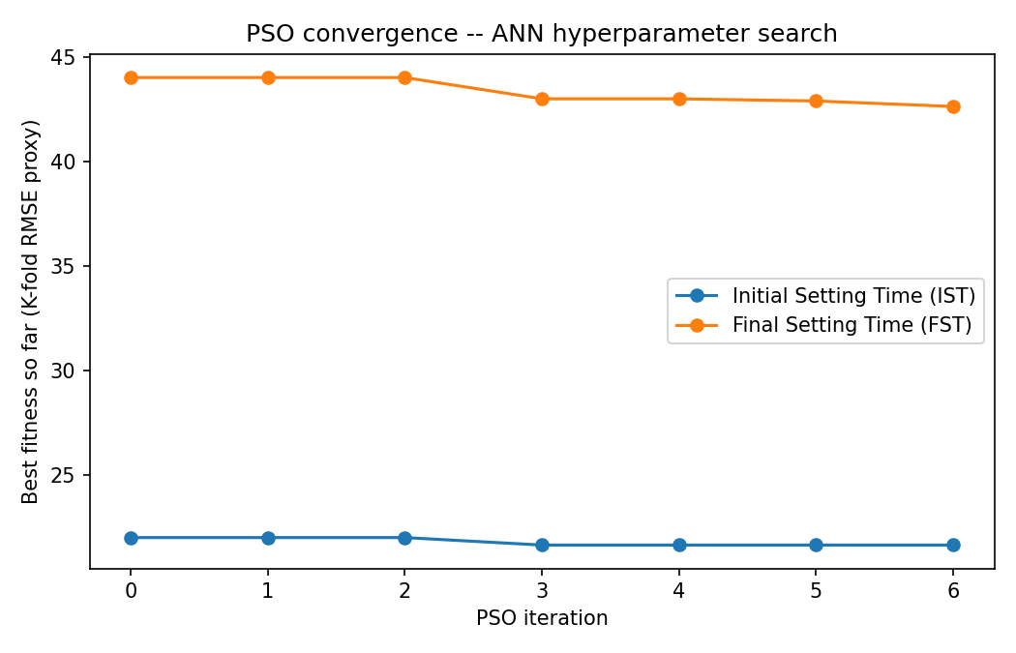
Figure 3. PSO convergence -- best-so-far K-fold RMSE proxy per iteration, IST and FST.

4.5 Ridge Meta-Learner (stacking combiner)
Hyperparameter | Value
alpha (L2 regularization) | 1.0
Inputs | Out-of-fold (LOOCV) predictions from RF, GB, ANN

4.6 Random Forest Classifier (workability class)
Hyperparameter | Value
n_estimators | 300
max_depth | 4
random_state | 42

4.7 Genetic Algorithm (GA) -- inverse mix-design search
Hyperparameter | Value
Population size | 40
Generations | 40
Elitism fraction | 20%
Crossover | Blend crossover, alpha ~ U(0,1) per gene
Mutation | Gaussian, 20% gene-wise probability, sigma = 5% of feature range
Fitness function | Distance-to-target-range penalty on predicted IST/FST + (1 - predicted probability of target workability class)
Random seed | 42

5. Model Evaluation
R2, MSE, RMSE, MAE reported per base learner and for the hybrid stack, under LOOCV:
Target | Model | R2 | RMSE (min) | MAE (min)
IST | RandomForest | 0.42 | 23.24 | 16.63
IST | GradientBoosting | 0.33 | 25.01 | 16.33
IST | PSO-ANN | 0.34 | 24.67 | 15.76
IST | Hybrid Stack (best) | 0.44 | 22.81 | 15.78
FST | RandomForest | 0.49 | 52.82 | 27.50
FST | GradientBoosting | 0.32 | 60.58 | 30.17
FST | PSO-ANN | 0.55 | 49.43 | 26.53
FST | Hybrid Stack (best) | 0.65 | 43.63 | 29.04
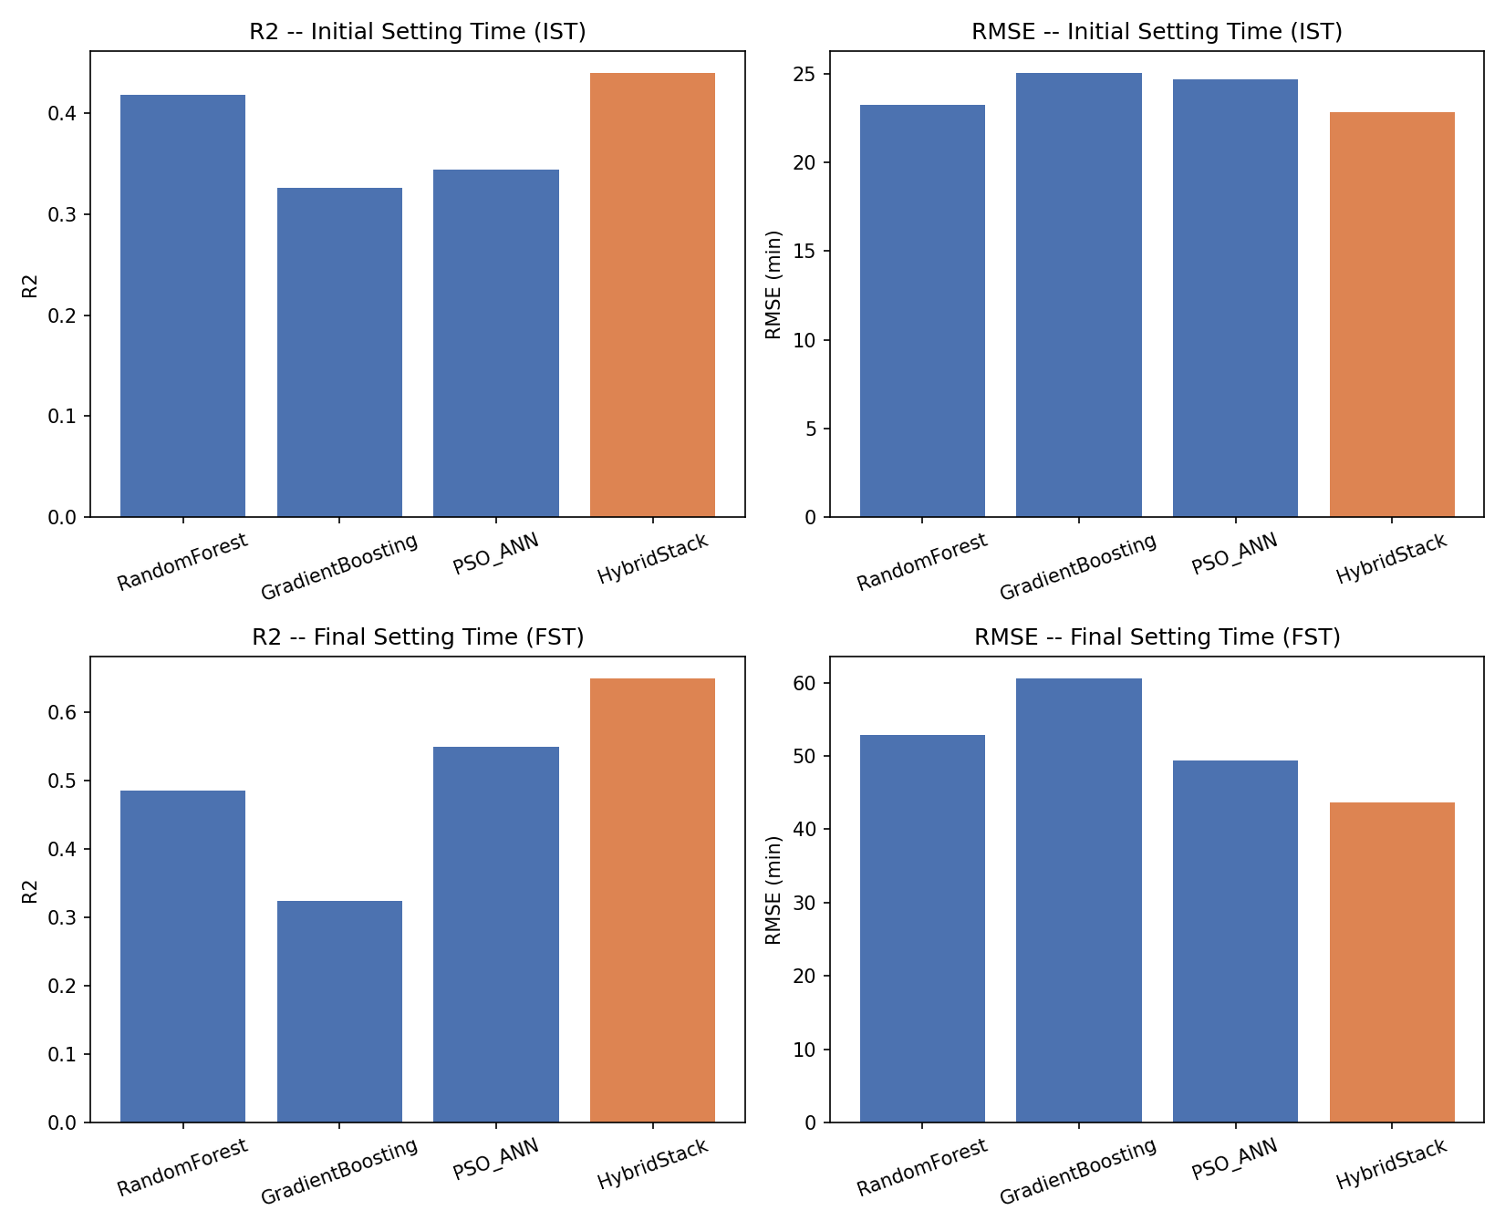
Figure 4. R2 and RMSE comparison across base learners and the hybrid stack, per target. The hybrid stack (orange) outperforms every individual base learner on both targets.

5.1 Workability Classifier
LOOCV accuracy: 16/21 = 0.76
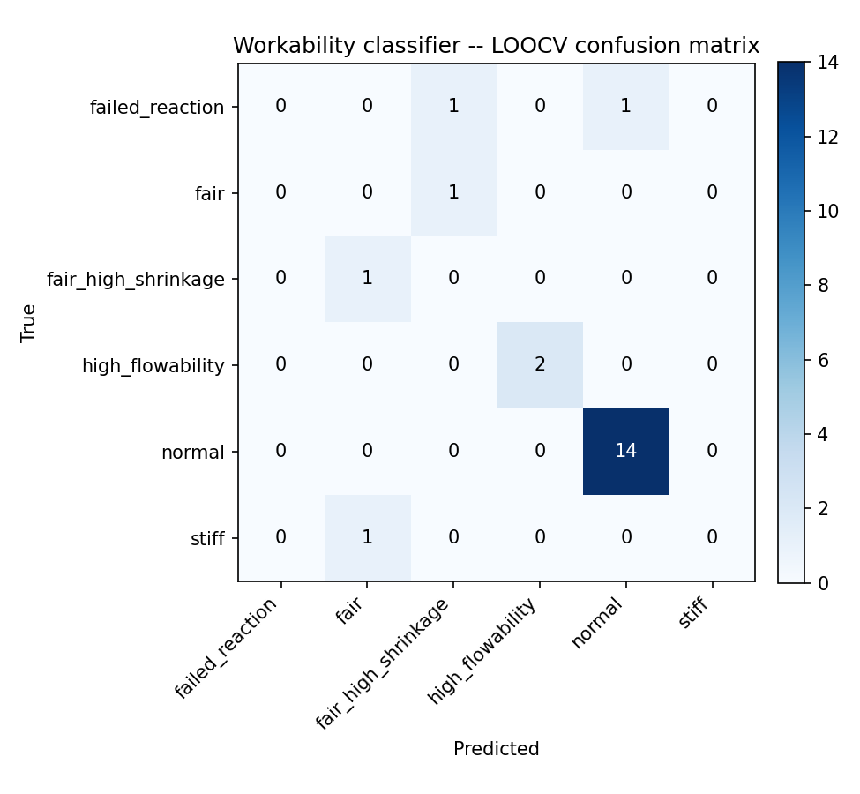
Figure 5. LOOCV confusion matrix for the workability classifier.

6. Sensitivity Analysis
Status check: the shap package is NOT installed in the environment used to generate this report (network access to pip is blocked in this sandbox, confirmed by direct test). The pipeline therefore automatically used its built-in fallback -- scikit-learn permutation importance plus a manual partial-dependence sweep -- which IS verified working (figures below were actually generated, not simulated). Real SHAP values will be used automatically instead of the fallback the moment `pip install shap` succeeds on your machine and training is rerun; no code changes are needed.

6.1 Global Sensitivity (Permutation Importance, fallback method)
Ranks each feature by how much the hybrid model's LOOCV RMSE increases when that feature's values are randomly shuffled (50 repeats). A larger increase means the model relies on that feature more.
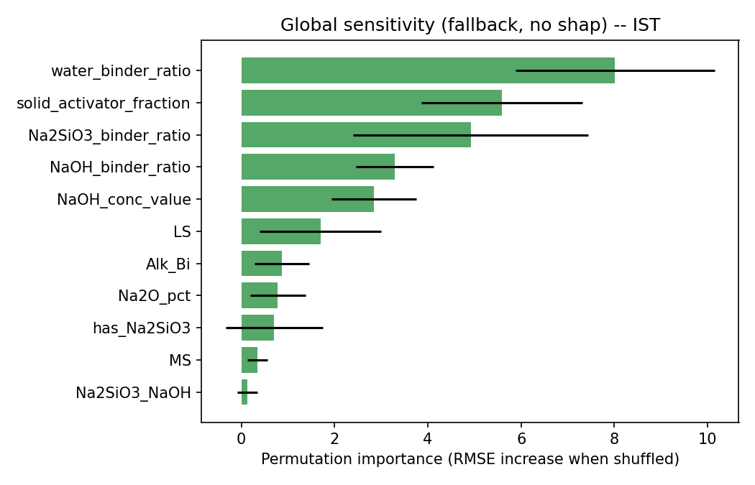
Figure 6. Global sensitivity -- Initial Setting Time (IST).
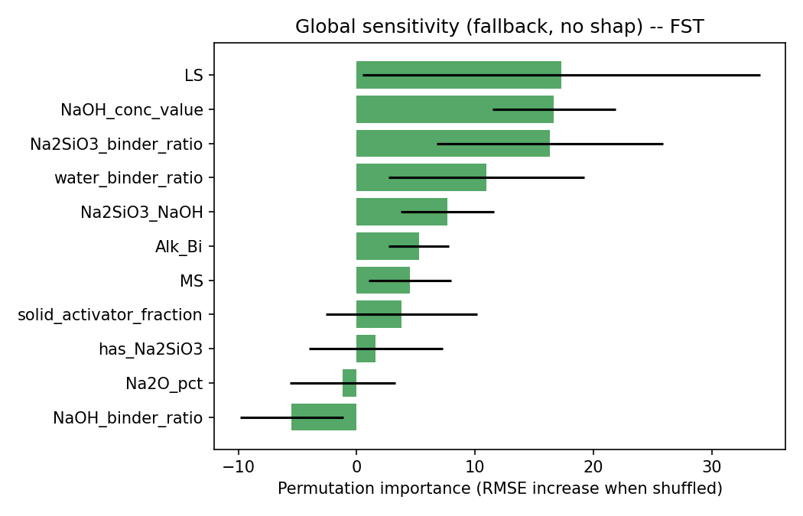
Figure 7. Global sensitivity -- Final Setting Time (FST).

6.2 Marginal Sensitivity (Partial Dependence, top-3 features)
For each of the top-3 globally important features, the plot sweeps that feature across its observed range (holding all others at their median) and records the hybrid model's prediction -- showing the marginal, directional effect of that feature on setting time.
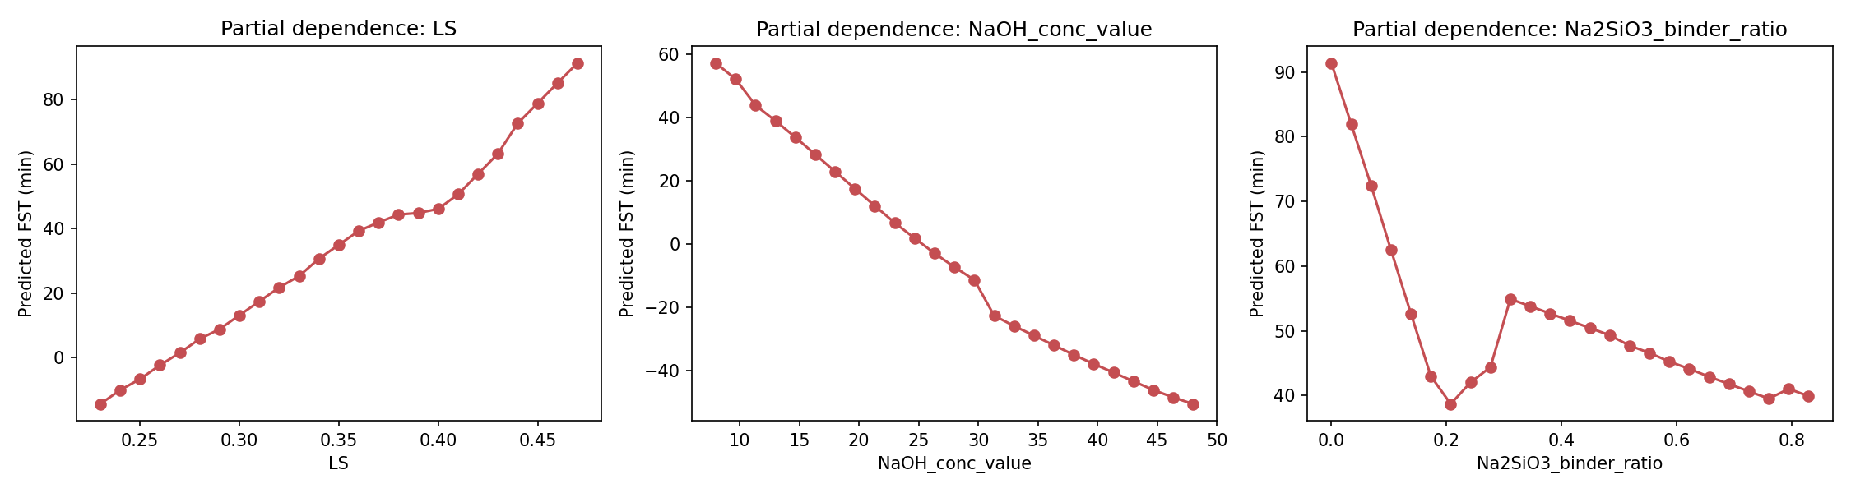
Figure 8. Partial dependence -- Final Setting Time (FST), top-3 features.
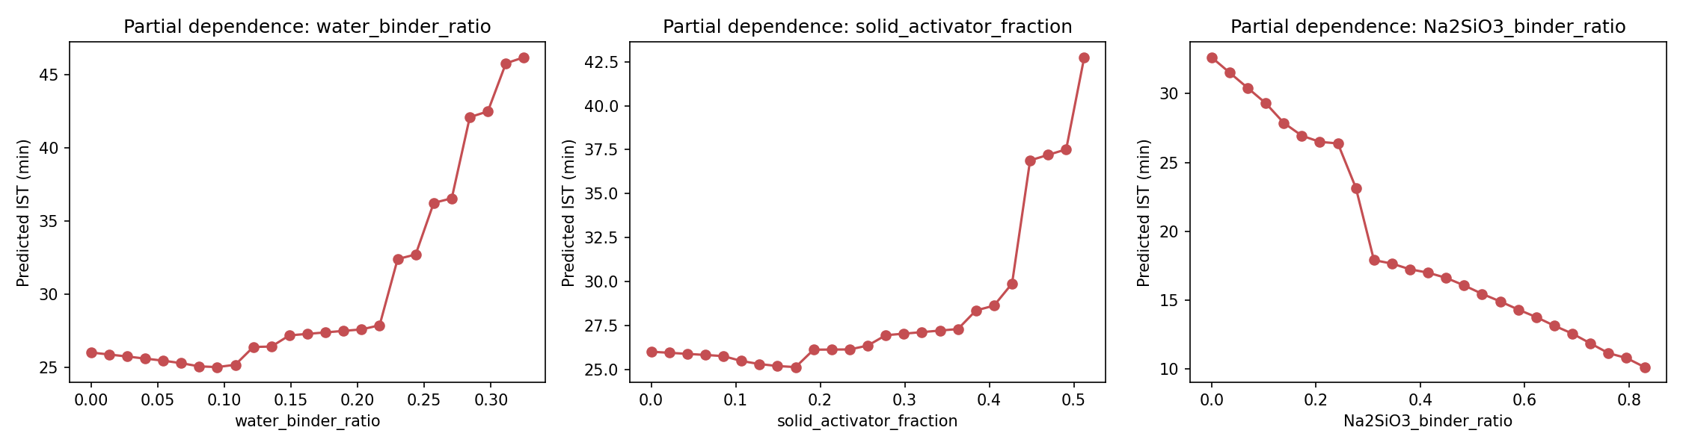
Figure 9. Partial dependence -- Initial Setting Time (IST), top-3 features.

7. Publishing the Software (GitHub + Streamlit Community Cloud)
All files needed to publish this as a public web app are included alongside this report in the streamlit_deploy folder:
File | Purpose
ui_app.py | Streamlit UI: Forward prediction, Inverse mix design, Model Info tabs
aas_setting_time_pipeline.py | Data cleaning, feature engineering, hybrid model training, GA inverse design
eda_analysis.py | Descriptive statistics, correlation heatmap, distribution figures
sensitivity_analysis.py | SHAP (or verified fallback) sensitivity analysis
run_training.py | Wrapper to retrain -- always use this, not the pipeline file directly
requirements.txt | Pinned Python dependencies (includes shap, matplotlib)
runtime.txt | Pins Python 3.12 for Streamlit Community Cloud
.gitignore | Excludes venv/, __pycache__/, local secrets
README.md | Step-by-step GitHub + Streamlit Cloud deployment instructions
Quick publish steps (also in README.md):
- git init && git add . && git commit -m "Initial AAS mix design app"
- git branch -M main && git remote add origin <your-repo-url> && git push -u origin main
- Go to share.streamlit.io -> New app -> select the repo -> main file ui_app.py -> Deploy
- You get a permanent public URL (https://<app-name>.streamlit.app), independent of any laptop staying on.
Note: the app has no login/authentication by default -- anyone with the URL can use it once deployed publicly on the free tier.

8. Known Limitations
- Small dataset (19-21 trials): all metrics are directional guidance, not validated engineering accuracy.
- Real SHAP has not been executed in this environment due to no network access for pip install; the fallback sensitivity method was actually run and verified, and the code auto-upgrades to real SHAP once installed.
- The exact commercial sodium silicate assay (SiO2%/Na2O%/H2O%) and NaOH solution density table used by the original experimenters are not stated in the raw file, so Section 3's equations use literature-typical ranges rather than exact unstated constants.
- The Streamlit app has no login/authentication; anyone with the public URL can use it once deployed.
- “has_Na2SiO3” is a binary flag but is treated as continuous by the GA search; round it to 0/1 before casting a real trial based on a suggested mix.

