Answer Key
- Answer: C) 10
Explanation: This is a sum of first n natural numbers → 4 + 3 + 2 + 1 + 0 = 10
- Answer: B) 2
Explanation: This is Fibonacci: f(3) = f(2) + f(1) = 1 + 1 = 2
- Answer: A) Correct
- Answer: B) Power of 2
Explanation: Doubles at each level → 2^(n-1)
- Answer: B) O(n)
- Answer: B) Infinite recursion and StackOverflow
- Answer: B) 24
- Answer: B) Merge Sort
- Answer: C) 4
Explanation: Doubles every level → 1 → 2 → 4
- Answer: D) Linear recursion
- Answer: C) Always returns 1
Explanation: n keeps halving till 0, then returns 1. No accumulation or calculation.
- Answer: A) 6
Explanation: Factorial → 3 × 2 × 1 = 6
- Answer: C) Merge Sort
- Answer: C) 7
Explanation: It's a binary recursion → T(n) = 2ⁿ - 1 = 7 for n = 3
- Answer: C) 8
Explanation: 2 × 2 × 2 = 8
- Answer: A) 6
Explanation: 3 + 1 + 0 = 4 (if odd), but recheck:
solve(3) → 3 + solve(1) → 3 + 1 + solve(-1) → base case not reached.
Needs condition like if (n <= 0) return 0;
If assuming fixed base case at 0 and works for negative:
Then correct: 3 + 1 = 4
- Answer: A) Yes
- Answer: B) Less memory usage
Explanation: Recursion uses more stack memory.
- Answer: C) 16
Explanation: Multiplies 2 recursively → 2⁴ = 16
- Answer: B) Fibonacci
Explanation: Fibonacci creates exponential number of calls.
- Output: 1 2 3
Explanation: This is post-order recursion: prints after recursive call.
- Output: 3 2 1
Explanation: Pre-order recursion.

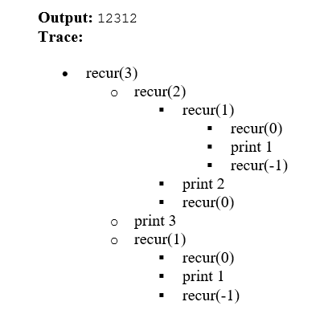
- Output: 1 3 5
Explanation: Recurses with n-2: 1, 3, 5
- Output: 101 Explanation: Converts decimal to binary recursively.
- Output: 3 2 1 1 2 3 Explanation: Prints before and after recursive call.
- Output: 8 Explanation: Fibonacci: F(5) = 8
- Output: 5 Explanation: Function is called 5 times (n = 5 to 1)
- Output: 10 Explanation: Sum of 4 + 3 + 2 + 1 = 10
- Output: 1 4 9
- Output: 1 2 3 Explanation: Digits printed left to right
- Output: 15
- Output: 8 4 2 1
- Output: A B C Explanation: ASCII values of 1 → A, 2 → B, etc.
- Output: 1 2 1 Explanation: Tree structure
- Output: 10 5 2 1 Explanation: Halving each time.
- Output: 1,1 2,2 3,3
- Output: 9 6 3 0
- Output: O E O E O
- Output: 2 1 0 0 1 0 0 Explanation: Tree recursion; 2 branches at each level.

Bug: return 0 causes result to be 0 always.
Fix:

int fact(int n) {
if (n == 0) return 1;
return n * fact(n - 1);
}

- Bug: Missing base case → infinite recursion
Fix:int fib(int n) {
if (n <= 1) return n;
return fib(n - 1) + fib(n - 2);
}

Bug: No termination → infinite recursion
Fix:

int call(int n) {
if (n == 0) return 0;
return call(n - 1);
}

