1. create simple spring boot application

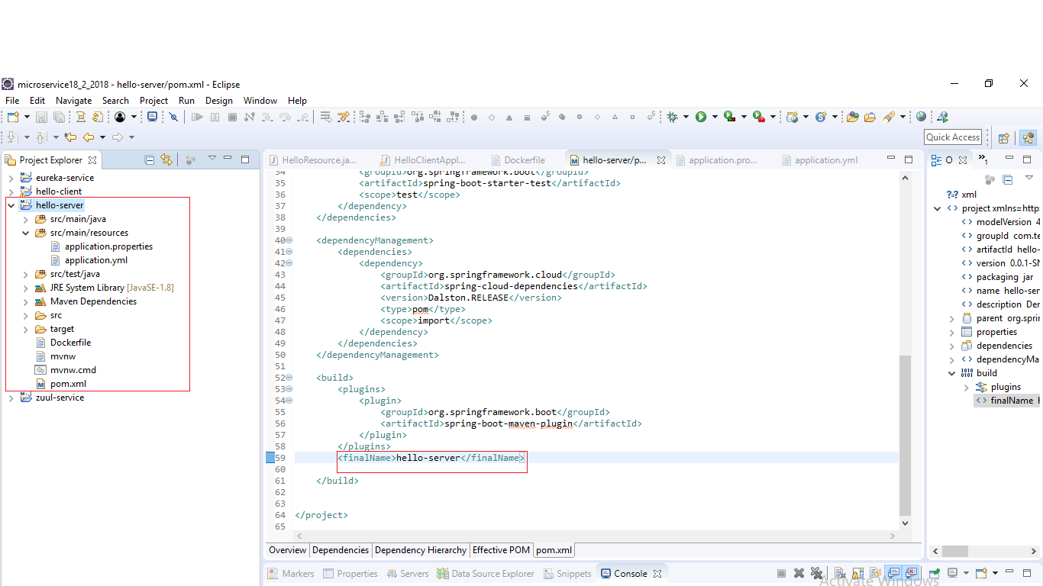

2. Now clean install maven project then generate jar in target folder

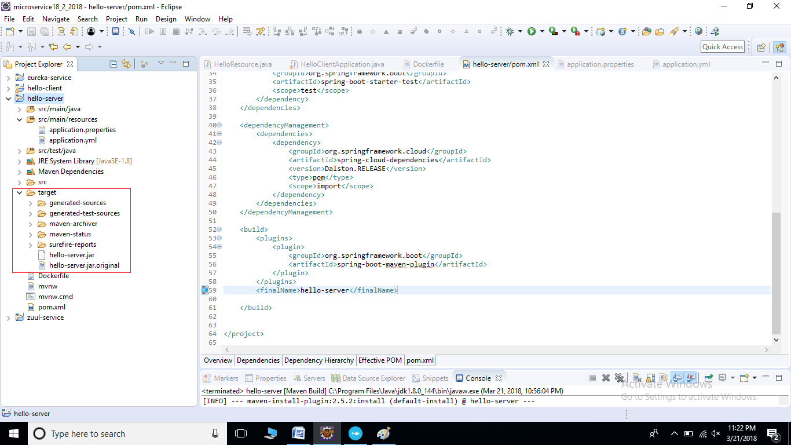

3. Then create Dockerfile under project pallel to pom.xml

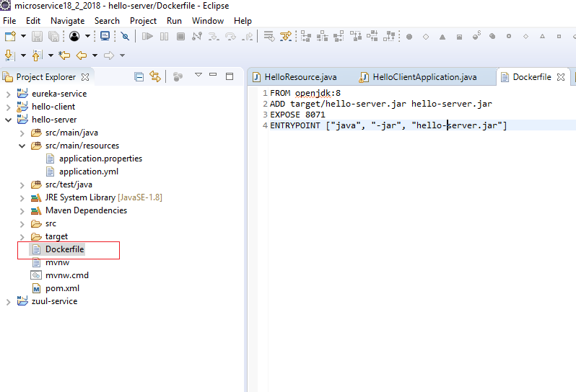

4. Now run docker container

5. Now open Terminal type following command for check docker install or not

**docker -v**

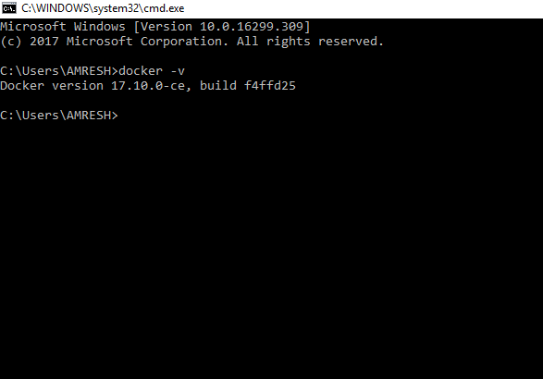

6. Now go to project root directory

**cd E:\newmicroservice\spring-cloud-zull-api-master\hello-server**

Then run the below docker command

**docker build -f Dockerfile -t hello-server .**

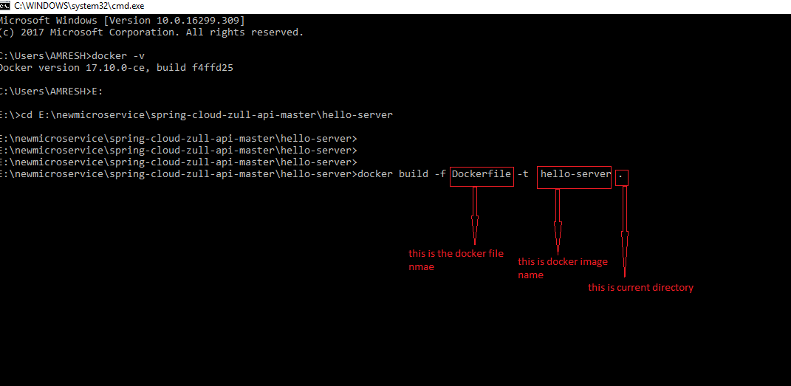

7. After created docker images then you can check docker image run below command

**docker images**

8. Now run the application

**docker run –p 8071:8071 hello-server**

