|  |  |
| --- | --- |
| Date | 20 September 2022 |
| Team ID | PNT2022TMID45285 |
| Project Name | IoT Based Gadget child safety monitoring and notification |

SOFTWARE

Step 1: Type python in Google and click on the first link

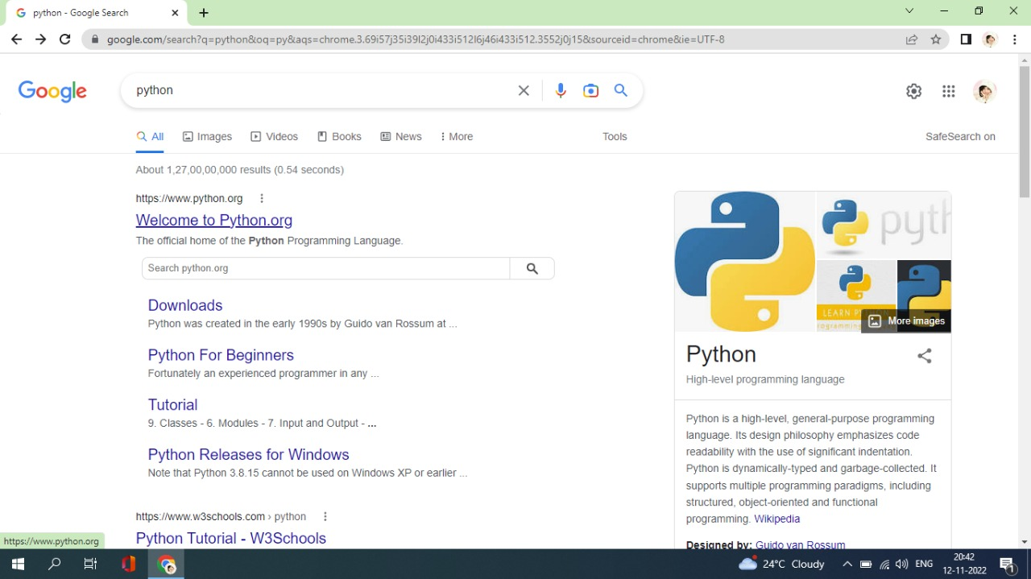

Step 2: click the python 3.7.4

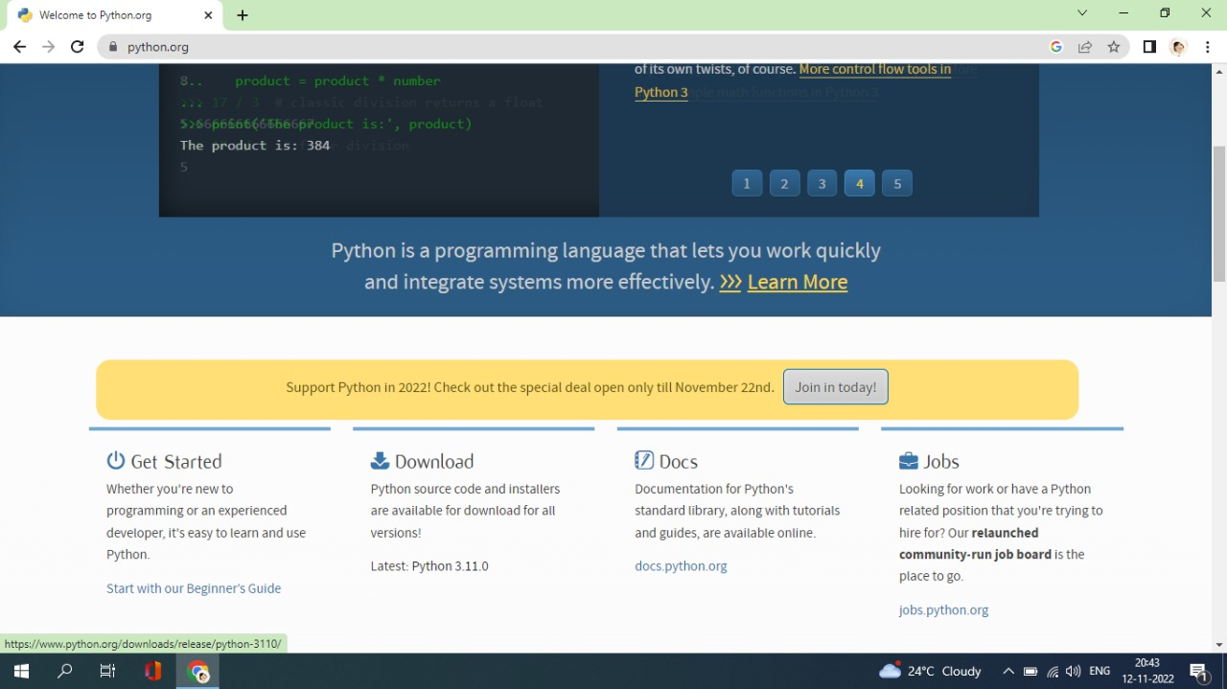

Step 3:Scroll down to reach the files and click windows x86-64executable installer

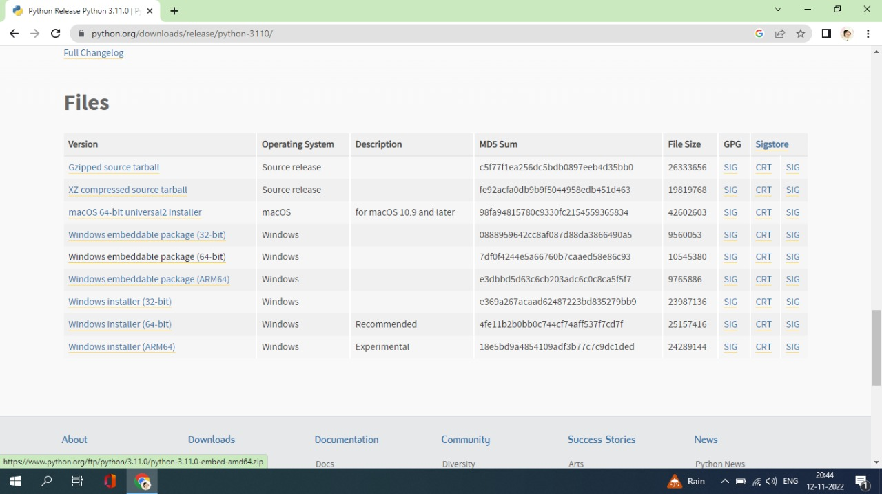

Step 4: click on the run button

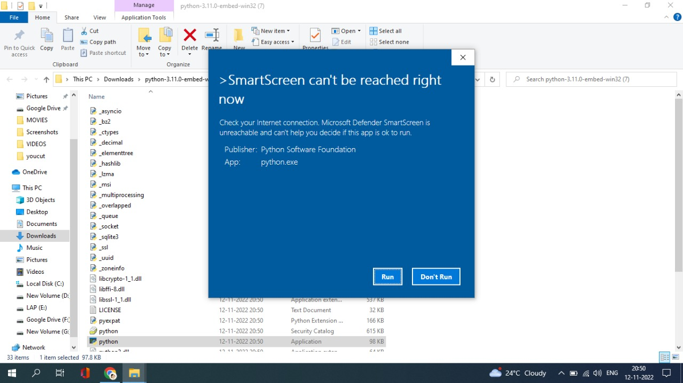

Step 5:To change the path click on the second check box add python 3.7 to PATH And then click the customize installation

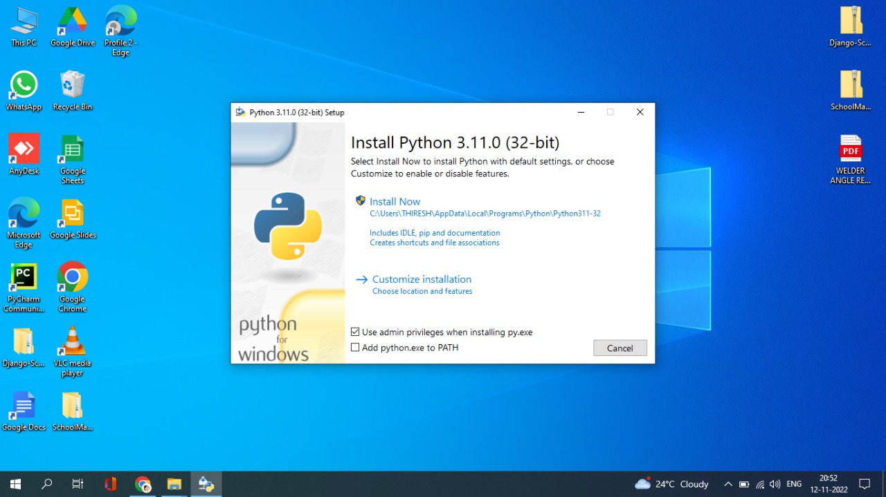

Step 6: click the next button

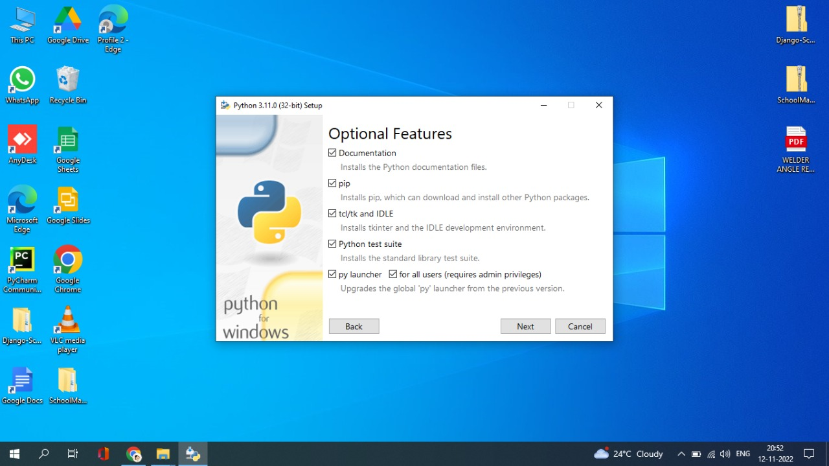

Step 7: you can change the path here and click on the install button

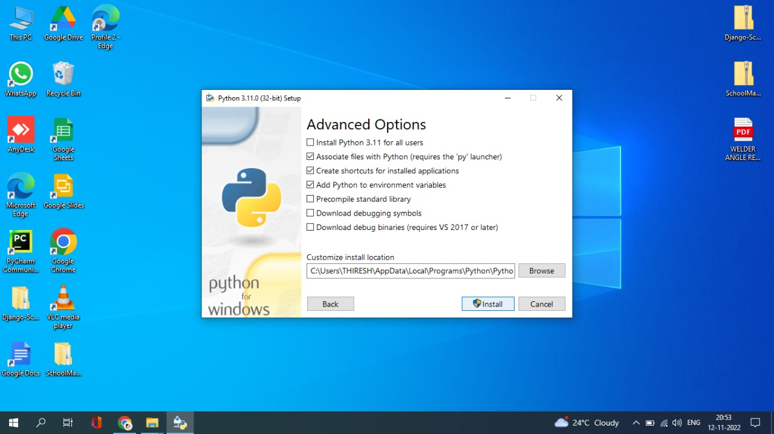

Step 8: Installation process

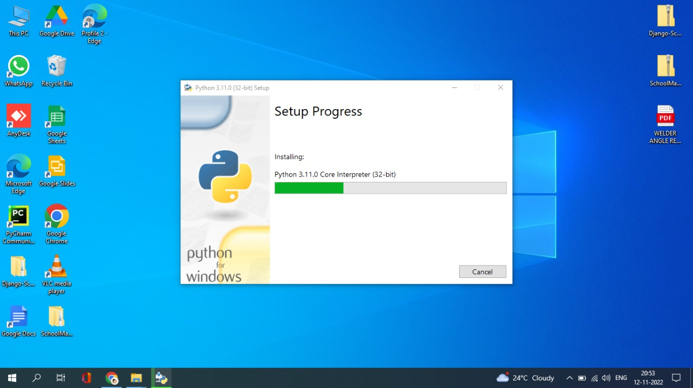

Step 9:Click YES Button

