**Assignment 1**

**We will use a class to define the two methods (Newton’s method & Golden Section method) because they both will solve the same problem.**

**Our Class Function Code:**

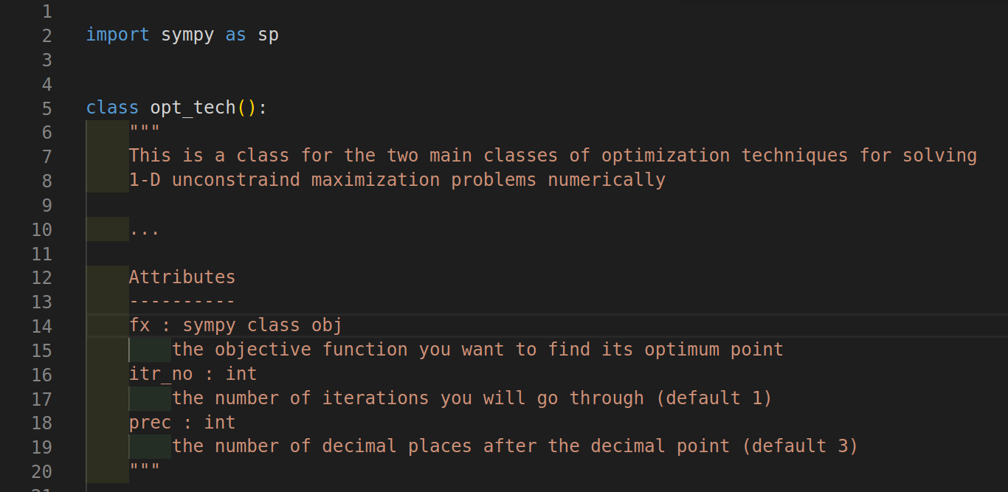**To initialize our Class we will require this parameters:**

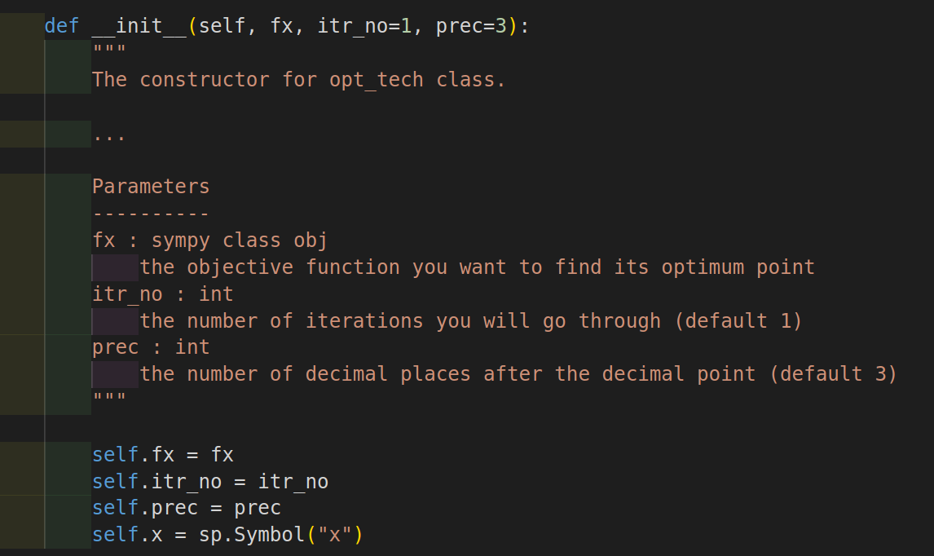

**Initializing our Class:**

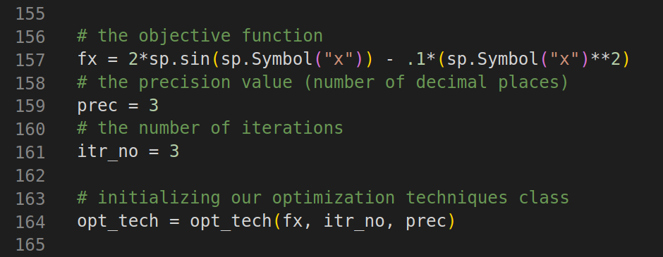

**Newton’s Method:**

It’s an iterative direct root finding technique, which requires an initial guess (xo) of the optimum point.

**Required Input:**

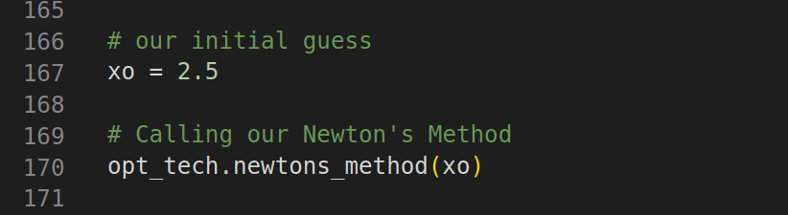

**Newton’s method code (part 1):**

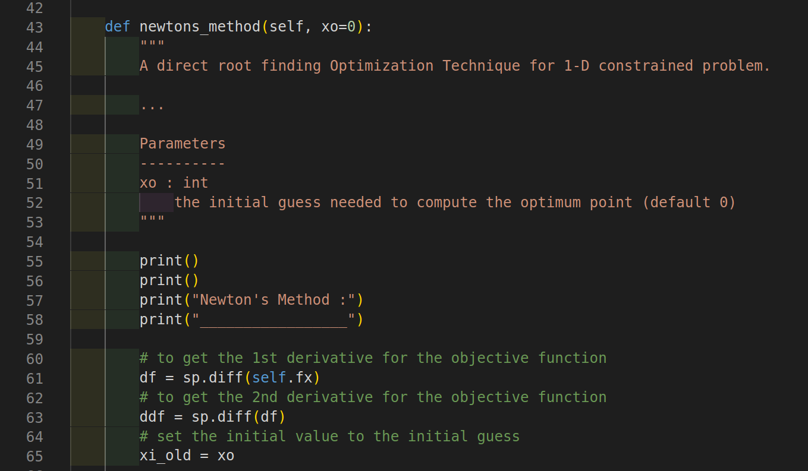

**Newton’s method code (part 2):**

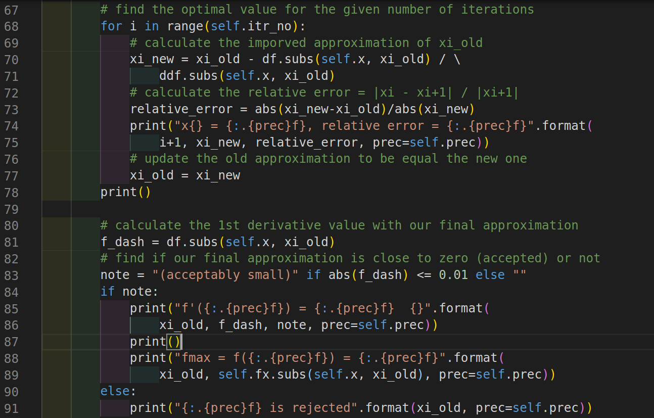

**Newton’s method output:**

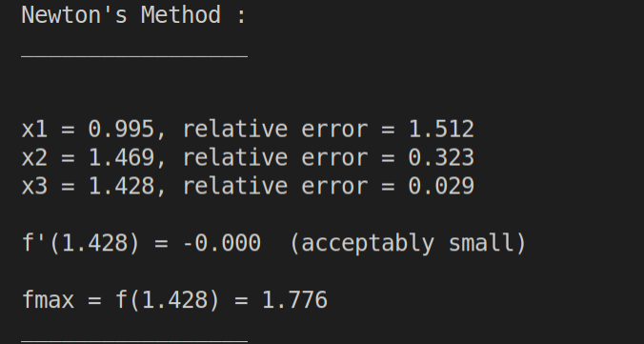

**Golden Section Method:**

It’s an iterative Elimination Technique, which requires an interval [xl, xu] where the objective function is unimodal.

We will use the same objective function from Newton's method but we will change the decimal precision point and the iteration number.

**Required Input:**

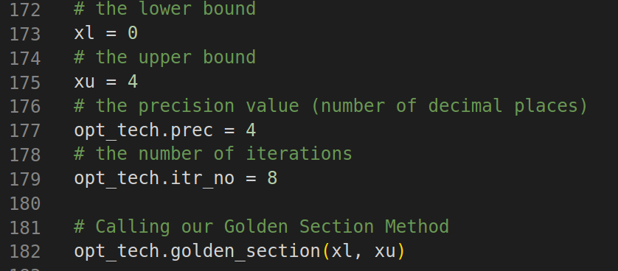

**Golden Section method code (part 1):**

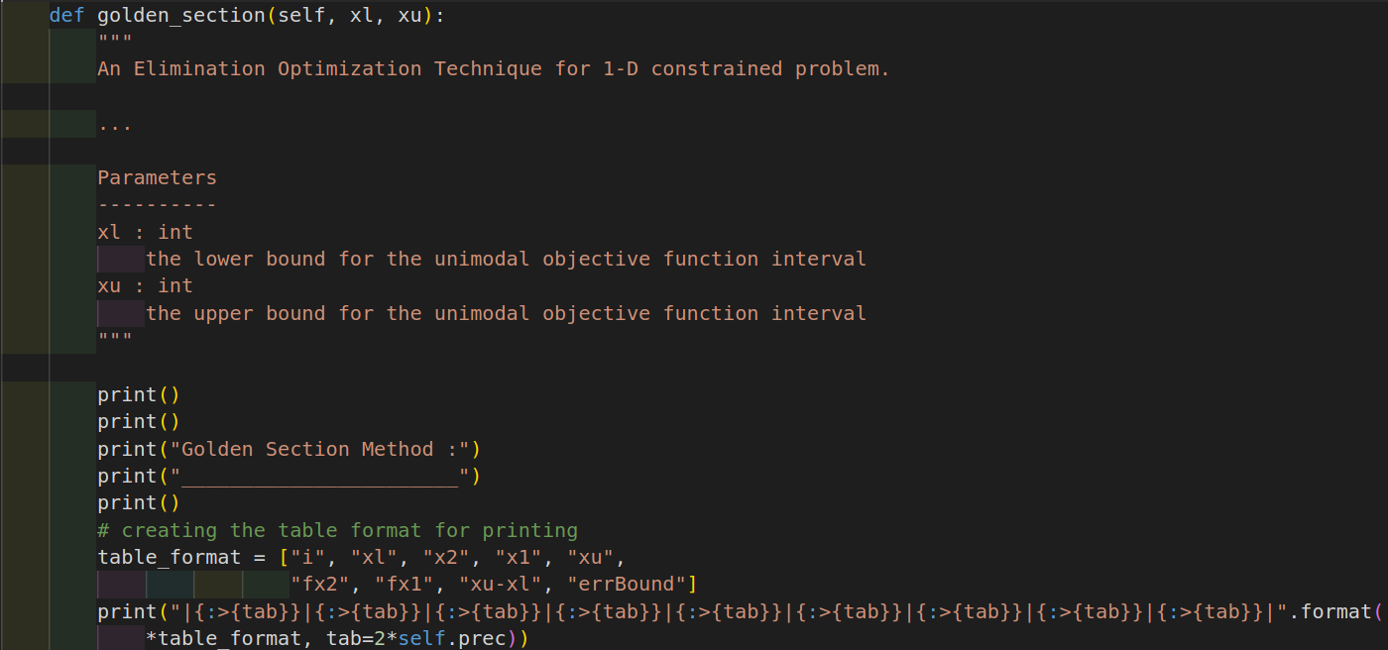

**Golden Section method code (part 2):**

We can calculate all the lengths and error bounds for each iteration before doing our loop.

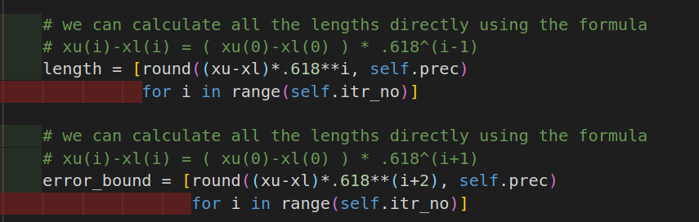

**Golden Section method code (part 3):**

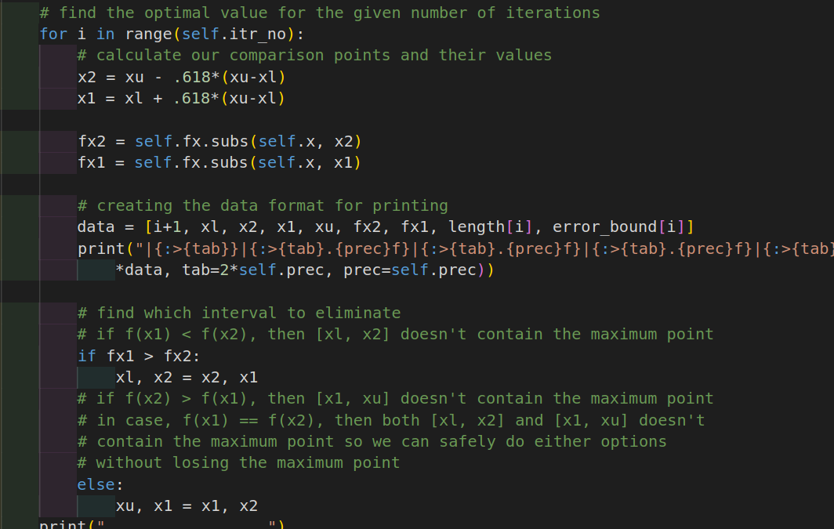

**Golden Section method output:**

