**Assignment 2**

**We will use a class to define the two methods (Powell’s method & Steepest Descent method) because they both will solve the same problem.**

**Our Class Function Code:**

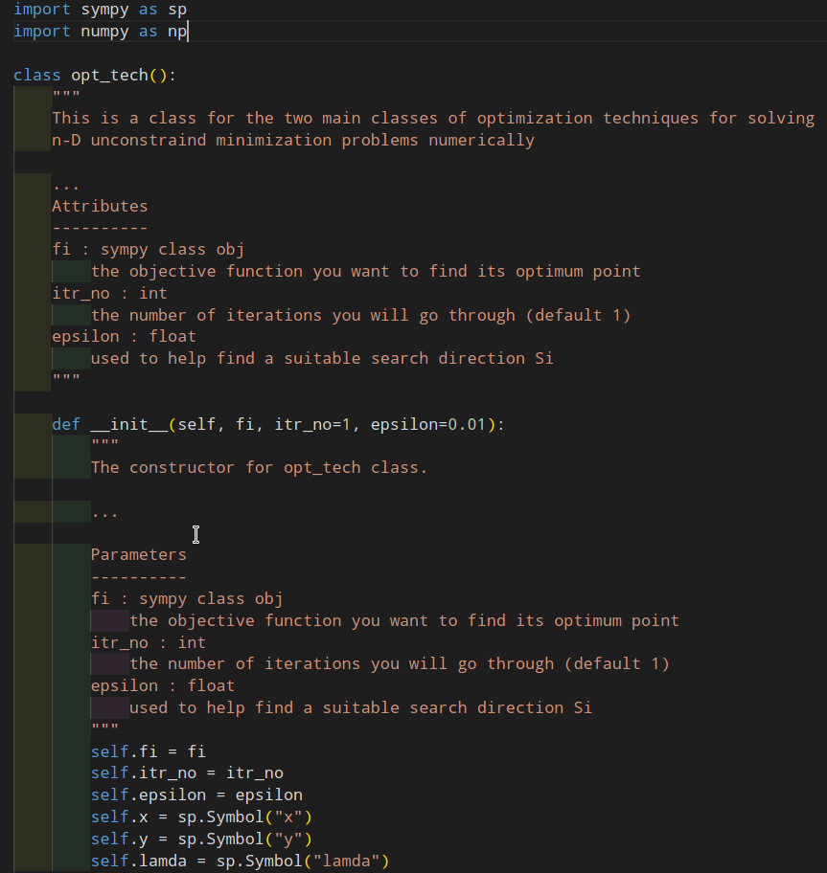

**Initializing our Class:**

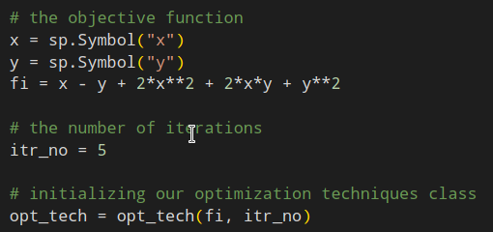

**Powell’s Method:**

It’s an iterative direct search optimization method, which requires an initial guess X1 vector for the optimum point.

**Required Input:**

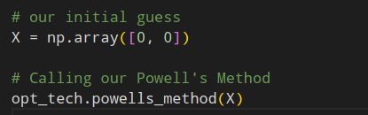

**Powell’s method code (part 1):**

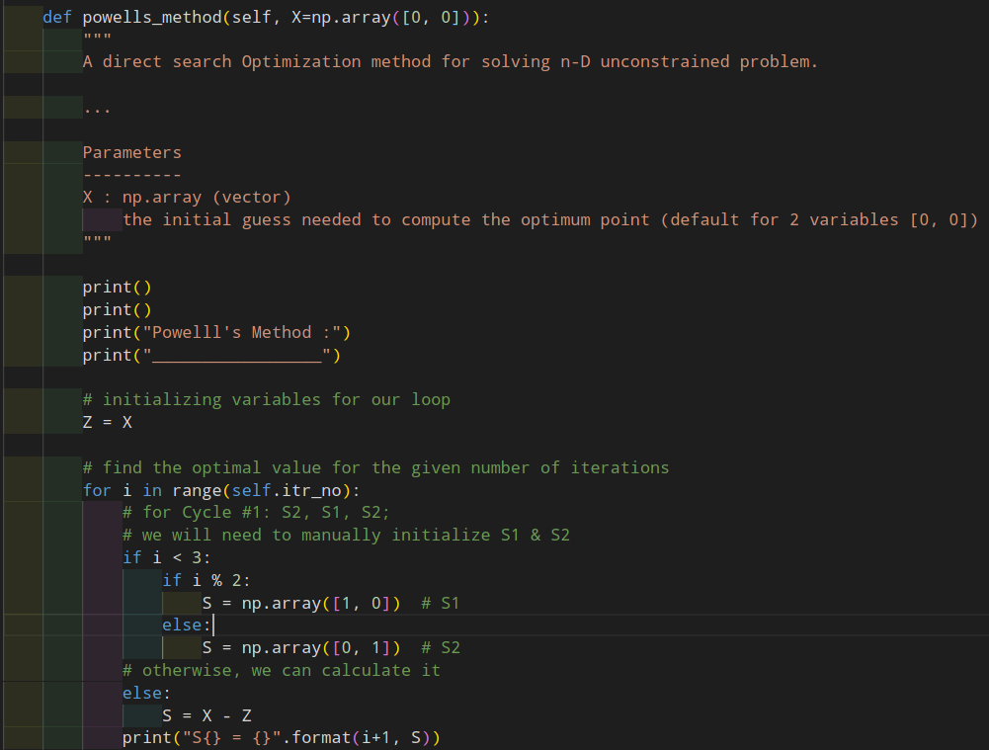

**Powell’s method code (part 2):**

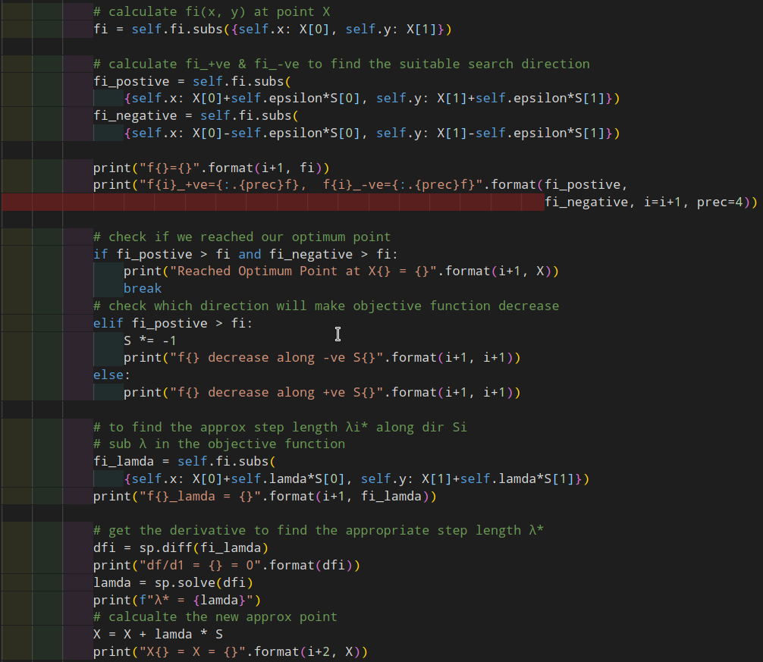



**Powell’s method output:**

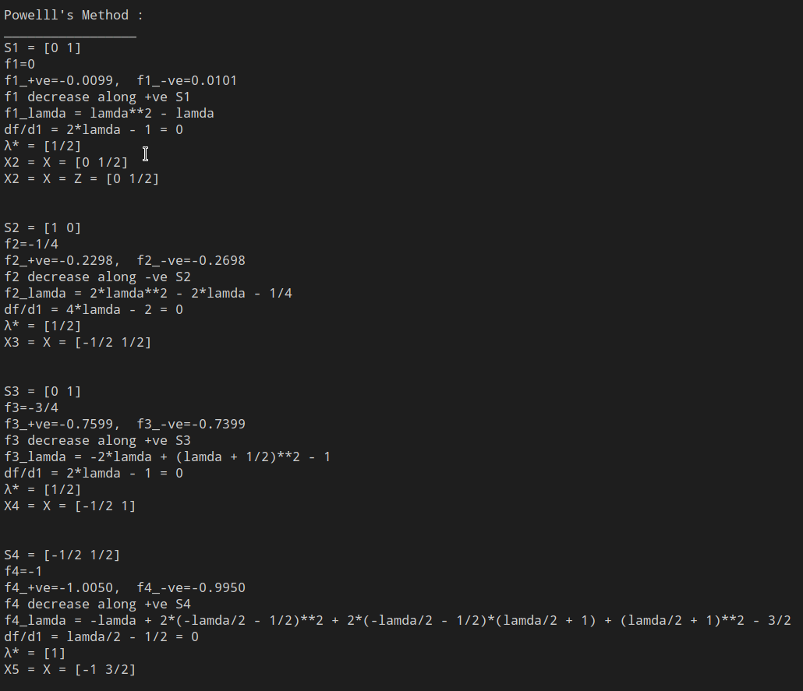

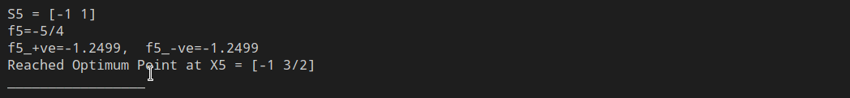

**Steepest Descent Method:**

It’s an iterative (Gradient) Descent search optimization method, which requires an initial guess X1 vector for the optimum point.

We will use the same objective function from Powell's method and same initial guess but we will change the iteration number.

**Required Input:**

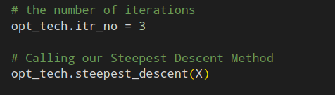

**Steepest Descent method code (part 1):**

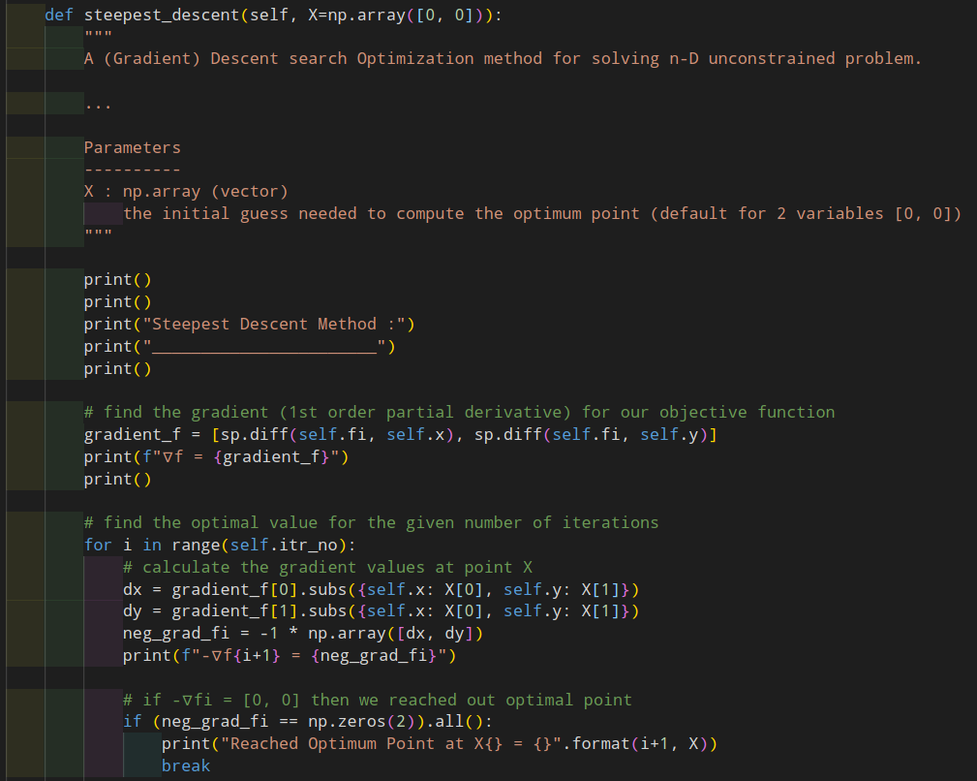

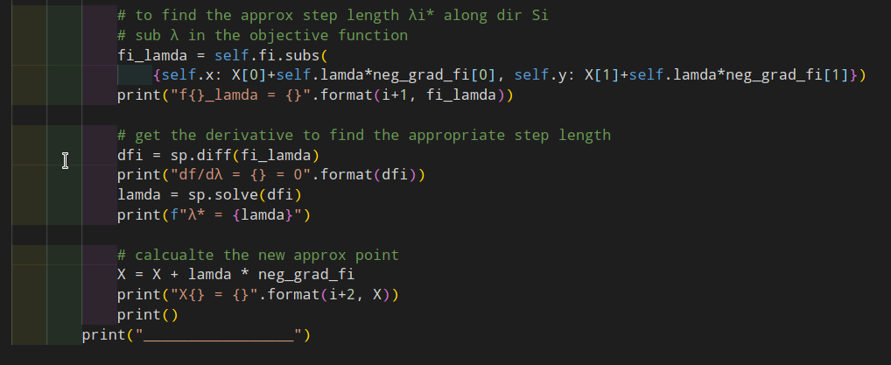

**Steepest Descent method output:**

