**JavaScript Assignment – Lecture 1**

**Part 1: Variables and Scope**

**1. Explain how var works in JavaScript. What is variable hoisting? Give a code example.**

* Declare a variable in a function scope, and could be globally scoped if it’s declared outside the function.
* Hoisting: moving the declaration of variable to the top of the scope, but assigning it as undefined variable.

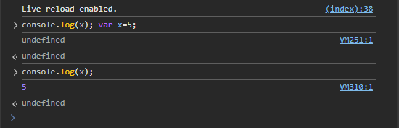

**2. What is the scope of a variable declared with var inside a function? What about inside a block (e.g., an if statement)?**

* The scope is function-scope.
* Global-scope.

**3. List all JavaScript primitive types in ES5. Give an example of each.**

1. Number
2. String
3. Bool
4. Undefined
5. Null

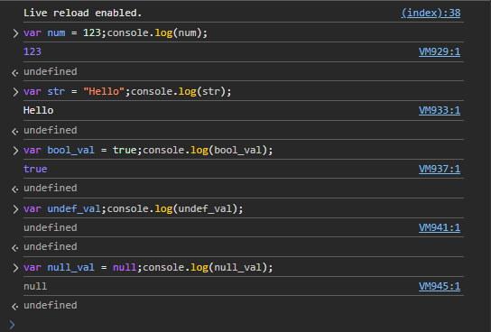

**4. What is the difference between a primitive type and an object type? Give an example where this difference is important.**

Primitive:

* Immutable
* Stores the value; so, it can be copied and preserve its data regardless the copy made.

Object Type:

* Mutable
* Store the reference; so, the copy affects the original.
* Can be used explicitly with methods.

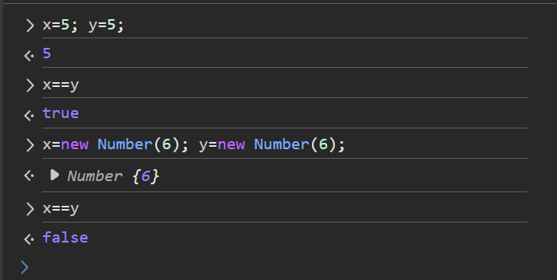

**5. Create a number, string, and boolean using both literal and constructor syntax. Show the difference in their types using typeof.**

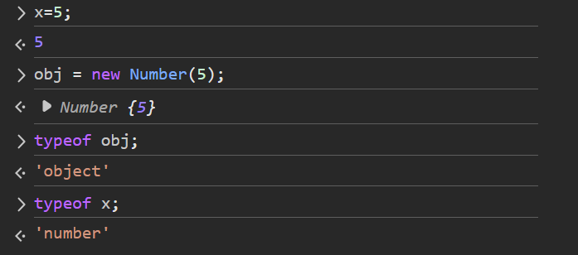

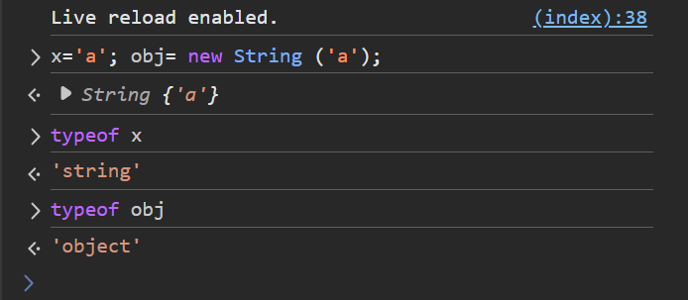

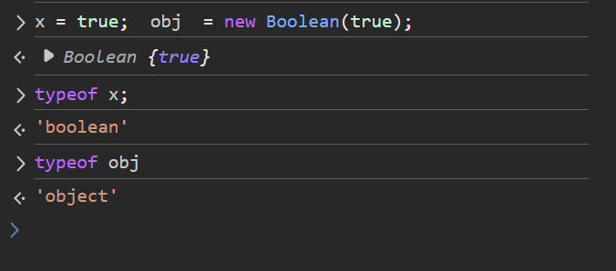

**6. Why is it generally recommended to use literals instead of constructors for primitive types?**

1. Simplicity
2. Readability
3. Performance
4. Objects Are Always Truthy

**7. Given the following code, what will be the output? Explain why.**

**var x = 123.4567;**

**console.log(x.toFixed(2));**

allow only 2 dig after the decimal point, not rounding. Casting to string.

**console.log(x.toPrecision(4));**

allow 4 dig in general, rounding after the point. Casting to string.

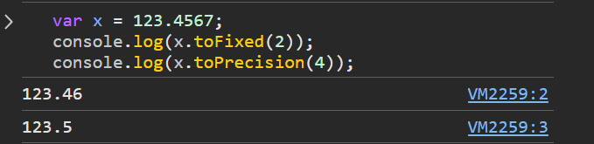

**8. What is NaN? How can you check if a value is NaN? Give an example.**

“Not a Number”: its type is Number.

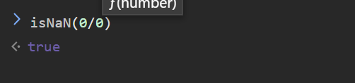

**9. What is the difference between parseInt, parseFloat, and Number? Give an example for each.**

**ParseInt:** convert string into Integer.

**ParseFloat:** convert string into float.

**Number:** convert string or bool (strictly) into number.

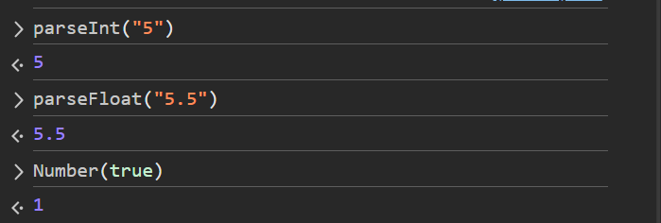

**10. What is the difference between implicit and explicit type casting? Give an example of each.**

**Implicit:** done automatically:

+ : concatenate

- : cast to number & subtract

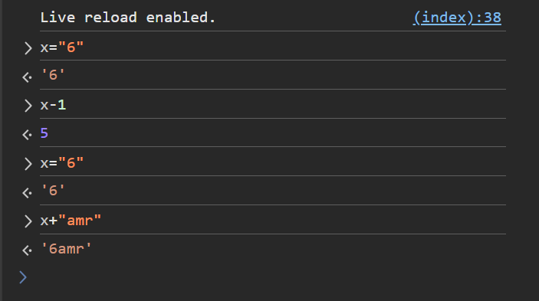

**Explicit:** done by creating object of the intended class.

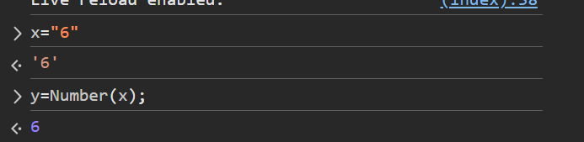

**11. What will be the result and type of the following expressions? Explain your answer.**

**- true + 5 :** asTrue equals 1, where False equals 0.

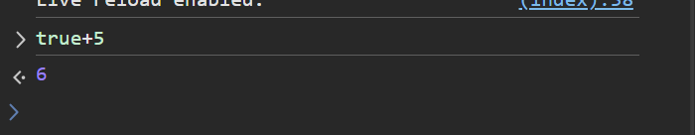

**- "10" – 2:** implicit casting to number, in case of (-): cast str into number

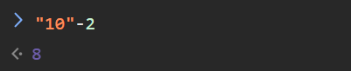

**- 12 - "1a" :** implicit casting to Number, founding “a” result in not valid number and a NaN value.

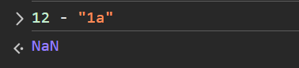

**- 5 / 0:** Number; infinity as it’s pos / 0.

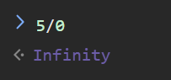

**- 5 + undefined :** casting undefined to number results in NaN.

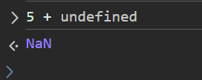

**12. What will be logged to the console in the following code? Explain each step.**

**var a = "15.5";**

**var b = +a;**

**console.log(b, typeof b);**

it’s **Unary plus** which converts string into number.

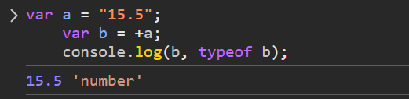

**13. What will be the output of:**

**var result = 20 > true < 5 == 1;**

**console.log(result);**

**Explain why.**

True.

It goes like this:

* 20>true 🡪 20>1 🡪 true
* True<5 🡪 1<5 🡪 True
* True ==1 🡪 1==1 🡪 True.

**14. Write a function that takes a string and returns true if it can be converted to a valid number, and false otherwise.**

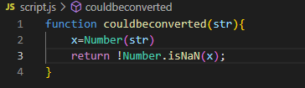

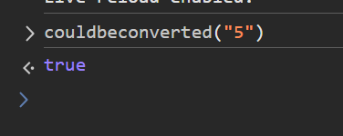

**15. Write a program that prints all numbers from 1 to 20 using a while loop.**

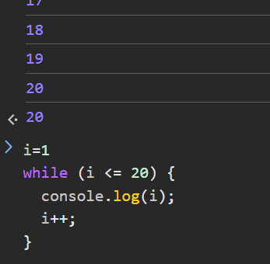

**16. Write a program that asks the user to enter numbers until they enter 0, using a do...while loop. After the loop ends, print the sum of all entered numbers (excluding 0).**

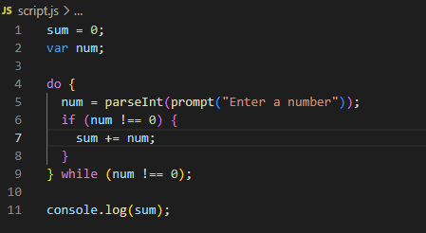

**17. Write a program that takes a number from 1 to 7 and prints the corresponding day of the week using a switch statement. Use a for loop to test your program with all numbers from 1 to 7.**

