

**Faculty of engineering - Shoubra**

**Benha University**

**Research Project**

in fulfillment of the requirements of

|  |  |
| --- | --- |
| **Department** | **Engineering Mathematics and Physics** |
| **Division** | **-----------------** |
| **Academic Year** | **2019-2020 Preparatory** |
| **Course name** | **Computer** |
| **Course code** | **ECE001** |

**Title: -**

**Cryptography** By:

|  |  |  |  |
| --- | --- | --- | --- |
|  | Name | Edu mail | B.N |
| 1 | عمرو محمد حسن محمد قنديل | amr195646@feng.bu.edu.eg | 583 |

**Link to GitHub website:**

**Link to GitHub:**

**Approved by:**

|  |  |
| --- | --- |
| Examiners committee | Signature |
| Dr. Ahmed Bayoumi |  |
| Dr. Shady Elmashad |  |
| Dr. Abdelhamid Attaby |  |

\

**Application brief**

Cryptography is Information Security science. The word derives from the Greek kryptos, which means hidden. Cryptography includes techniques such as microdots, merging words with images, and other ways of concealing storage or transit information. Modern cryptography intersects the disciplines of mathematics, electrical engineering and computer science. Cryptographic applications include ATM cards, computer passwords, and electronic commerce.Before the modern age cryptology was almost synonymous with encryption, the conversion of information from a readable state to apparent absurdity. The sender retained the ability to decrypt the information and thus to avoid being able to read it by unwanted persons. The methods used to perform cryptology have become increasingly complex and their application more widespread since the WWI and the advent of the computer.Modern cryptography follows a strongly scientific approach, and designs cryptographic algorithms around assumptions of computational hardness, making such algorithms difficult for an adversary to break through. In theory, such systems are not unbreakable but it is impossible to do so by any practical means. So these schemes are computationally secure. Secure schemes exist that can not be proven to be broken — an example is the one-time pad — but these schemes are harder to implement than the theoretically breakable but computationally secure mechanisms.Tags: cryptography subject, cryptography ppt, cryptography pdf, cryptography seminar, latest

seminar topic cryptography, full seminar report on cryptography, source code cryptography

**Screen shots**

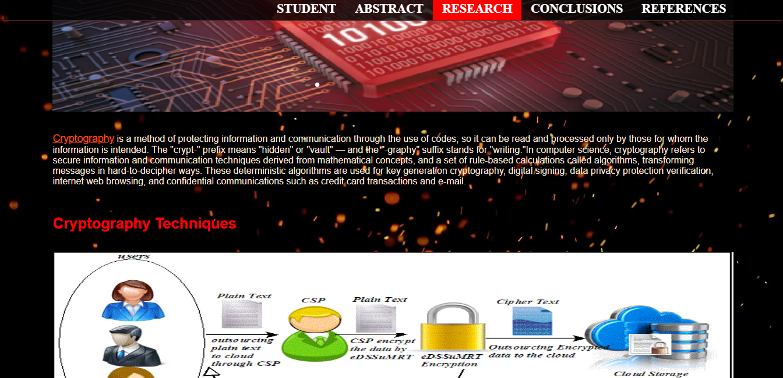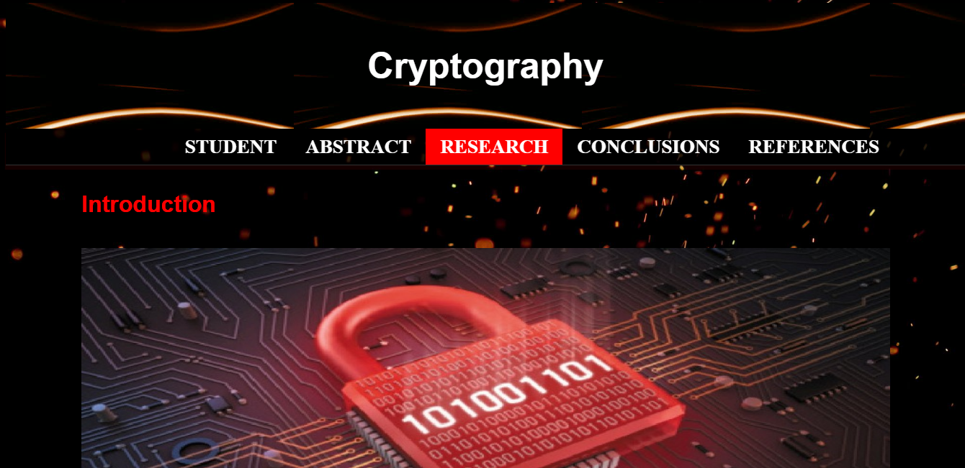

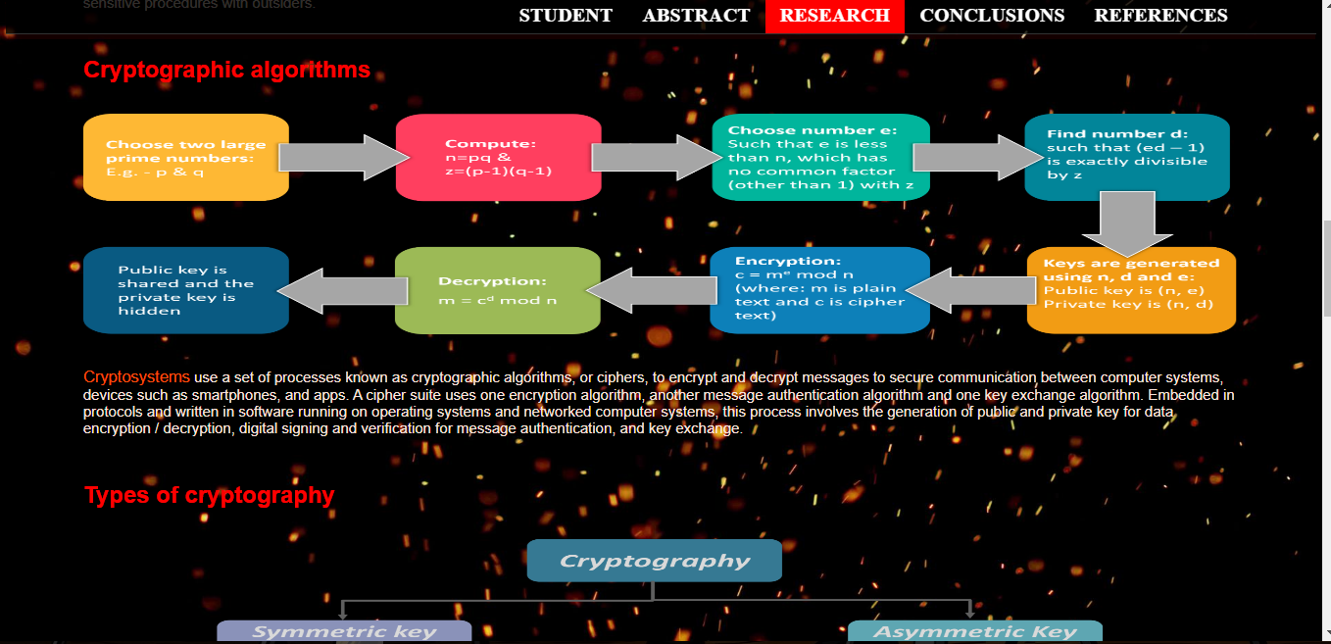

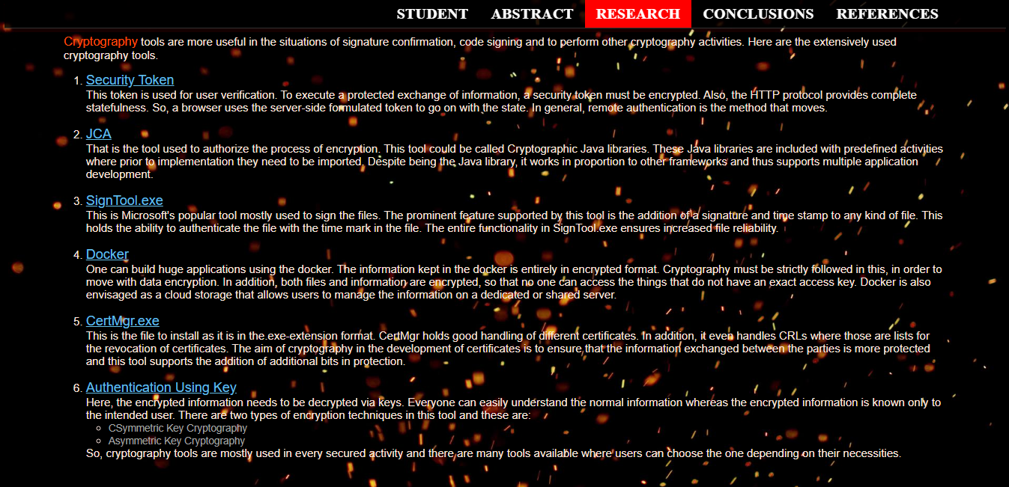

**Abstract**

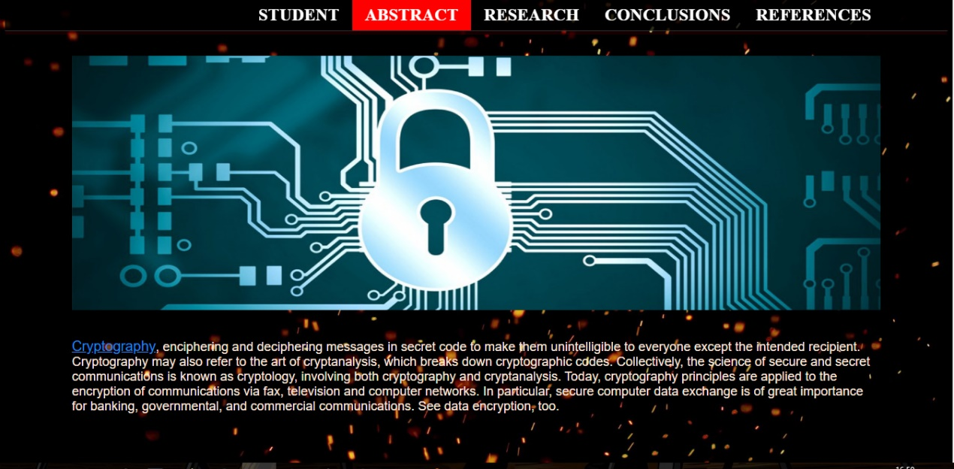

**Conclusions**

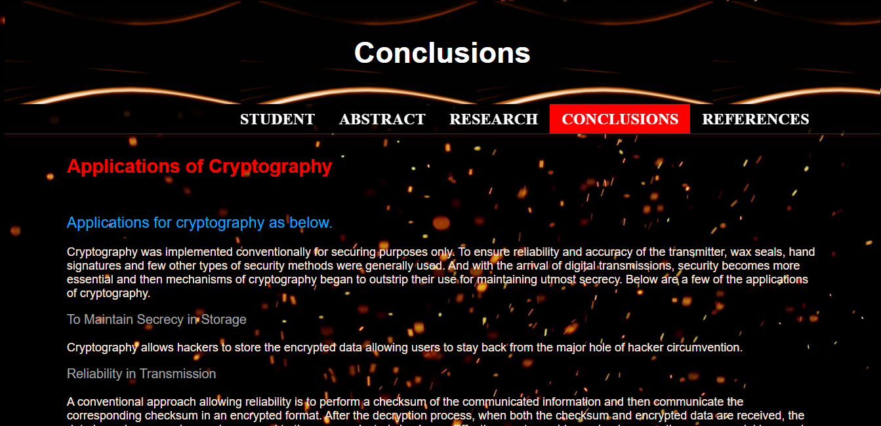

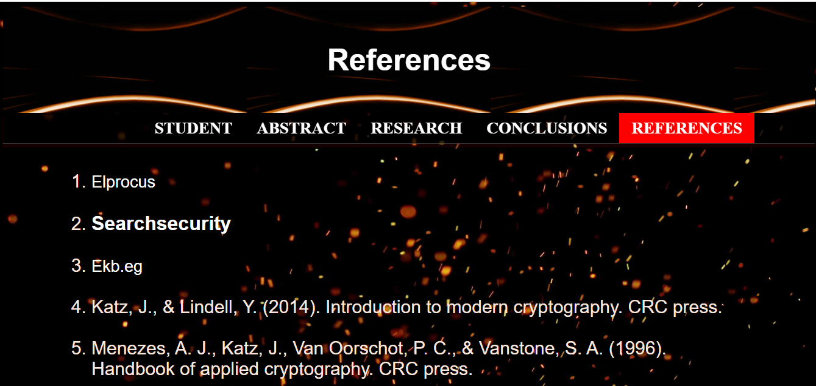**References**

**Student**

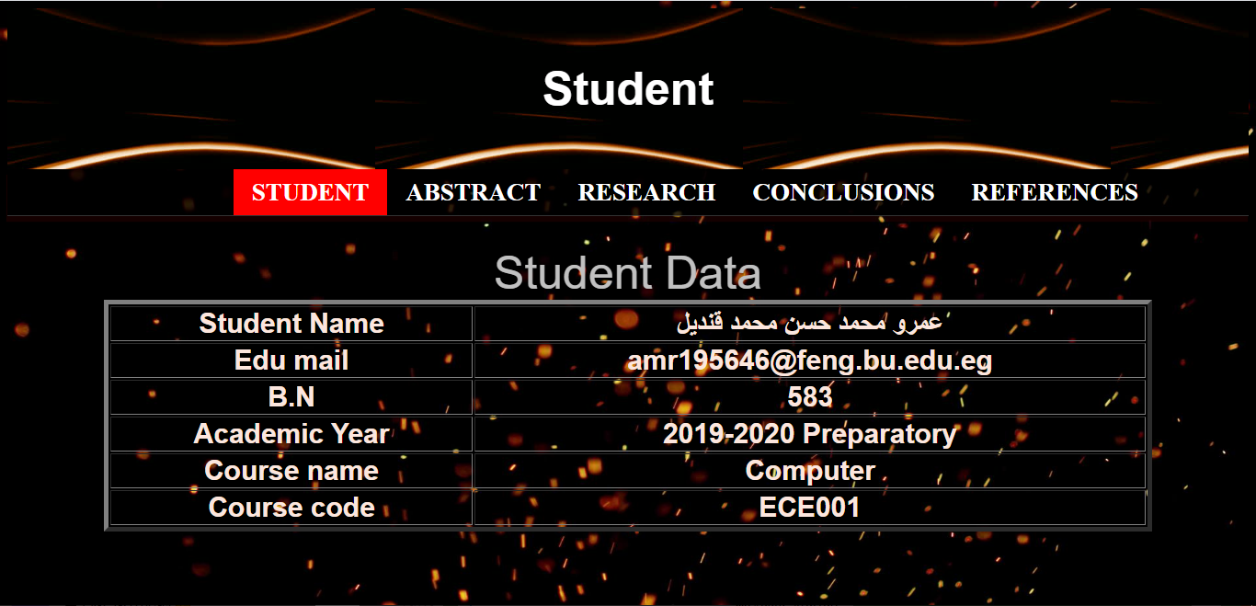

**Source code**

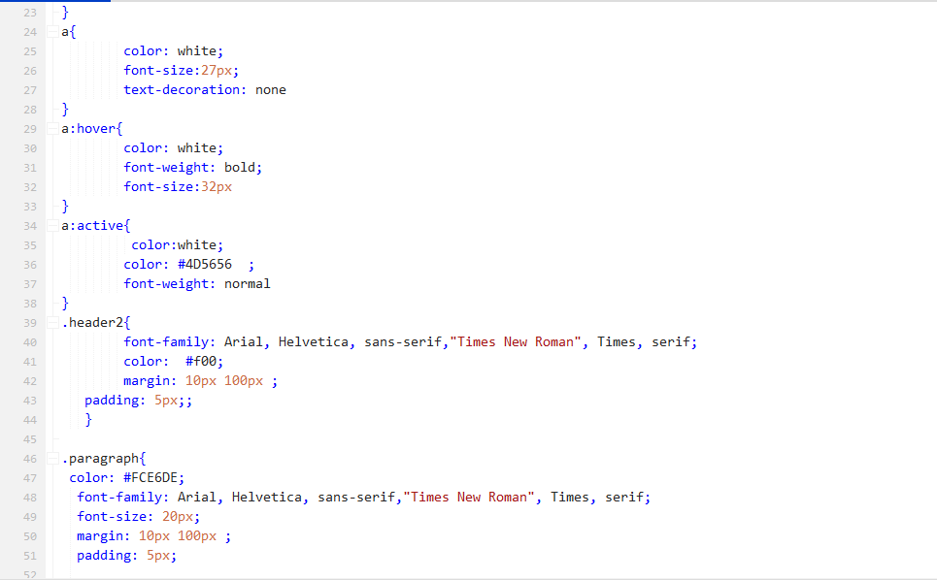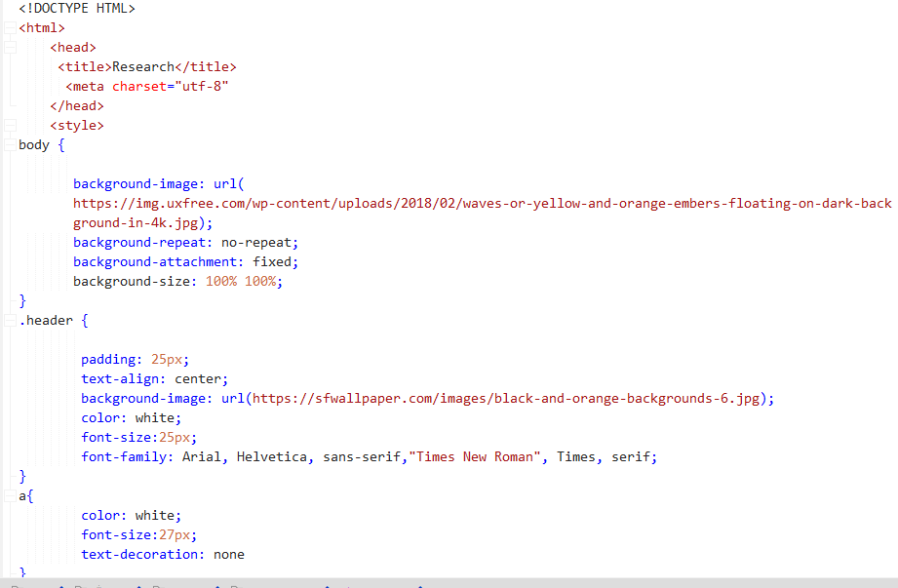**Style**

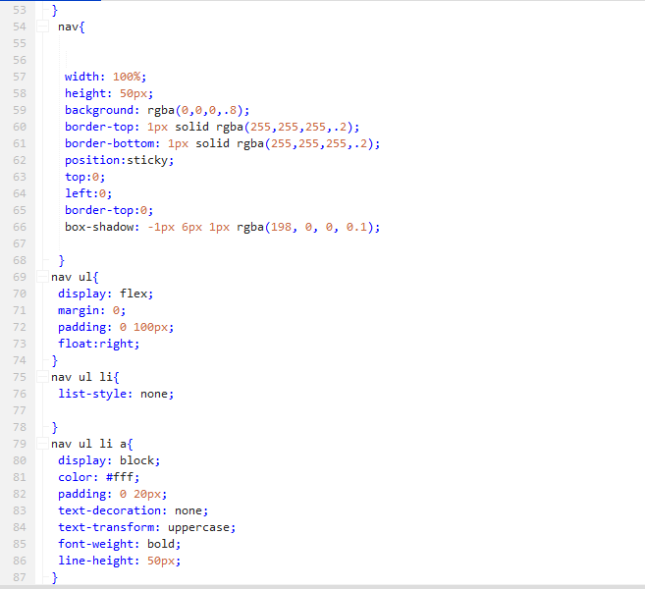

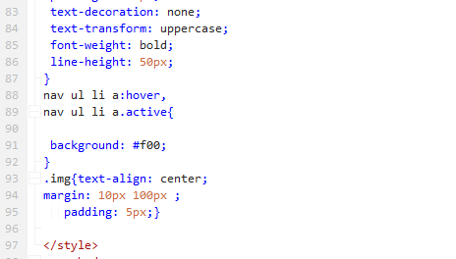

**links, headers, images & paragraphs**

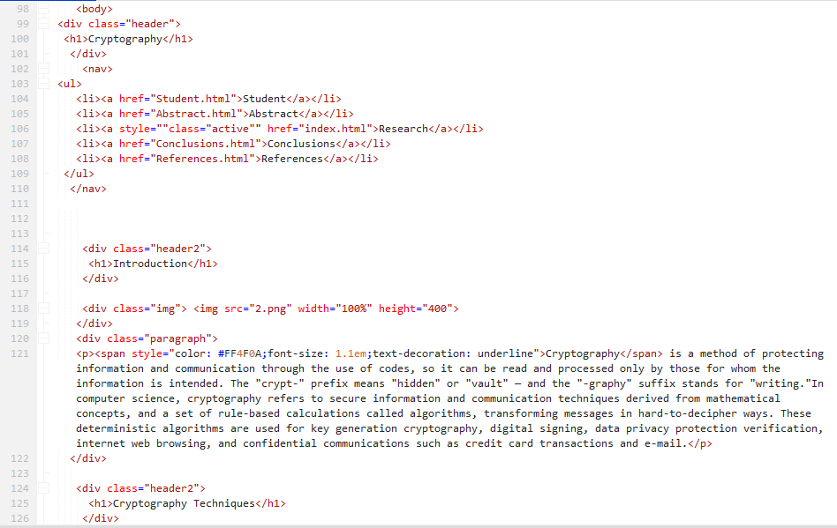

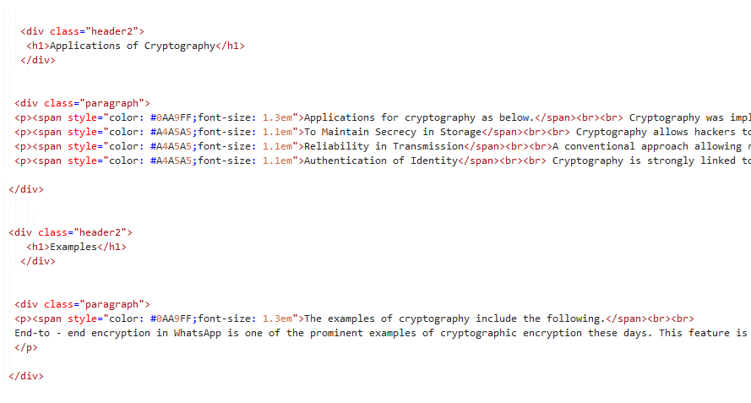

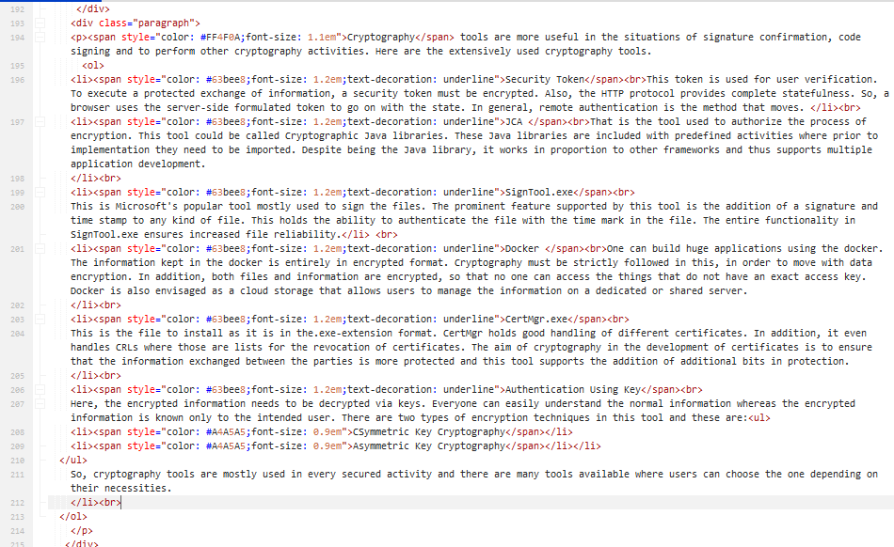**Lists**

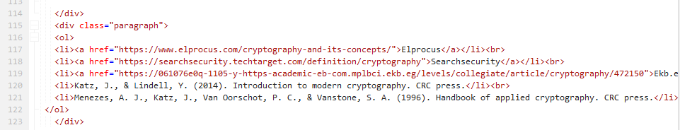

**Tables**

