

Palestine Technical University (PTUK)

Faculty of Engineering and Technology

Department of Computer Systems Engineering

Software Engineering Requirements Document

**Designing a website that manages patient appointments**

Supervisor:

**Dr.Osama Hamed**

**Submitted By:**

|  |  |
| --- | --- |
| **Student's Name** | **Student's ID** |
| Amr Haytham Hoji | 202110624 |
| Amjad Khalel AL-Tanni | 202110719 |
| Haneen Mohammad Sabra | 202111914 |
| Areej Essam Amer | 202110242 |

Table of Contents

**CHAPTER 1 INTRODUCTION**

1.1 Project Overview & Background

1.2 Project Domain

1.3 Project Objectives

1.4 Project Scope

**CHAPTER 2 REQUIREMENTS GATHERING APPROACH**

**CHAPTER 3 USER REQUIREMENTS DEFINITION**

3.1 Functional User Requirements

3.2 Non-Functional User Requirements

**CHAPTER 4 SYSTEM ARCHITECTURE**

4.1 What is Outside the System’s Borders

4.2 Context Diagram

**CHAPTER 5 SYSTEM REQUIREMENTS SPECIFICATION**

5.1 FUNCTIONAL SYSTEM REQUIREMENTS

5.2 NON-FUNCTIONAL SYSTEM-REQUIREMENTS

**CHAPTER 6 SYSTEM MODELS**

6.1 Use-case Diagrams

6.2 Class Diagram

6.3 Activity Diagrams

6.4 Sequence Diagram

**CHAPTER 7 SYSTEM EVOLUTION**

**CHAPTER 8 PLAN FOR REST OF WORK**

**CHAPTER 9 CONCLUSION**

REFERENCES

**CHAPTER 1: INTRODUCTION**

Managing patient appointments in hospitals

**1.1 Project Overview & Background:**

. For decades, hospitals have been struggling with managing and organizing patient appointments, due to the increased influx of patients to hospitals and the difficulty of organizing and scheduling patient appointments. Appointments were handled by the patient coming to the hospital to take the appointment, and this system has disadvantages, including:

. Inconveniencing the patient to come to the hospital to book an appointment, taking into account the distances he will travel to the hospital.

. It is necessary to have an employee to book appointments for patients.

.Wasting time and effort on the employee and patient.

Hence, there is a need for a site that manages patient appointments in hospitals and facilitates communication between hospitals and patients.

**1.2 Problem Domain:**

Managing patient appointments in hospitals

The challenges faced by the current traditional ordering system are a major problem Obstacles to achieving efficiency and customer satisfaction:

.Patients will have to stand in long lines to submit requests to book an appointment.

. Hospital staff will manually record appointment requests.

. After submitting an application, the patient must wait until he receives the application confirmation paper.

. Manual work reduces efficiency and increases the possibility of errors occurring during the application process.

**1.3 Project Objectives:**

Managing patient appointments in hospitals

Our project aims to develop an online appointment booking system for use in the appointment booking service for patients in hospitals, which will allow hospitals to quickly and easily manage the list of booking appointments available through the website. The customer can complete the operation he wants quickly, easily and without complications.

•How We Propose to Address the Diagnosed Problems:

We aim to provide a solution to the problems facing hospitals in managing patient appointments by helping patients (customers) book an appointment that is appropriate for them and also appropriate for the hospital management.

This can be achieved by creating a database dedicated to hospitals to store the largest possible number of hospitals in Palestinian cities.

• Save time:

Through the service provided by the site, the customer can, within a few minutes, book an appointment, thus saving the customer time and effort, and thus increasing the customer’s satisfaction with the service provided to him through the site.

• Security of data:

The data is well protected for personal use by registering for an account through Personal email and password for each user.

• Minimized manual data entry:

Managing patient appointments in hospitals

Automation ensures data accuracy during the booking request submission process. in general We propose an online appointment booking system, the main advantage of our system is that it is highly Simplifies the booking process for both the customer and the hospital administration.

The project will improve the management of medical appointments and increase their efficiency and accuracy. because This system will reduce all manual work by replacing the traditional system System in a computer system. It will eliminate manual work such as the employee entering patient data and booking an appointment for him.

**1.4 Project Scope:**

The system will be a web-based platform that will be developed to allow customers (patients) to view everything, appointments booked and unbooked, doctors you can book with, and then place the order through the system. It is available for customers to book an appointment with a specific doctor, and they can also cancel this reservation, and they can also pay through the website.

The system will be able to allow the hospital administration to update appointments and make changes to them, and will also allow employees to create the reports they want to create, such as the monthly patient records report.

**Product Features:**

Managing patient appointments in hospitals

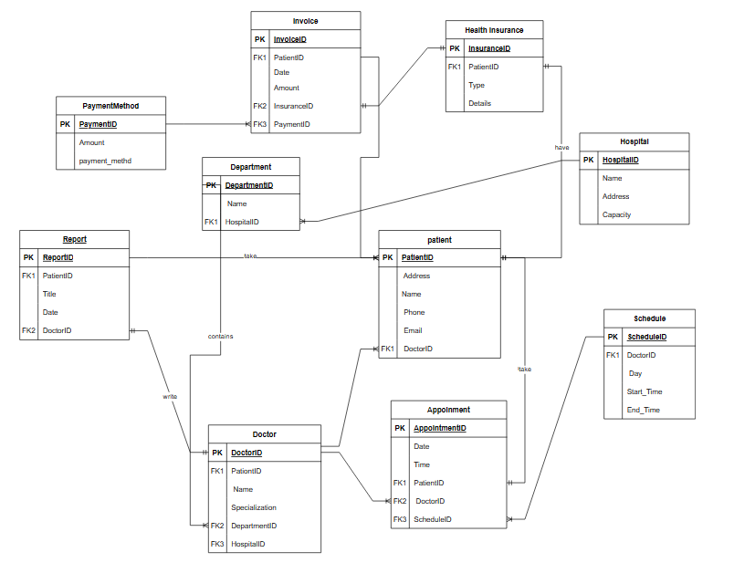The major features of the patient appointments database system as shown in below [**entity–relationship model**](https://en.wikipedia.org/wiki/Entity%E2%80%93relationship_model) (**ER model**)

Figure1.1 ER (Entity-Relationship) Diagram