**GENERATE QR CODE IN JAVA PROGRAM**

**What are QR Codes?**

QR Code or Quick Response Code is a two dimensional barcode that can be read by modern smartphones and special QR Code scanner devices.

A QR code consists of black squares arranged in a square grid on a white background. There are several variants of QR codes depending on their symbol size, layout, encoding and structure.

**How to generate QR Code in Java?**

I’m use Zxing library or API to generate QR codes for my application.

Zxing, pronounced as Zebra Crossing, is an open source, multi-format 1D/2D barcode image processing library implemented in java.

**Program Generate QR Code**

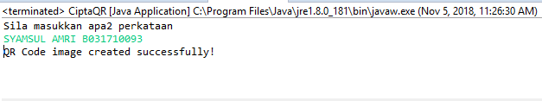

Locate file maklumat.png

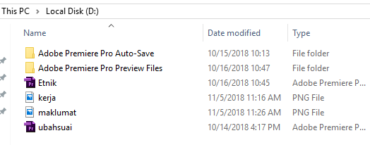

Open QR reader online, (ZXing Decoder Online), upload maklumat.png.

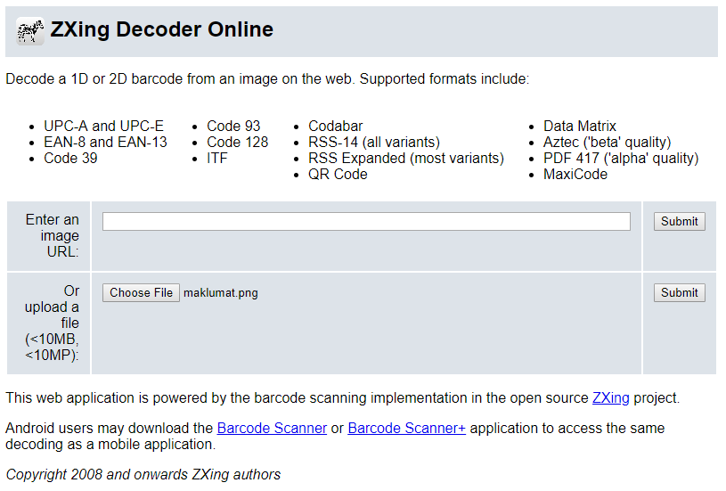

Submit!!

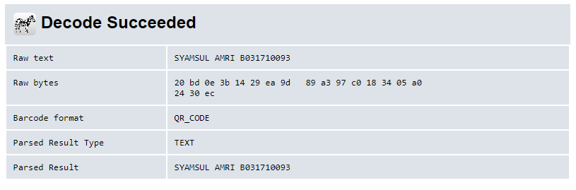

Done.