**Solutions**

1. YAML format file
2. Store full file path in database table
3. Store data in hierarchy

**My Solution**

1. **Store data in hierarchy**

**File option**

* To get the directory structure from file we have a different solution
  + YAML file
  + Text file
* If we use the YAML file we can easily convert that structure in to an array and can insert hierarchy structure with parent child relationship in database.
* I have used text file I have read line by line and check each line

**DB Structure and insert**

* I have read line by line and check each line and calculate string length with space and without space based on that size I have define the parent or child level.
* After get the level I have inserted the record in database in parent and child relationship.
* To keep structure, I have created table with

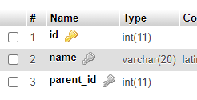

* It will store data in below format.
* 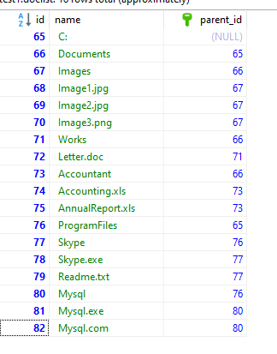

**Search result**

* For search I have used recursive stored procedure in which it will return the result base on search
* I have used stored procedure to load the search data fast speed.