Owners of the Kitchen
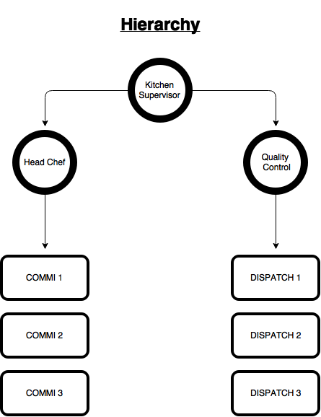

This is a chart depicting the hierarchy in the kitchen which will ensure proper functioning within the kitchen. This document will also clearly mention roles for every person in the kitchen. (Starting next page)

Kitchen Supervisor
- Overall Responsible for smooth functioning of the kitchen.
- Monitoring the Dashboard and giving KOT to the Head Chef and Quality Controller.
- Final Check on the food leaving the kitchen.
- Keep a continuous check on the cleanliness and hygiene of the kitchen.
- Make sure the dispatchers are well dressed daily.
- Keep a track of the packaging inventory remaining and inform well in advance if we need to order.
- Make sure the staff members report on time daily and fulfil their duties.
- Ensure there is harmony among the members of the kitchen and build a good working culture.
- Collect the money from the dispatchers and manages the accounts.
- Ensures there is enough petty cash in the kitchen.
- Oversees the dispatch of orders to make sure it is running smooth.
- Customer Issue management. – Calls and receives all the calls regarding queries from customers.

Head Chef
- Responsible for smooth processing of all the orders coming in.
- Distributes the KOT tickets (partials) given by the Kitchen Supervisor and distributes to the individuals responsible (Salads, Panini’s, and Pastas etc.).
- Prepare Ingredients for Box Assembly in time.
- Ensures dispatch of food happens within 15 minutes of ordering. (not applicable for bulk orders)
- Makes sure that the ingredients used to prep the box are fresh.
- Ensures proper hygiene within the kitchen is maintained by all the Commi.
- Order food supplies for the upcoming days well in advance. Inform the Supervisor about his ordering plans.
- Check incoming ingredients quality and get invoices. Store them properly.
- Train other chefs on all the recipes.
- Hire Kitchen Staff (as and when required)

Quality Controller
- Receives the full KOT of every order from the Kitchen Supervisor.
- Responsible for packaging all the components of each box.
- Make sure that each box contains all the mentioned boxes and also label the box correctly.( Containers, Recipe Cards)
- Give clear instructions to the delivery boy going to deliver the box.
- Make sure each delivery guy has the required change, is properly dressed and is clear about the delivery address.
- Make sure that dispatch happens within 15 minutes of order. (not for bulk orders)
- Monitor Delivery time.
- Ensures proper address is written/printed on every box.
- Train all the dispatch guys on communication with the customer.

Commi
- Takes his individual KOT from the Head Chef and prepare the dish on time.
- Ensures the food is of good quality by making sure the ingredients being used are fresh.
- Informs the Head Chef of ingredients running out well in advance.
- Maintains good personal and surrounding hygiene in the kitchen.
Dispatcher
- Ensures the bike he/she uses is clean and well oiled.
- Maintains personal and surrounding hygiene in the kitchen.
- Places the box properly in the container for delivery.
- Ensures there aren’t too many jerks so that the food doesn’t spill out of their individual containers.
- Understands the location of the delivery address properly.
- Call (if required) the customer only once per delivery.
- Have decent communication skills and etiquettes while talking to a customer.
- Has to make sure the delivery is made on time.

