Step 1: Visit <https://apps.sentinel-hub.com/>

Step 2: click sign up

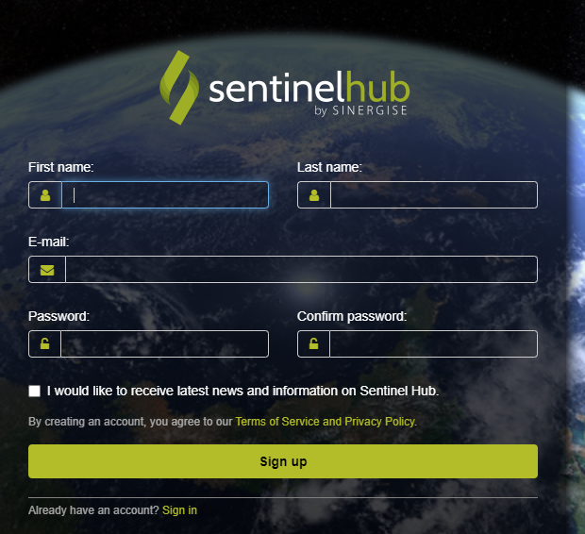

Step 3: provide your email and password. Check terms and condition. You will receive an confirmation email.

Step 4: Verify your email address.

Step 5: Visit <https://apps.sentinel-hub.com/eo-browser>

Step 6: login by using your UserID and Password.

Step 7: Zoom in out to you area of interest

Step 8: provide your time range and click visualize to add image over map.

Step 9 : Zoom in the image so that it covers whole screen of your laptop/pc

Step 10: click download bottom and go to analytical

Step 11. Select image format, resolution etc

Step 12: click download