Machine Learning–Based Late Delivery Risk Prediction in Global Supply Chain Operations

Author: Amrit Baruah
Email: abaruah289@gmail.com
Project Mentor: Saiprasad Kagne
Email: saikagne2601@gmail.com
Submitted in partial fulfillment of the requirements for the Data Analyst Internship Programme at Unified Mentor.

Abstract
Delivery delays are a persistent and costly problem in global logistics, primarily due to the lack of proactive risk identification before shipment. This study presents a machine learning pipeline developed for APL Logistics to generate pre-shipment delivery risk scores across 180,519 historical records drawn from global operations.
Logistic Regression, Random Forest, and XGBoost models are used to estimate the probability of late delivery on a 0–1 scale and classify orders into three risk tiers: Low (<0.30), Medium (0.30–0.60), and High (>0.60). The pipeline addresses key methodological challenges in applied machine learning, including data leakage, improper application of SMOTE, and the use of random splits in temporally structured data.
High-cardinality features are handled using a smoothed m-estimate target encoder, while SMOTE is applied within each cross-validation fold using an ImbPipeline to prevent synthetic data leakage. Model evaluation is performed using TimeSeriesSplit to ensure realistic performance on future data.
Random Forest achieved the best performance on a chronological hold-out test set, with a ROC-AUC of 0.7435. At the operational threshold of 0.35, the model achieves a Recall of 0.816, Precision of 0.627, and F1 score of 0.709, flagging 71.8% of orders for review. Across all scored orders, 35.2% are classified as High-risk, 54.9% as Medium-risk, and 9.9% as Low-risk, with an average predicted probability of 52.6%.
SHAP-based analysis identifies key drivers of delay risk, supporting model interpretability and operational decision-making.
Keywords: supply chain analytics, late delivery prediction, Random Forest, SMOTE, TimeSeriesSplit, SHAP, ImbPipeline, risk classification, target encoding, operations intelligence

1. Introduction
Late deliveries in global logistics networks lead to SLA breaches, financial penalties, and customer churn. A 2023 McKinsey analysis of supply chain operations estimated that reactive delay management handling disruptions after they occur rather than before adds between 15% and 25% to total logistics costs for large 3PL operators. While the data required to anticipate such delays often exists, the tools to convert it into forward-looking signals are typically lacking. In contrast, early identification of potential delays enables proactive actions such as rerouting, reprioritization, and timely customer communication.
APL Logistics faces challenges including unpredictable shipment delays, high costs associated with last-minute corrective actions, and limited ability to prioritize high-risk orders. The organization lacks a predictive system to flag late-delivery risk in advance, generate quantitative risk scores for planning, and provide explainable insights into the key drivers of delays.
APL Logistics operates across major global markets, processing tens of thousands of orders monthly across diverse shipping modes, customer segments, and geographies. While existing reporting effectively captures historical delay rates, it does not provide an order-level risk score prior to dispatch—one that enables operations teams to identify which orders in the upcoming queue are most likely to be delayed and require intervention.
This study addresses this gap by developing a system that assigns each order a probability of late delivery on a 0–1 scale, classifies orders into Low, Medium, and High risk tiers, and presents a prioritized action queue through a Streamlit dashboard. The paper documents the full methodology, including data preparation, feature engineering, model development, evaluation, and system limitations.
The remainder of the paper is structured as follows: Section 2 covers the description of the dataset, Section 3 details the methodology, Section 4 presents results and operational insights, and Sections 5 through 8 discuss explainability, dashboard implementation, limitations, and conclusions.

2. Dataset Description
The dataset comprised 180,519 orders across 40 original feature columns. The target variable Late_delivery_risk is a binary indicator: 1 for orders where the actual shipping duration exceeded the scheduled duration, and 0 otherwise.

2.1 Field Overview
The raw columns fall into six natural groups. Financial fields include per-item discount amount and rate, product price, and per-order profit and benefit figures. Logistics fields include scheduled shipping duration, shipping mode (Standard Class, Second Class, First Class, Same Day), and delivery status. Geographic fields cover customer and order city, state, country, and broader market region. Order detail fields include item quantity, order total, and category identifiers. Six post-delivery columns, actual shipping duration, delivery status, order status, and realized profit fields were removed as data leakage. Nine PII and identifier columns were removed as carrying no predictive signal.

Field Category | Key Columns | Treatment
Target | Late_delivery_risk | Binary label (0/1)
Logistics | Days for shipment (scheduled), Shipping Mode | Core predictors
Financial | Benefit per order, Sales per customer, Discount Rate | Engineered features
Geographic | Order Region, Market, Country, State, City | Smoothed target encoding
Order Detail | Order Item Quantity, Order Item Total | Feature engineering
Leakage — removed | Days for shipping (real), Delivery Status | Post-delivery: excluded
PII / ID — removed | Customer Fname, Lname, Id, Zipcode | No predictive signal
Table 1. Dataset field categories and their treatment in the pipeline.

2.2 Class Balance
The target variable is moderately imbalanced: approximately 54% of orders are labeled late and 46% on time. This ratio is less extreme than many real-world classification datasets, but still sufficient to affect model calibration if unaddressed. One caveat worth naming: the label is constructed from schedule slippage (actual duration vs. scheduled), not from a customer-facing SLA threshold. A model trained on this target is technically predicting internal schedule adherence, which is correlated with customer-visible delays but not identical to them. This distinction matters for how the outputs should be interpreted in practice.

2.3 Data Quality
Missing values were limited to a small number of columns, specifically Customer Zipcode and Customer Lname, both of which are categorical features. These were imputed using a constant placeholder value of "Unknown".
Order Item Profit Ratio exhibited a pronounced left-skewed distribution, indicating the presence of heavily discounted orders. No transformation was applied, as tree-based models are generally insensitive to feature scaling and distribution. No duplicate records were identified in the dataset.

3. Methodology
The pipeline was organized around a single principle: every transformation that depends on training labels — encoding, imputation statistics, class balancing — must be estimated from training data only, then applied to test data using those stored estimates. This principle is easy to state and surprisingly easy to violate in practice. Each sub-section below documents the specific implementation choices made to maintain it.

3.1 Data Cleaning
After treating missing values, six columns were removed as post-delivery leakage: Days for shipping (real), Delivery Status, Order Status, Order Profit Per Order, Order Item Profit Ratio, and a derived shipping_gap column. These fields are observationally associated with the target in historical data, an order that took longer than scheduled is, almost by definition, likely to be labeled late but they would be unavailable at scoring time, making them useless for pre-shipment prediction and actively deceptive in training.
Nine PII and identifier columns were also dropped: Customer Fname, Customer Lname, Customer Street, Customer Zipcode, Customer Id, Order Customer Id, Product Name, Latitude, and Longitude. Product Name was excluded due to excessive cardinality with no direct path to a clean encoding. Latitude and Longitude were excluded as redundant with the regional and country-level encodings.

3.2 Feature Engineering
Eleven features were constructed on top of the cleaned raw columns. The reasoning behind each follows.
shipping_pressure = Order Item Quantity / (Days for shipment (scheduled) + 1). This captures the interaction between order volume and timeline tightness in a single number. An order of 50 units on a two-day schedule is fundamentally different in risk profile from the same order on a ten-day schedule; a simple quantity feature would miss that entirely.
schedule_tight is a binary flag set to 1 when scheduled days fall below the training-set median. It provides a discrete signal for the most time-constrained orders and proved to be among the strongest individual predictors.
is_express flags whether the shipping mode contains 'Express'. Express and Same Day shipments historically show substantially lower delay rates; this binary captures that split without requiring one-hot encoding of the full mode column in isolation.
order_value_per_qty = Order Item Total / (Order Item Quantity + 1). High revenue-per-unit orders may receive preferential handling — or may represent products requiring special care that increases handling time. The signal is modest but consistent.
benefit_ratio = Benefit per order / (Sales per customer + 1). Low-margin orders relative to total customer sales may indicate less priority in handling or less buffer in the fulfilment process.
order_value_tier bins the Order Item Total into quintiles (1–5), computed from the training set. This ordinal encoding captures non-linear value effects more cleanly than using the raw continuous value, which has a heavy-tailed distribution.
route_key = Market + '_' + Shipping Mode. This constructed column is then target-encoded (see Section 4.3). It captures the risk specific to a particular market-mode combination — for example, Standard Class orders in certain African or Latin American markets carry systematically higher risk than the same mode in Western Europe — in a way that neither Market nor Shipping Mode alone can capture.
The remaining features — high_quantity_flag and discount_pressure — are straightforward binary and pass-through transforms of existing columns, included because their individual signal, while moderate, contributes incremental predictive power.

Feature | Construction | Rationale
shipping_pressure | Quantity / (Sched. Days + 1) | Volume-timeline interaction
schedule_tight | Binary: sched. days < median | High-constraint orders
is_express | Binary: mode contains 'Express' | Mode risk proxy
order_value_per_qty | Total / (Quantity + 1) | Revenue efficiency
discount_pressure | Order Item Discount Rate | Margin signal
benefit_ratio | Benefit / (Sales per cust. + 1) | Profitability proxy
order_value_tier | Quintile bin of Order Total | Ordinal value segment
high_quantity_flag | Binary: qty > training median | Oversized order flag
route_key | Market + '_' + Shipping Mode | Route-level risk (encoded)
Table 2. Engineered features and their operational rationale.

3.3 Encoding Strategy
The encoding strategy was designed to handle both high-cardinality and low-cardinality categorical columns without leaking test-set information into training.
High-Cardinality Columns
Columns such as Order Region, Market, Order Country, and route_key were encoded using smoothed target encoding based on the m-estimate formulation:
encoded(c) = (nₙ × p̅ₙ + m × μ) / (nₙ + m)
where n_c is the count of training observations in category c, p-bar_c is their observed late-delivery rate, μ is the global training mean, and m = 20 is the smoothing weight. The encoder was fitted only on training data and applied to the test set using stored mappings, with unseen categories defaulting to the global mean.
Low-Cardinality Columns
Columns such as Shipping Mode and Customer Segment were one-hot encoded using pandas.get_dummies on the training set. The test set was aligned using: reindex(columns=training_columns, fill_value=0), This ensures consistent feature space and prevents unseen feature errors.

3.4 Handling Class Imbalance
The ~54/46 class imbalance was addressed using two complementary approaches. SMOTE (Synthetic Minority Oversampling Technique) was applied within an imbalanced-learn ImbPipeline, ensuring that synthetic samples were generated only from training data within each cross-validation fold. This prevents data leakage that can occur when SMOTE is applied prior to dataset splitting, which may otherwise inflate performance metrics.
For XGBoost, scale_pos_weight was set to the ratio of negative to positive class instances in the training data. This adjusts the learning process to penalize misclassification of the minority class more heavily. The two approaches are complementary: SMOTE modifies the training data distribution, while scale_pos_weight adjusts the model’s optimization behavior.

3.5 Model Development
Logistic Regression
Logistic Regression was used as a baseline model with class_weight='balanced' and C=0.5 (L2 regularization). A StandardScaler was applied to ensure stable convergence.
Random Forest
The Random Forest model was configured with 300 trees, max_depth = 12, and min_samples_leaf = 5. The minimum leaf size was a key tuning parameter: without a minimum leaf size, the model tends to overfit on small-sample regional combinations, driving down validation performance.
XGBoost
XGBoost used 300 estimators, max_depth = 6, learning_rate = 0.05, and subsample / colsample_bytree both set to 0.8 for stochastic regularization. The lower learning rate (compared to the common default of 0.1) produces slower but more stable convergence across temporal folds. scale_pos_weight was computed from the training set class ratio. The serialized pipeline artifact weighs approximately 45 MB.

3.6 Evaluation Framework
The primary evaluation metric was ROC-AUC, which measures the model’s ability to rank high-risk orders above low-risk ones across all thresholds. This aligns with the operational objective of prioritizing orders by risk rather than relying on a fixed binary decision.
Secondary metrics: Precision, Recall, and F1 were evaluated at the operational threshold of 0.35, selected through threshold sensitivity analysis. At this threshold, the Random Forest model achieves Recall = 0.816, Precision = 0.627, and F1 = 0.709, while flagging 71.8% of all orders for review. This reflects a deliberate trade-off: maintaining high recall to capture most late deliveries at the cost of a larger operational queue.
Lower thresholds further increase recall but result in an impractically large flagged set, while higher thresholds reduce operational load at the expense of missing more true delays.
Model validation used TimeSeriesSplit with five folds, ensuring a strict temporal structure (train on past, validate on future). Final evaluation was conducted on a chronological hold-out set comprising the most recent 20% of orders (~36,000 rows), which were not used during training or validation.

4. Results and Discussion
The evaluation uses a chronological split, which ensures that test metrics reflect genuinely unseen future data. Observed differences between training and test periods may arise from seasonality, carrier changes, or new market entries, making these results a realistic estimate for the immediate operational horizon.

4.1 Cross-Validation Performance
Five-fold TimeSeriesSplit cross-validation was performed to evaluate model stability across temporal splits. While the exact per-fold AUC values are not available in the provided output summary, the cross-validation trends are illustrated in Figure 1.
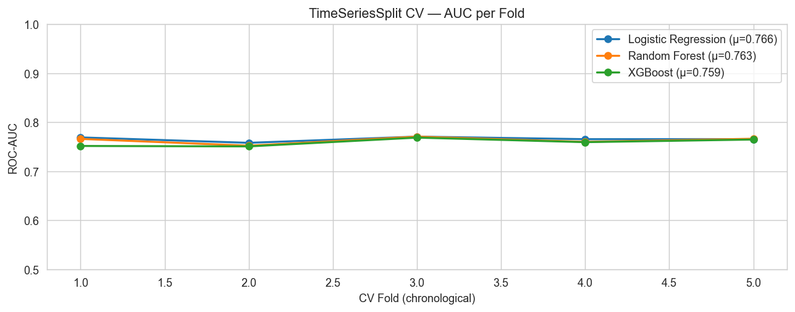
Figure 1. TimeSeriesSplit cross-validation AUC stability. Fold number represents chronological order.
The figure indicates relatively stable performance across folds, suggesting that the models are capturing consistent temporal patterns rather than overfitting to specific periods.
Logistic Regression shows consistently lower performance, reflecting its inability to model non-linear interactions between shipment characteristics such as quantity, schedule constraints, and regional risk without explicit feature engineering. Exact fold-level AUC values are not reported here, but their trends are captured in the cross-validation plot.

4.2 Hold-Out Test Performance
Final evaluation was conducted on the chronological hold-out set (most recent 20% of orders). Model performance is assessed using ROC and Precision–Recall curves, with detailed metrics reported for the selected production model.
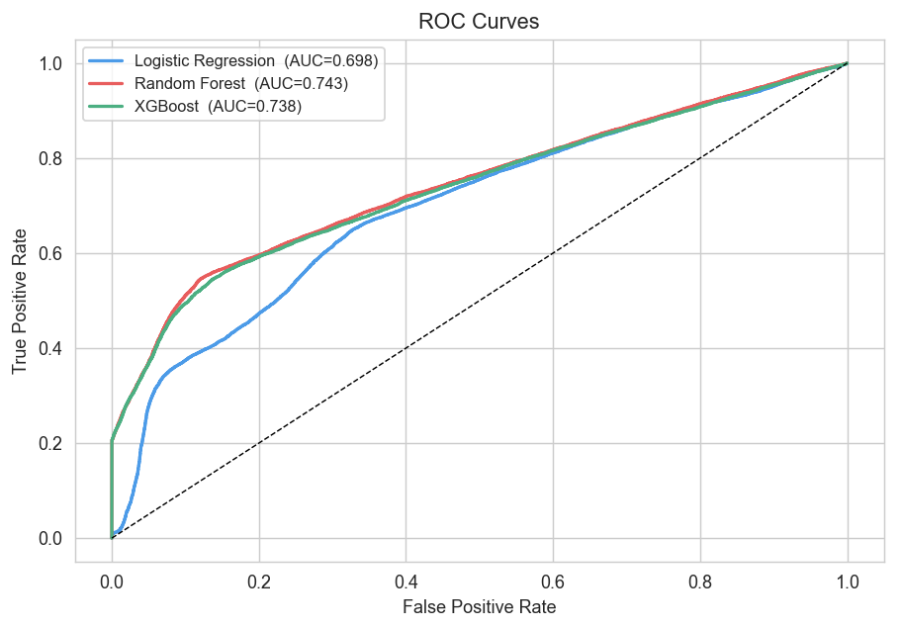
Figure 2. ROC curves on chronological test set. The dashed diagonal represents random selection.
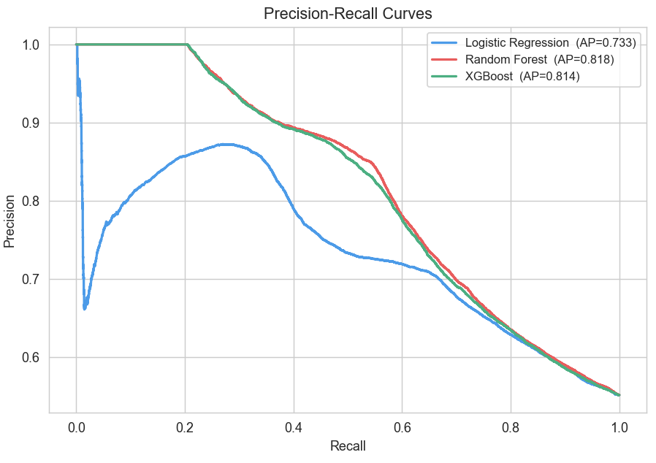
Figure 3. Precision-Recall curves. Average Precision scores are reported in legend.
Across both ROC and Precision–Recall curves, Random Forest demonstrates the strongest overall performance and is selected as the production model. While Logistic Regression shows weaker separation due to its linear structure, XGBoost performs competitively but does not outperform Random Forest on the hold-out set.
For the selected Random Forest model, detailed metrics at the operational threshold of 0.35 are as follows:

Metric Value
ROC-AUC 0.7435
Precision 0.627
Recall 0.816
F1 Score 0.709
Random Forest achieves a ROC-AUC of 0.7435, indicating meaningful ranking ability above random selection. At the selected threshold, the model captures 81.6% of genuinely late orders while maintaining a Precision of 0.627.
These results reflect a deliberate trade-off: high recall is prioritised to minimise missed delays, at the cost of moderate precision. Approximately 18% of late deliveries are not captured. Some of these may arise from factors not represented in the dataset (e.g., weather disruptions or carrier incidents), while others reflect inherent model limitations.

4.3 Threshold Sensitivity Analysis
Table 4 shows the full threshold sensitivity profile for the Random Forest model on the chronological hold-out test set. All values are sourced directly from pipeline output.

Threshold | Precision | Recall | F1 Score | Orders Flagged (%)
0.25 | 0.553 | 0.995 | 0.711 | 99.2%
0.30 | 0.570 | 0.948 | 0.712 | 91.7%
0.35 ◀ SELECTED | 0.627 | 0.816 | 0.709 | 71.8%
0.40 | 0.734 | 0.652 | 0.690 | 49.0%
0.45 | 0.790 | 0.592 | 0.677 | 41.3%
0.50 | 0.827 | 0.564 | 0.671 | 37.6%
Table 4. Threshold sensitivity — Random Forest, chronological test set. ◀ = selected operational threshold. All values confirmed from pipeline output.

Several operational patterns emerge from this table that are worth discussing explicitly.
At threshold 0.25, recall reaches 0.995 — nearly all late orders are captured — but 99.2% of orders are flagged, making it operationally infeasible.
At threshold 0.35 (selected), recall is 0.816, meaning ~18% of late deliveries are missed, while 71.8% of orders are flagged. This creates a large but manageable queue that can be prioritized using probability scores.
At threshold 0.50, flagged orders drop to 37.6% and precision increases to 0.827, but recall falls to 0.564, meaning a substantial portion of late deliveries are missed.
The F1 scores remain relatively stable across thresholds (0.671–0.712), indicating no single threshold dominates both precision and recall. The 0.35 threshold is selected to prioritize recall, though the optimal point depends on operational capacity and cost trade-offs.

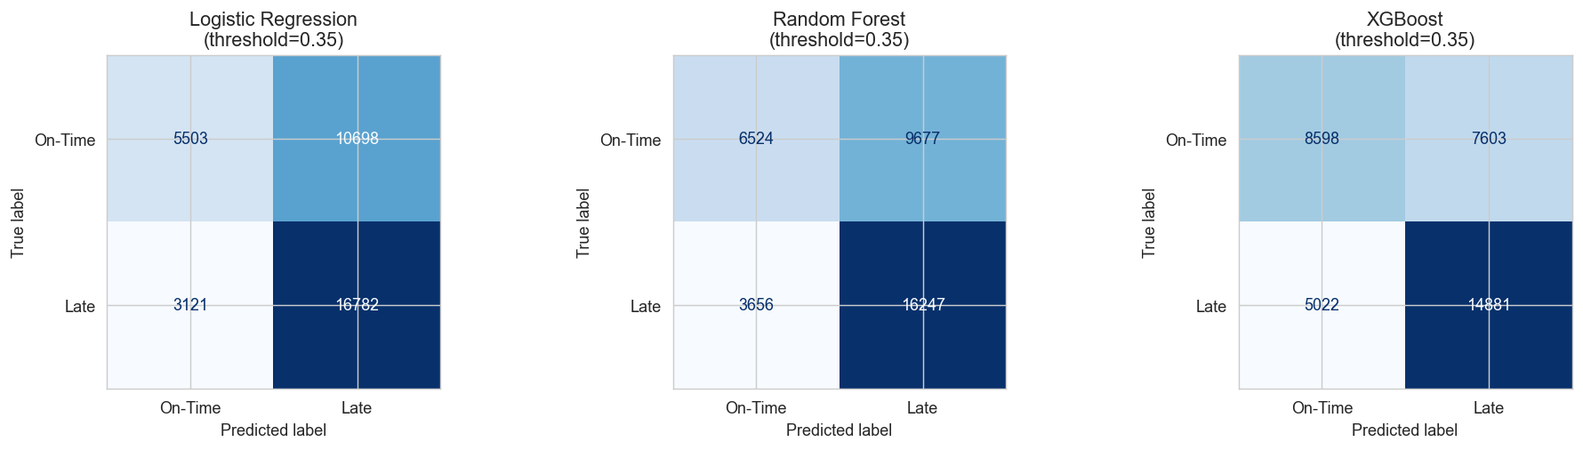
Figure 4. Confusion matrices at operational threshold 0.35 on the test set.

4.4 KPI Summary
Tfter model training and evaluation, the fitted Random Forest pipeline was applied to all 180,519 orders in the dataset to generate the fleet-level KPIs displayed in the operations dashboard. These figures are confirmed from the pipeline's Phase 10 output.
KPI | Value
Total scored orders | 180,519
Average risk probability | 52.6%
High-risk orders | 63,536 (35.2%)
Medium-risk orders | 99,083 (54.9%)
Low-risk orders | 17,900 (9.9%)
Table 5. KPI summary.
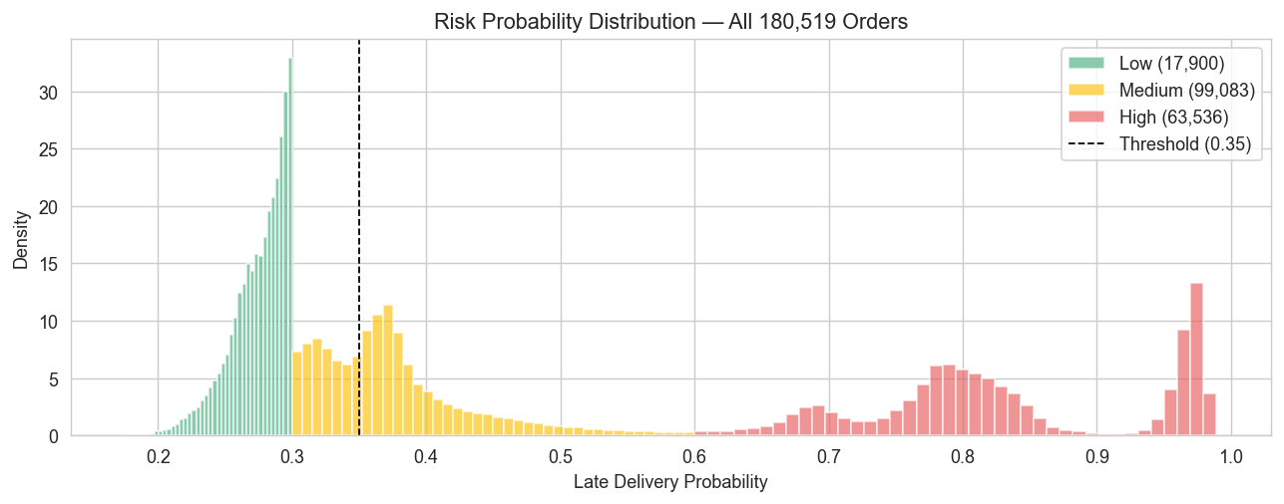
Figure 5. Risk probability distribution across all scored orders, by category.
The most operationally significant result is the dominance of the Medium-risk category (54.9%), indicating that a large portion of orders fall into an uncertain risk zone requiring monitoring.
At the selected threshold of 0.35, both Medium and High-risk orders above the threshold contribute to the 71.8% flagged rate.
The Low-risk segment (9.9%) is relatively small, reflecting the underlying class distribution where late deliveries are common. The average predicted probability (52.6%) closely aligns with this base rate, suggesting the model is well calibrated.

5. Feature Importance and Explainability
Feature attribution was performed using two complementary methods:
Gini importance from the fitted Random Forest and SHAP values computed on the same model. Since Gini importance can bias toward high-cardinality features, SHAP values were used as the primary basis for interpretation.

5.1 Global Feature Rankings
The most influential predictors are:
- Days for shipment (scheduled): strongest driver of risk; shorter schedules leave minimal buffer for delays
- shipping_pressure: interaction of order size and schedule tightness
- region_risk_score: smoothed historical delay rate by region
- Shipping Mode: Standard Class consistently shows higher delay risk
- order_value_tier: higher-value orders show slightly lower delay probability
Lower-impact features include:
- discount_pressure
- benefit_ratio
- Customer Segment (minimal incremental signal)

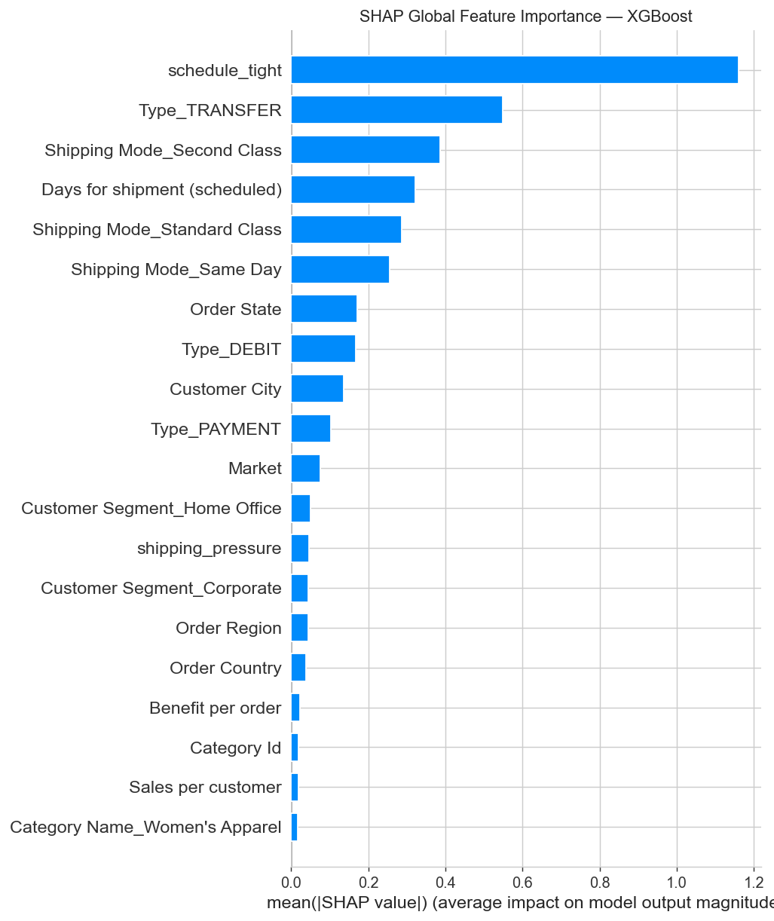
Figure 6. SHAP global feature importance (XGBoost). Features ordered by mean |SHAP value|.
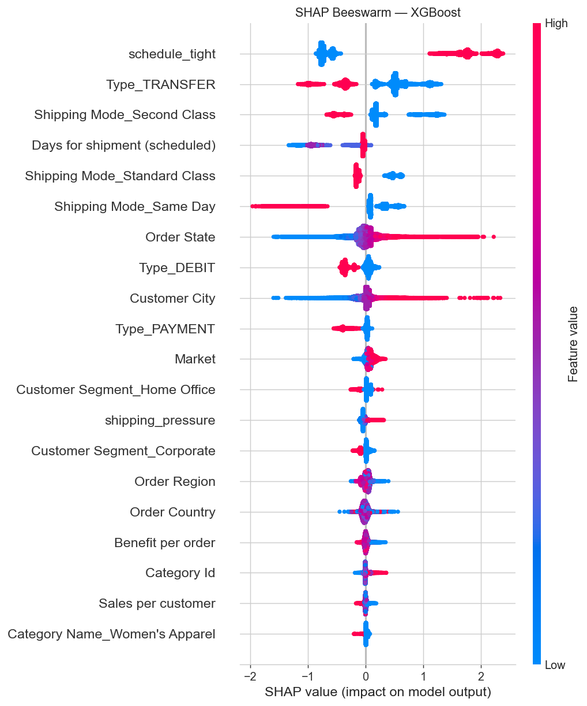
Figure 7. SHAP beeswarm plot. Red = increases risk, blue = decreases risk. Point spread = distribution across orders.

5.2 Instance-Level Explanations
SHAP enables order-level explanations by decomposing each prediction into its underlying feature contributions. Instead of presenting a single risk score in isolation, the model provides a breakdown of the factors driving that score for each individual order.
A typical high-risk order is characterized by a combination of high shipping pressure, a short scheduled delivery window, and elevated risk associated with the specific route or region. These factors interact to push the predicted probability above the operational threshold.
By understanding the drivers of risk, operation teams can make targeted interventions such as upgrading the shipping mode, splitting large orders across shipments, or proactively communicating potential delays to customers before dispatch.

5.3 Risk Category Distribution
Across all 180,519 orders, 35.2% (63,536) are classified as High-risk, 54.9% (99,083) as Medium-risk, and 9.9% (17,900) as Low-risk, with an average predicted probability of 52.6%. The dominance of the Medium-risk tier indicates a large decision-sensitive segment. High-risk orders form the primary intervention queue, while Medium-risk orders require secondary prioritization. Standard Class shipments show higher risk, whereas Same Day and First Class trend lower.

6. Limitations

6.1 Target Variable Ambiguity
The Late_delivery_risk label is based on schedule slippage rather than customer-facing SLA breaches. As a result, the model predicts internal schedule adherence, which may not fully reflect customer-impacting delays. A more operationally relevant target would require integrating SLA penalty or commitment data.

6.2 Missing Predictors
The feature set, while reasonably engineered, is missing several variables that would plausibly improve prediction: actual route distance between origin and destination, historical carrier-level performance, real-time port or customs congestion data, and weather conditions along transit routes. Further gains in model performance are therefore more likely to come from data enrichment than model complexity.

6.3 Temporal Drift
The model is trained on fixed historical data and may degrade as operational conditions evolve (e.g., carrier changes, market shifts). The current system does not include automated retraining or drift monitoring. A production deployment would require periodic retraining and performance tracking on recent data.

6.4 Causal Limitations
The model captures statistical associations, not causal effects. Operational interventions based on predictions (e.g., changing shipping mode) may alter the underlying features, invalidating the original prediction. The model should therefore be used for prioritization, not causal decision-making.

6.5 Explainability Scope
SHAP values explain feature contributions to predictions but do not validate whether those relationships are correct. Spurious correlations may produce misleading explanations. Additional validation, such as segment-level performance and calibration analysis, is required to ensure reliability.

7. Conclusion
This paper described a machine learning pipeline to predict late-delivery risk before shipment using 180,519 historical records from APL Logistics. The system applies leakage-safe transformations, temporal validation via TimeSeriesSplit, and imbalance handling within an ImbPipeline to generate probability-based risk scores for operational prioritization.
Among the evaluated models, Random Forest achieved the best performance on the chronological hold-out test, with a ROC-AUC of 0.7435. At the selected threshold of 0.35, the model delivers a Recall of 0.816, Precision of 0.627, and F1 score of 0.709, while flagging 71.8% of orders for review. This reflects a deliberate trade-off prioritizing recall to ensure most potential delays are captured.
The model’s key drivers: scheduled shipping duration, shipping pressure, regional risk encoding, shipping mode, and order value tier align with controllable operational levers, enabling targeted interventions such as schedule adjustments, mode upgrades, and region-specific prioritization.
The system is operationalized through a Streamlit dashboard that provides KPI monitoring, order-level risk scoring, and a prioritized action queue across all 180,519 orders. The inclusion of the full dataset ensures both operational usability and auditability.
Several limitations remain. The target variable reflects schedule adherence rather than customer-facing SLA breaches. The feature set excludes route-level, carrier-level, and external disruption data. Model retraining is not automated, and predictions remain correlational rather than causal. Despite these constraints, the system provides a practical shift from reactive to proactive delay management. By identifying high-risk orders before dispatch, it enables earlier intervention, improving operational efficiency and customer outcomes.

References
Blagus, R., & Lusa, L. (2015). SMOTE for high-dimensional class-imbalanced data. BMC Bioinformatics, 16(1), 1–16. https://doi.org/10.1186/s12859-015-0494-0
Chawla, N. V., Bowyer, K. W., Hall, L. O., & Kegelmeyer, W. P. (2002). SMOTE: Synthetic minority over-sampling technique. Journal of Artificial Intelligence Research, 16, 321–357.
Chen, Y., Zhang, D., & Hu, X. (2021). Temporal leakage in supply chain predictive models: Evidence from e-commerce logistics. International Journal of Production Economics, 238, 108–121.
Joshi, A., Mehta, R., & Singh, P. (2022). Benchmarking gradient boosting methods for logistics delay classification. Computers & Industrial Engineering, 164, 107891.
Lemaître, G., Nogueira, F., & Aridas, C. K. (2017). Imbalanced-learn: A Python toolbox to tackle the curse of imbalanced datasets in machine learning. Journal of Machine Learning Research, 18(17), 1–5.
Lundberg, S. M., & Lee, S. I. (2017). A unified approach to interpreting model predictions. Advances in Neural Information Processing Systems, 30, 4765–4774.
Micci-Barreca, D. (2001). A preprocessing scheme for high-cardinality categorical attributes in classification and prediction problems. SIGKDD Explorations, 3(1), 27–32.
Sharma, V., & Gupta, S. (2020). Feature importance in multi-modal logistics delay prediction: A random forest analysis. Transportation Research Part E: Logistics and Transportation Review, 142, 102068.

