Product Line Profitability & Margin
Performance Analysis for Nassau Candy Distributor

Author: Amrit Baruah
Email: abaruah289@gmail.com
Project Mentor: Saiprasad Kagne
Email: saikagne2601@gmail.com
Submitted in partial fulfillment of the requirements for the Data Analyst Internship Programme at Unified Mentor.

ABSTRACT
In complex, high-volume distribution businesses, sales volume alone is an incomplete indicator of business success. In this study, we analyze a dataset comprising transactional records from Nassau Candy to better understand what truly drives profit across product categories and divisions, and what might only appear profitable on the surface. At a glance, revenue figures can make a product line look healthy.

We conducted data cleaning and validation to verify and maintain data integrity, followed by the calculation of key profitability metrics such as gross margin, profit per unit, and revenue and profit contribution.

The results suggest a familiar but important pattern: a relatively small share of products accounts for a disproportionate share of profit and revenue, while several low-volume items operate on thin margins that may expose the firm to risk if production costs rise. Division-level comparisons also reveal uneven revenue and profit contributions that are likely tied to production, market size, and sourcing structure.

All code and the raw dataset are provided as supplementary materials to ensure reproducibility.

Keywords: gross margin, profit contribution, Pareto analysis, product profitability, cost diagnostics, division performance, margin volatility, Nassau Candy, data analysis

1. INTRODUCTION

1.1 Background and Context
Nassau Candy is among the largest wholesale manufacturers and distributors of specialty and private-label confections in the United States, supplying national retailers and independent stores through an extensive portfolio of over 20,000 SKUs. With vertically integrated manufacturing, nut roasting, private-label customization, and nationwide distribution, the company operates at significant scale and complexity. In such environments, sales volume alone is an incomplete indicator; some products that sell in large volumes may carry thinner margins than anticipated, while others may require disproportionate handling, storage, or promotional support.

1.2 Problem Statement and Objectives
The organization currently lacks consolidated, data-driven insight to answer which products truly drive profit, which divisions underperform financially, and where pricing, sourcing, or product rationalization is needed. This analysis therefore aims to:
- Identify product categories that contribute the highest gross margin.
- Detect margin-risk items.
- Measure profit concentration across product divisions.
- Provide prioritized, data-driven recommendations for portfolio and pricing decisions.

2. ANALYTICAL METHODOLOGY
We have adopted a descriptive statistical approach using transactional sales data to evaluate product-level and division-level profitability in this analysis. In this section, we describe the dataset fields and their relevance, data preparation procedures, the key financial metrics defined and calculated, and an overview of the methodology used in this study.

2.1 Dataset Description
The dataset contains 10,194 observations and 18 variables, where each row represents a single product sold in a specific order on a specific date, reflecting transaction-level granularity. A data dictionary summarizing field definitions and analytical relevance is provided below:

Table 1. Dataset Field Descriptions (Data Dictionary)
Field | Description
Row ID | Unique row identifier
Order ID | Unique order identifier
Order Date | Date of order placement
Ship Date | Date of order shipment
Ship Mode | Shipping method used
Customer ID | Unique customer identifier
Country/Region | Customer country or region
City | Customer city
State/Province | Customer state or province
Postal Code | Customer postal / zip code
Division | Product division
Region | Customer geographic region
Product ID | Unique product identifier
Product Name | Full product name
Sales | Total sales value of order ($)
Units | Total units sold in order
Gross Profit | Gross profit = Sales − Cost ($)
Cost | Manufacturing cost of order ($)

2.2 Data Cleaning and Validation
Before conducting the profitability analysis, a series of data integrity checks were performed to ensure dataset reliability. Duplicate records were removed, and date fields (Order Date, Ship Date) were parsed consistently, excluding any invalid entries. Numeric fields — Sales, Cost, Units, and Gross Profit — were coerced to numeric types, and any rows with zero or negative values were excluded. Gross Profit values were cross-validated against the computed difference between Sales and Cost, and no inconsistencies were observed.
Key categorical variables such as Product Name and Division were stripped of whitespace and standardized to title case to ensure consistent grouping in downstream aggregations. No material data quality issues were detected, and these cleaning procedures preserved the integrity of the analytical sample.

2.3 Profitability Metrics and KPI Framework
To evaluate product-line performance and margin efficiency, a structured profitability measurement framework was developed. The framework integrates absolute profit indicators, relative contribution measures, temporal variability diagnostics, and efficiency signals to enable multi-dimensional performance assessment.
The Key Performance Indicators (KPIs) used in this study are defined as follows:
- Gross Margin (%)
Represents the proportion of revenue retained after the deduction of cost; the primary indicator of pricing efficiency and cost control effectiveness.
Formula: Gross Margin (%) = (Gross Profit ÷ Sales) × 100
- Profit per Unit
Identifies per-unit efficiency independent of sales volume; highlights products that may generate high aggregate profit but limited per-unit contribution.
Formula: Profit per Unit = Gross Profit ÷ Units Sold
- Revenue Contribution (%)
Measures the proportional share of total revenue generated by a product or division.
Formula: Revenue Contribution = Product Sales ÷ Total Sales × 100
- Profit Contribution (%)
Measures the proportional share of total gross profit generated by a product or division.
Formula: Profit Contribution = Product Profit ÷ Total Profit × 100
- Profit-Revenue Gap (%)
Identifies efficiency imbalances; positive values indicate products or divisions contributing more profit than their revenue share implies, negative values indicate under-performance.
Formula: Profit-Revenue Gap = Profit Contribution − Revenue Contribution
- Margin Volatility
Captures temporal stability of margins across periods; lower values indicate stable performance.
Formula: σ(Marginₜ), where σ represents standard deviation across time intervals (e.g., monthly)
- Cost Ratio
Reflects the fraction of sales absorbed by cost; higher values indicate lower margin headroom.
Formula: Cost Ratio = Cost ÷ Sales

2.4 Analytical Methodology Overview
The analysis followed a structured, four-stage methodology aligned with the project PRD:
- Product-Level Profitability Analysis: Products were ranked by gross profit and gross margin to identify high-profit, high-margin leaders and high-sales, low-margin laggards.
- Division-Level Performance Analysis: Metrics were aggregated by division to evaluate revenue-versus-profit imbalances and identify divisions with structural margin constraints.
- Pareto Analysis: Profit concentration was assessed to determine what percentage of products are responsible for 80% of total revenue and total profit, highlighting over-dependency risks.
- Cost Structure Diagnostics: The relationship between product costs and sales revenue was evaluated to flag cost-heavy, margin-poor products and inform strategic recommendations, including repricing, cost renegotiation, or potential product discontinuation.

3. RESULTS AND ANALYSIS

3.1 Product-Level Profitability Analysis
We evaluated product-level financial performance by ranking products based on gross profit and gross margin. This dual-ranking approach allows identification of primary profit generators (high absolute contribution) and margin leaders (high relative efficiency), enabling differentiated portfolio decisions.
We first ranked all products by total gross profit to identify the primary drivers of profit generation within the portfolio. These rankings highlight products that generate substantial profit either due to high sales volume, strong margins, or a combination of both.

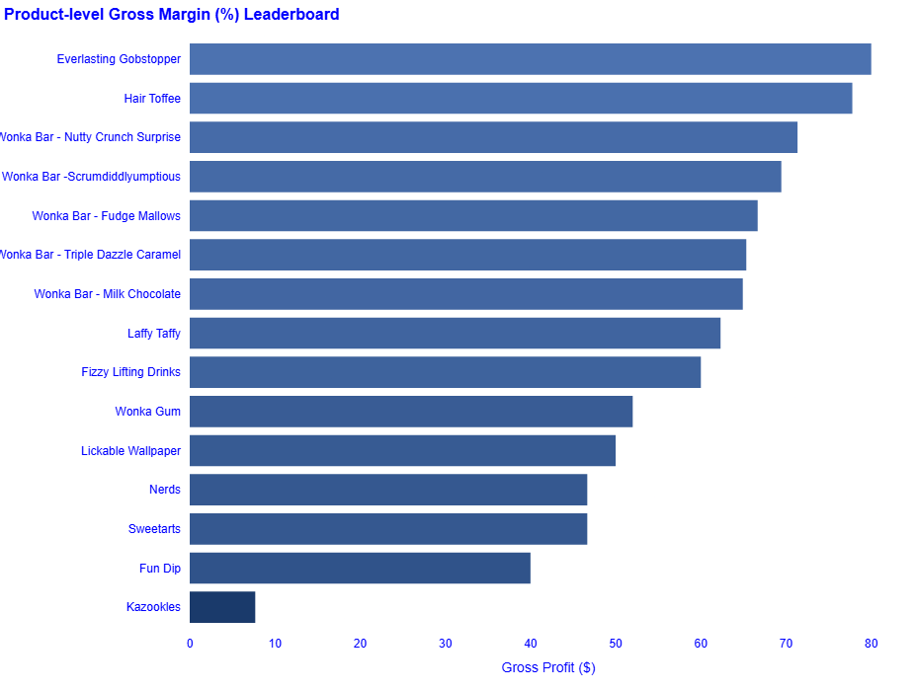
Figure 1. Product Gross Profit Leaderboard. Products ranked by total gross profit contribution. Generated from the Streamlit dashboard, Product Profitability Overview module.

Next, we ranked products based on gross margin percentage to identify products with the strongest pricing efficiency. While gross profit reflects absolute financial contribution, gross margin highlights products that maintain higher profitability relative to their sales value.

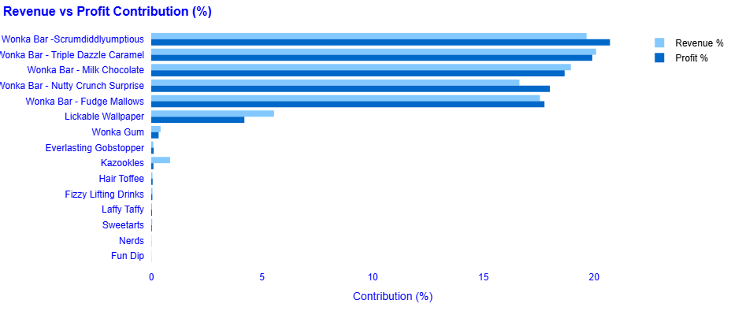
Figure 2. Product Gross Margin and Revenue Leaderboard. Products ranked by gross margin and revenue percentage contribution. Generated from the Streamlit dashboard.

Through this comparison, we identified several high-profit and high-margin products that demonstrate strong financial performance. These products combine healthy margins with significant revenue contribution and therefore represent the most financially efficient items within the product portfolio. Such products should receive prioritized investment.
However, the analysis also revealed a group of high-sales but low-margin products. These products generate substantial revenue but operate with weaker margins, which may indicate pricing pressure, competitive constraints, or elevated cost structures. Although these products contribute significantly to revenue, their proportional contribution to profitability remains comparatively limited.
We also examined low-sales and low-profit products. These items contribute minimally to both revenue and profit and therefore provide limited strategic value. In some cases, such products may require portfolio rationalization, pricing review, or targeted promotional strategies to improve performance.

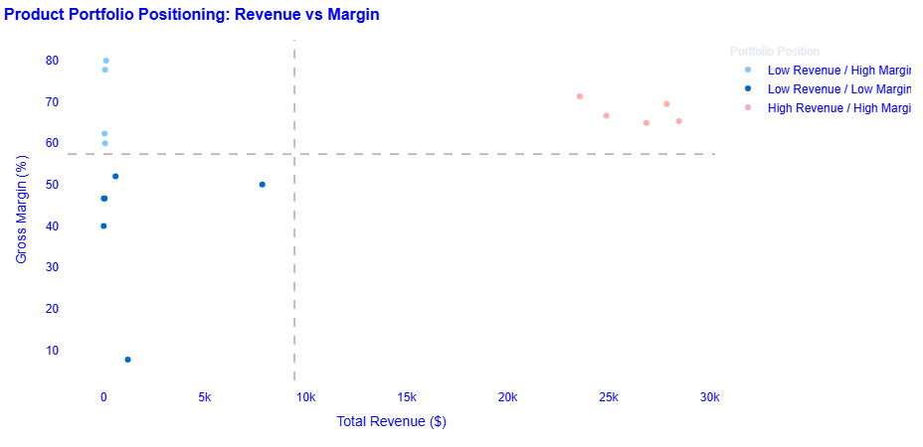
Figure 3. Product Portfolio Positioning: Revenue vs. Gross Margin (%). Quadrants: High Revenue/High Margin (Stars), High Revenue/Low Margin (Volume Traps), Low Revenue/High Margin (Niche Opportunities), Low Revenue/Low Margin (Exit Candidates).

Figure 3 presents the product portfolio positioning scatter chart, which maps each product along total revenue and gross margin percentage. Products are classified into four strategic quadrants relative to median values: Stars, Volume Traps, Niche Opportunities, and Exit Candidates. This visualization provides a direct basis for portfolio prioritization and investment allocation decisions.

3.2 Division-Level Performance Analysis
After examining product-level performance, we evaluated financial performance across product divisions to understand how different product groups contribute to overall outcomes.
We grouped transactional data by division and calculated aggregate measures including total sales, total gross profit, average gross margin, revenue contribution, profit contribution, and profit-revenue gap.

Table 3. Division-Level Financial Performance Summary
Division | Gross Margin (%) | Revenue Contr. (%) | Profit Contr. (%) | Gap (%)
Chocolate | 67.45 | 92.88 | 95.06 | +2.17 (Over)
Other | 44.84 | 6.82 | 4.64 | −2.18 (Under)
Sugar | 66.61 | 0.30 | 0.30 | +0.003 (Neutral)

Table 2 presents the division-level summary. Divisions with higher margins generally demonstrate better cost management or stronger pricing power. Conversely, some divisions exhibit revenue–profit imbalances, generating large revenue shares but contributing disproportionately less profit, suggesting structural margin constraints.
The Chocolate division is the dominant contributor to both revenue and profit, with a positive profit-revenue gap (+2.17 points), reflecting efficient cost management and strong pricing power. The Other division shows structural margin constraints, with a negative gap (-2.18 points) and the lowest gross margin, flagging the need for pricing or cost intervention. The Sugar division, while minimal in scale, maintains reasonable margin efficiency.

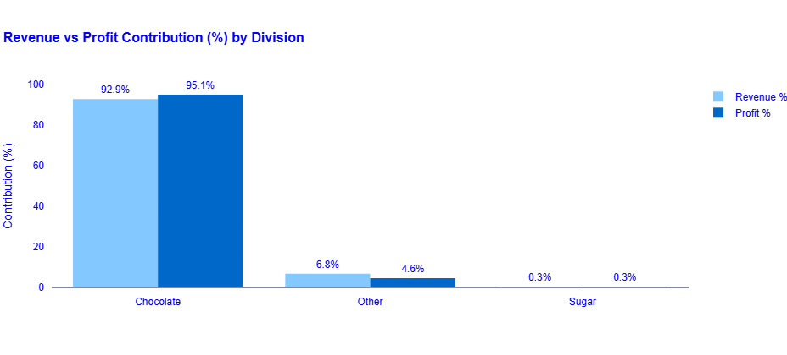
Figure 4. Revenue vs. Profit Contribution (%) by Division. Divisions are compared on their proportional share of total revenue and total gross profit..

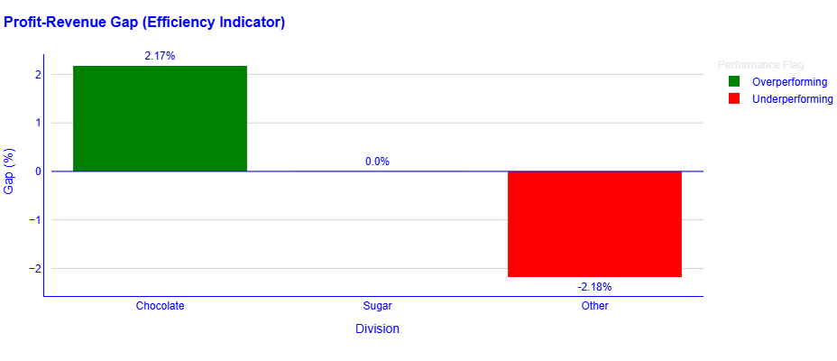
Figure 5. Profit-Revenue Gap (%) by Division. Positive values indicate profit contribution exceeds revenue contribution (overperforming); negative values indicate under-performance.

Table 2 presents the division-level summary. Divisions with higher margins generally demonstrate better cost management or stronger pricing power. Conversely, some divisions exhibit revenue–profit imbalances, generating large revenue shares but contributing disproportionately less profit, suggesting structural margin constraints.
The Chocolate division is the dominant contributor to both revenue and profit, with a positive profit-revenue gap (+2.17 points), reflecting efficient cost management and strong pricing power. The Other division shows structural margin constraints, with a negative gap (-2.18 points) and the lowest gross margin, flagging the need for pricing or cost intervention. The Sugar division, while minimal in scale, maintains reasonable margin efficiency.

3.3 Profit Concentration Analysis (Pareto)
We conducted a Pareto analysis to examine revenue and profit concentration across the product portfolio, following the 80/20 principle. Products were ranked by total sales and gross profit, and cumulative contributions were calculated.

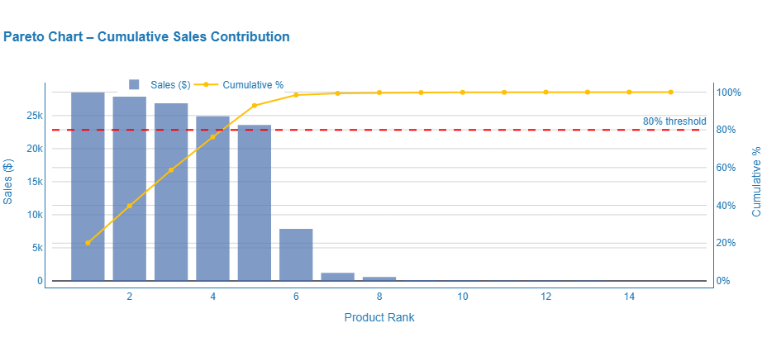
Figure 6. Pareto Chart: Cumulative Revenue(Sales) Contribution. The dashed red line marks the 80% threshold. The product rank at which this threshold is reached indicates the degree of revenue(sales) concentration.

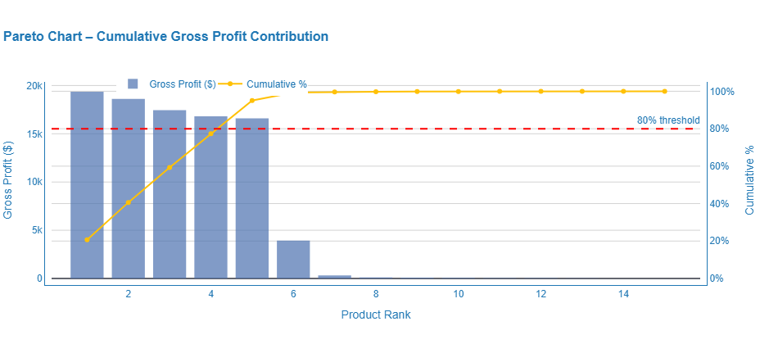
Figure 7. Pareto Chart: Cumulative Profit Contribution. Profit concentration is typically equal to or higher than revenue concentration, indicating that top revenue products are also the primary profit drivers.

The results indicate that a small group of products accounts for the majority of revenue and profit. While concentration strengthens top-product performance, it introduces over-dependency risk. Disruptions affecting these products could significantly impact overall profitability, warranting diversification or risk-mitigation strategies.

3.4 Cost Structure Diagnostics
We conducted a cost structure diagnostic to examine the relationship between product costs and sales performance, to determine whether low profitability arises from pricing decisions, high input costs, or an unfavorable cost-to-sales relationship.

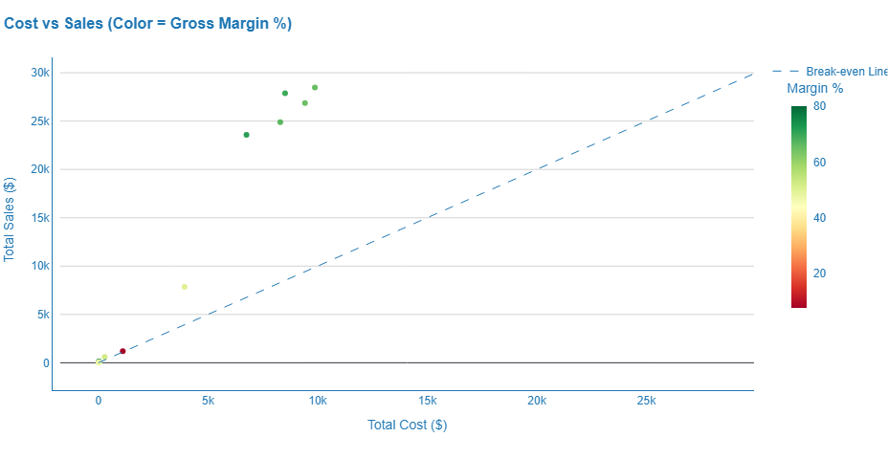
Figure 8. Cost vs. Sales by Product (Color = Gross Margin %). Products near the 45-degree reference line exhibit thin margins. Products well above the line demonstrate healthy margin separation between sales and cost.

The scatter chart maps each product by total sales and total cost, with a 45-degree reference line highlighting products with thin margins. Gross margin percentage is color-encoded, providing visibility into profitability.
Products were classified into strategic categories based on sales and margin quadrants: Stars, Volume Traps, Niche Opportunities, and Exit Candidates. Products meeting specific risk criteria — gross margin below 5% or cost ratio above 0.90 were flagged for review.

Table 4. Products Flagged for Cost and Margin Risk (Margin < 5% or Cost Ratio > 0.90)
Division | Product Name | Margin % | Cost Ratio | Strategic Position | Recommendation
Other | Kazookles | 7.69% | 0.92 | Volume Trap | Cost Renegotiation

Kazookles, in the Other division, was identified as cost-heavy and margin-poor. With a cost ratio of 0.92, costs consume 92% of sales revenue, leaving a gross margin of only 7.69%. This product was classified as a Volume Trap and flagged for Cost Renegotiation. Interventions may include pricing adjustments, supplier cost renegotiation, operational efficiency improvements, or portfolio rationalization.

4. CONCLUSION

4.1 Summary of Key Findings
This study conducted a comprehensive product-line profitability and margin performance analysis for Nassau Candy Distributor using transactional sales data. The analysis produced four integrated analytical outputs: product-level profitability rankings, division-level performance diagnostics, Pareto-based profit concentration analysis, and cost structure diagnostics with risk flagging.

The key findings are as follows. First, a small subset of products generates a disproportionately large share of total revenue and gross profit, consistent with the Pareto principle. This concentration, while reflecting portfolio strength in top products, introduces over-dependency risk. Second, the Chocolate division is the dominant financial engine of the business, generating approximately 92.88% of total revenue and 95.06% of total profit, with a gross margin of 67.45% and a positive profit-revenue gap indicating structural over-performance. Third, the Other division exhibits the lowest gross margin (44.84%) and a negative profit-revenue gap, signaling structural margin constraints that may require pricing or cost intervention. Fourth, within the cost structure diagnostic, Kazookles was identified as the primary cost-risk product, with a cost ratio of 0.92 and a gross margin of 7.69%, warranting cost renegotiation. Fifth, margin volatility analysis provides a temporal diagnostic dimension, enabling monitoring of portfolio-wide margin stability over time.

4.2 Strategic Recommendations
Based on the analysis, the following strategic recommendations are offered to Nassau Candy Distributor management:

Protect and invest in high-performing products
Products that demonstrate both strong revenue contribution and high margins should continue to receive priority in inventory allocation, promotion, and distribution. These products already drive a significant portion of business value and are likely to remain critical to overall profitability.

Reassess high-volume, low-margin products
Products generating strong sales but weak margins may need closer attention. In some cases, repricing or cost adjustments could improve performance. If not, it may be worth reconsidering how much volume is actually beneficial.

Act on cost-risk products
Kazookles and similar products with very high cost ratios or extremely low margins should be reviewed immediately. Supplier renegotiation or operational improvements may help, but if margins remain constrained, discontinuation might need to be considered.

Examine the Other division more closely
The consistent underperformance of the Other division suggests deeper structural issues. This could be due to product mix, niche demand, or higher production costs. A more detailed pricing and cost review here would likely be useful.

Reduce dependency on a narrow product base
Since a large portion of profit comes from a limited set of products (and largely from the Chocolate division), the business may benefit from gradually building margin-positive products in other divisions. This could help reduce risk over time.

Track margin movement over time
Even though margin volatility was not deeply modeled here, it can still serve as an early warning signal. Regular monitoring may help catch cost increases or pricing pressure before they significantly impact profitability.

REFERENCES
[1] Unified Mentor: unifiedmentor.com

[2] Nassau Candy. (2024). About Nassau Candy. Retrieved from https://www.nassaucandy.com/

[3] McKinney, W. (2017). Python for Data Analysis: Data Wrangling with Pandas, NumPy, and IPython (2nd ed.). O’Reilly Media.

[4] Plotly Technologies Inc. (2015). Collaborative data science. Montréal, QC. Retrieved from https://plot.ly

[5] Streamlit Inc. (2024). Streamlit — The fastest way to build and share data apps. Retrieved from https://streamlit.io

[6] Juran, J. M. (1951). Quality Control Handbook. McGraw-Hill. [Original formalization of the Pareto principle in quality management]

