**INFO6205 31514 Program Structure & Algorithms SEC 01 Spring 2024**

**Assignment 4**

**Name: Amrita Nischal**

**NUID: 002839305**

**Observations mentioned in the excel sheet attached!**

**Part 1(a):**

**Part 1(b):**

**Part 2:**

**Part 3:**

**Relationship between m and n:**

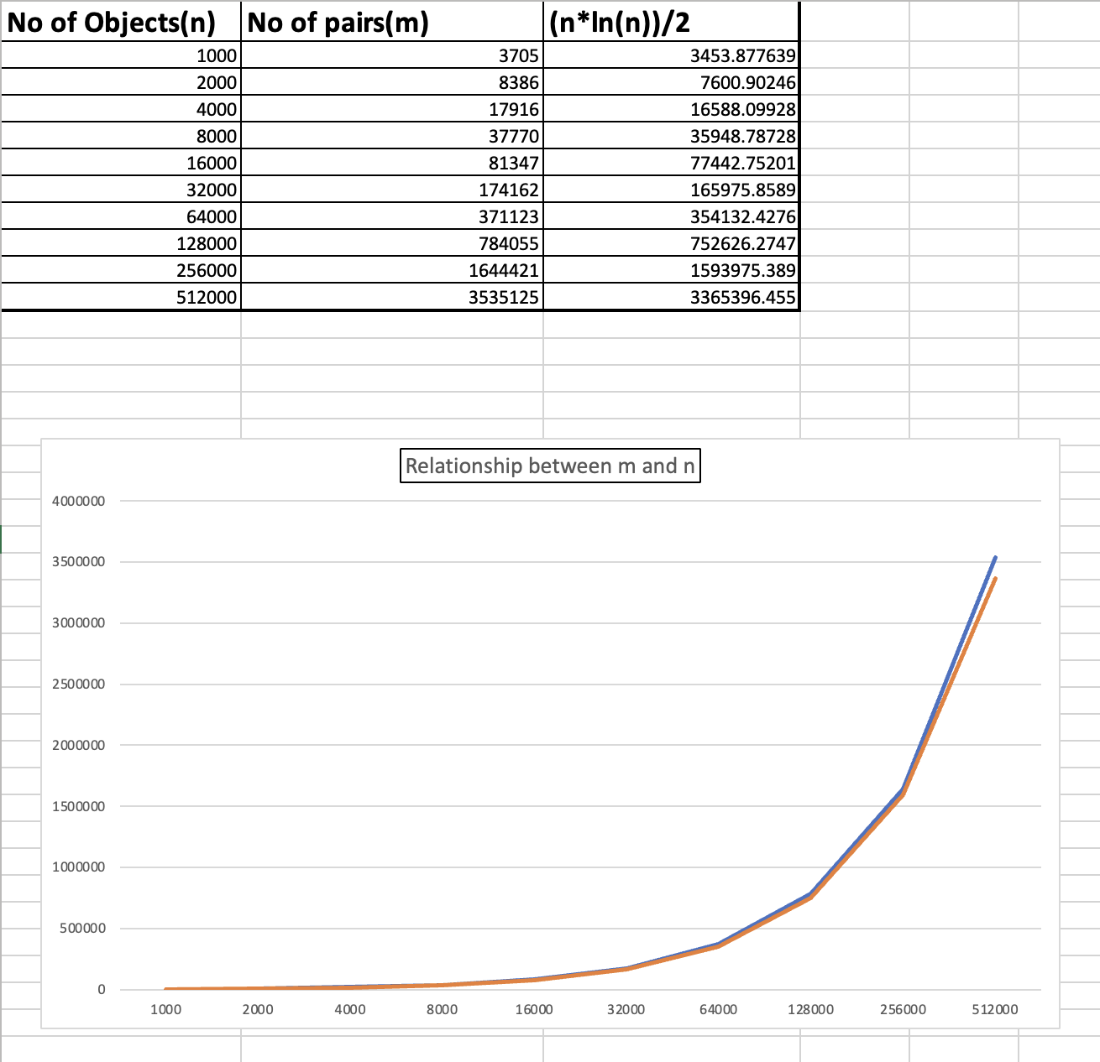

**m ≈ ½(n*ln(n))**