1) Lexical Analyzer to identify identifiers, constants, operators
Aim
To develop a lexical analyzer that identifies identifiers, constants, and operators in a C program while ignoring spaces, tabs, newlines, and comments.
Algorithm
- Read input C program.
- Ignore spaces, tabs, new lines.
- Ignore comments.
- Check each token:
  - Identifier → starts with letter/underscore
  - Constant → numeric value
  - Operator → +,-,*,/,=
- Display token type.
Input
a=5+b
output
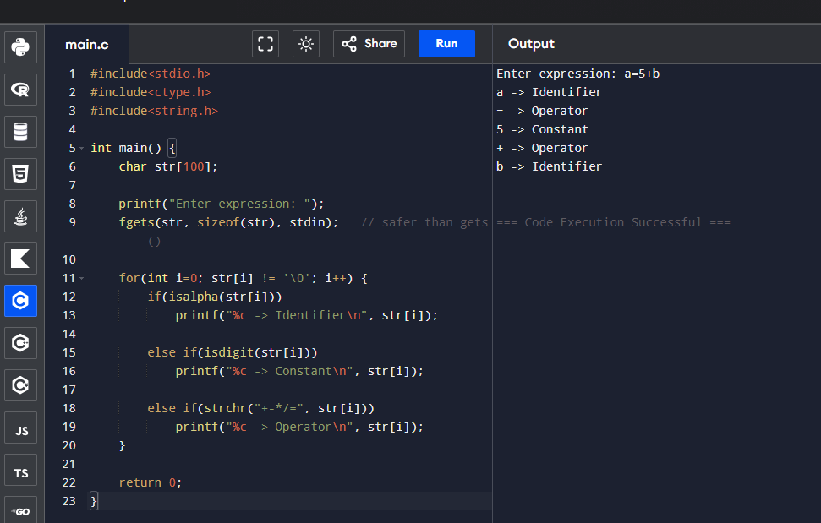

Result
Thus lexical analyzer was implemented successfully.

2) Lexical Analyzer to check comments
Aim
To identify whether a given line is a comment or not.
Algorithm
- Read input line.
- Check:
  - starts with //
  - starts with /* and ends with */
- Print result.
}Input
//hello
Output
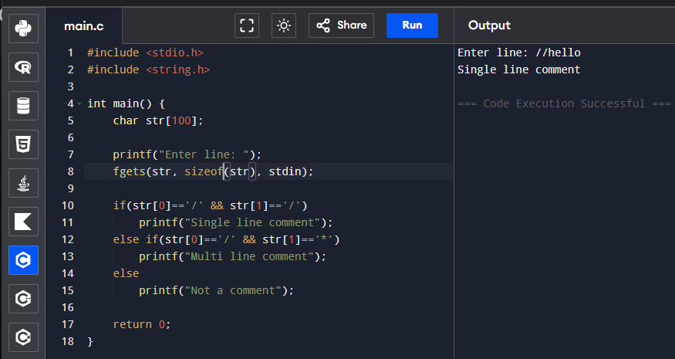
Result
Thus comment detection was performed successfully.

3) Lexical Analyzer ignoring spaces/comments
Aim
To design lexical analyzer ignoring spaces, tabs, new lines and comments.
Algorithm
- Read characters.
- Ignore spaces/tabs/newlines.
- Ignore comments.
- Print valid tokens.
}Input
a + b
Output
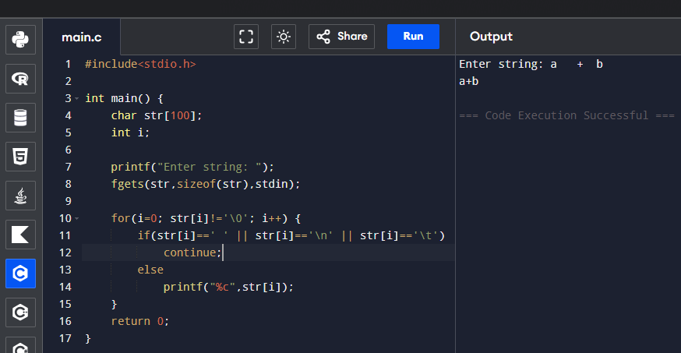

Result
Thus unwanted spaces were removed successfully.

4) Lexical Analyzer for arithmetic operators
Aim
To recognize arithmetic operators.
Algorithm
- Read character.
- Check whether it belongs to +,-,*,/.
Input
+
Output
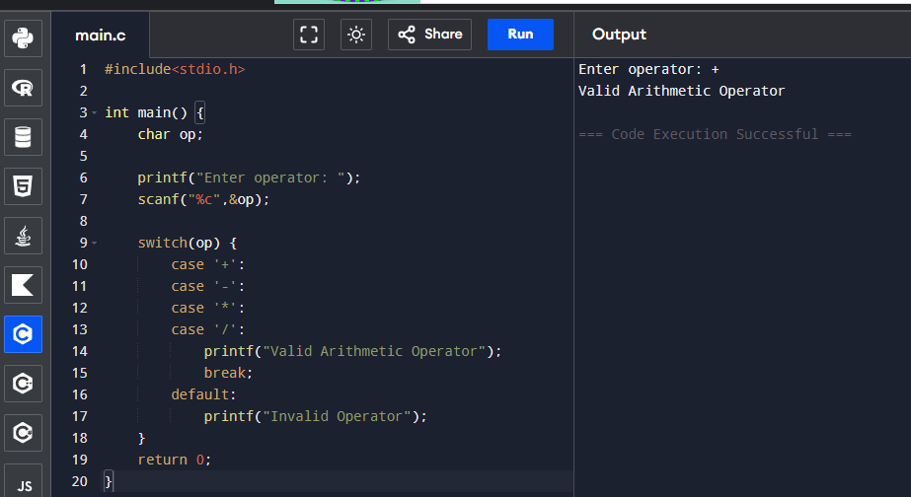
Result
Thus arithmetic operator validation was done.

5) Count whitespaces and newline characters
Aim
To count spaces and newlines.
Algorithm
- Read string.
- Count spaces.
- Count newline characters.
Output
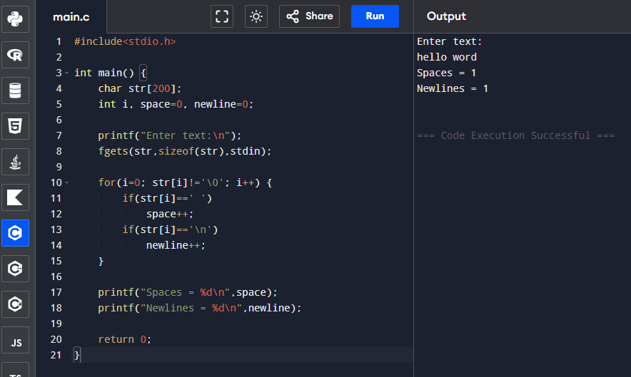
Result
Thus whitespaces were counted.

6) Identifier validation
Aim
To check valid identifier.
Algorithm
- Read identifier.
- First character must be letter/_.
- Remaining may contain digits.
Input
_var1
Output
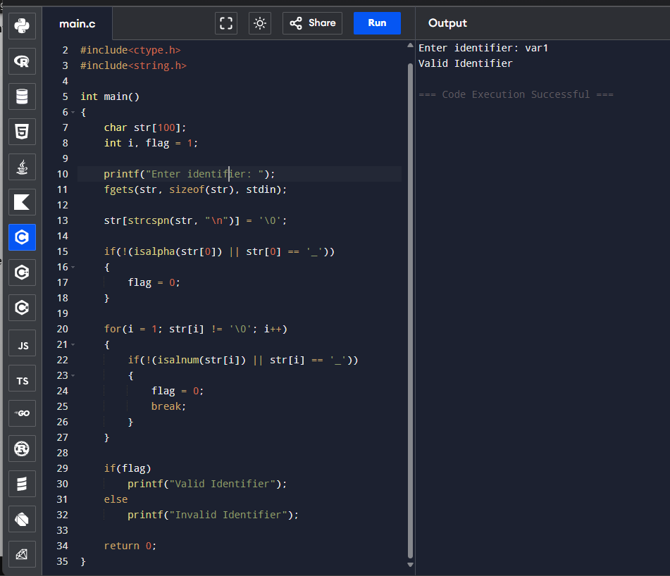
Result
Thus identifier validation was completed.

7. Program to Find FIRST()
Aim
To find FIRST set of the given grammar.
Grammar:
S → AaAb / BbBa
A → ε
B → ε

Algorithm
- Define grammar productions
- For each non-terminal, check first symbol
- If ε production exists, include ε
- Display FIRST sets

Input

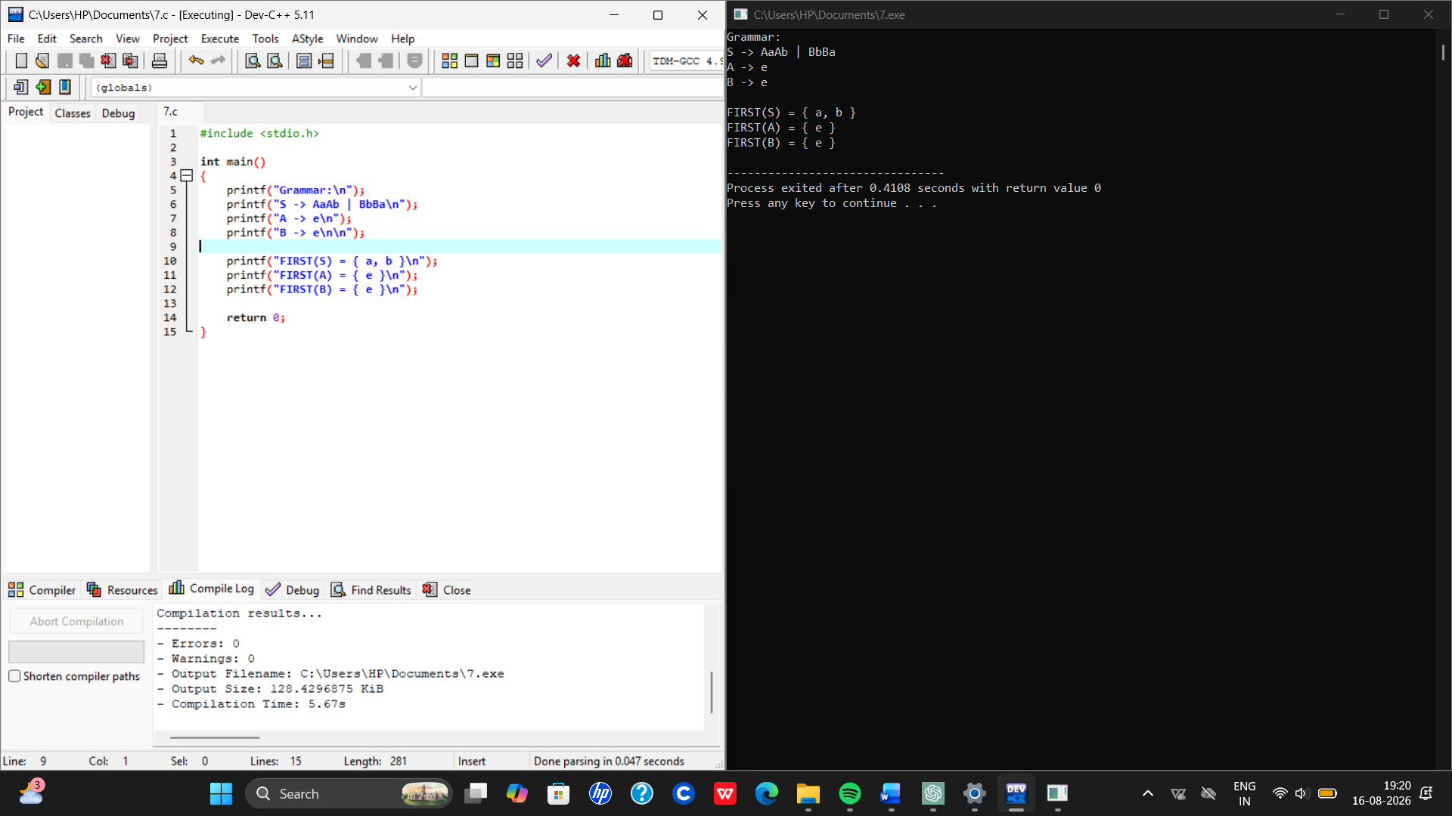

Result
Thus FIRST set was found successfully.

8. Program to Find FOLLOW()
Aim
To find FOLLOW set of grammar.
Algorithm
- Start symbol gets $
- Check occurrences of non-terminals
- Add next terminal/non-terminal FIRST
- Display FOLLOW sets
Input
Given grammar
Output

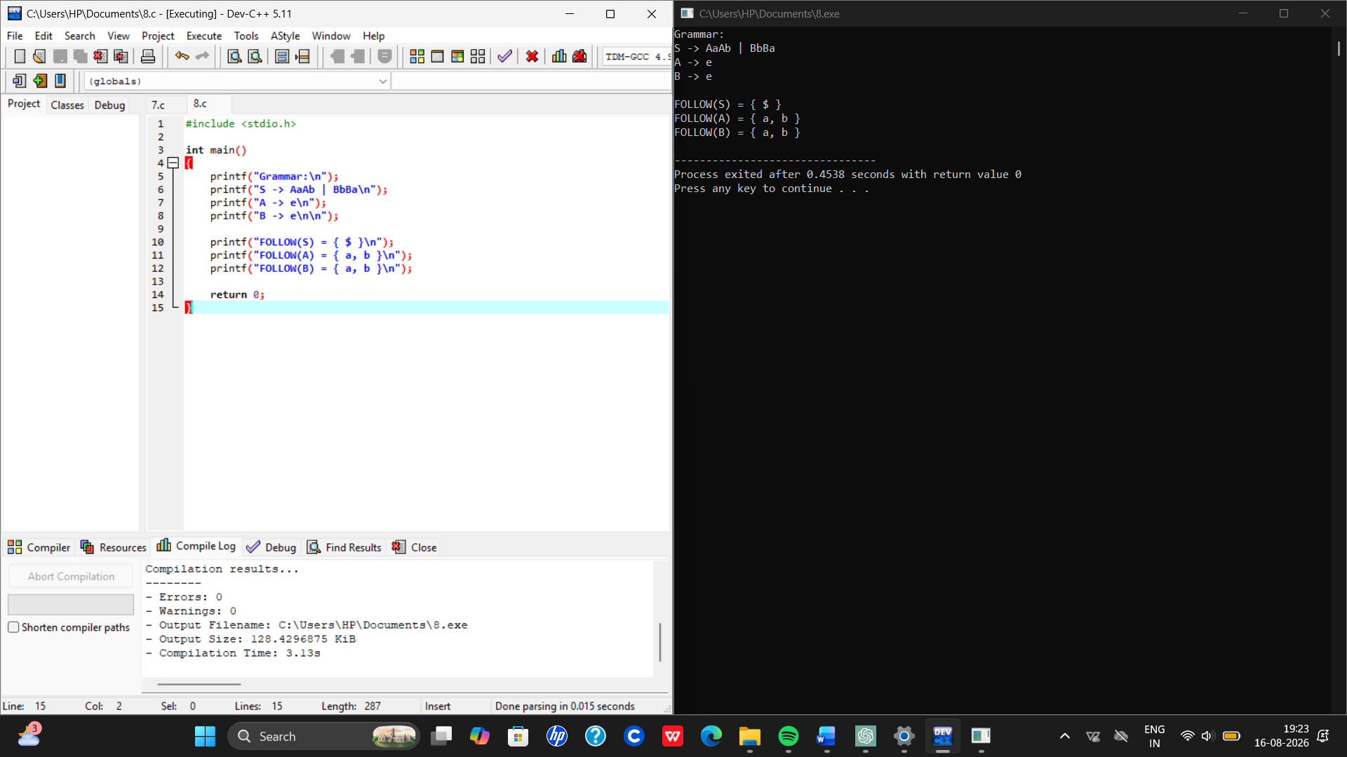

Result
Thus FOLLOW set was computed successfully.

9. Eliminate Left Recursion
Grammar:
S → (L) / a
L → L,S / S

Aim
To eliminate left recursion.

Algorithm
- Check productions with left recursion
- Separate recursive/non-recursive productions
- Create new production
- Print transformed grammar

Input
Given grammar

Output
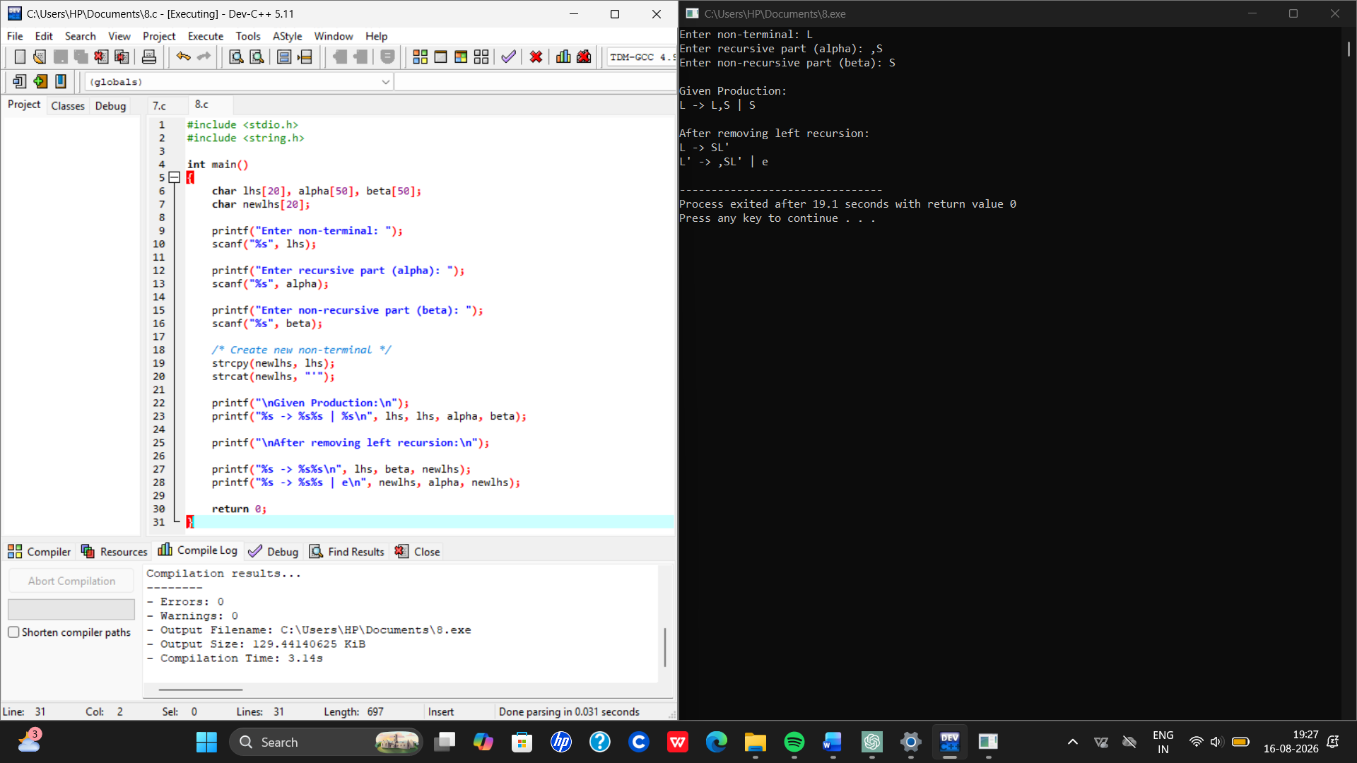
Result
Thus left recursion was removed successfully.

10. Eliminate Left Factoring
Grammar:
S → iEtS / iEtSeS / a
E → b
Aim
To eliminate left factoring.
Algorithm
- Identify common prefixes
- Create new non-terminal
- Rewrite productions
Input
Given grammar
Output
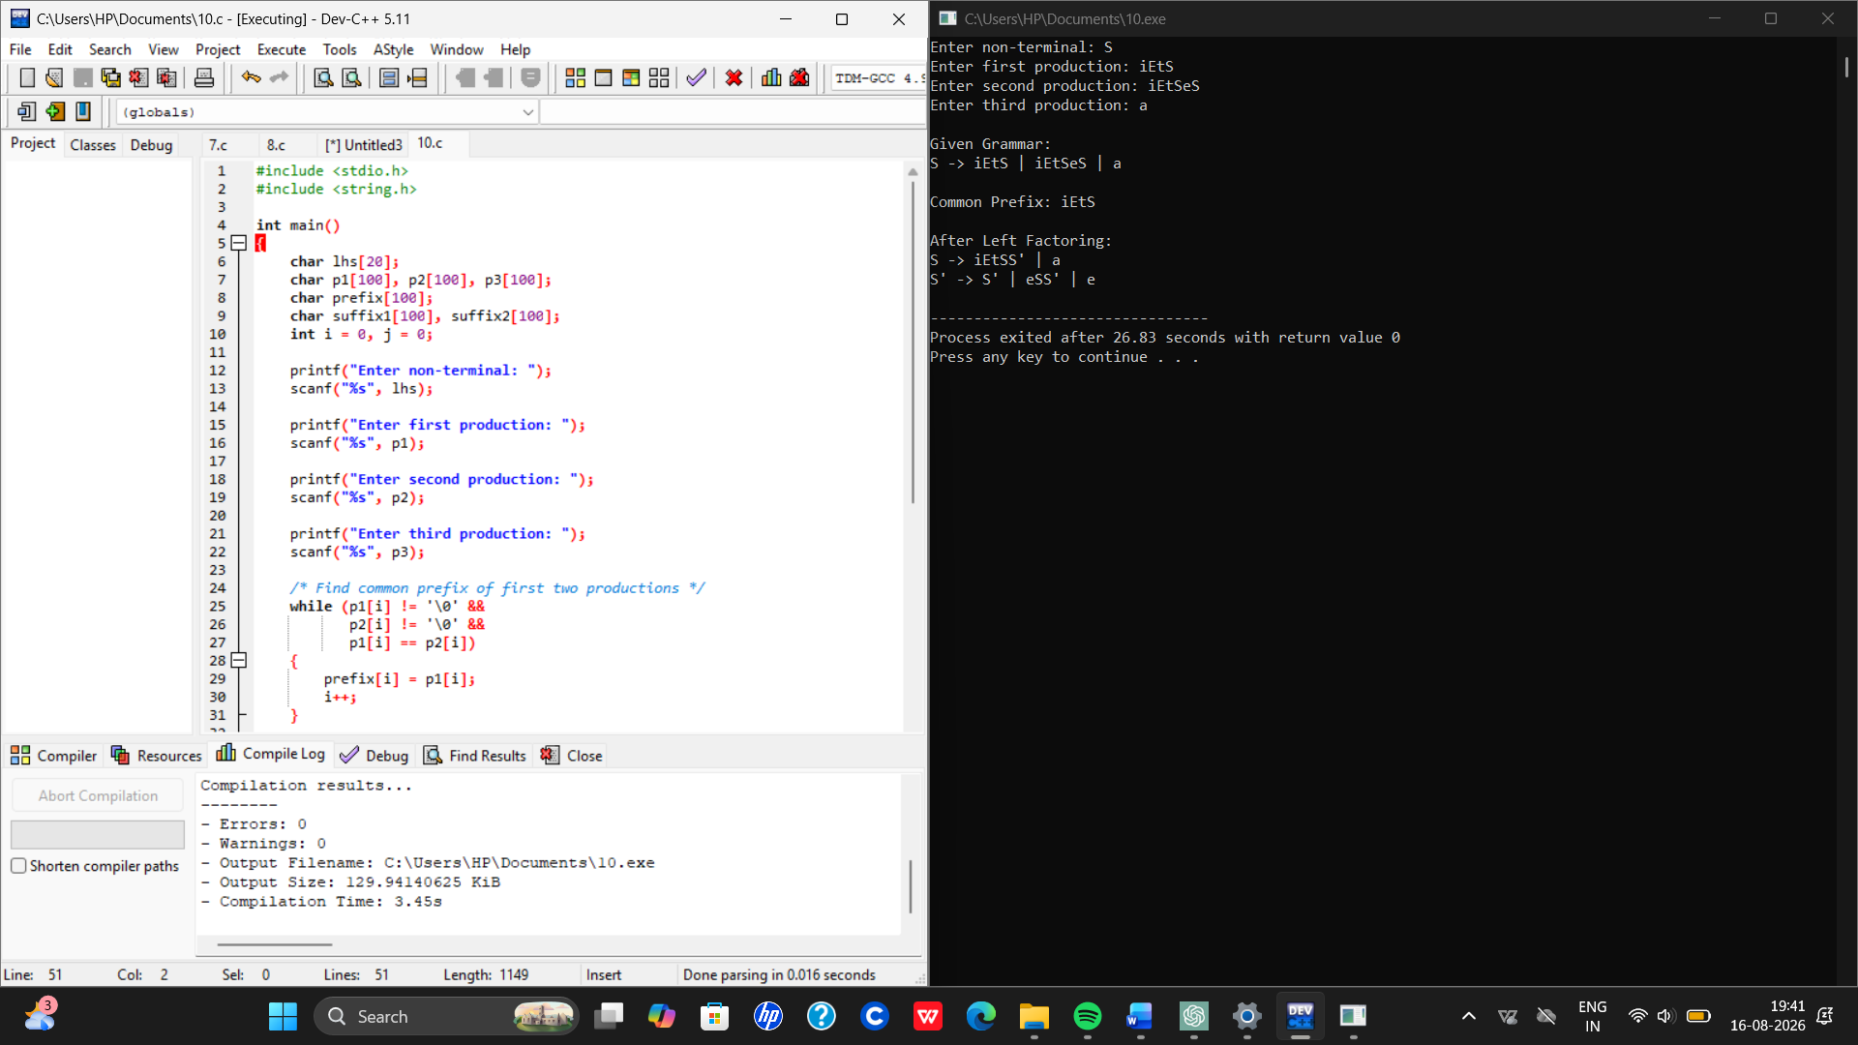

Result
Thus left factoring was eliminated successfully.

11. Symbol Table Operations
Aim
To implement symbol table operations.

Algorithm
- Read symbols
- Store them in table
- Display symbols

Output
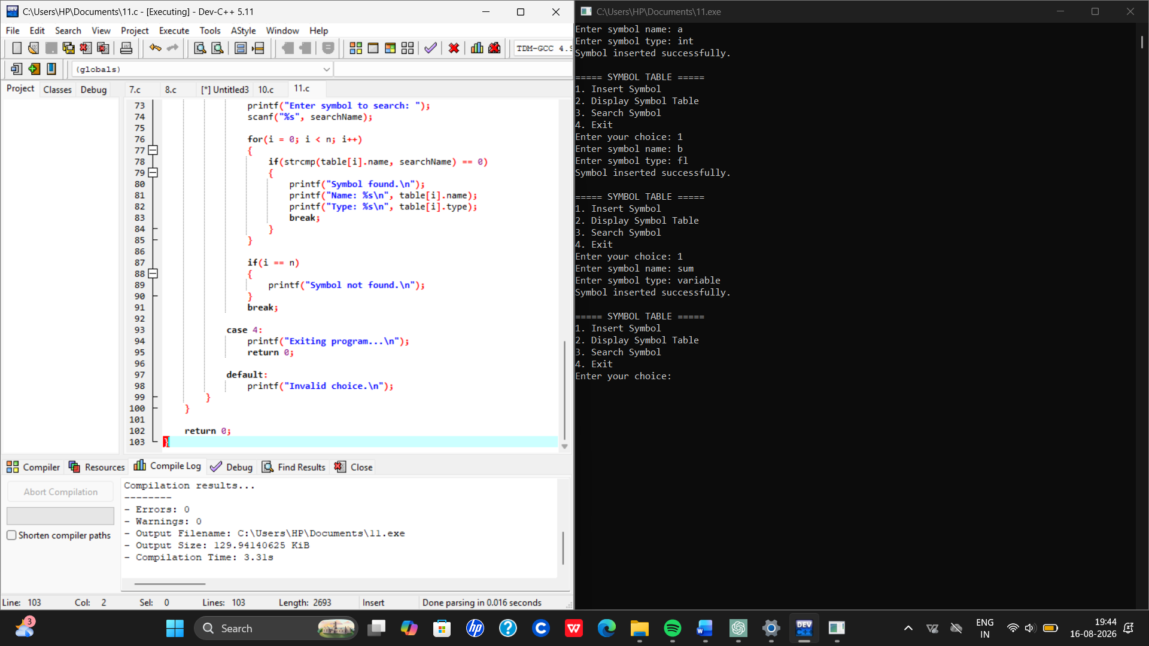
Result
Thus symbol table was implemented successfully.

12. Recursive Descent Parser
Grammar:
E → TE’
E’ → +TE’ / ε
T → FT’
T’ → *FT’ / ε
F → (E) / id
Aim
To implement recursive descent parser.
Algorithm
- Define grammar functions
- Parse input recursively
- Check validity
a+a*a

Output
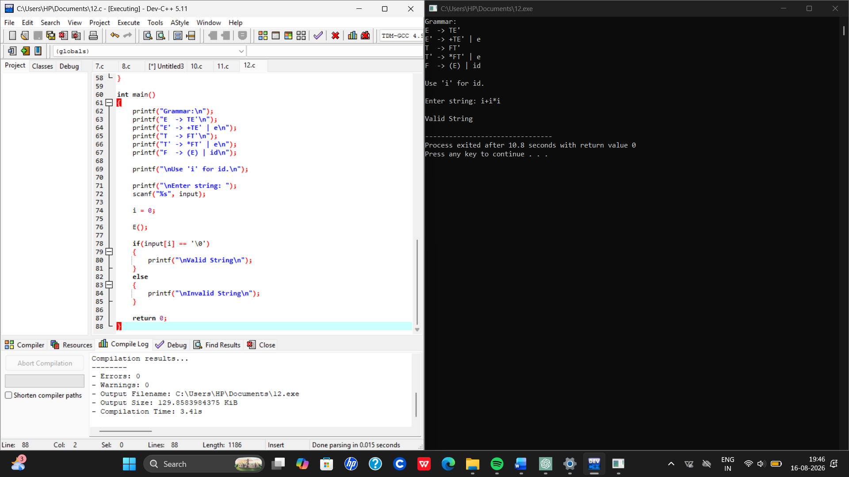

Result
Thus recursive descent parsing was implemented.

13. Top Down Parsing Check
Aim
To check whether input satisfies grammar.
Algorithm
- Read input
- Compare with grammar rules
- Print valid/invalid

Input
ab

Output
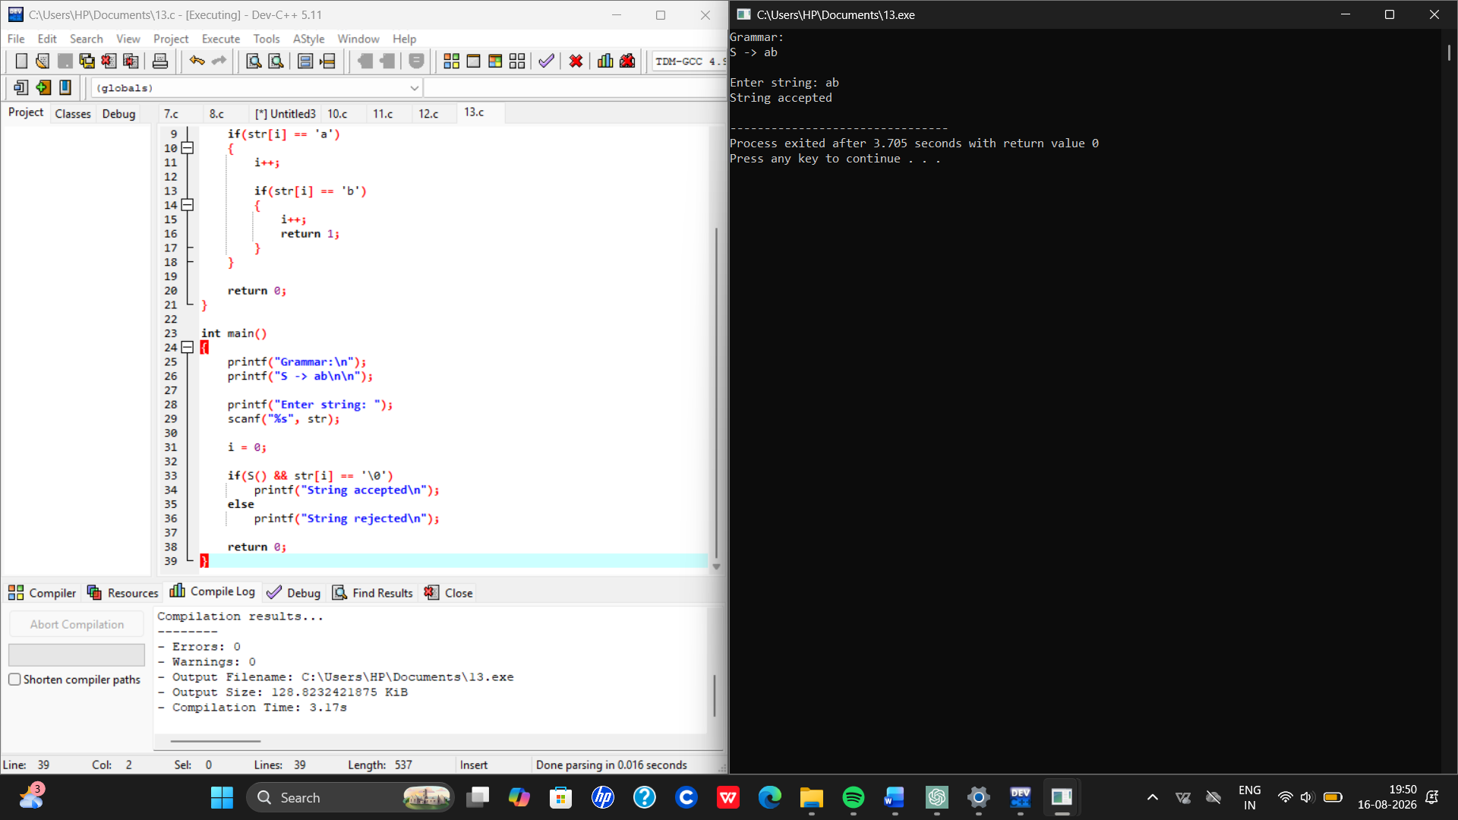
String accepted

Result
Thus parsing validation was done successfully.

14. Three Address Code
Aim
To generate three address code.
Algorithm
- Read expression
- Process operators
- Generate temporary variables
- Print TAC

Input
a+b*c
Output
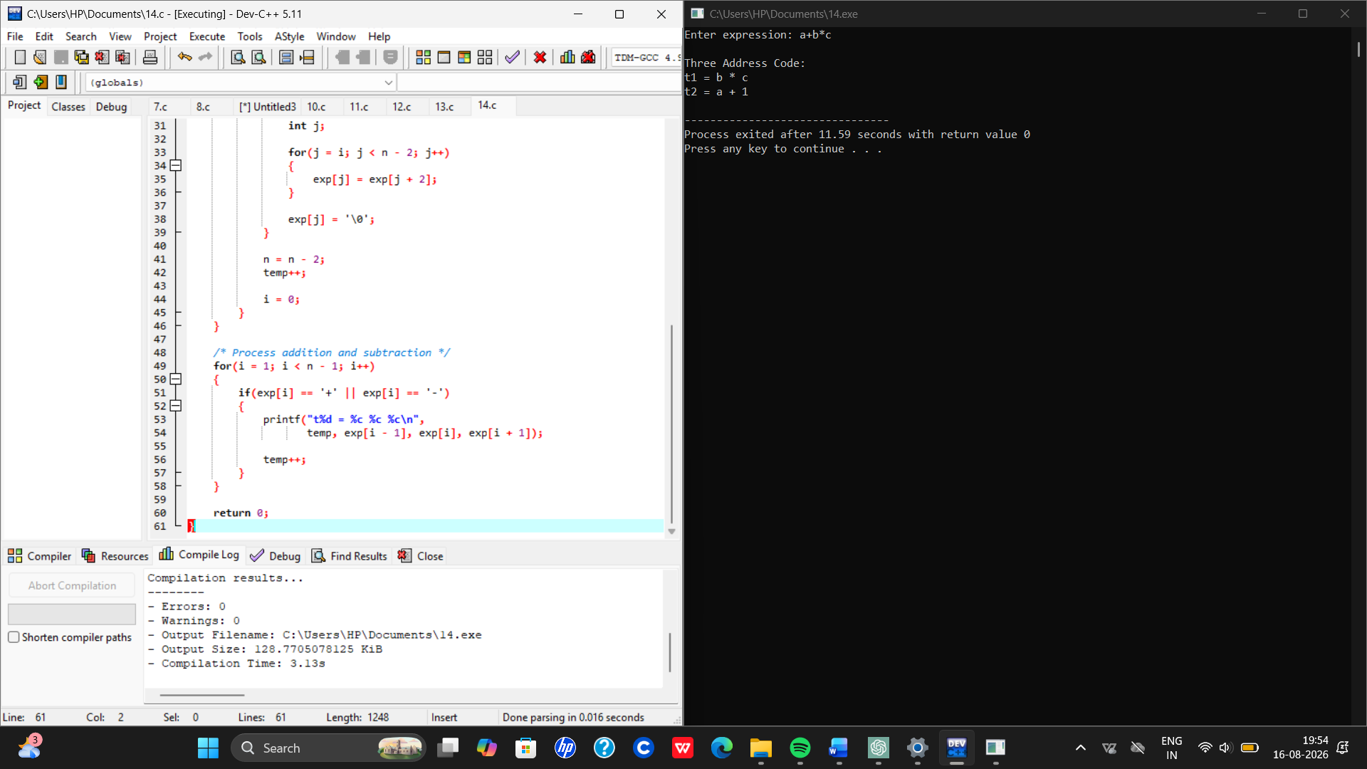
t1 = b*c
t2 = a+t1

Result
Thus three address code was generated successfully.

15. Count Characters, Words, Lines in File
Aim
To count characters, words, and lines.
Algorithm
- Open file
- Read character by character
- Count chars, words, lines
- Display count
Input
test.txt contains:
Hello World
Compiler Design
Output
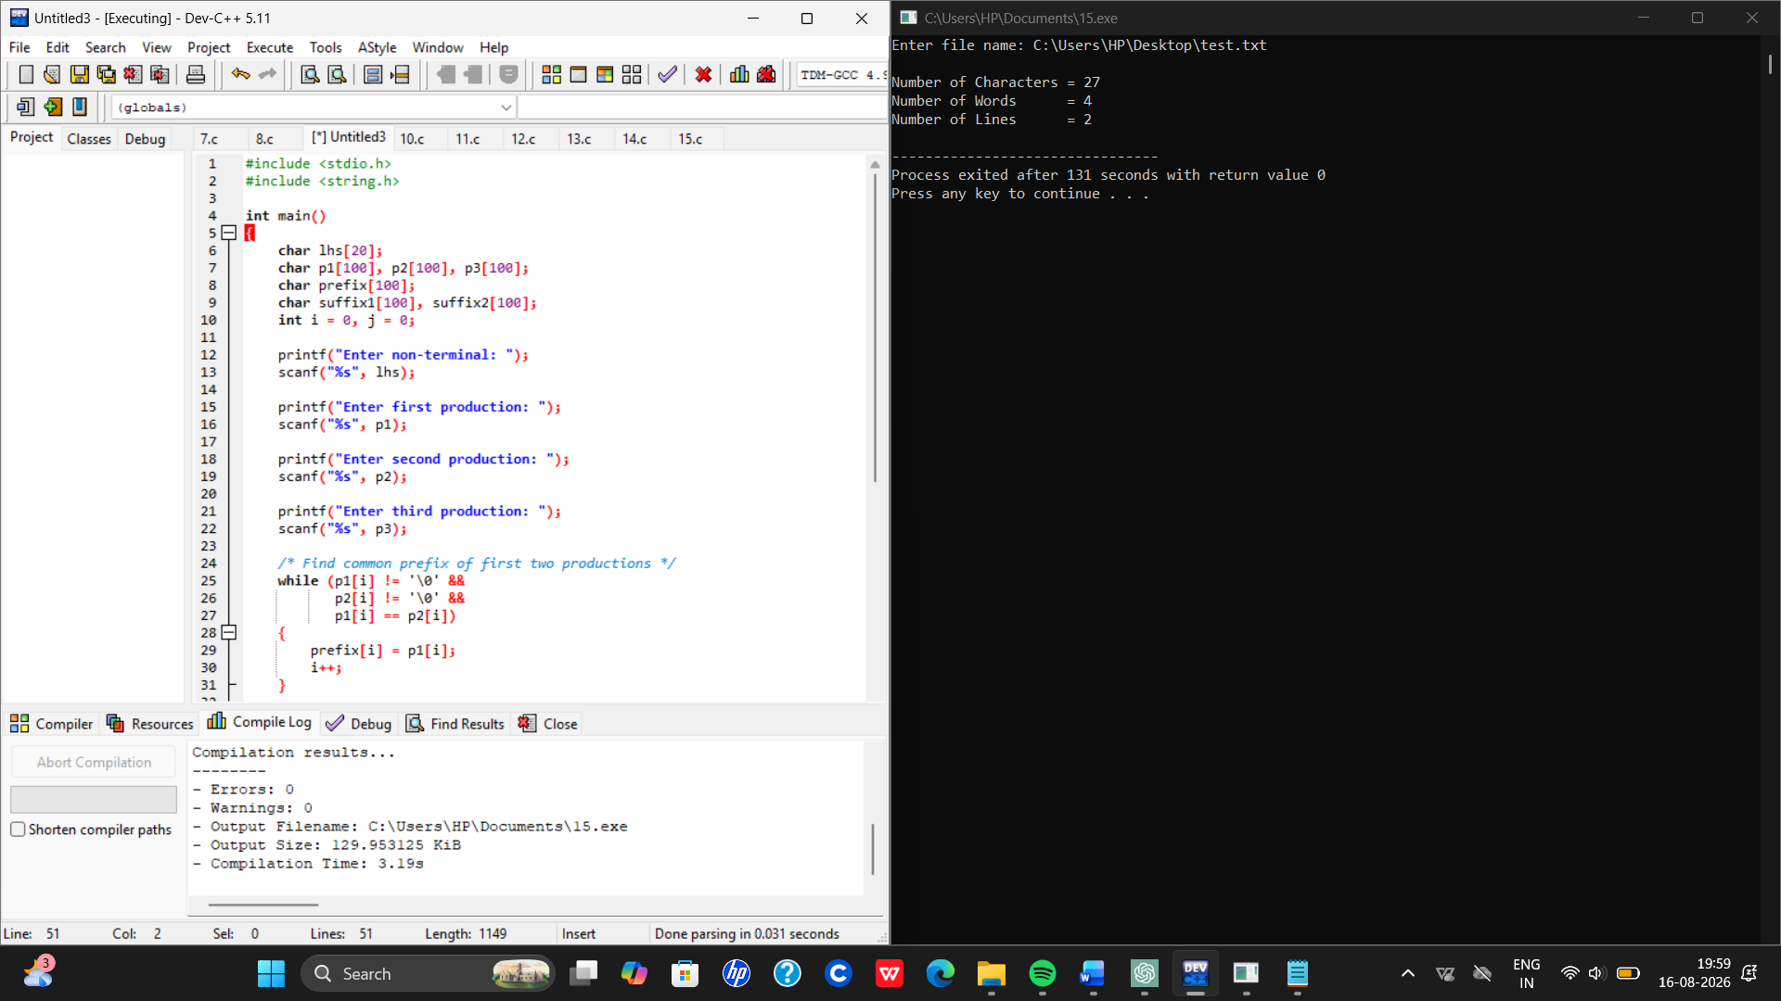
Characters=27
Words=4
Lines=1

Result
Thus characters, words and lines were counted.

16. Back End of Compiler
Aim
To implement backend code generation.
Algorithm
- Read intermediate code
- Convert to machine-like instructions
- Display output

Input
A+B
Output
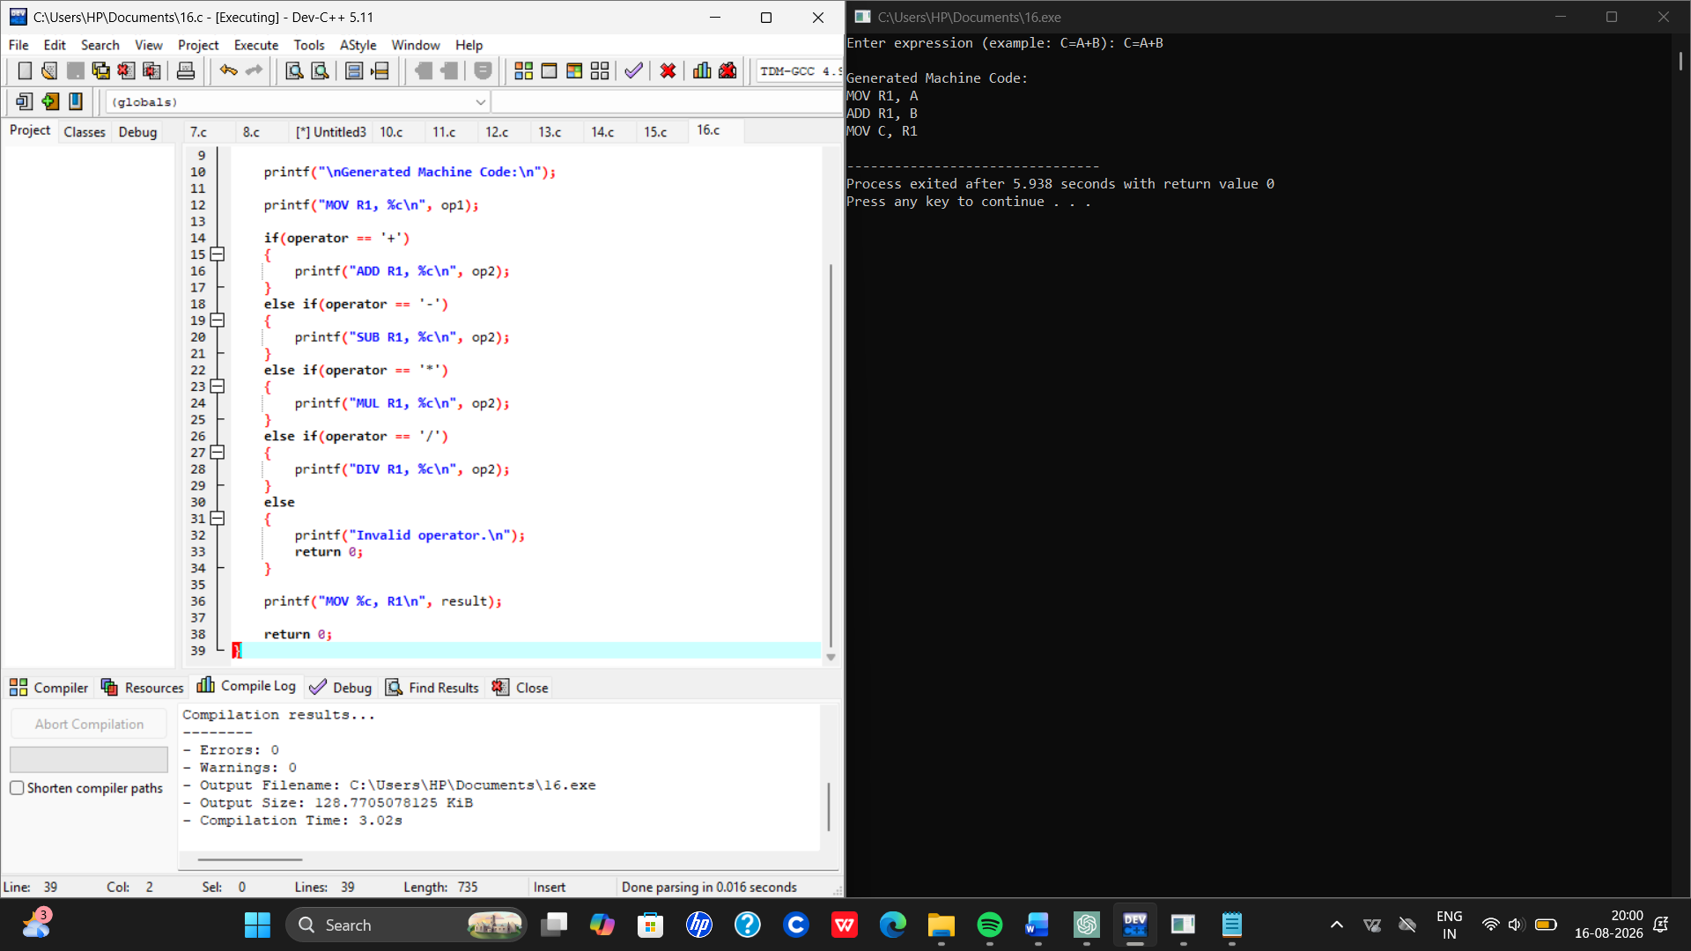
MOV R1,A
ADD R1,B
MOV C,R1
Result
Thus backend code generation was implemented.

17. LEADING()
Grammar:
E → E+T | T
T → T*F | F
F → (E) | id
Aim
To compute LEADING set.
Algorithm
- Check leftmost terminals
- Store in set
- Display result
Input
Given grammar

Output
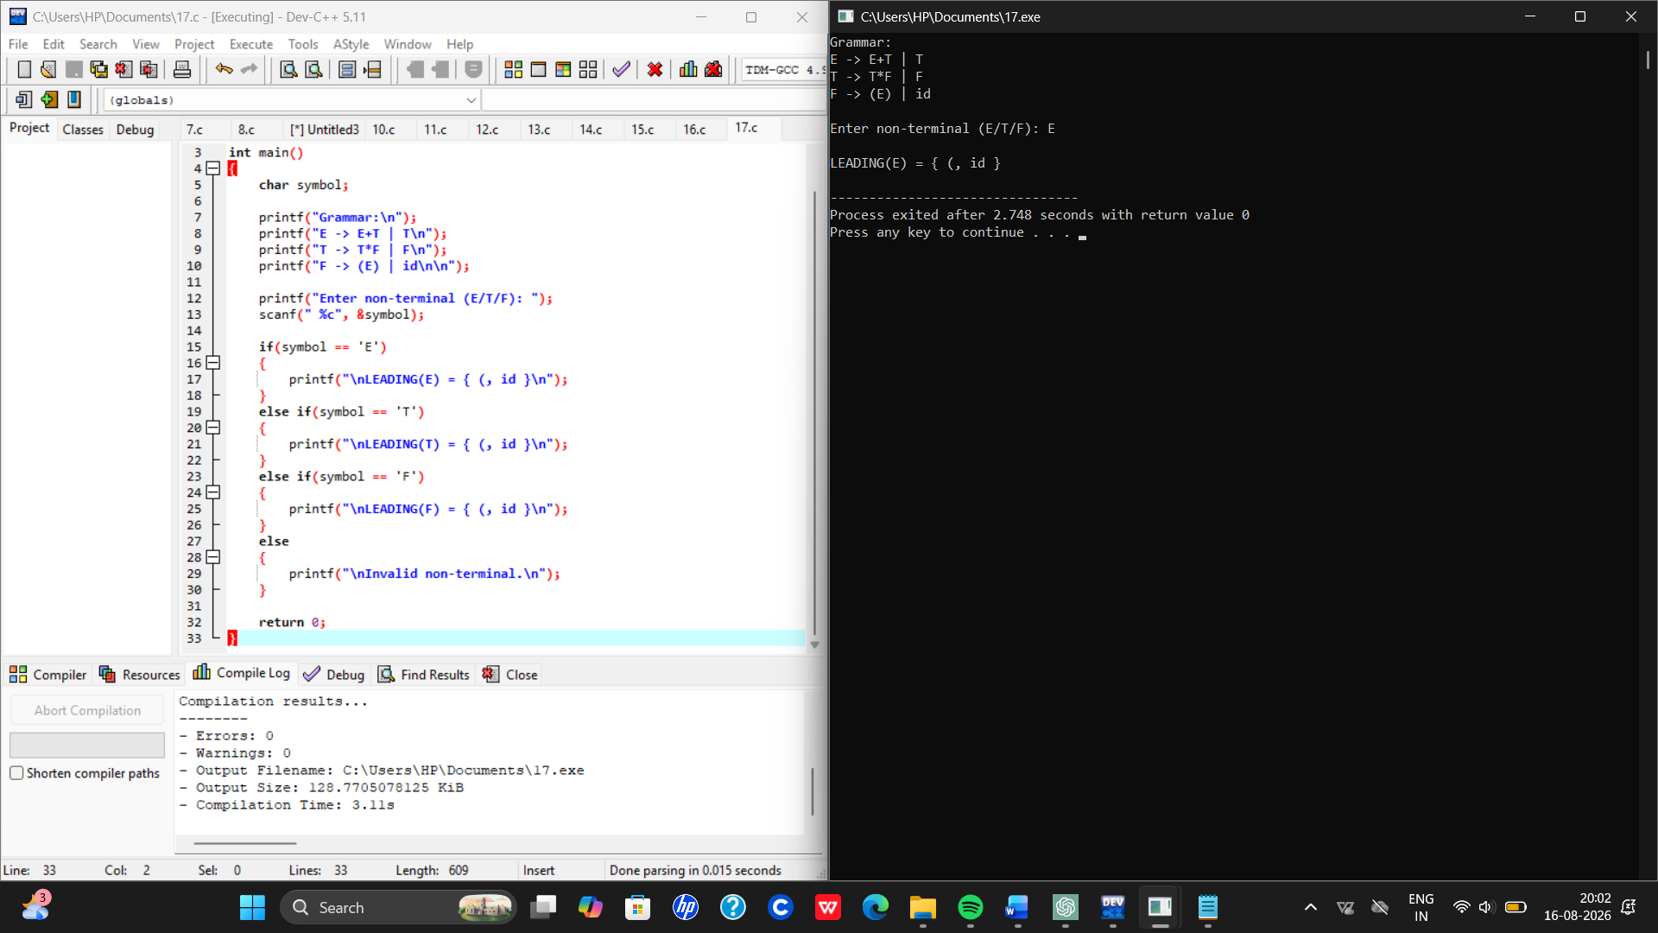
Result
Thus LEADING set was computed successfully.

18. TRAILING()
Grammar:
E → E+T | T
T → T*F | F
F → (E) | id
Aim
To compute TRAILING set.
Algorithm
- Check rightmost terminals
- Store in set
- Display result

Input
Given grammar
Output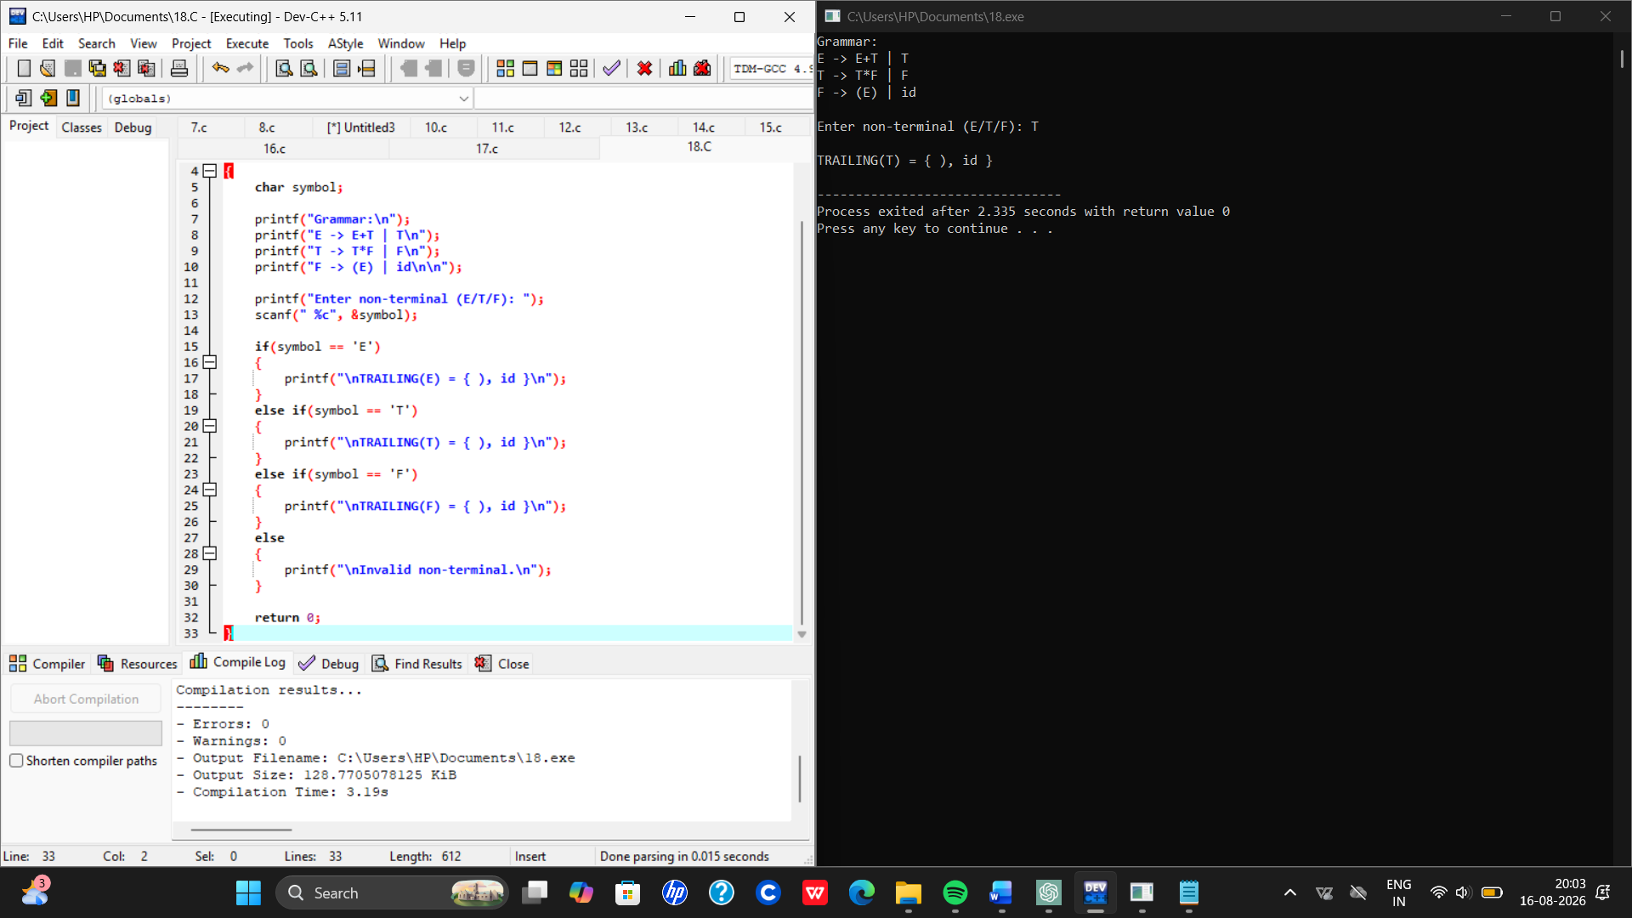
Result
Thus TRAILING set was computed successfully.

