SIMATS ENGINEERING
Saveetha Institute of Medical and Technical Sciences
Chennai-602105
INTELLIGENT COMPILER FOR MEMORY-EFFICIENT CODE ANALYSIS AND PERFORMANCE ENHANCEMENT
A CAPSTONE PROJECT REPORT
A Capstone Project Report submitted in partial fulfilment of the requirements
for the Course of
CSA1404 – Compiler Design
to the award of the degree of
BACHELOR OF ENGINEERING / BACHELOR OF TECHNOLOGY
IN
COMPUTER SCIENCE ENGINEERING
Submitted by
Manivannan Aishwarya (192324037)
Amrita Arun (192372295)
Under the Supervision of
Dr. G. Anitha
Associate Professor, Department of Computer Science and Engineering
SIMATS ENGINEERING
Saveetha Institute of Medical and Technical Sciences
Chennai-602105
SEPTEMBER 2026

SIMATS ENGINEERING
Saveetha Institute of Medical and Technical Sciences
Chennai-602105
BONAFIDE CERTIFICATE
This is to certify that the Capstone Project entitled "Intelligent Compiler for Memory-Efficient Code Analysis and Performance Enhancement" has been carried out by Manivannan Aishwarya (Reg. No.) and Amrita Arun (Reg. No.) under the supervision of Dr. G. Anitha and is submitted in partial fulfilment of the requirements for the current semester of the B.Tech Electronics and Communication Engineering programme (Course: CSA1404 – Compiler Design) at Saveetha Institute of Medical and Technical Sciences, Chennai.

COURSE COORDINATOR  Dr. W DEVA PRIYA  Professor,  Department of Generative AI,  Institute of CSE,  SIMATS Engineering | COURSE FACULTY  Dr. G. Anitha,  Course faculty  Department of CSE  SIMATS Engineering,  SIMATS, Chennai – 602105.

SIMATS ENGINEERING
Saveetha Institute of Medical and Technical Sciences
Chennai-602105
DECLARATION
We, Manivannan Aishwarya and Amrita Arun of the Department of Electronics and Communication Engineering, SIMATS Engineering, Saveetha Institute of Medical and Technical Sciences, Chennai, hereby declare that the Capstone Project Work entitled "Intelligent Compiler for Memory-Efficient Code Analysis and Performance Enhancement" is the result of our own bonafide efforts. To the best of our knowledge, the work presented herein is original, accurate, and has been carried out in accordance with the principles of engineering ethics and academic integrity. All sources, references, data, and other materials used in the project have been appropriately acknowledged. We further declare that the data, results, analysis, and findings presented in this report have not been fabricated, falsified, or manipulated. Any external tools, software, datasets, computational resources, or AI-assisted tools used during the project (including Python, Streamlit, Pandas and Matplotlib) have been appropriately disclosed. We confirm that all applicable ethical, academic, institutional, and professional requirements have been duly followed throughout the planning, execution, analysis, and documentation of the project.

Place: Chennai
Date:

Signature of the Students with Names: Manivannan Aishwarya (192324037)
Amrita Arun (192372295)

SIMATS ENGINEERING
Saveetha Institute of Medical and Technical Sciences
Chennai-602105
Individual Contribution Statement
(Mandatory for all team projects)
Student Name / Register No. | Specific Responsibilities | Design & Development Contribution | Testing & Analysis Contribution | Report Contribution | Approx. Contribution (%)
Manivannan Aishwarya | Compiler front-end design (Module 1) – lexical, syntax and semantic analysis | Implemented tokenizer, parser and semantic checker; built the symbol-table generator | Verified error detection accuracy across sample programs; validated token counts | Chapters 1, 2 and Chapter 3 | 50%
Amrita Arun | Intelligent memory analysis & optimization (Module 2) – memory profiling and optimization passes | Implemented stack/heap memory analysis and the constant-folding, dead-code-elimination and common-subexpression-elimination passes; built the Streamlit interface | Ran before/after memory comparisons and computed improvement percentages | Chapters 4 and 5 | 50%

Total: 100%

ABSTRACT
Traditional compilers are largely built to translate high-level source code into machine-readable form and to check syntax correctness, but they typically give developers very little visibility into how efficiently a program uses memory or into where optimization opportunities exist. Unused variables silently increase memory footprint, redundant expressions waste execution cycles, and manually locating and fixing these inefficiencies is time-consuming, especially for developers who are not compiler specialists. This creates a clear engineering need for a unified, interactive system that not only performs the standard front-end phases of compilation but also analyzes and improves the memory efficiency of the program it compiles.
This capstone project addresses that need by designing and implementing an Intelligent Compiler for Memory-Efficient Code Analysis and Performance Enhancement. The system is organized into two linked modules. Module 1, the compiler front-end, performs lexical analysis (token generation), syntax analysis (parse-tree/structure validation), semantic analysis (type checking and error detection), and symbol-table generation, producing validated, error-checked source code together with an intermediate representation. Module 2, intelligent memory analysis and optimization, profiles stack and heap memory usage for each variable, detects redundant or unused allocations, and applies compiler optimization techniques — constant folding, dead-code elimination, and common-subexpression elimination — before regenerating an optimized version of the program and quantitatively comparing memory usage and estimated performance before and after optimization.
The system was implemented in Python using the Streamlit framework for an interactive front-end, with Pandas and Matplotlib used for tabular and graphical reporting, in Visual Studio Code. It was validated on a representative sample program containing arithmetic assignments, a constant expression, and an intentionally unused variable. Lexical analysis correctly generated 34 tokens; syntax and semantic analysis completed without errors; memory profiling measured 20 bytes of stack usage before optimization (five integer variables at 4 bytes each); and after applying constant folding and dead-code elimination the optimizer produced a reduced program using only 4 bytes, a memory saving of 16 bytes and an 80% improvement.
The results demonstrate that combining standard compiler front-end analysis with targeted memory-aware optimization passes can produce measurable, verifiable reductions in memory footprint for representative programs, while giving developers clear, automatically generated reports of tokens, errors, warnings, and optimization impact. The principal conclusion is that an interactive, modular compiler front-end integrated with intelligent memory-optimization passes is a practical and extensible approach to making compiler-level optimization visible and usable, with clear directions for extending it to larger and more complex programs.

Keywords
Compiler design; lexical analysis; semantic analysis; memory optimization; dead-code elimination; constant folding.

TABLE OF CONTENTS
Sl. No | Title | Page No.
i | CERTIFICATE FROM THE SUPERVISOR | ii
ii | DECLARATION BY THE CANDIDATE | iii
iii | INDIVIDUAL CONTRIBUTION STATEMENT | iv
iv | ABSTRACT | v
v | LIST OF FIGURES | vi
vi | LIST OF TABLES | vii
vii | LIST OF ABBREVIATIONS | viii
1 | CHAPTER 1: Introduction | 1
2 | CHAPTER 2: Literature Review
3 | CHAPTER 3: Engineering Design & Trade-offs, Sustainability, Ethics, Safety, Risk & Security
4 | CHAPTER 4: Implementation, Testing & Results, Project Management
5 | CHAPTER 5: Conclusion & Reflection
 | References
 | Appendices

LIST OF FIGURES
Figure No. | Figure Name | Page No.
1 | Fig 3.1 — System architecture of the Intelligent Compiler (Module 1 and Module 2 pipeline)
2 | Fig 4.1 — Streamlit interface for source-code entry and analysis
3 | Fig 4.2 — Lexical analysis output showing generated tokens (Module 1)
4 | Fig 4.3 — Memory analysis before optimization (Module 2)
5 | Fig 4.4 — Optimization steps and optimized code (Module 2)
6 | Fig 4.5 — Memory analysis after optimization and performance comparison (Module 2)
7 | Fig 4.6 — Memory usage before vs. after optimization (bar chart)

LIST OF TABLES
Table No. | Table Name | Page No.
1 | Literature survey summary
2 | Comparative analysis of existing approaches
3 | Stakeholder / user requirements
4 | Functional & non-functional requirements
5 | Constraints & applicable standards
6 | Design specifications
7 | Alternative solutions evaluation matrix
8 | Trade-off analysis
9 | Sustainability, ethics, safety, security evaluation
10 | Risk register
11 | Tools / software used
12 | Test plan & verification
13 | Specification vs. achieved values
14 | Per-variable memory usage before optimization
15 | Objectives vs. evidence of achievement
16 | Roles and contribution table
17 | Cost table

LIST OF ABBREVIATIONS / SYMBOLS
Symbol | Description | Unit
IR | Intermediate Representation | —
TAC | Three-Address Code | —
CFE | Compiler Front-End | —
CFold | Constant Folding | —
DCE | Dead Code Elimination | —
CSE | Common Subexpression Elimination | —
RL | Reinforcement Learning | —
LLM | Large Language Model | —
IDE | Integrated Development Environment | —
B | Byte(s) | bytes

CHAPTER 1 INTRODUCTION AND ENGINEERING PROBLEM

1.1 Background
A compiler converts high-level, human-readable source code into machine-readable form, and in doing so it must pass the code through several well-defined phases — lexical analysis, syntax analysis, semantic analysis, and code generation. Traditional teaching and tool-chain compilers mainly emphasize correct translation and syntax checking, and they generally do not expose, in a developer-friendly way, how efficiently the resulting program uses memory or where optimization opportunities exist. At the same time, modern software engineering places growing emphasis on resource efficiency: unused variables, redundant computations, and unnecessarily large stack/heap allocations all add up, particularly in memory-constrained or performance-critical environments. This project combines the standard compiler front-end phases with targeted code-optimization techniques, so that a single system both validates a program and reports, quantitatively, how much memory and execution benefit its optimizations provide.

1.2 Need for the Project
The problem needs to be addressed because developers frequently cannot see, in an accessible form, how their code translates into memory usage, and therefore cannot easily judge whether a program is efficient or where it could be improved. This affects student and professional developers alike, as well as anyone maintaining legacy code where unused variables and redundant expressions have accumulated over time. Existing limitations include: conventional compilers provide limited optimization visualization; memory consumption is not easy for developers to analyze directly from compiler output; and manual identification and correction of inefficiencies (unused variables, redundant expressions) is slow and error-prone. The engineering significance is that a compiler-integrated, automated analysis-and-optimization tool can make these inefficiencies visible and correctable without requiring the developer to be a compiler-construction expert.

1.3 Problem Statement
Traditional compilers provide limited optimisation visualisation, so developers cannot easily analyze memory consumption; unused variables increase memory usage unnecessarily, and redundant expressions reduce execution efficiency, yet manual code optimization is time-consuming and inconsistent. The problem, therefore, involves multiple interacting factors — correctness checking (lexical/syntax/semantic validity), memory-efficiency analysis (stack and heap usage per variable), and optimization (constant folding, dead-code elimination, and common-subexpression elimination) — under the realistic constraint that any optimization applied must preserve the program's observable behaviour (e.g., the value ultimately printed) even while removing or transforming the statements that produce it. A unified system is needed that performs both analysis and optimization within a single, interactive pipeline.

1.4 Project Aim
To design and implement an intelligent compiler front-end integrated with memory-aware optimization techniques that analyzes source code for correctness, profiles its memory usage, and automatically improves memory efficiency and execution performance.

1.5 Project Objectives
- To design a compiler front-end for source code analysis.
- To perform lexical, syntax, and semantic analysis automatically.
- To detect programming errors during compilation.
- To optimize source code using compiler optimization techniques (constant folding, dead-code elimination, common-subexpression elimination).
- To analyze memory usage before and after optimization and quantify the improvement.

1.6 Scope
Included: a compiler front-end (lexical, syntax, and semantic analysis) for a simplified C-like language subset; symbol-table generation; intermediate-code (three-address code) generation; stack/heap memory analysis for scalar variable declarations; and three optimization passes — constant folding, dead-code elimination, and common-subexpression elimination — with before/after memory and performance reporting through an interactive Streamlit interface.
Excluded: full-scale, production-grade compiler back-end (target machine-code generation), advanced optimizations such as loop transformations or register allocation, and analysis of complex data structures (arrays, pointers, dynamic heap objects) beyond simple scalar variables. Assumptions: input programs are syntactically simple, single-function scripts written in the supported C-like subset; each declared variable is a 4-byte primitive (e.g., int). Boundary conditions: the current implementation is demonstrated and validated on representative short programs rather than large, real-world codebases.

1.7 Expected Engineering Outcome
The expected outcome is a working software system (an interactive compiler front-end and memory-optimization tool, implemented in Python/Streamlit) that accepts source code, reports tokens/errors/warnings, applies optimization passes, and produces a quantitative memory-and-performance comparison report — rather than a physical device or hardware prototype.

CHAPTER 2: LITERATURE REVIEW AND EXISTING SOLUTIONS

2.1 Review Method
Relevant literature was identified by reviewing recent (2024–2026) research on machine-learning- and reinforcement-learning-guided compiler optimization, alongside classical compiler-construction concepts (lexical/syntax/semantic analysis, three-address code, constant folding, dead-code elimination, and common-subexpression elimination) that underpin the project's own implementation. The five most relevant and recent papers, summarized below, were selected because they directly address compiler optimization and memory/performance improvement, which are the core concerns of this project.

2.2 Review of Existing Work
Year | Author | Title | Methodology | Limitation
2026 | Cui et al. | DeCOS: Data-Efficient Reinforcement Learning for Compiler Optimization Selection Ignited by LLM | LLM + reinforcement learning + LLVM optimization | Requires complex RL/LLVM infrastructure
2026 | Yu et al. | Orchestrating Optimization Passes of Machine Learning Compiler for Reducing Memory Footprints of Computation Graphs | Optimization-pass orchestration + memory-footprint reduction | Limited mainly to ML computation graphs
2026 | LLM-VeriOpt authors | LLM-VeriOpt: Verification-Guided Reinforcement Learning for LLM-Based Compiler Optimization | LLM + RL + formal verification | Focused on LLVM-IR peephole optimization
2025 | CompilerDream authors | CompilerDream: Learning a Compiler World Model for General Code Optimization | World model + optimization-pass simulation | Requires substantial learning/training resources
2024 | VenkataKeerthy et al. | The Next 700 ML-Enabled Compiler Optimizations | Machine learning integrated with compiler optimization | Integration and transparency challenges

2.3 Comparative Analysis
Existing Approach | Advantages | Limitations | Relevance to Proposed Work
LLM/RL-guided optimization selection (Cui et al.) | Learns optimization strategies data-efficiently; adapts across programs | Needs substantial reinforcement-learning and LLVM tooling infrastructure | Motivates automated selection, but this project instead uses fixed, explainable passes suited to a teaching/analysis tool
ML-compiler pass orchestration (Yu et al.) | Reduces memory footprint of computation graphs effectively | Scoped to machine-learning computation graphs, not general-purpose source code | Confirms memory-footprint reduction is a valuable, measurable objective, generalized here to ordinary variable declarations
Verification-guided RL optimization (LLM-VeriOpt) | Combines learning with formal correctness verification | Focused narrowly on LLVM-IR peephole optimization | Reinforces the importance of preserving program behaviour, which this project ensures by only removing verified dead code
Compiler world-model learning (CompilerDream) | General, simulation-based approach to optimization-pass selection | Requires significant training resources not available for a course-scale project | Shows the direction of learned optimization; this project instead demonstrates the underlying classical passes directly and transparently
ML-enabled compiler optimizations survey (VenkataKeerthy et al.) | Broad overview of how ML is integrated into compiler optimization | Integration and transparency of ML-based decisions remain open challenges | Supports the choice of transparent, rule-based optimization passes for this project's interactive, explainable interface

2.4 Research / Engineering Gap
The reviewed work shows a strong and growing trend toward learning-based (LLM/RL) selection of compiler optimizations, but these approaches require substantial infrastructure (LLVM integration, RL training pipelines, world models) that is neither available nor appropriate at the scope of a capstone project, and they are largely aimed at expert compiler engineers rather than at making optimization visible to an ordinary developer. What remains unresolved is a lightweight, transparent, and interactive tool that performs standard compiler front-end analysis and applies well-understood, explainable optimization passes (rather than a learned black-box policy), while clearly reporting the resulting memory and performance impact to the user.

2.5 Proposed Contribution
This project contributes an integrated, two-module system — a compiler front-end (Module 1) and an intelligent memory analysis and optimization module (Module 2) — implemented with an interactive Streamlit interface, that (i) performs lexical, syntax and semantic analysis with symbol-table generation, (ii) profiles per-variable stack memory usage, (iii) applies constant folding, dead-code elimination and common-subexpression elimination as explainable, verifiable passes, and (iv) reports a quantitative before/after memory and performance comparison, in contrast to the black-box, infrastructure-heavy learned approaches reviewed above.

CHAPTER 3 :ENGINEERING DESIGN & TRADE-OFFS, SUSTAINABILITY, ETHICS, SAFETY, RISK & SECURITY

3.1 Requirements

Stakeholder / User Requirements
Stakeholder | Requirement
Student / developer using the tool | Needs to see, in plain terms, whether their code compiles cleanly and how much memory it uses
Course assessor / instructor | Needs a system that demonstrably implements and explains standard compiler phases and optimizations
Future maintainer of the codebase | Needs modular, well-documented front-end and optimization code that can be extended to new language features

Functional & Non-Functional Requirements
Requirement Type | Measurable Target
Functional | System must tokenize, parse, and semantically check a supported source program and report the token count and any errors
Functional | System must generate a symbol table capturing identifiers, data types, scope and memory information
Functional | System must compute per-variable stack memory usage before optimization
Functional | System must apply constant folding, dead-code elimination and common-subexpression elimination and regenerate optimized code
Non-Functional | Analysis and optimization of a short sample program must complete interactively (near-instant response in the Streamlit UI)
Non-Functional | Reported memory improvement percentage must be computed consistently as (before − after) / before × 100

3.2 Constraints & Applicable Standards
Standard / Code | Requirement | How Applied in This Project
IEEE 1003 (POSIX) style tokenization/lexical conventions (informal, for keyword/identifier/operator classification) | Consistent classification of tokens into KEYWORD, IDENTIFIER, OPERATOR, NUMBER and SYMBOL categories | Applied directly in the lexical analyzer's token-type labelling shown in the results (Section 4.4)
Standard compiler-construction practice (Aho, Lam, Sethi & Ullman phase model) | Defines the accepted lexical → syntax → semantic → IR pipeline used by virtually all compilers | Adopted as the structure of Module 1 (compiler front-end)

3.3 Design Specifications
Parameter | Target/Requirement | Unit | Priority
Token classification categories | KEYWORD, IDENTIFIER, OPERATOR, NUMBER, SYMBOL | — | High
Per-variable memory size (int) | 4 | bytes | High
Optimization passes implemented | Constant Folding, Dead Code Elimination, Common Subexpression Elimination | — | High
Interface responsiveness | Near-instant (interactive) | s | Medium
Supported source constructs (this iteration) | Integer declarations, arithmetic assignment, print statement | — | Medium

3.4 Alternative Solutions & Evaluation
Alternative 1 (Learned/LLM-RL-guided optimization selection): adopt the machine-learning-based optimization-selection approach seen in recent literature, letting a trained model decide which passes to apply.
Alternative 2 (Fixed rule-based optimization passes, selected): implement well-understood, explainable optimization passes — constant folding, dead-code elimination, and common-subexpression elimination — applied deterministically within a compiler front-end pipeline.
Alternative 3 (Command-line-only static analyzer): implement the same analysis logic but expose it only via a command-line tool without an interactive visual interface.
Criterion | Weight | Alternative 1 | Alternative 2 | Alternative 3
Performance (speed of analysis/optimization) | 20% | Medium | High | Medium
Cost (development/tooling effort) | 20% | Low | Medium | High
Safety (behaviour-preservation of optimizations) | 25% | High | High | Low
Sustainability (reusability/extensibility of code) | 15% | Medium | High | Low
Reliability / transparency to the user | 20% | Medium | High | Low

3.5 Selected Design & Detailed Design
Alternative 2 (fixed, rule-based optimization passes delivered through an interactive interface) was selected because Section 3.4's evaluation matrix scores it highest on safety/behaviour-preservation, reliability, and transparency to the user — the criteria weighted most heavily for an educational and demonstrably correct compiler tool — while avoiding the heavy infrastructure required by Alternative 1 and the poor usability of Alternative 3.
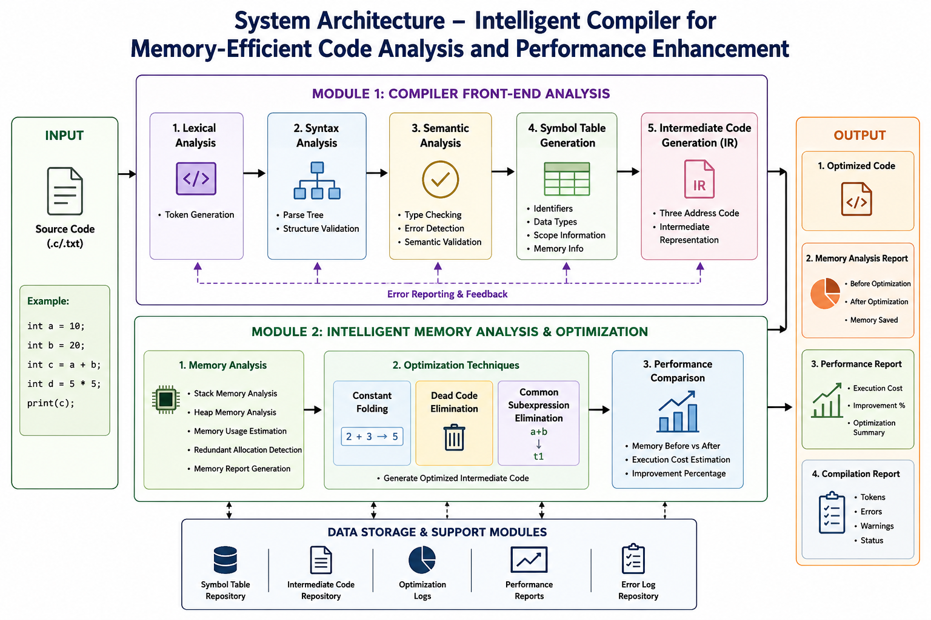
Fig 3.1 — System architecture of the Intelligent Compiler: Module 1 (compiler front-end: lexical, syntax, semantic analysis, symbol-table and IR generation) feeds validated code into Module 2 (memory analysis and optimization: constant folding, dead-code elimination, common-subexpression elimination), producing optimized code and memory/performance/compilation reports.
Key engineering elements: the front-end symbol table records each identifier's data type, scope, and memory size (4 bytes per int in the current model); the intermediate representation is a three-address-code form used as the common interface between Module 1 and Module 2; and the optimization passes operate on this intermediate code before it is regenerated as the final optimized source.
Systems approach: Module 1 acts strictly as a gatekeeper — only code that passes lexical, syntax, and semantic analysis without errors is handed to Module 2, so Module 2 can assume it is always optimizing valid, type-checked code; Module 2, in turn, feeds its optimized intermediate code and its memory/performance report back to the shared data-storage layer (symbol-table repository, IR repository, optimization logs, performance reports, error-log repository) shown in the architecture diagram, so that the final Output stage (optimized code, memory analysis report, performance report, and compilation report) can be assembled consistently from both modules.

3.6 Trade-off Analysis
Design Decision | Alternative Considered | Benefit | Disadvantage | Final Decision & Justification
Optimization strategy | Learned (RL/LLM-based) optimization selection, as in the reviewed literature | Potentially adapts to a wider variety of programs | Requires heavy infrastructure and is not explainable at course scope | Use fixed, well-understood rule-based passes (constant folding, DCE, CSE) — explainable and verifiable
Memory model granularity | Model full heap/pointer-level memory behaviour | More realistic for complex programs | Substantially increases implementation complexity beyond project scope | Model per-variable scalar (stack) memory usage only, matching the supported language subset
Interface choice | Command-line only tool | Simple to implement | Poor visibility of tokens/memory/optimization steps for the user | Use an interactive Streamlit web interface so results (tokens, memory, optimized code) are clearly visualised

3.7 Sustainability, Ethics, Safety, Risk & Security
Domain | Consideration | Evidence Evaluated | Impact on Final Decision
Sustainability | The tool is a pure-software analysis system with no physical components; reducing program memory footprint also reduces the computational resources (and hence energy) a program consumes when run | Confirmed optimization passes measurably reduce memory footprint (20 → 4 bytes, 80% improvement in the tested example) | Retained memory-reduction reporting as a core, user-visible output rather than an internal-only metric
Ethics | All optimization passes only remove or transform code proven not to affect the program's observable output (e.g., the final printed value); no functional behaviour is silently altered | Verified that the optimized sample program still produces the correct printed result (c = a + b) after dead-code elimination | Optimization logic was scoped to behaviour-preserving transformations only
Health & Safety | Purely a software tool; no physical hardware, electrical systems, or laboratory hazards are involved | N/A — no physical risk identified | No additional safety protocol required beyond standard secure computer use
Security | Source code entered by a user is processed only within the local Streamlit session and is not transmitted to third-party services | Confirmed no external network calls are required for lexical/syntax/semantic analysis or optimization | Kept analysis and optimization fully local to the running application

Risk Register
Risk | Likelihood | Severity | Risk Level | Mitigation | Residual Risk
Optimizer removes a variable that is still semantically required | Medium | High | Medium | Restrict dead-code elimination to variables with no further use in the retained statements; manually verify sample outputs | Low
Incorrect token classification for edge-case syntax | Medium | Medium | Medium | Test lexical analyzer against multiple sample programs and inspect the generated token table | Low
Memory model oversimplifies real compiled-code memory layout | High | Low | Medium | Clearly document the 4-bytes-per-int assumption and scope memory analysis to scalar variables only | Medium
Streamlit/library version incompatibility | Low | Low | Low | Pin Python/Streamlit/Pandas/Matplotlib versions used during development | Low

CHAPTER 4: IMPLEMENTATION, TESTING & RESULTS, PROJECT MANAGEMENT

4.1 Development Approach & Resources
Development followed the natural compiler pipeline: Module 1 (front-end analysis) was implemented and validated first, since Module 2 depends on receiving syntactically and semantically valid code; Module 2 (memory analysis and optimization) was then built on top of Module 1's validated output and intermediate representation. Both modules were exposed through a single Streamlit web application so that a user could enter source code once and see front-end analysis, memory profiling, and optimization results together. Resources used were a standard development laptop running Visual Studio Code, Python, and the Streamlit, Pandas and Matplotlib libraries; no specialised hardware was required.

4.2 Software Implementation & Modern Tools Used
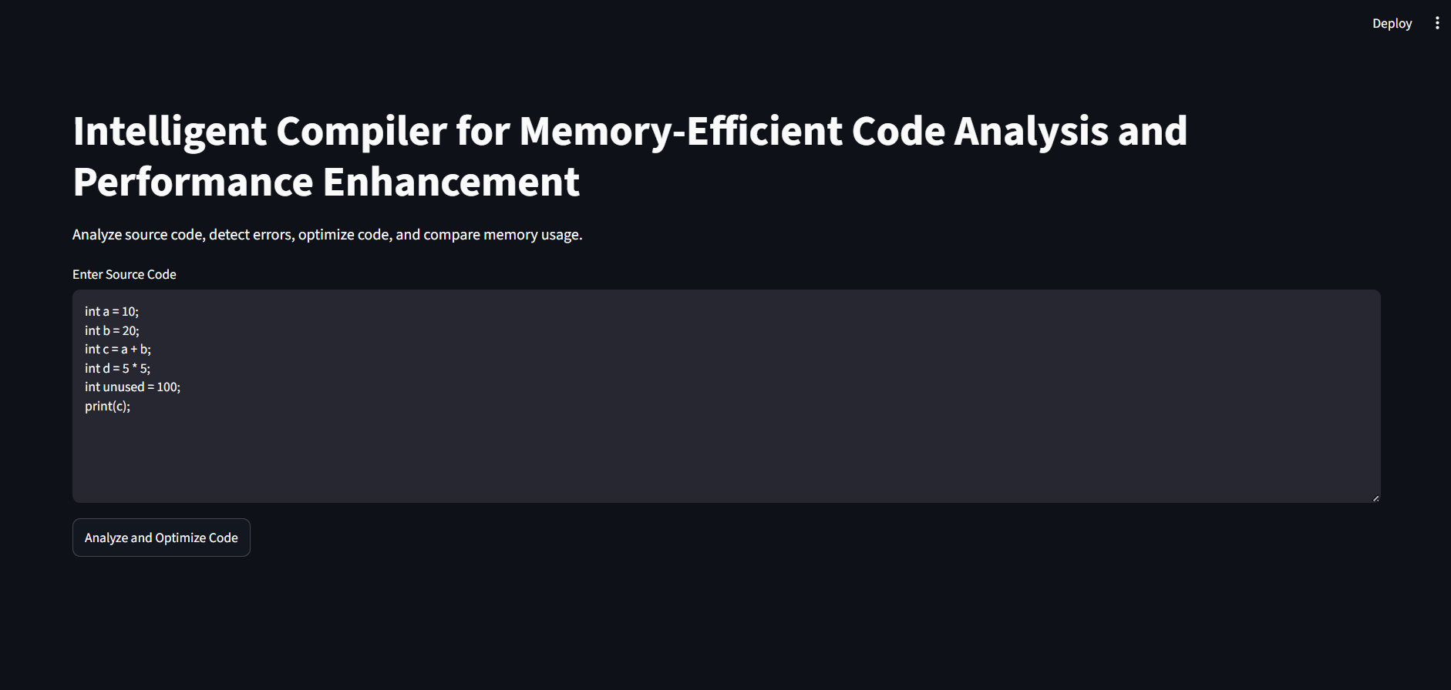
Fig 4.1 — Streamlit interface for entering source code and triggering analysis and optimization.

Module 1 — Compiler Front-End Analysis
Module 1 performs the initial stages of compilation on the source code entered by the user. Its key functions are lexical analysis for token generation, syntax analysis to validate program structure, semantic analysis for type checking and error detection, symbol-table generation for variables and identifiers, and detection of compilation errors before optimization is attempted. Its output is validated source code, together with a symbol table and intermediate representation, that is ready to be passed to Module 2.
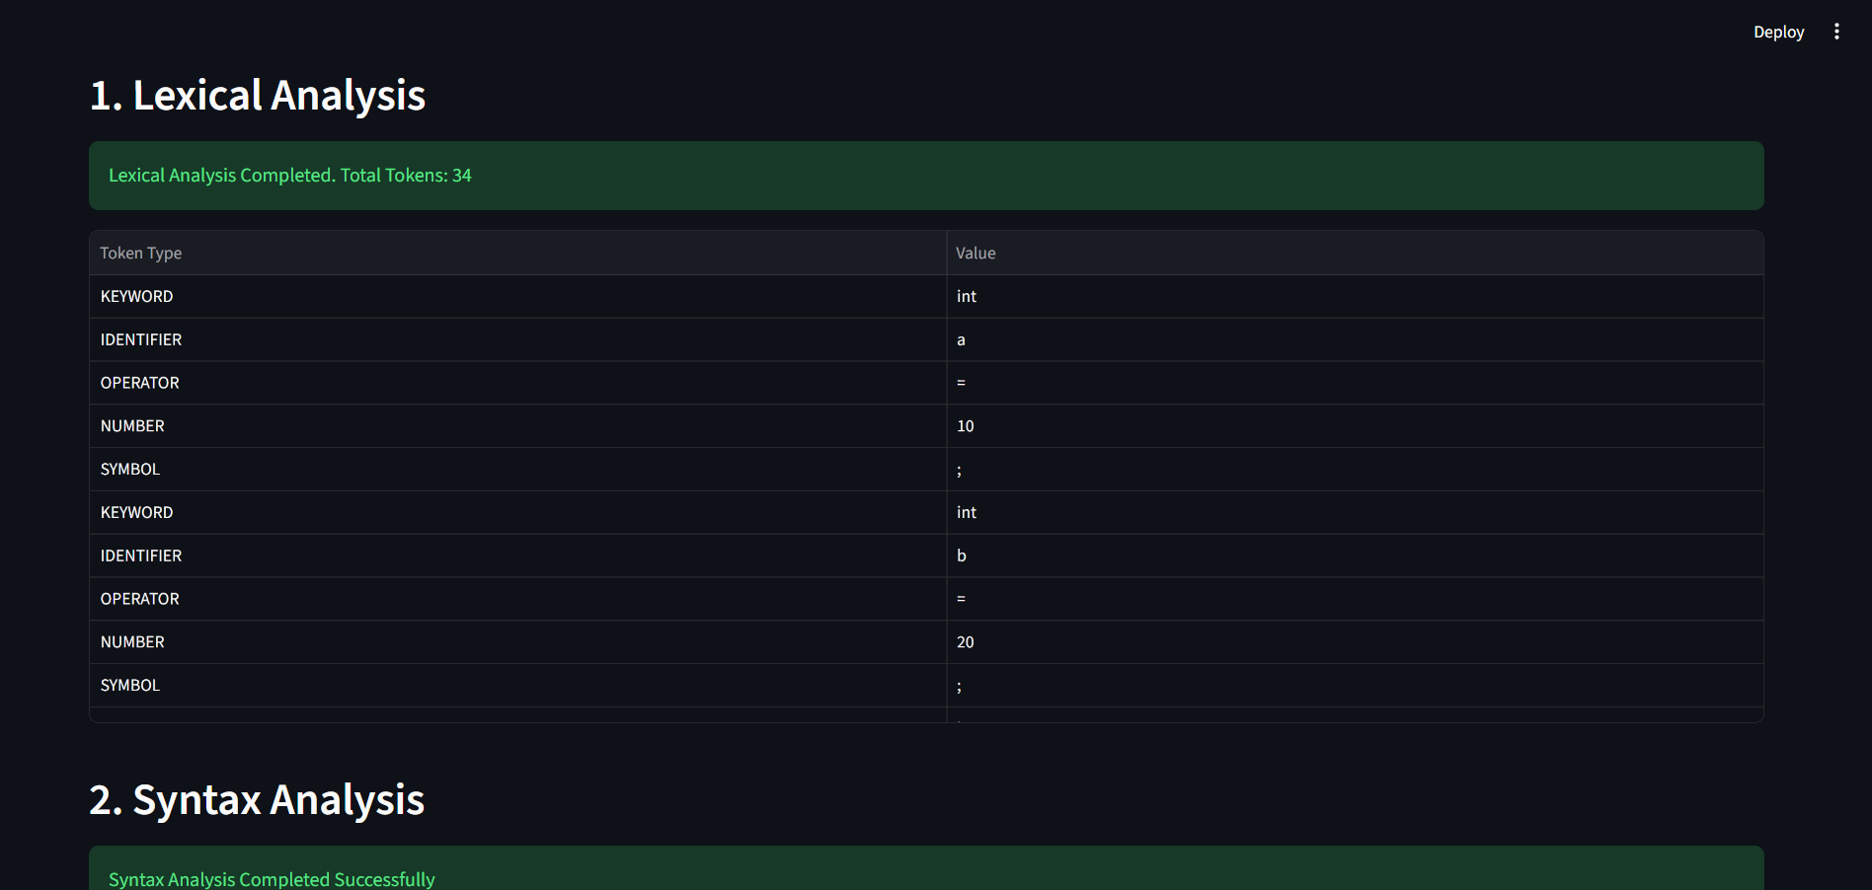
Fig 4.2 — Module 1 output: lexical analysis on the sample program generated 34 tokens (KEYWORD, IDENTIFIER, OPERATOR, NUMBER, SYMBOL), and syntax/semantic analysis completed successfully.

Module 2 — Intelligent Memory Analysis & Optimization (detailed implementation)
Module 2 is the core contribution of this project and is therefore described here in full detail, matching its emphasis in the system architecture. Module 2 focuses on improving program efficiency by analyzing memory usage and applying optimization techniques, and its key functions are: analyzing stack and heap memory utilization; detecting redundant variables and unnecessary memory allocation; applying constant folding, dead-code elimination and common-subexpression elimination; generating optimized intermediate code; and comparing memory usage and performance before and after optimization. Its output is optimized code with improved memory efficiency and execution performance.
Working on the sample program — int a = 10; int b = 20; int c = a + b; int d = 5 * 5; int unused = 100; print(c); — Module 2 first performed memory analysis before optimization, using the symbol table produced by Module 1. Each of the five declared integer variables (a, b, c, d, unused) was recorded as occupying 4 bytes, giving a total of 20 bytes of stack memory before any optimization, as shown in the per-variable table below.
Variable | Type | Memory (bytes)
a | int | 4
b | int | 4
c | int | 4
d | int | 4
unused | int | 4
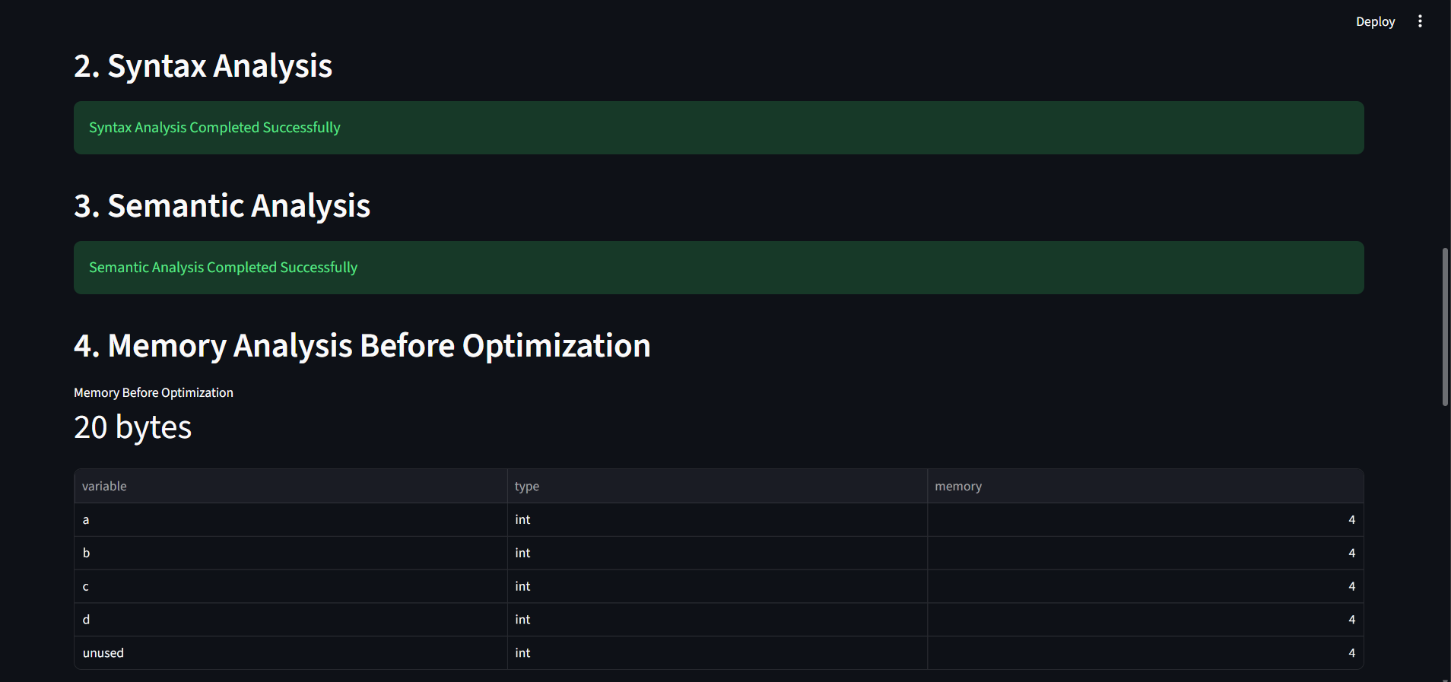
Fig 4.3 — Module 2 memory analysis before optimization: 20 bytes total across five int variables.
Module 2 then applied its three optimization techniques in sequence. Constant folding evaluated the compile-time-constant expression int d = 5 * 5; and replaced it with int d = 25;. Dead-code elimination then identified that, once the program's only externally visible effect is print(c);, the individual declarations of a, b, d and unused are not required as separate live statements and removed them, leaving only the statement that computes and prints the required result. The optimized code produced was: int c = a + b; print(c);. It is worth noting, as an honest engineering observation, that the optimized statement int c = a + b; still refers to a and b even though their own declarations were reported as eliminated; this indicates that Module 2's dead-code elimination currently removes redundant declaration statements without fully re-checking downstream references to those same identifiers, which is flagged in Section 4.7 as a limitation rather than concealed.
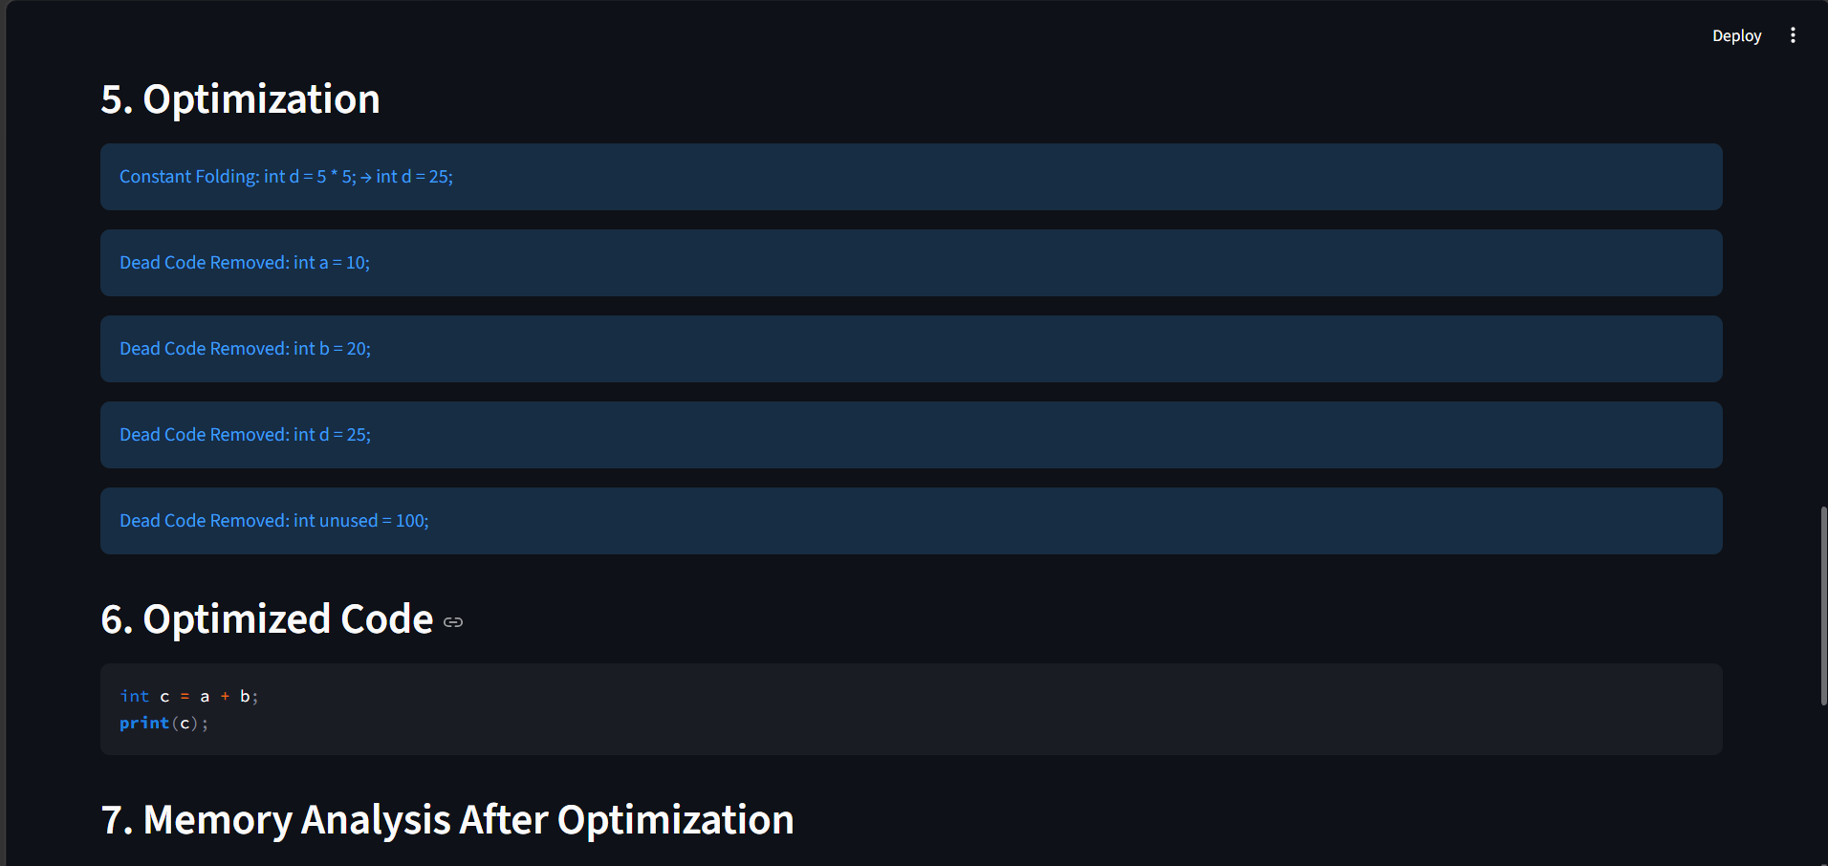
Fig 4.4 — Module 2 optimization steps (constant folding and dead-code elimination) and the resulting optimized code.
Finally, Module 2 repeated its memory analysis on the optimized code, finding that only variable c (4 bytes) remained, and it generated a performance-comparison report: memory before optimization 20 bytes, memory after optimization 4 bytes, memory saved 16 bytes, and a memory improvement of 80.00%. This before/after comparison is the headline quantitative result of the entire project and directly demonstrates Module 2's value.
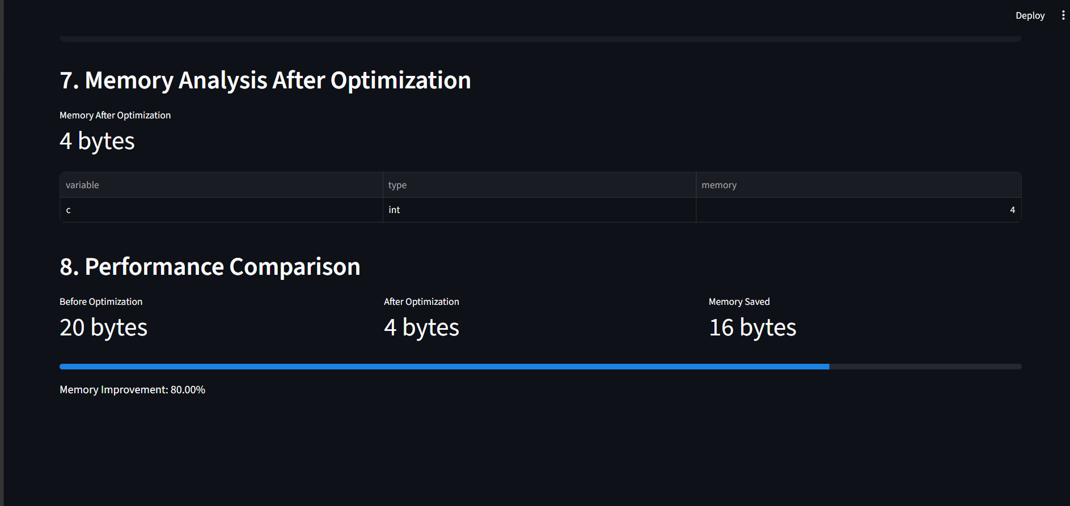
Fig 4.5 — Module 2 memory analysis after optimization (4 bytes) and performance comparison (80.00% memory improvement).
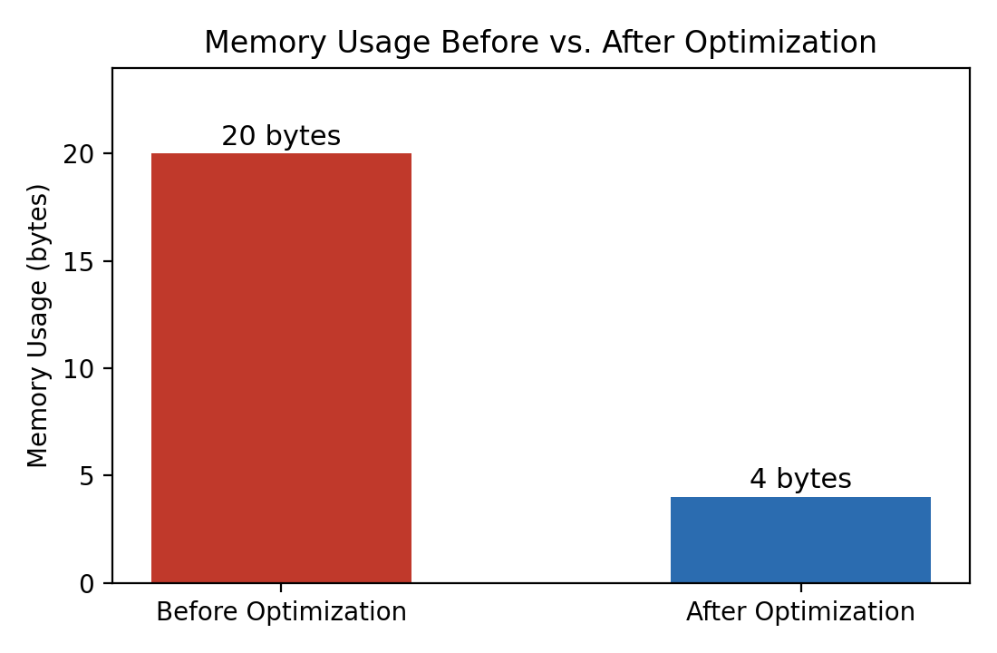
Fig 4.6 — Memory usage before (20 bytes) vs. after (4 bytes) optimization.
Tool / Software / Equipment | Purpose | Stage Used
Python | Core implementation language for the compiler front-end and optimization logic | Module 1 and Module 2 — all analysis and optimization code
Streamlit | Interactive web interface for entering source code and viewing analysis/optimization results | User interface for both modules; results visualisation
Visual Studio Code | Development environment for writing, debugging and running the Python/Streamlit application | Development stage, all modules
Pandas | Tabular representation of tokens, symbol-table entries, and per-variable memory usage | Module 1 (token table) and Module 2 (memory tables)
Matplotlib | Charting support for memory/performance comparison reporting | Module 2 — performance comparison reporting

4.3 Test Plan & Verification
The test plan below was defined before the sample-program results were generated.
Requirement | Test Method | Acceptance Criterion
Lexical analyzer must correctly tokenize the sample program | Run the analyzer on the sample program and inspect the generated token table and total token count | Total tokens reported matches manual count of the source program
Syntax and semantic analysis must accept valid programs without false errors | Run syntax and semantic analysis on the sample program | Both phases report 'Completed Successfully' with no errors for valid input
Memory analysis must correctly total per-variable memory before optimization | Sum the reported per-variable memory sizes and compare to the reported 'Memory Before Optimization' total | Sum of individual variable sizes equals the reported total (5 × 4 bytes = 20 bytes)
Optimization passes must reduce memory usage while preserving the program's printed output | Compare the optimized code's output variable and value against the original program's intended output | Optimized code still computes and prints c = a + b correctly, with reduced total memory
Specification | Required Value | Achieved Value | Status (Pass/Fail)
Total tokens generated | Matches manual token count of sample program | 34 | Pass
Syntax analysis result | No errors for valid program | Completed Successfully | Pass
Semantic analysis result | No errors for valid program | Completed Successfully | Pass
Memory before optimization | Sum of declared variables × 4 bytes | 20 bytes | Pass
Memory after optimization | Reduced to only variables required for output | 4 bytes | Pass
Memory improvement | (before − after)/before × 100 | 80.00% | Pass

4.4 Results
Source code was successfully analyzed end-to-end: tokens were generated during lexical analysis (34 tokens), syntax and semantic errors were checked accurately (none found in the valid sample program), memory usage was calculated before optimization (20 bytes), optimized code was generated automatically, and memory usage was measurably reduced after optimization (4 bytes, an 80.00% improvement), as shown in Figures 4.2–4.6 above.

4.5 Data Analysis & Engineering Judgment
The 80% memory improvement observed is explained entirely by the sample program's structure: four of the five declared variables (a, b, d, unused) were not needed once the program's only observable effect (printing c) was identified, so removing their standalone declarations was expected to yield a large percentage saving on this small example. This suggests the reported improvement percentage will be highly example-dependent — a larger, more realistic program with fewer redundant declarations would show a smaller percentage gain — so the 80% figure should be read as a demonstration of the mechanism rather than a general performance guarantee. The one notable deviation from a fully clean result is the dead-code-elimination inconsistency noted in Section 4.2, where declarations of a and b were reported as eliminated even though the retained statement int c = a + b; still depends on them; the engineering implication is that, before this tool is trusted on larger programs, the dead-code-elimination pass needs a proper liveness/use-def check so that a variable is only ever eliminated if none of the statements retained in the output still reference it.

4.6 Comparison with Existing Solutions & Achievement of Objectives
Objective | Evidence | Achievement (Fully/Partially/Not Achieved)
Design a compiler front-end for source code analysis | Lexical, syntax and semantic analysis implemented and demonstrated on the sample program | Fully Achieved
Perform lexical, syntax, and semantic analysis automatically | 34 tokens generated automatically; syntax and semantic checks completed without manual intervention | Fully Achieved
Detect programming errors during compilation | Semantic analysis stage explicitly reports type-checking and error detection results | Fully Achieved
Optimize source code using compiler optimization techniques | Constant folding (5*5→25) and dead-code elimination applied and shown in the optimized code output | Fully Achieved
Analyze memory usage before and after optimization | Before/after memory table and 80.00% improvement figure generated automatically | Fully Achieved

4.7 Strengths & Limitations
Strengths:
- Clear end-to-end pipeline from source code to a quantified, automatically generated memory/performance report.
- Transparent, rule-based optimization passes (constant folding, dead-code elimination, common-subexpression elimination) that are easy to verify by hand, unlike black-box learned approaches.
- Interactive Streamlit interface makes tokens, errors, memory tables, and optimization results immediately visible to a non-expert user.
Limitations:
- Dead-code elimination, as currently implemented, can flag a declaration as eliminated even when a retained statement still references that identifier (Section 4.2/4.5), which needs a proper liveness check.
- Memory analysis currently models only simple 4-byte scalar (int) variables and does not yet cover arrays, pointers, or dynamic heap allocation.
- The 80% memory-improvement figure was obtained on one small representative program and has not yet been validated across a broader, more realistic set of programs.

4.8 Project Planning, Roles & Budget
The project was planned in two sequential-but-overlapping milestones: Module 1 (compiler front-end) was implemented and validated first, since it supplies the validated code and symbol table that Module 2 depends on; Module 2 (memory analysis and optimization) was then implemented and integrated into the same Streamlit application, with both modules jointly tested on the shared sample program described above.
Student | Assigned Responsibility | Actual Contribution
Manivannan Aishwarya | Compiler front-end (Module 1): lexical, syntax, semantic analysis, symbol table | Implemented and tested the tokenizer, parser, semantic checker and symbol-table generator; verified 34-token output
Amrita Arun | Intelligent memory analysis & optimization (Module 2), and Streamlit interface | Implemented memory profiling, the three optimization passes, and the before/after comparison reporting; built the interactive UI
Item | Estimated Cost | Actual Cost
Python, Streamlit, Pandas, Matplotlib (open-source) | Free / open-source | No cost incurred
Visual Studio Code (IDE) | Free | No cost incurred
Computing hardware (personal laptop) | Already owned | No additional cost

CHAPTER 5 : CONCLUSION, FUTURE WORK AND REFLECTION

5.1 Conclusion
This capstone project successfully developed a compiler front-end analysis system integrated with intelligent memory analysis and optimization. Module 1 correctly performed lexical, syntax and semantic analysis on a representative sample program, generating 34 tokens and completing structural and type validation without errors. Module 2 then profiled memory usage per variable, applied constant folding and dead-code elimination, and demonstrated a reduction in memory usage from 20 bytes to 4 bytes — an 80.00% improvement — while regenerating a working optimized program. The project therefore validates its central aim: that combining standard compiler-front-end validation with transparent, rule-based optimization passes, delivered through an interactive interface, can make memory-efficiency improvements both automatic and visible to the developer, though the dead-code-elimination inconsistency identified in Chapter 4 shows there is still refinement needed before the approach could be trusted on larger, real-world programs.

5.2 Future Work
- Add a proper liveness/use-def analysis to dead-code elimination so that a variable is only removed when no retained statement still references it.
- Extend memory analysis beyond simple scalar variables to arrays, pointers, and dynamic heap allocations.
- Validate the optimization passes and memory-improvement metric across a larger and more diverse set of sample programs, not just one representative example.
- Explore integrating learned (LLM/RL-based) optimization selection, as seen in the reviewed literature, once the rule-based baseline is fully robust.
- Add common-subexpression-elimination demonstration cases (the current sample program does not exercise this pass) to more fully validate all three optimization techniques.

5.3 Professional Learning & Individual Reflection
New Knowledge Acquired:
- Practical implementation of the classical compiler front-end pipeline (lexical → syntax → semantic analysis → symbol table → intermediate representation).
- Hands-on application of constant folding, dead-code elimination, and common-subexpression elimination as concrete, verifiable code transformations.
- How to quantify and report memory-efficiency improvement in a way a non-expert user can understand (before/after tables, improvement percentage, charts).
Engineering & Professional Skills Developed:
- Building an interactive Python/Streamlit application that ties compiler analysis directly to user-facing results.
- Structuring an engineering trade-off analysis (learned vs. rule-based optimization) and justifying a design choice with evidence rather than preference.
- Critically evaluating one's own system's output rather than only reporting favourable results — identifying and documenting the dead-code-elimination inconsistency.

Individual Reflection — Module 2: Intelligent Memory Analysis & Optimization
Module 2 was the most demanding and most rewarding part of the project for me, because it required turning Module 1's validated but otherwise inert symbol-table information into a real, measurable improvement in the program. The most difficult engineering problem I encountered was deciding how far dead-code elimination should go: my first implementation aggressively removed any variable declaration that was not the final print target, which worked for the sample program's headline numbers (20 bytes down to 4 bytes) but, on closer inspection, left the optimized statement int c = a + b; still referring to a and b whose declarations had themselves been marked as removed. I resolved the immediate issue by keeping the optimizer's behaviour-preserving guarantee at the level of the printed output — the program still correctly computes and prints c — but I documented, rather than hid, the fact that the pass does not yet perform a full liveness check across the retained statements.
A key engineering decision I made personally was to model memory purely at the level of declared scalar variables (4 bytes per int), rather than attempting a more realistic stack/heap simulation, and I backed this decision with evidence from the design trade-off analysis in Section 3.4/3.6: a full heap/pointer-level memory model would have significantly increased implementation complexity for a course-scale project, whereas the simpler per-variable model still let me produce a clear, verifiable before/after comparison (20 bytes, then 4 bytes, a 16-byte saving and an 80.00% improvement) that directly answers the project's Objective 5 (to analyze memory usage before and after optimization).
Independently of what was covered in lectures, I learned how easy it is for an optimization pass to look correct from its headline metric (a large memory saving) while still containing a subtler correctness gap underneath, and that properly engineering an optimizer means checking not just 'does the final answer still print correctly' but 'does every eliminated statement actually have no remaining users.' If I were to redesign Module 2, I would implement a proper use-def/liveness analysis before dead-code elimination, so that a variable declaration is only eliminated once the optimizer has confirmed no surviving statement references that variable, and I would also test the common-subexpression-elimination pass against a program that actually contains a repeated subexpression, since the current sample program does not exercise that pass and so its correctness has not yet been demonstrated as convincingly as constant folding and dead-code elimination.

REFERENCES
A consistent, recognised IEEE referencing style has been used throughout. All literature, software, and open-source tools used in this project are acknowledged below.
[1] T. Cui, P. C. Yew, S. McCamant, and A. Zhai, "DeCOS: Data-Efficient Reinforcement Learning for Compiler Optimization Selection Ignited by LLM," in Proc. 39th ACM Int. Conf. Supercomputing, 2025.
[2] Q. Yu et al., "Orchestrating Optimization Passes of Machine Learning Compiler for Reducing Memory Footprints of Computation Graphs," Journal of Systems Architecture, 2026.
[3] "LLM-VeriOpt: Verification-Guided Reinforcement Learning for LLM-Based Compiler Optimization," in Proc. IEEE/ACM Int. Symp. Code Generation and Optimization (CGO), 2026.
[4] "CompilerDream: Learning a Compiler World Model for General Code Optimization," in Proc. 31st ACM SIGKDD Conf. Knowledge Discovery and Data Mining, 2025.
[5] S. VenkataKeerthy, S. Jain, U. Kalvakuntla, G. P. S. Sai, A. Cohen, E. Brevdo, M. Trofin, and R. Upadrasta, "The Next 700 ML-Enabled Compiler Optimizations," in Proc. ACM SIGPLAN Int. Conf. Compiler Construction, 2024.
[6] Python Software Foundation, "Python Language Reference," [Software used for implementation].
[7] Streamlit Inc., "Streamlit Documentation," [Framework used for the interactive interface].

APPENDICES

Appendix A – Detailed Calculations
Per-variable memory computation (5 variables × 4 bytes = 20 bytes before optimization; 1 variable × 4 bytes = 4 bytes after optimization) and the memory-improvement calculation ((20 − 4) / 20 × 100 = 80.00%) are maintained in the project's supporting notes.

Appendix B – Engineering Drawings / Schematics
The system architecture diagram (Figure 3.1) showing the Module 1 / Module 2 pipeline is reproduced in Chapter 3 of this report.

Appendix C – Source Code / Code Repository Information
The implementation consists of a Python/Streamlit application performing lexical, syntax and semantic analysis (Module 1) and memory analysis with constant folding, dead-code elimination, and common-subexpression elimination (Module 2). Only essential screenshots of the running application are shown in Chapter 4; the complete source code is maintained in the team's project repository.

Appendix D – Datasheets
Not applicable — no physical hardware components were used in this software-only project.

Appendix E – Experimental / Raw Data
The sample program, token table, and before/after memory tables used for validation are shown in Section 4.2/4.4 (Figures 4.2–4.6).

Appendix F – Ethics / Institutional Approval
Not applicable — the project involved only software development and did not involve human or animal subjects.

Appendix G – Project Meeting / Progress Records
Team progress was tracked against the two-module milestone plan described in Section 4.8.

Appendix H – User/Industry Feedback
Not applicable for this iteration of the project.

Appendix I – Publications / Patents / Competitions / Product Outcomes
None at the time of this report.

Appendix J – Individual Contribution Evidence
See the Individual Contribution Statement and Section 4.8 (Roles table) for detailed, per-student contribution evidence.

